Project 2 : Property Listing Analysis

By Sandeep Phatak, Vidyashree CM

1. The hosts who has most number of listing

select top 10 h.host_id,h.host_name, count(l.id) count_

from dallas_hosts h inner join dallas_listings l on h.host_id = l.host_id group by h.host_id, h.host_name order by count_ desc;

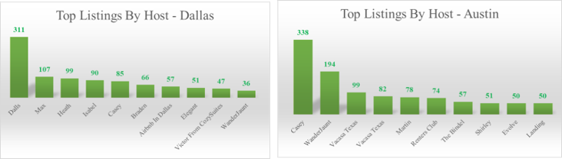

1. Price per accomdate for each property type

select property_type, avg(price)/ avg(accommodates) price_per_accomodate

from dallas_listings group by property_type order by price_per_accomodate desc;

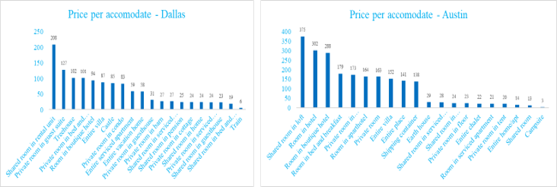

1. Average price of Property Types which are instant bookable and having all ratings above 4.5

select property_type, avg(price) as average_price  
from listingD  
where instant_bookable like 'true'  
group by property_type  
having avg(review_scores_rating) >= 4.5   
 and avg(review_scores_accuracy) >= 4.5  
 and avg(review_scores_checkin) >= 4.5  
 and avg(review_scores_cleanliness) >= 4.5  
 and avg(review_scores_accuracy) >= 4.5

and avg(review_scores_communication) >= 4.5  
 and avg(review_scores_location) >= 4.5  
 and avg(review_scores_value) >= 4.5  
order by average_price;

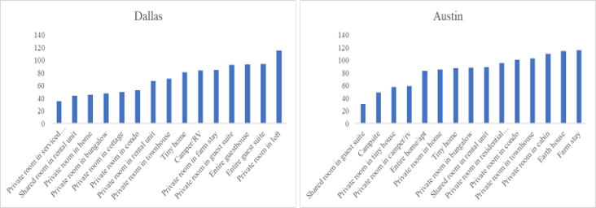

1. Average Price and Price per accommodate for each property type

select property_type, avg(price) Average_price, avg(price)/avg(accommodates) Price_per_accommodate  
from listingA group by property_type  
order by Average_price desc;

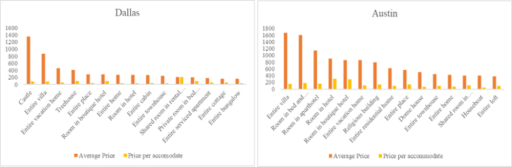

1. Number of listings with instant booking status

with cte1 as (select case when instant_bookable= 0 then 'not_instant_bookable'

else 'instant_bookable' end as booking_type, id

from dallas_listings)

select booking_type, count(id) num_of_listings from cte1 group by booking_type order by count(id) desc;

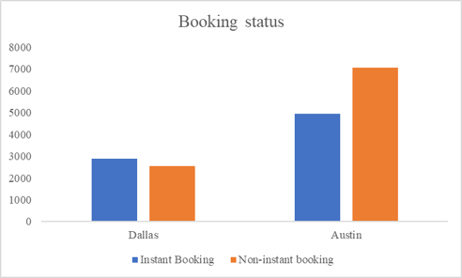

1. Availability of listings day wise

select datename(weekday, date) days_of_the_week , count(id) num_of_available_listings

from dallas_availability where available = 'true'

group by datename(weekday, date) order by num_of_available_listings desc;

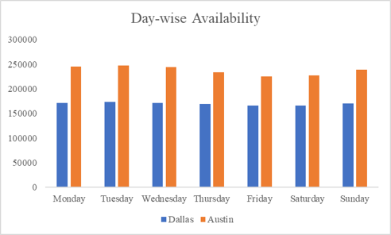

1. Count of listings available month wise

select month(date) month_num ,datename(month, date) month_of_availability, count(listing_id) count_of_listings_available

from dallas_availability

where available like 'true'

group by datename(month, date), month(date)

order by month_num

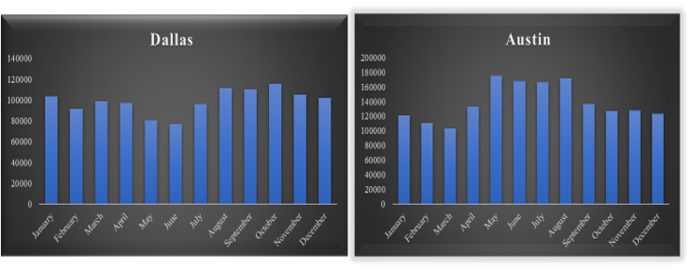

1. Property wise percentage of good and bad comments

with cte1 as(

select l.property_type , count(r.comments) number_of_good_comments

from dallas_listings l

inner join dallas_review r on l.id = r.listing_id

where r.comments like '%good%' or r.comments like '%great%' or r.comments like '%awesome%' or r.comments like '%love%' or r.comments = '%easy%'or r.comments = '%wonderful%' or r.comments = '%comfortable%' or r.comments = '%recommended%' group by l.property_type ),

cte2 as (

select l.property_type , count(r.comments) number_of_bad_comments

from dallas_listings l

inner join dallas_review r on l.id = r.listing_id

where r.comments like '%not%' or r.comments like '%bad%' or r.comments like '%worst%' or r.comments like '%uncomfortable%' or r.comments = '%issue%' group by l.property_type ),

cte3 as (

select cte1.*, cte2.number_of_bad_comments, number_of_bad_comments+ number_of_good_comments total_number_of_comments from cte1 inner join cte2

on cte1.property_type = cte2.property_type)

select property_type, number_of_good_comments*100/total_number_of_comments Percent_of_good_comments, number_of_bad_comments*100/total_number_of_comments percent_of_bad_comments

from cte3 order by Percent_of_good_comments desc;

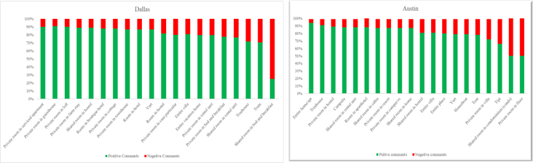

1. Maximum availability month wise for each property type

select * from(  
select month(a.date) as months_, l.property_type, datename(month,a.date) month_,count(a.id) as available_listing,  
DENSE_RANK() over(partition by l.property_type order by count(a.id) desc) rank_  
from dallas_listings l left join dallas_availability a on l.id = a.listing_id  
where a.available like 'true'  
group by month(a.date), l.property_type, datename(month,a.date)  
) a  
where rank_ = 1  
order by months_;

1. Property type-wise Host acceptance rate

Select l.property_type,avg( h.host_acceptance_rate) host_acceptance_rate

from listing_austin l join host_austin h on l.host_id = h.host_id

Group by l.property_type

Order by host_acceptance_rate desc;

1. Instant Bookable listings in each property Type

select property_type, count(id) instant_bookables  
from listingD  
where instant_bookable = 'True'  
group by property_type  
order by instant_bookables desc;