Republic of the Philippines

CITY OF CEBU

**BARANGAY SAWANG CALERO**

Tupas St., Sawang Calero, Cebu City * Tel.No. 032 342-0532

**OFFICE OF THE BARANGAY CAPTAIN**

**THE BARANGAY OFFICIALS**

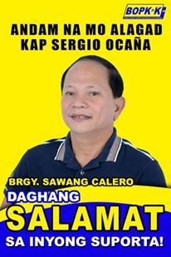

**HON. SERGIO S. OCAŇA**

*Punong Barangay*

**HON. JONAS B. ABELLAR**

*Barangay Councilor*

**HON. MARVIN B. CUYNO**

*Barangay Councilor*

**HON. NOVENCIO A. ABAYAN**

*Barangay Councilor*

**HON. IMELDA CORAZON I. SILUD**

*Barangay Councilor*

**HON. RAMON V. DIAMANTE**

*Barangay Councilor*

**HON. ARISTEDIZA A. JAVINES**

*Barangay Councilor*

**HON. RENATO L. CABANES**

*Barangay Councilor*

**HON. PAIGE IANAH I. SILUD**

*SK Chairperson*

Not Valid Without

Official Seal

**NOT VALID WITHOUT SEAL**

**Certificate of Indigency**

**TO WHOM IT MAY CONCERN:**

This is to certify that **${name}** a bonafide resident and a registered voter **${address}**, Cebu City.

Certify further that {name} is one of the many constituents who have no fixed monthly income and is considered as one of the many underprivileged individuals in our barangay. This is also to certify further that the said person has no record in the barangay.

This certification is hereby issued upon the request of **${name}** for **${purpose}** for whatever legalpurpose it may serve.

Issued on **${date}** at Barangay Sawang Calero, City of Cebu.

______________________

Signature

Prepared by:

NHOVIE JEAN C. DE OCAMPO

Barangay Secretary

Right Thumb Print