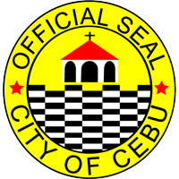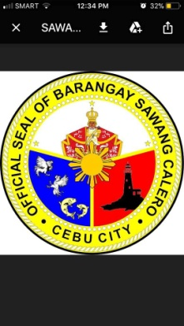

Republic of the Philippines

CITY OF CEBU

BARANGAY SAWANG CALERO

Tupas St., Sawang Calero, Cebu City * Tel.No. (032) 342-0532

**OFFICE OF THE BARANGAY CAPTAIN**

**THE BARANGAY OFFICIALS**

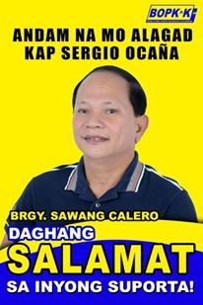

**HON. SERGIO S. OCAŇA**

*Punong Barangay*

**HON. JONAS B. ABELLAR**

*Barangay Councilor*

**HON. MARVIN B. CUYNO**

*Barangay Councilor*

**HON. NOVENCIO A. ABAYAN**

*Barangay Councilor*

**HON. IMELDA CORAZON I. SILUD**

*Barangay Councilor*

**HON. RAMON V. DIAMANTE**

*Barangay Councilor*

**HON. ARISTEDIZA A. JAVINES**

*Barangay Councilor*

**HON. RENATO L. CABANES**

*Barangay Councilor*

**HON. PAIGE IANAH I. SILUD**

*SK Chairperson*

Not Valid Without

Official Seal

**C e r t**  **i f i c a t i o n**

**TO WHOM IT MAY CONCERN:**

This is to certify that the person whose name, signature or

right thumb print appears herein:

|  |  |
| --- | --- |
| Full Name: | **${name}** |
| Birth Date: | **${birthdate}** |
| ­­Status: | **${status}** |
| Address: | **${address}** |

Certify further that as per records filed in this office, subject

person, has NO derogatory records as of this date of issue.

This certification is hereby issued upon the request of the claimant in connection with his/her application for:

|  |  |  |  |  |
| --- | --- | --- | --- | --- |
| **${school_requirement}** | School Requirement |  | **${mcwd}** | MCWD |
| **${local_employment}** | Local Employment |  | **${postal_id}** | Postal ID |
| **${proper_identification}** | Proper Identification |  | **${police_clearance}** | Police Clearance |
| **${residency}** | Residency |  | **${nbi_clearance}** | NBI Clearance |
| **${good_moral}** | Good Moral Character |  | **${license_renewal}** | License Renewal (Firearms/Driver’s) |
| **${open_account}** | Open an Account |  | **${school_requirement}** | Others (Specify Below) |
| **${electrification}** | Electrification (VECO) |  |  |  |

Issued on February 15, 2024 at Barangay Sawang Calero, Cebu City.

______________________

Signature Prepared by:

CINDERELLA I. MONTERMOSO Barangay Secretary

Right Thumb Print

8