**THE BARANGAY OFFICIALS**

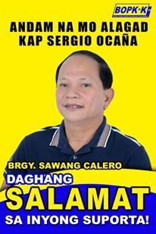

**HON. SERGIO S. OCAŇA**

*Punong Barangay*

**HON. JONAS B. ABELLAR**

*Barangay Councilor*

**HON. MARVIN B. CUYNO**

*Barangay Councilor*

**HON. NOVENCIO A. ABAYAN**

*Barangay Councilor*

**HON. IMELDA CORAZON I. SILUD**

*Barangay Councilor*

**HON. RAMON V. DIAMANTE**

*Barangay Councilor*

**HON. ARISTEDIZA A. JAVINES**

*Barangay Councilor*

**HON. RENATO L. CABANES**

*Barangay Councilor*

**HON. PAIGE IANAH I. SILUD**

*SK Chairperson*

Not Valid Without

Official Seal

**BUSINESS CLEARANCE**

**TO WHOM IT MAY CONCERN:**

This is to certify that **BIDLISIW FOUNDATION INC.,** an establishment/business located at 3 Figueroa Street, Block 1, Sawang Calero Cebu City.

Further certifies thatcertify that **BIDLISIW FOUNDATION INC.,** is conducting its business operation within the jurisdiction of Barangay Sawang Calero, Cebu City.

This certification is hereby issued upon the request of **BIDLISIW FOUNDATION INC.,** for **RENEWAL OF** **BUSSINESS PERMIT** purposesandfor whatever legal purpose it may serve best.

Issued on February 03, 2025 at Barangay Sawang Calero, City of Cebu.

_________________

Signature Issued by:

NHOVIE JEAN C. DE OCAMPO

Barangay Secretary

Right Thumb Print