Windows下生成控制台日志操作方法

作者: HAND

创建日期: 2018-04-28

最后更新: 2018-04-28

控制码:

版本: 1.0

1. **Title, Subject, Last Updated Date, Reference Number**, **and** **Version** are marked by a Word Bookmark so that they can be easily reproduced in the header and footer of documents. When you change any of these values, be careful not to accidentally delete the bookmark. **You can make bookmarks visible by selecting Tools->Options…View and checking the Bookmarks option in the Show region.**

**审批签字:**

|  |  |
| --- | --- |
| 项目经理 |  |
| HAND项目经理 |  |

1. To add additional approval lines, press [Tab] from the last cell in the table above.

Copy Number _____

1. You can delete any elements of this cover page that you do not need for your document. For example, Copy Number is only required if this is a controlled document and you need to track each copy that you distribute.

## 文档控制

**修改记录**

1

| 日期 | 作者 | 版本 | 修改参考 |
| --- | --- | --- | --- |
|  |  |  |  |
| 2018-05-04 | 徐钢 | 1.0 | No |
|  |  |  |  |
|  |  |  |  |
|  |  |  |  |

**审阅**

| 姓名 | 职位 |
| --- | --- |
|  |  |
|  |  |
|  |  |
|  |  |
|  |  |

目录

文档控制 ii

概述 1

操作系统设置 2

Linux主机 2

1. To update the table of contents, put the cursor anywhere in the table and press [F9]. To change the number of levels displayed, select the menu option Insert‑>Index and Tables, make sure the Table of Contents tab is active, and change the Number of Levels to a new value.

## 概述

本文描述了HDM等系统在windows下安装后生成每天日志的详细操作步骤。

## Tomcat配置

直接在项目tomcat底下进行配置。

### Windows主机

#### 修改startup.bat

右键编辑startup.bat

看到最底下有如下字段：

call "%EXECUTABLE%" start %CMD_LINE_ARGS%

修改为：

call "%EXECUTABLE%" run %CMD_LINE_ARGS%

#### 修改catalina.bat

右键编辑catalina.bat

看到最底下有如下字段：

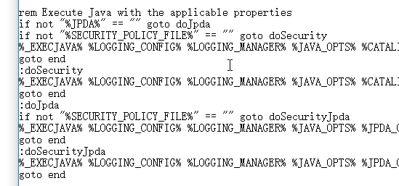

每一段最后面均有 %ACTION% ，总共有四段都有。然后在每一个%ACTION%后添加如下内容：

>> %CATALINA_BASE%\logs\hdmLog.%date:~0,4%-%date:~5,2%-%date:~8,2%.log

效果如下：

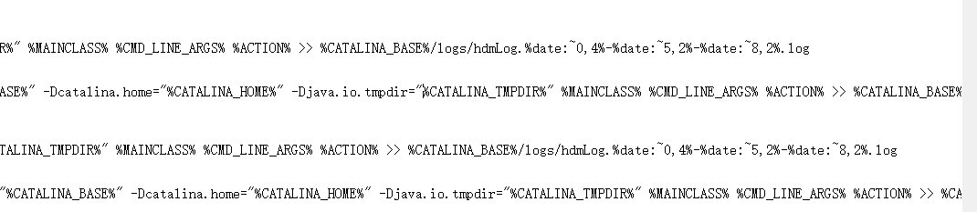

#### 重启tomcat

直接重启tomcat即可，之后有关HDM的控制台日志将生成在tomcat/logs/hdmLog+日期.log中