#### CURDATE

Explanation:

#### Returns the current date in the format YYYY-MM-DD. It’s useful when logging or filtering data based on today’s date; like finding all records created today.

Use Example:

Can be used in reports or queries where you want to compare a date field to the current date, like showing today's sales or appointments.

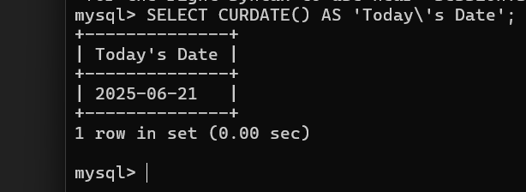

#### CURTIME

Explanation:

Returns the current time in HH:MM:SS format. It’s useful when logging time-based data like login times or system events.

Use Example:

Can be used to track or log the exact time a transaction or user login happens.

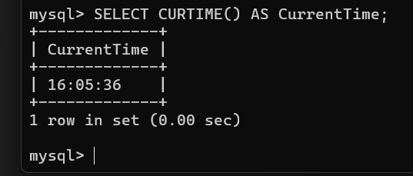

#### LOCALTIMESTAMP

Explanation:

Returns the current date and time based on the server’s local time zone. It’s useful for complete timestamping in logs or reports.

Use Case Example:

This is ideal for tracking real-time actions like when a record is created or modified.

