Project: <Test Plan> | Zachary Anderson
Course: <CSD380>
Description: <Todo Test Cases>
Date: <2/7/2026
To complete the test case plan, fill out the information for Project, Course, Description and Date in the header below.
.
TABLE OF CONTENTS
<Add a Valid Task> 2
<Prevent Empty Task Submission> 3
<Mark Task as Completed> 4
<Delete a Task> 4
<Tasks Remain after Refresh> 5

For each test, the developer should: provide a test description, a test objective, the developer name and date tested. For each step, fill out the actions to be taken and describe the expected results, and indicate yes or no for each step depending upon the result. The peer tester should provide their name, date tested, indicate yes or no for each step depending upon the result, and a screenshot (thumbnail) of the result.

Test 1 | <Add a valid task>
 | Test Objective: Verifies a user can add a valid task | Developer: Zachary Anderson  Date tested: <2026/2/7> | Peer tester: Cameron Mendez  Date tested: 2026/02/08
Step | Action | Expected results: | Developer pass/fail | Tester pass/fail  + Screenshot
1 | <  Open https://buwebdev.github.io/todo  /> | <  Website loads correctly  > | <Yes> | 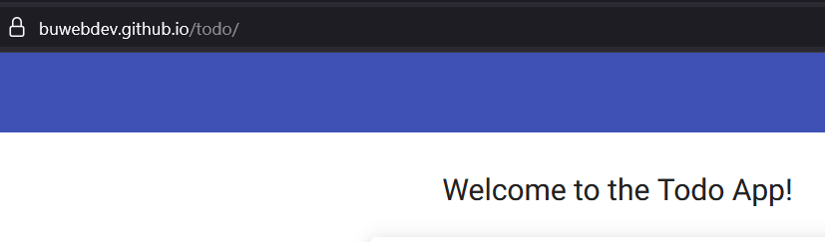
2 | <  Click in input field  > | <  Cursor appears  > | <Yes> | 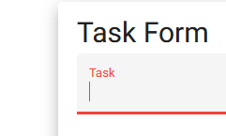
3 | <  Type “Check broken sprinkler”  > | <  Text appears in input field  > | <Yes>
4 | <  Click Add button  > | <  Task is added to the list  > | <Yes>
5 | <Check task list> | <Task is visible> | <Yes> | 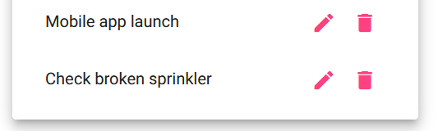
Comments | The application successfully allows users to add a new task. The interface is easy to understand and is responsive. Adding tasks works as expected with no noticeable delays.

Test 2 | <Prevent Empty Task Submission>
 | Test Objective: Verifies empty tasks cannot be added | Developer:Zachary Anderson  Date tested: <2026/2/7> | Peer tester: Cameron Mendez  Date tested: 2026/02/08
Step | Action | Expected results: | Developer pass/fail | Tester pass/fail
1 | <  Openhttps://buwebdev.github.io/todo/  > | <Website loads> | <yes> | 
2 | <Leave input blank> | <add tasks greyed out> | <yes> | 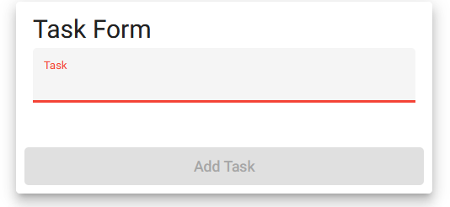
3 | <Click add> | <add task unable> | <yes> | 
4 | <Observe list> | <list unchanged> | <yes> | 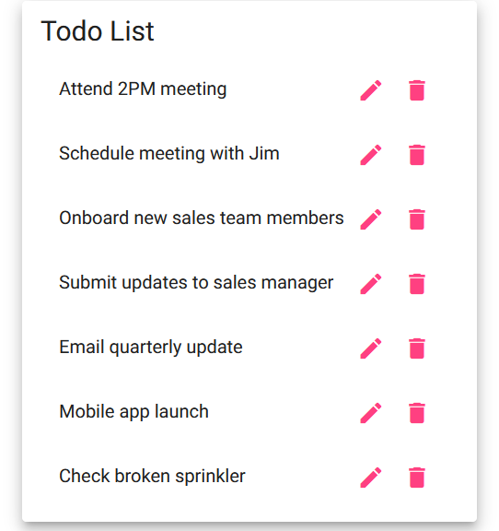
5 | <Try a second time> | <still no task added> | <yes> | 
Comments | The system correctly blocks empty tasks from being added. This helps maintain data quality. This will continuously add to the usability of the website.

Test 3 | <Mark Task as Completed>
 | Test Objective: Verifies users can mark tasks as complete | Developer:Zachary Anderson  Date tested: <2026/2/7> | Peer tester: Cameron Mendez  Date tested: 2026/02/08
Step | Action | Expected results: | Developer pass/fail | Tester pass/fail
1 | <  Openhttps://buwebdev.github.io/todo/  > | <Enter the expected results> | <yes> | 
2 | <add task> | <task added to Todo list> | <yes> | <no>
3 | <select task from Todo list > | <display option to check mark as complete> | <no> | <no>
4 | <click check mark> | <task greys out to mark as complete> | <no> | <no>
5 | <verify list is updated after page refresh> | <task stays greyed out with check mark after refresh> | <no> | <no>
Comments | There doesn’t seem to be an ability to mark tasks as completed when they are. Todo lists should have this feature.

Test 4 | <Delete a Task>
 | Test Objective: Verifies users can remove tasks | Developer:Zachary Anderson  Date tested: <2026/2/7> | Peer tester: Cameron Mendez  Date tested: 2026/02/08
Step | Action | Expected results: | Developer pass/fail | Tester pass/fail
1 | <  Openhttps://buwebdev.github.io/todo/  > | <Enter the expected results> | <yes> | 
2 | <add task> | <task added to Todo list> | <yes> | <yes/no>
3 | <Click trash can icon > | <Delete task from todo list> | <yes> | 
4 | <check list> | <task is gone> | <yes> | 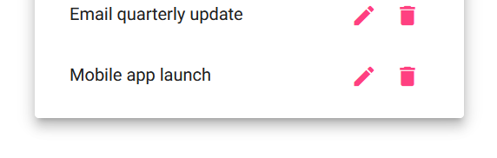
5 | <refresh page and check list again> | <task is still gone> | <yes> | <yes>
Comments | The delete function performs reliably and instantly removes tasks. No errors occurred during the testing.

Test 5 | <Tasks Remain after Refresh>
 | Test Objective: Verifies tasks remain after refreshing | Developer:Zachary Anderson  Date tested: <2026/2/7> | Peer tester: Cameron Mendez  Date tested: 2026/02/08
Step | Action | Expected results: | Developer pass/fail | Tester pass/fail
1 | <  Openhttps://buwebdev.github.io/todo/  > | <Enter the expected results> | <yes> | <yes>
2 | <add multiple tasks> | <tasks added to Todo list> | <yes> | 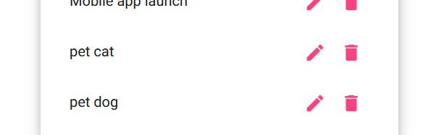
3 | <refresh browser > | <page reloads> | <yes> | <yes>
4 | <check list> | <tasks still present> | <yes> | <no>  
5 | <delete one task> | <task is removed from list> | <yes> | <no>
6 | <refresh browser again> | <todo list retains list with task deleted> | <yes> | no
Comments | The application successfully saves task data between page reloads. This improves user experience and reliability. Data persistence makes the app practical for long-term use.

