CNPN LAB WEBSITE USER MANUAL
A Step-by-Step Guide to Editing and Publishing Content with Antigravity IDE
1. Introduction
This user manual provides step-by-step instructions for editing the content of the Clinical Neurophysiology & Precision Neuromodulation Lab (CNPN Lab) website. All data (text, research themes, people profiles, recognition lists, and publications) is stored in a structured format at the top of a single JavaScript file named script.js. By editing this file in Antigravity IDE, you can make updates easily without touching complex HTML layouts.
2. General Rules for Content Editing
All website data is stored in JavaScript arrays or objects. Follow these strict rules to prevent breaking the website layout:
- Make a Backup: Before editing script.js, copy it and save it as script_backup.js. If the website breaks, restore script.js from this backup.
- Double Quotes: Wrap text strings in double quotation marks (e.g., "Text Here"). If your text contains single quotes, it is safe (e.g., "Dr. Sagarika's Research").
- Commas are Crucial: Items in a list are separated by commas. E.g., [item1, item2, item3]. Missing or trailing commas are the most common source of page errors.
- Brackets and Braces must Match: Every [ must have a corresponding ], and every { must have a }.
- Use Antigravity IDE: Do not use Microsoft Word or simple Notepad. Use Antigravity IDE or VS Code. It highlights errors and helps you edit code blocks.
3. Getting Started (GitHub & Antigravity IDE)
3.1 Logging in and Downloading from GitHub
To access and download the website repository its not necessary to login (Go to step 3)but required if uploading changed files (By section 7. Uploading and Publishing Changes to GitHub, Method A) .
1. Open your browser and go to: https://github.com/login
2. Enter your GitHub credentials to sign in.
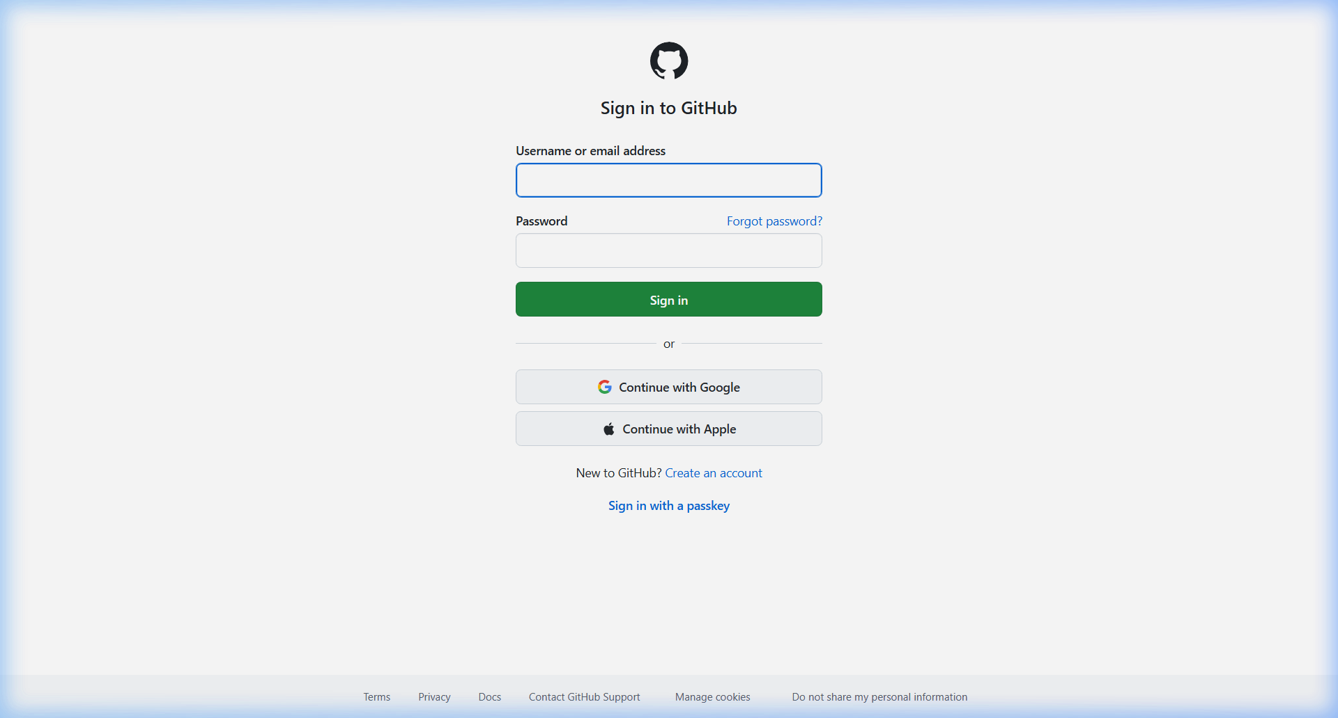
Figure: GitHub Login Screen.
3. Once logged in, navigate to the repository page: https://github.com/cn-pn/LabWeb (also directly open in web browser to download)
4. Click the green "Code" button on the right.
5. Select "Download ZIP" from the dropdown options.
6. Extract the downloaded ZIP file on your computer to access the project folder.
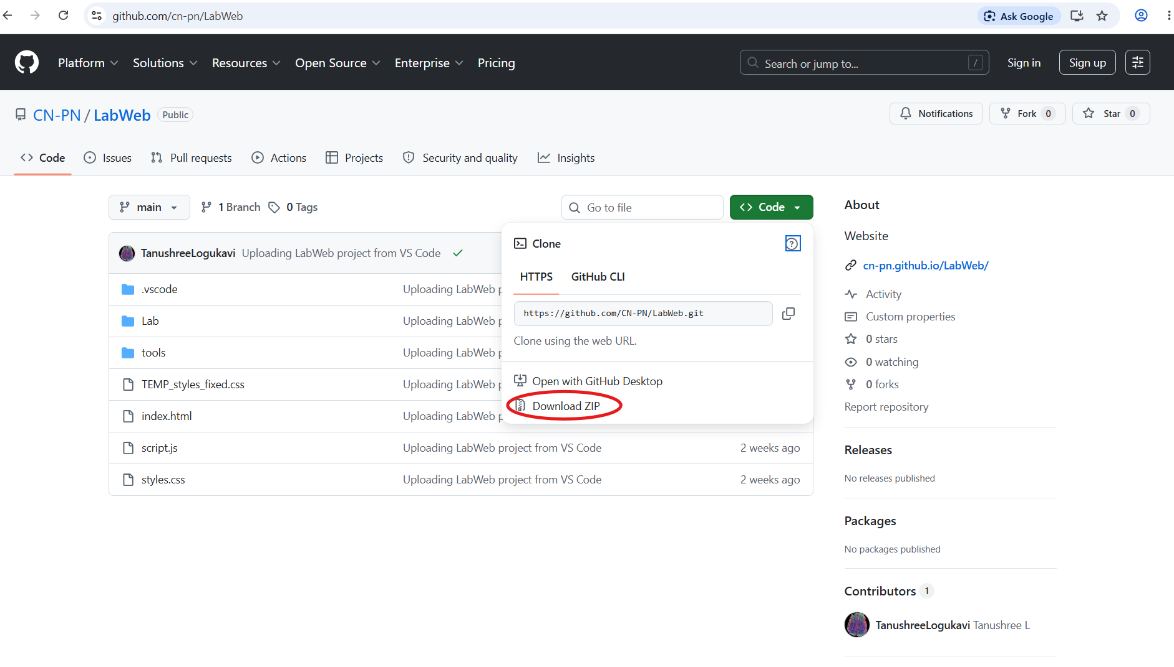
Figure: GitHub Repository view showing the green Code dropdown button.
3.2 Setting Up Antigravity IDE
Antigravity IDE is a powerful coding editor. It features built-in AI coding assistance that helps you write templates and troubleshoot bugs.
1. Download the Antigravity IDE installer for Windows and run it.
2. Follow the setup prompts and install the program.
3. The IDE provides a clean sidebar menu on the left and a central code editor panel.
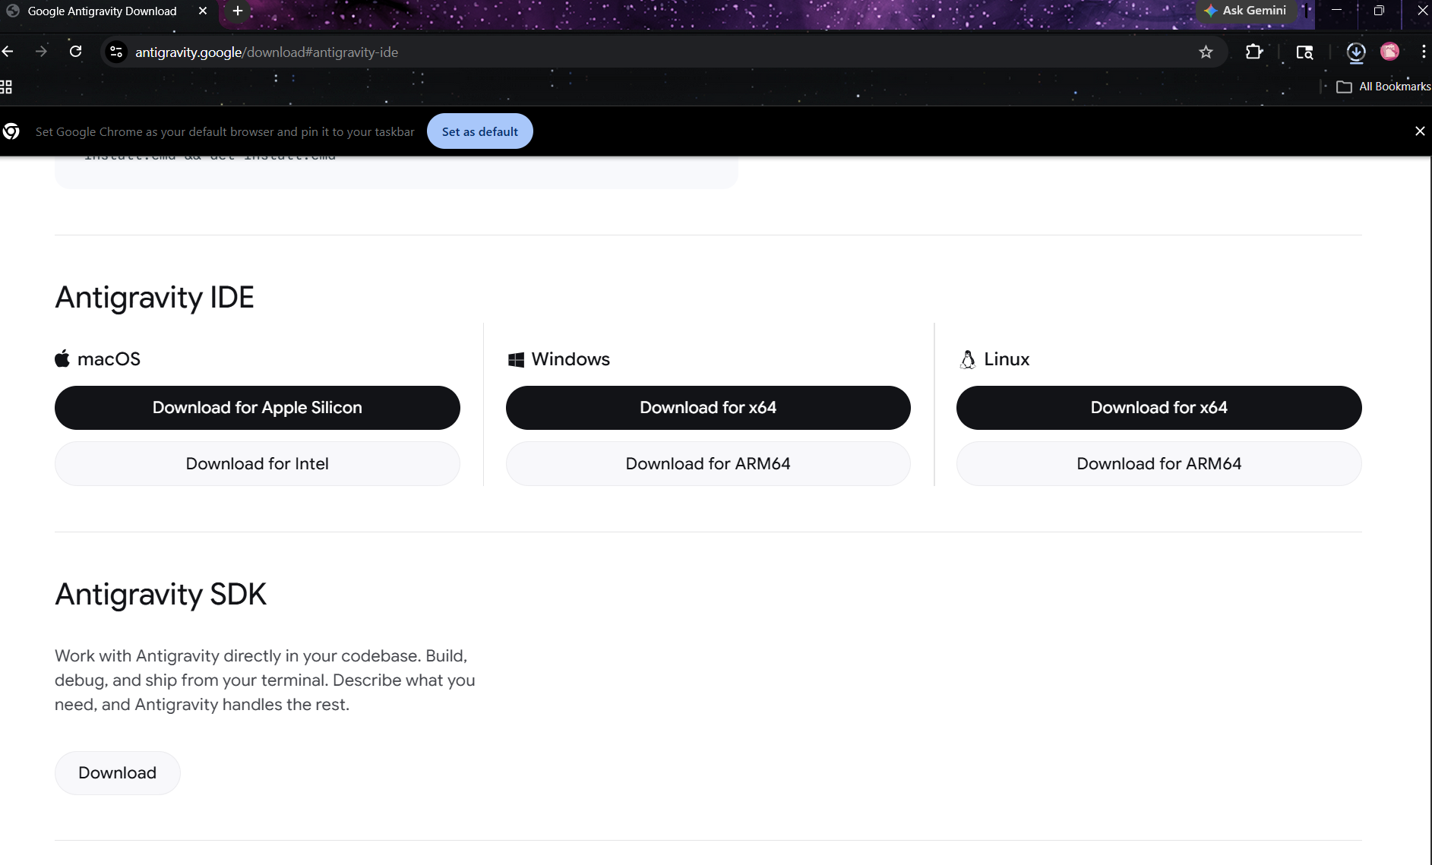
3.3 Opening the Project in Antigravity IDE
1. Launch Antigravity IDE.
2. Click File -> Open Folder... and select the extracted LabWeb-main folder. (or just drag and drop the folder)
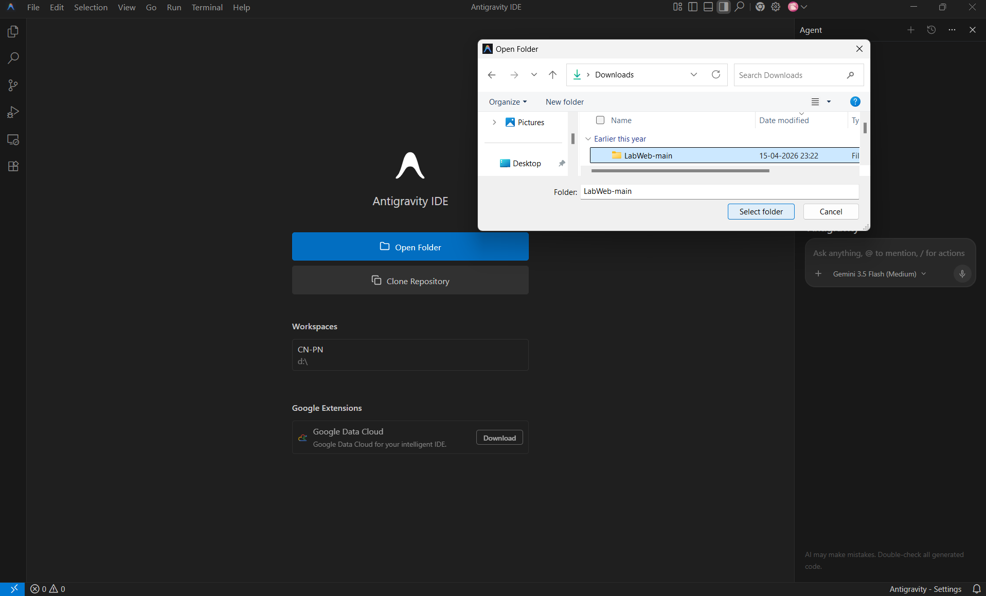
3. Open index.html from the file explorer sidebar on the left.
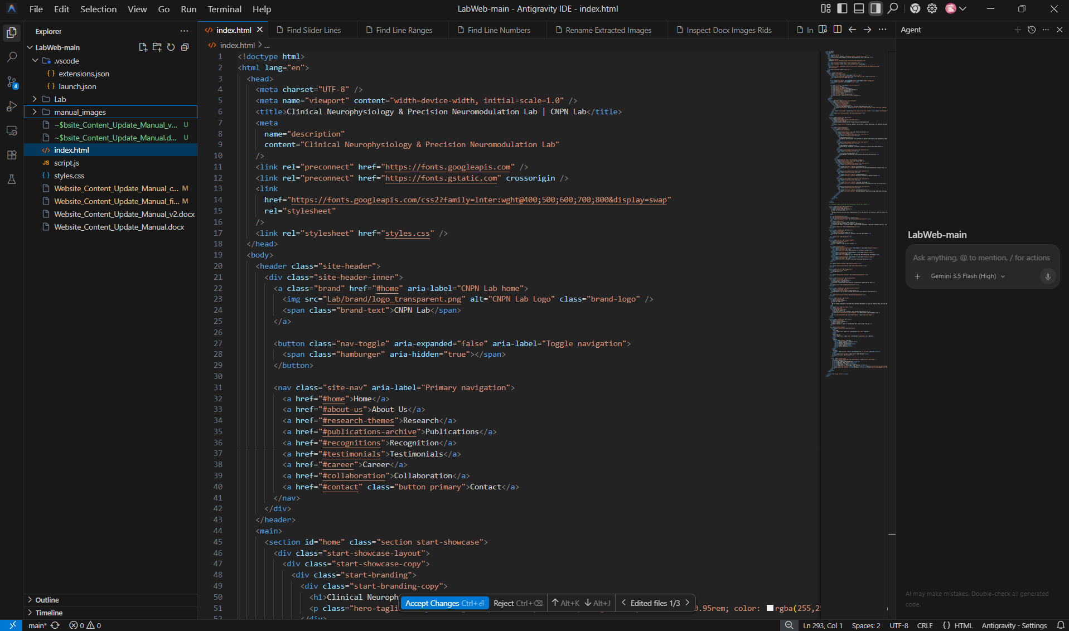
Figure: Antigravity IDE interface with the workspace files
3.4 Navigating Files & Commands (Quick Open Palette)
Instead of manually searching the file explorer on the left, you can use the built-in Quick Open search bar at the top of the editor. This panel behaves exactly like VS Code's command launcher:
- How to open: Press Ctrl + P on your keyboard. A search box will drop down at the top center of the editor prompting you to 'Type the name of a file to open...'
- Finding key words Ctrl + F
- Finding files: Simply type 'script.js' or 'index.html' and press Enter to open the file immediately.
- Running editor commands: Press Ctrl + Shift + P (or F1) to change the search box prefix to '>'. This opens the Command Palette, prompting you to type a command (such as 'Terminal: Focus on Terminal View' or 'Git: Push').
- How to close: If you want to dismiss the search box without choosing a file, press the Esc key.
4. Website Content Editing (By Menu Tap Order)
This section describes how to edit each part of the website, listed in the exact order of the navigation tabs at the top of the webpage.
4.1 Home Section (Showcase Slider)
The main home section features a dynamic slideshow of highlight images. The slides are loaded from the startLabSlides array in script.js.
File to open: script.js | Keyword to search: const startLabSlides | Line Range: Lines 459-467
A. Original Script Structure (Before):
const startLabSlides = [
"Lab/showcase/showcase_slide1.jpeg",
"Lab/showcase/showcase_slide2.jpeg",
"Lab/showcase/showcase_slide3.jpeg",
"Lab/showcase/showcase_slide4.jpeg",
"Lab/showcase/showcase_slide5.jpeg"
].map((src) => ({ src }));
B. Edited Script Structure (After adding showcase_slide6.jpeg):
const startLabSlides = [
"Lab/showcase/showcase_slide1.jpeg",
"Lab/showcase/showcase_slide2.jpeg",
"Lab/showcase/showcase_slide3.jpeg",
"Lab/showcase/showcase_slide4.jpeg",
"Lab/showcase/showcase_slide5.jpeg",
"Lab/showcase/showcase_slide6.jpeg"
].map((src) => ({ src }));
C. Step-by-Step Instructions:
- Place your new image file in the Lab/showcase/ folder.
- Open script.js and search for const startLabSlides .
- Add a comma to the end of the last line, press Enter to create a new line, and paste your new image pathway wrapped in double quotes.

4.2 About Us Section (Principal Investigator, Fellows & Interns)
This section manages profiles for the Principal Investigator (Dr. Sagarika Bhattacharjee), Research Fellows (const fellows), and Interns (const interns).
File to open: script.js | Keyword to search: const fellows or const interns | Line Range: Lines 255-306
A. Original Script Structure (Before adding new Intern profile):
const interns = [
{
name: "Dhwani Shah",
text: "Dhwani Shah is a UX and product experience designer..."
},
{
name: "Varsha Shree",
text: "Varsha Shree Gandhimathinathan..."
}
];
B. Edited Script Structure (After adding new Intern profile):
const interns = [
{
name: "Dhwani Shah",
text: "Dhwani Shah is a UX and product experience designer..."
},
{
name: "Varsha Shree",
text: "Varsha Shree Gandhimathinathan..."
},
{
name: "New Member Name",
text: "Description of education and research focus.",
images: ["Lab/intern_members/new_photo.jpg"]
}
];
C. Step-by-Step Instructions:
- Save the profile photos in the appropriate subfolders (e.g. Lab/intern_members/ for interns).
- Search for const interns in script.js (approx line 292).
- To add a member, copy and paste the block format, separating objects with a comma.
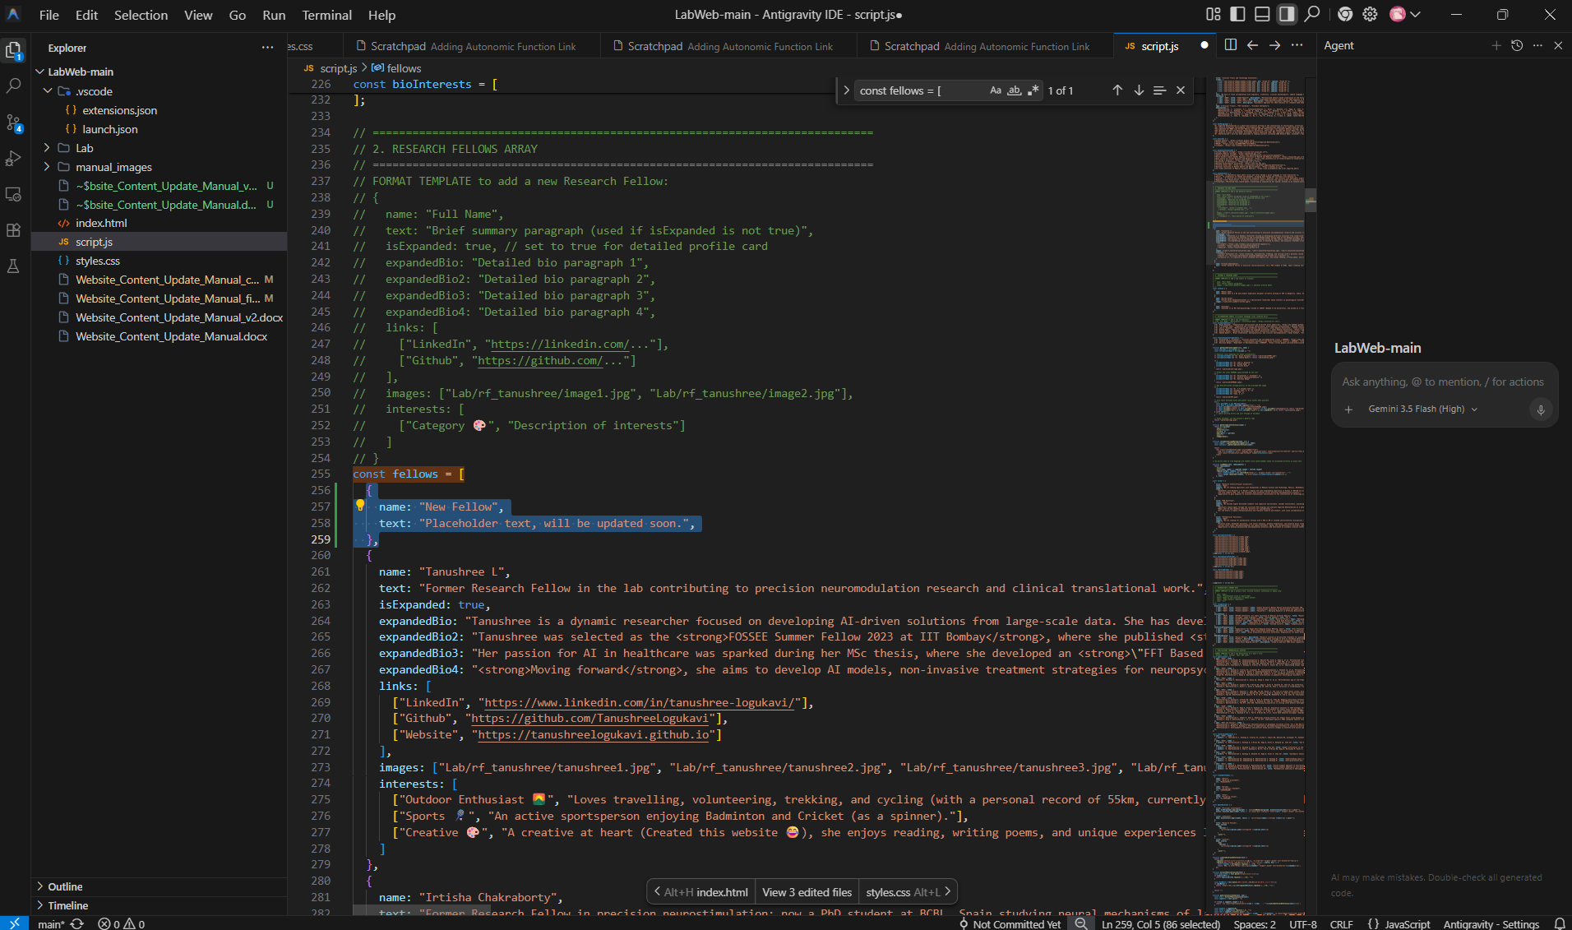
Figure: Antigravity IDE view showing the interns array structure and member profile object editing. Here its for adding a research fellow above Tanushree L.
4.3 Research Section (Themes & Spotlight Publications)
This section contains three research themes, each including slides, description text, tags, publications, and optional computational toolboxes.
File to open: script.js | Keyword to search: const research | Line Range: Lines 112-194
A. Original Script Structure (Before):
publications: [
"Bhattacharjee, S., Kashyap, R., Udupa, K., Bashir, S., ... (2024). Alignment..."
]
B. Edited Script Structure (After adding new spotlight publication):
publications: [
"Author1, Author2. Title of the publication. Journal Name. 2025.",
"Bhattacharjee, S., Kashyap, R., Udupa, K., Bashir, S., ... (2024). Alignment..."
]
C. Step-by-Step Instructions:
- Search for the research array inside script.js (line 112).
- Within the target theme block, locate the publications array.
- Insert the new citation string wrapped in quotes, separated by a comma. Bullet points will render automatically without numbers.
- Below copy any such research block as it is and paste at the end of 3 existing research theme or above as required.
- Edit the block and add new research theme.
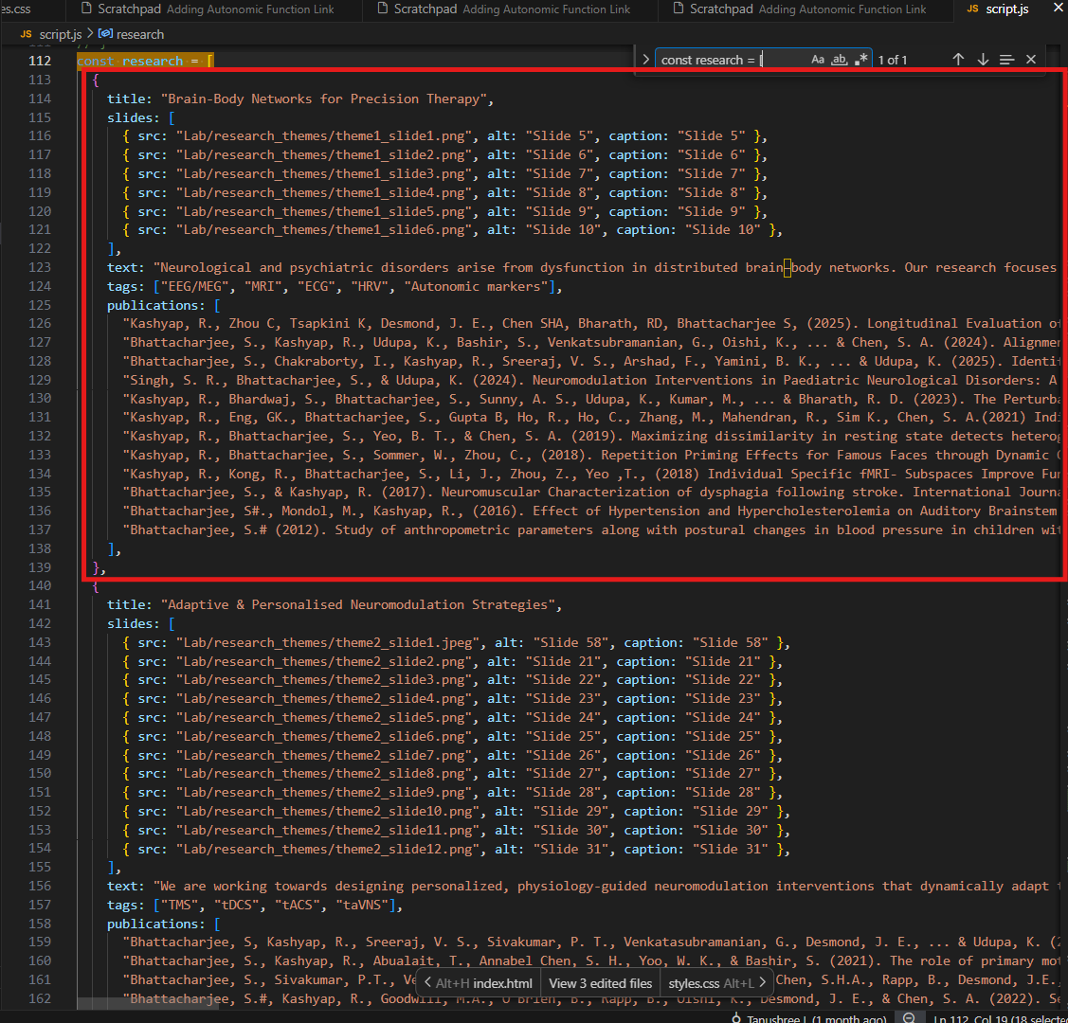
Figure: Antigravity IDE view showing the research theme object with slides and publication list arrays. Marked a research theme block.
4.4 Publications Section (Chronological Archive)
The Publications page lists the full chronological archive. The numbering is fully automated; the newest publication at the top is dynamically labeled as 1, and the numbering increases downwards. You only need to add the citation string.
File to open: script.js | Keyword to search: const publications | Line Range: Lines 512-575
A. Original Publications Block (Before adding new item):
const publications = [
{ year: "2025", items: [
"Bhattacharjee S, Sivakumar PT, Venkatasubramanian G, Bharath RD, Oishi K, Rapp B, et al. Personalized transcranial direct current stimulation for behavioral and neurophysiologic outcomes. JAMA Netw Open. 2025;8(8):e2526148. DOI: 10.1001/jamanetworkopen.2025.26148",
]},
B. Edited Publications Block (After adding new item):
const publications = [
{ year: "2025", items: [
"NewAuthor A, CoAuthor B. Title of the brand new paper. Journal Name. 2025;1(1):10.",
"Bhattacharjee S, Sivakumar PT, Venkatasubramanian G, Bharath RD, Oishi K, Rapp B, et al. Personalized transcranial direct current stimulation for behavioral and neurophysiologic outcomes. JAMA Netw Open. 2025;8(8):e2526148. DOI: 10.1001/jamanetworkopen.2025.26148",
]},
C. Step-by-Step Instructions:
- Search for const publications in script.js (approx line 512).
- Locate the appropriate year block (e.g. 2025).
- Add a new citation string inside the items array. Do not include any hardcoded numbers (e.g. '1. ') at the beginning; the code handles this automatically.
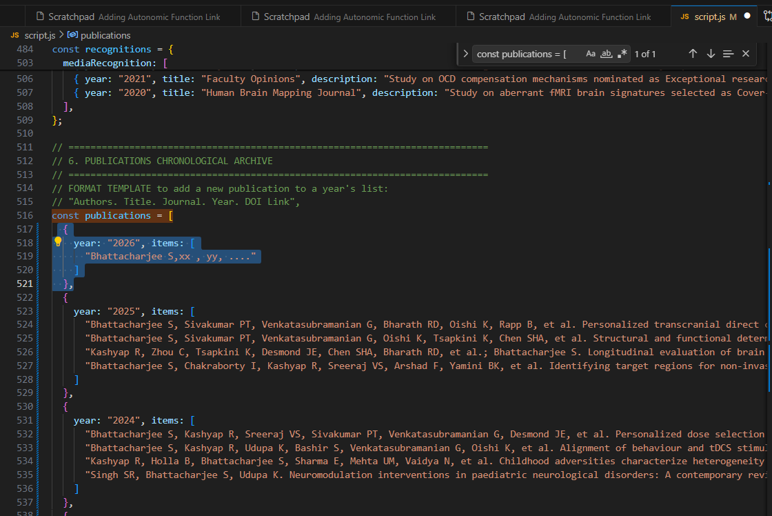
Figure: Antigravity IDE view showing the publications list, where adding a citation string automatically generates numbering.
4.5 Recognition Section (Lectures, Talks, Conferences, Media)
This section manages plenary speaker roles, invited talks, conference presentations, and media coverage.
File to open: script.js | Keyword to search: const recognitions | Line Range: Lines 480-505
A. Original Script Structure (Before):
plenaryLectures: [
{ year: "2025", title: "Plenary Speaker", event: "IGMHA National CME", month: "May", topic: "Dementia", icon: "🧠" }
]
B. Edited Script Structure (After adding new lecture):
plenaryLectures: [
{ year: "2026", title: "Plenary Speaker", event: "Name of the Conference", month: "May", topic: "Title of your presentation topic.", icon: "🧠" },
{ year: "2025", title: "Plenary Speaker", event: "IGMHA National CME", month: "May", topic: "Dementia", icon: "🧠" }
]
C. Step-by-Step Instructions:
- Search for const recognitions in script.js (approx line 480).
- Locate the category list (e.g., plenaryLectures, invitedTalks, or mediaRecognition).
- Copy the structure template and insert it at the top of the list, separating objects with a comma.
4.6 Testimonials Section (Patient Stories & Videos)
This section contains patient slide galleries and representative clinical video summaries.
File to open: script.js | Keywords to search: const testimonialSlides or const treatmentVideos | Line Range: Lines 438-449 and Lines 579-595
A. Original Script Structure (Before):
const testimonialSlides = [
"Lab/testimonials/testimonial_slide1.jpeg",
"Lab/testimonials/testimonial_slide2.jpg"
].map((src) => ({ src }));
B. Edited Script Structure (After adding slide 11):
const testimonialSlides = [
"Lab/testimonials/testimonial_slide1.jpeg",
"Lab/testimonials/testimonial_slide2.jpg",
"Lab/testimonials/testimonial_slide11.jpg"
].map((src) => ({ src }));
C. Step-by-Step Instructions:
- Place the new testimonial slide in Lab/testimonials/.
- Search for const testimonialSlides = [ (approx line 438) in script.js.
- Add a comma to the last slide line and append the new file path in double quotes.

- For adding any other testimonial video login to lab email cnpnlab@gmail.com
- Go to YouTube. In Lab channel there is a playlist created.
- Best practice create new playlist instead of directly editing existing one.
- Go to existing playlist “CNPN_website” there please upload a new video (setting as not for kids and Unlisted)
- Replace the existing ID code where you want the video to play before or during or after.
- For example if you click your playlist get the sharing link of your upload video that is https://youtu.be/kSNh930AsBM?si=Y0gcD4QsFTocbN0X then ID is kSNh930AsBM (current During video code)
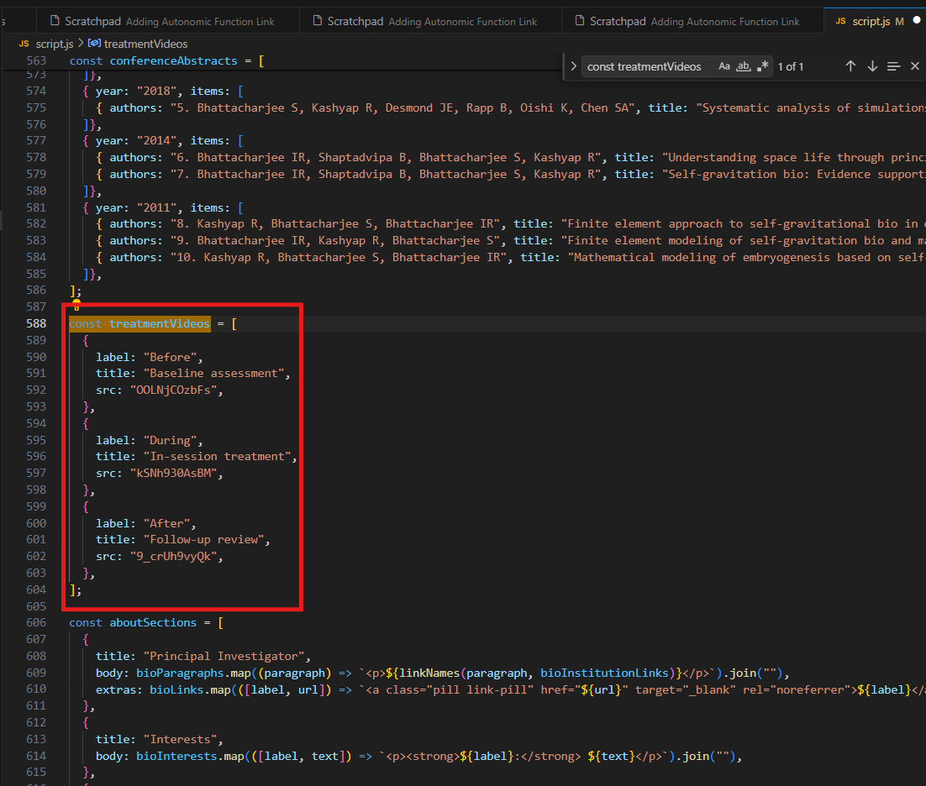
Figure: Antigravity IDE view showing patient testimonial clinical videos.
4.7 Career Section (Positions & Openings)
The Career tab lists active openings for research assistants, PhD, and postdoctoral scholars.
File to open: script.js | Keyword to search: const career | Line Range: Lines 405-436
A. Original Script Structure (Before):
title: "PhD Positions",
status: "Open",
summary: "Description..."
B. Edited Script Structure (After closing opening):
title: "PhD Positions",
status: "Closed",
summary: "Description..."
C. Step-by-Step Instructions:
- Search for const career in script.js (approx line 405).
- Locate the position card you want to edit.
- Modify the status field value to "Open" or "Closed" inside the quotation marks.
4.8 Collaboration Section (Core & Clinical Partners)
This section displays the logos and descriptions of core research and clinical partners.
File to open: script.js | Keywords: const coreCollaborators or const translationalCollaborators | Line Range: Lines 313-326
A. Original Script Structure (Before):
const coreCollaborators = [
["Dr. Rajan Kashyap", "Computational neuroscience...", "https://url..."]
];
B. Edited Script Structure (After adding new collaborator):
const coreCollaborators = [
["Dr. Rajan Kashyap", "Computational neuroscience...", "https://url..."],
["Dr. New Partner", "Precision neuromodulation | NTU", "https://newurl.com"]
];
C. Step-by-Step Instructions:
- Add the partner logo image to Lab/brand/ folder.
- Locate the collaborators arrays in script.js (approx line 313).
- Append a new line inside the list brackets following the pattern: ["Name", "Description", "URL"], separating lines with commas.
- In below 3 red text box is where one can add the new partner.
- After adding in core or translation collaborators you have to add their respective University logo image in path “Lab/brand/New_logo.png”
- After 332 in line approximately add this new collaborator logo for example :
if (collaboratorName === "Dr. New partner") return "Lab/brand/New_logo.png";

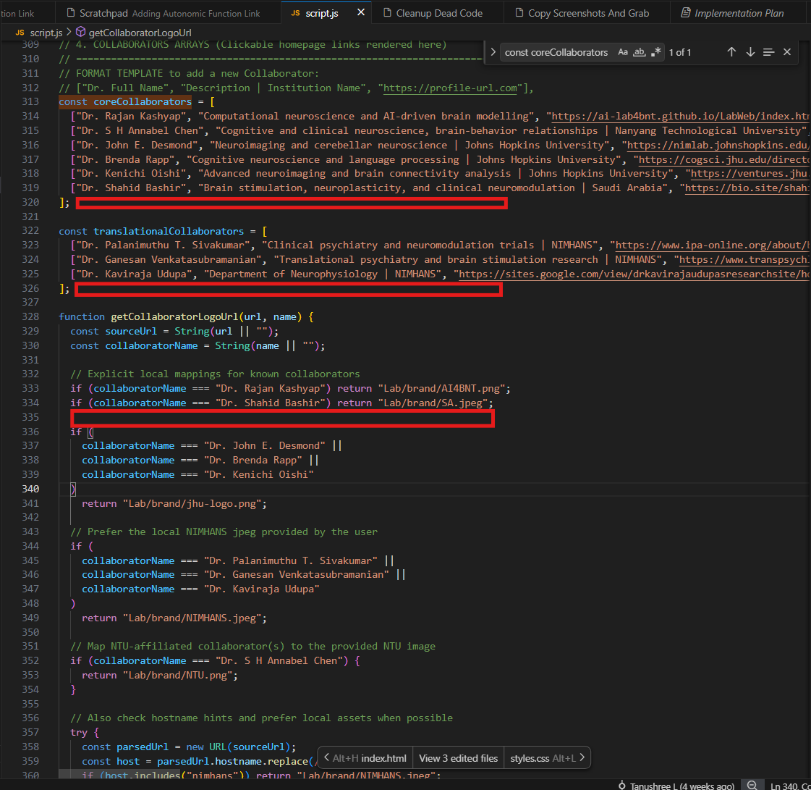
Figure: Antigravity IDE view showing collaborators arrays and custom logo mappings.
4.9 Contact Section (Form & Information)
The contact form submits queries to the lab's Formspree backend, and the card displays Dr. Sagarika's email address.
Files to open: script.js and index.html | Keywords: contactForm or bhattacharya.sagarika7@gmail.com | Line Range: Lines 1523-1570 (script.js form listener) and lines 276-285 (index.html details)
A. Original Script Structure (Before):
fetch("https://formspree.io/f/xvzybyrv", {
method: "POST",
B. Edited Script Structure (After updating endpoint ID):
fetch("https://formspree.io/f/new_endpoint_id", {
method: "POST",
C. Step-by-Step Instructions:
- To edit the contact display details, open index.html, search for bhattacharya.sagarika7@gmail.com, and edit the email links or addresses.
- To edit the Formspree submission link, open script.js, locate the contactForm listener (approx line 1523), and modify the Formspree fetch target URL.
.
5. Managing Image assets and Sliders
All images must be optimized for size (JPEG/PNG, under 500KB) and saved in their respective directories under the Lab/ folder (e.g. Lab/pi_sagarika/ for Sagarika profile slides, Lab/rf_tanushree/ for Tanushree profile slides, and Lab/testimonials/ for patient stories). Use the specific templates detailed in Section 4 to update slider references inside script.js.
6. Previewing & Testing Changes Locally
1. Save script.js in Antigravity IDE (Ctrl+S).
2. Navigate to your local folder, and double-click index.html to open it in a web browser.
3. Always perform a Hard Refresh to bypass the browser cache and load your new script.js updates:
- Windows/Linux: Press Ctrl + F5 or Shift + F5
- macOS: Press Cmd + Shift + R
7. Uploading and Publishing Changes to GitHub
Once you have verified your edits work locally, upload them to publish the site live. (Prefer Method B if changes has error its easy in this to revert back using commands)
Method A: Manual Web Upload (Drag-and-Drop)
This is the easiest method and requires no command-line tools:
Login to your git hub account and go to https://github.com/CN-PN/LabWeb/upload/main
1. Open your browser and go to: https://github.com/cn-pn/LabWeb
2. Click on the "Add file" button near the top right and select "Upload files".
3. Drag and drop your modified files (e.g. script.js) into the box.
4. Scroll down to the "Commit changes" section.
5. Enter a brief description (e.g. "Updated collaborator links"), select "Commit directly to the main branch", and click "Commit changes".
Method B: Built-in Terminal in Antigravity IDE
To push changes directly using Git, run these commands inside Antigravity IDE's built-in terminal panel:
- Open the Terminal panel in Antigravity IDE.
- Navigate Terminal/+/Git Bash/copy(below commands)/Paste (red arrow bash )/Enter
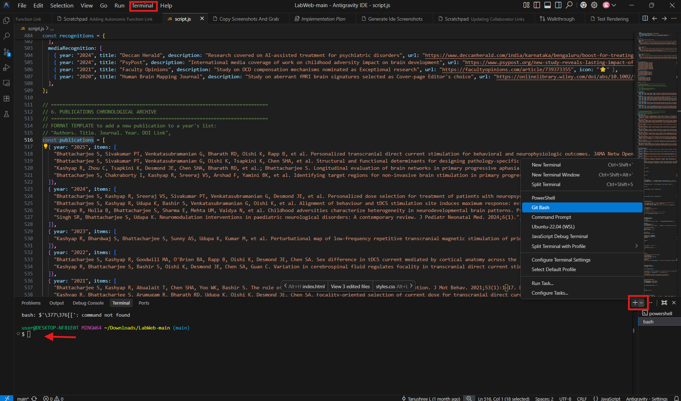
2. Run the following commands sequentially:
# Change the remote to the cn-pn repository
git remote set-url origin https://github.com/cn-pn/LabWeb.git
# Stage your changes
git add .
# Commit your changes
git commit -m "Uploading LabWeb project from Antigravity IDE"
# Push to the main branch
git push -u origin main
Method C: Source Control Panel in Antigravity IDE
1. Click the Source Control (git branch) icon in the left-hand sidebar.
2. Hover over the modified files and click the '+' icon to stage them.
3. Type your commit message in the textbox.
4. Click the checkmark (Commit) button at the top.
5. Click "Sync Changes" or "Push" to upload.

Created by Tanushree L for inquiries contact tanushreelogukavi@gmail.com

