**CSB 353: Compiler Design**

**LAB 1**

**Submitted By:**

**Name: PREM KUMAR**

**Roll No: 191210037**

**Branch: CSE**

**Semester: 6 th**

**Submitted To: Dr. Shelly Sachdeva**

Department of Computer Science and Engineering

**NATIONAL INSTITUTE OF TECHNOLOGY DELHI**

2019-2023

Ques 1. Identify the files created while compilation and execution of a C program.

Sol.

Compiling Prog1.c ( C Program File)

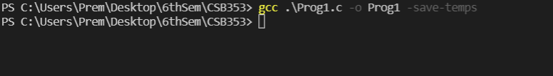

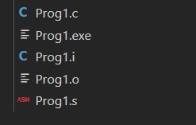

* When we compile a .c file, it is first passed to the preprocessor for code substitutions.
* The Preprocessor substitutes codes from header files and macros defined by #define. All of these header files and macros are substituted from preprocessor directives. After substituting the code, the preprocessor generates the .i file.
* The .i file contains substituted code which further passed to the compiler which converts the .i file into a .s file which contains assembly language code.
* The .s file is then passed to the assembler for further processing which converts the .s file into .o file which contains the object code.
* The .o file is an incomplete object file as it does not contain references to external subroutines and therefore cannot be executed directly by the operating system.
* When we execute a .c file, then the .o file is passed through a linker which performs linking and generates a .exe file.
* The .exe file is a complete object file with references to external subroutines and it can be executed directly by the operating system.

.Ques2. Create a C program for generating a Lexical Analyzer to identify the following tokens:

* Keywords; Examples-for, while, if etc.
* Identifier; Examples-Variable name, function name, etc.
* Operators; Examples '+', '++', '-' etc.
* Separators; Examples ',' ';' etc.

Program:

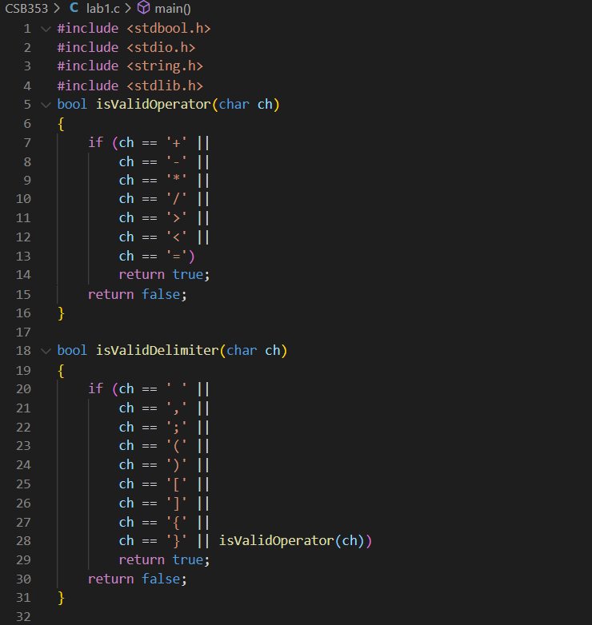

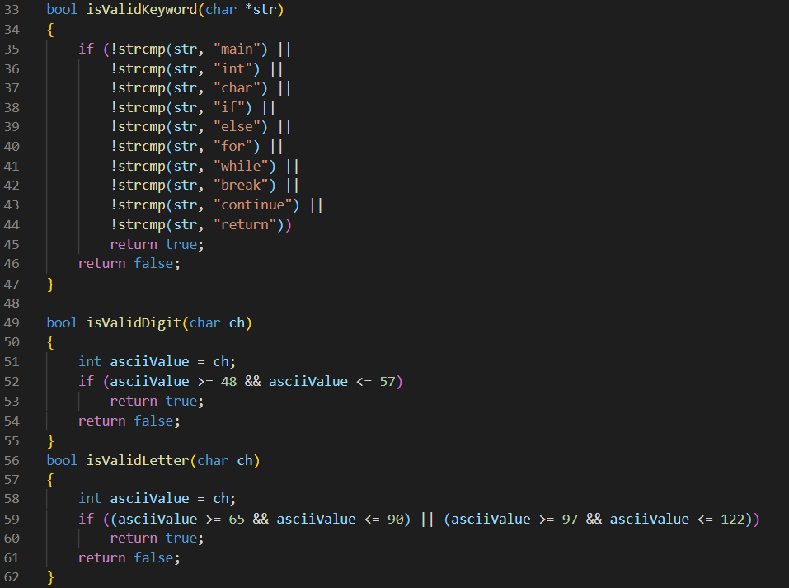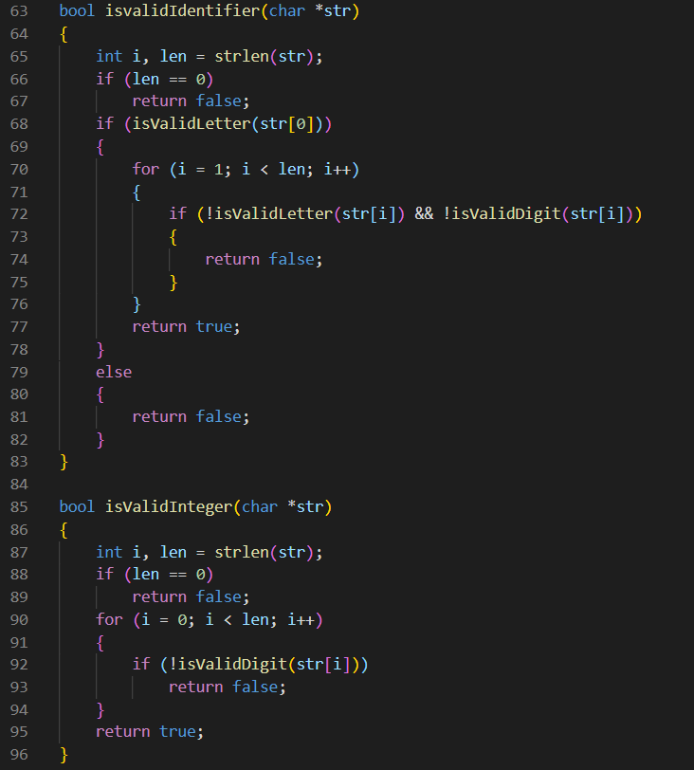

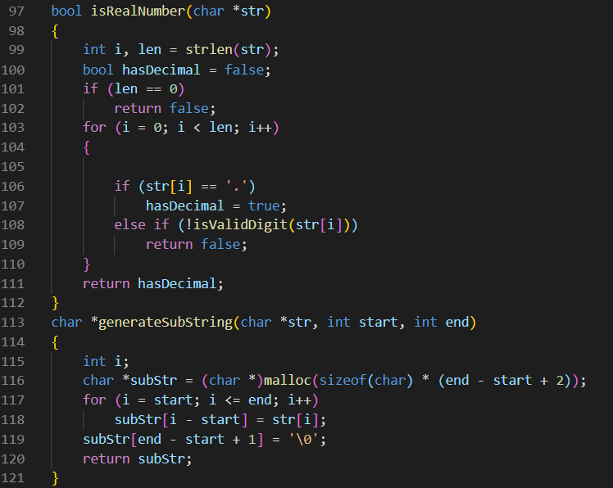

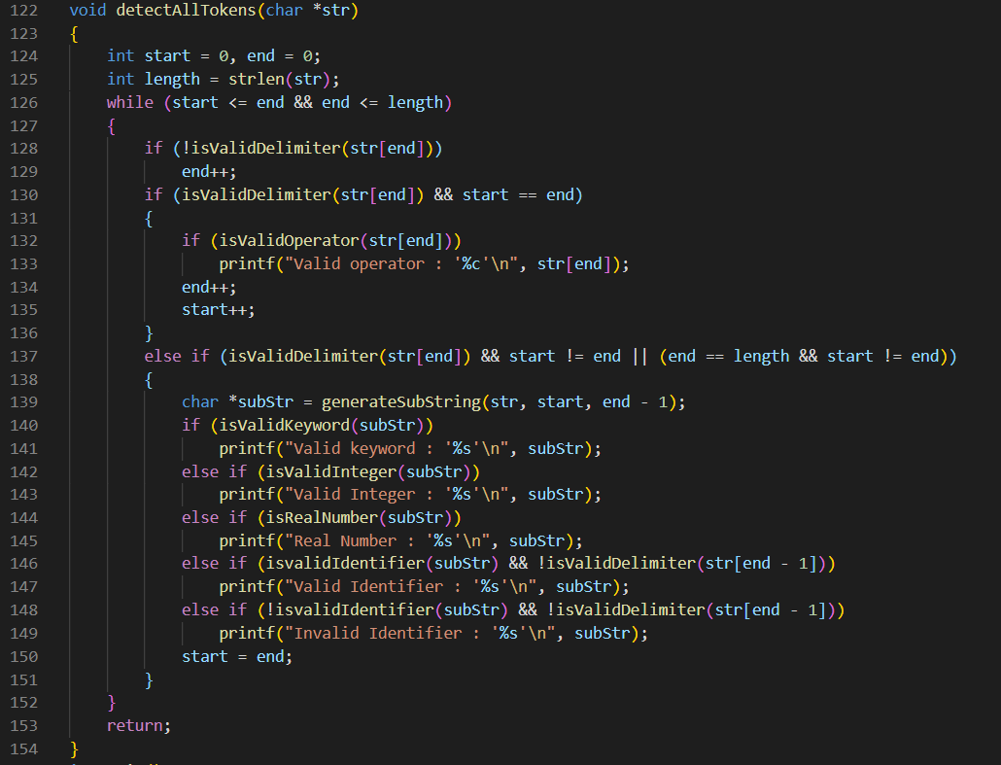

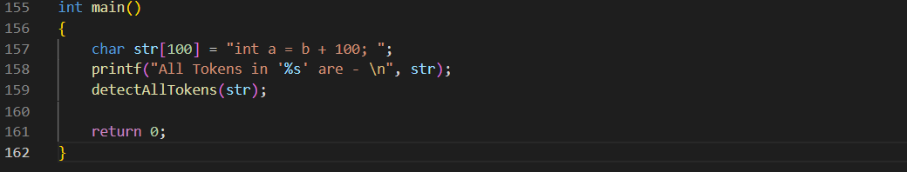

Output:

