**CSB 353: Compiler Design**

**LAB 2**

**Submitted By:**

**Name: PREM KUMAR**

**Roll No: 191210037**

**Branch: CSE**

**Semester: 6 th**

**Submitted To: Dr. Shelly Sachdeva**

Department of Computer Science and Engineering

**NATIONAL INSTITUTE OF TECHNOLOGY DELHI**

2019-2023

Ques 1. Install Flex.

* Download [FLEX Setup](http://gnuwin32.sourceforge.net/packages/flex.htm)

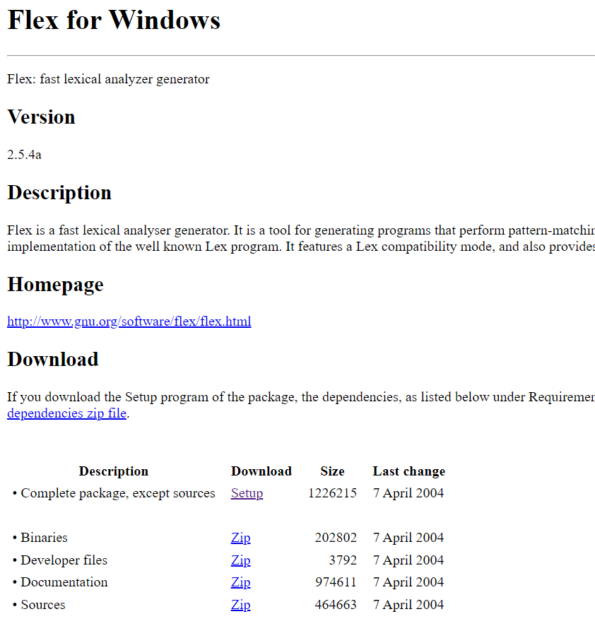

* Run the Installation file

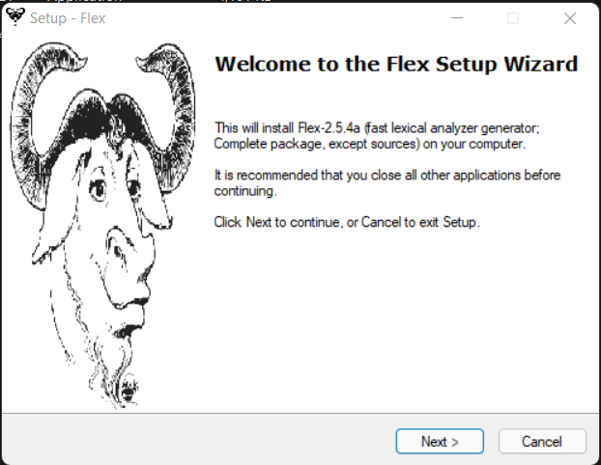

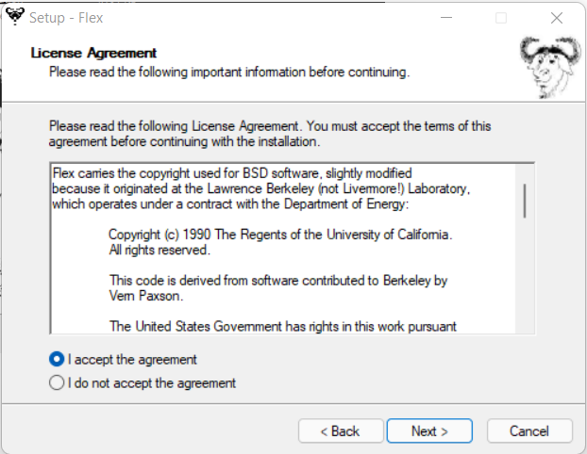

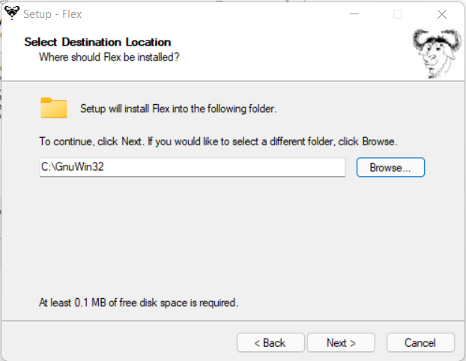

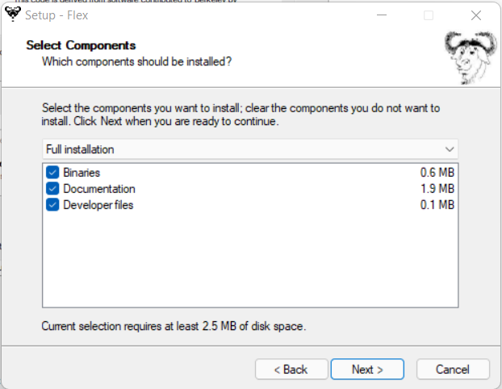

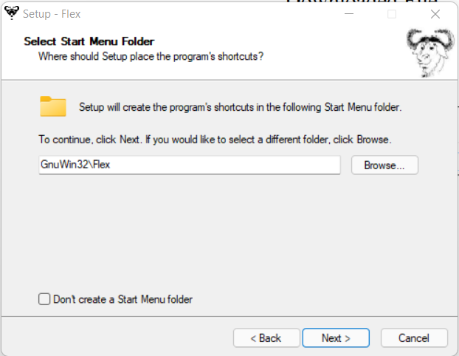

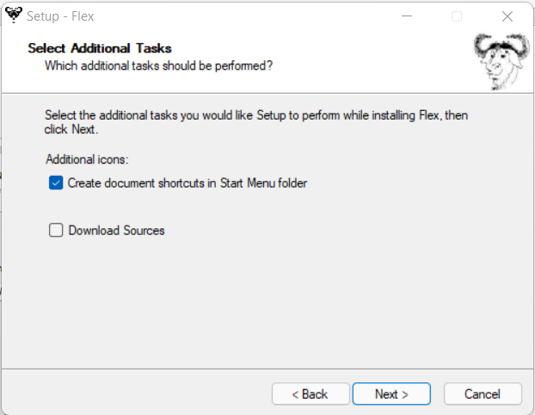

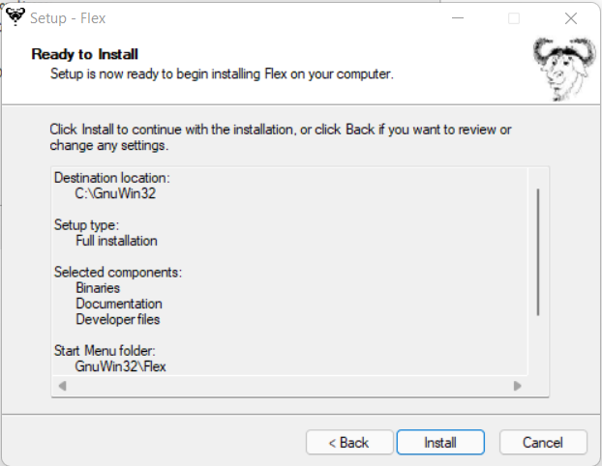

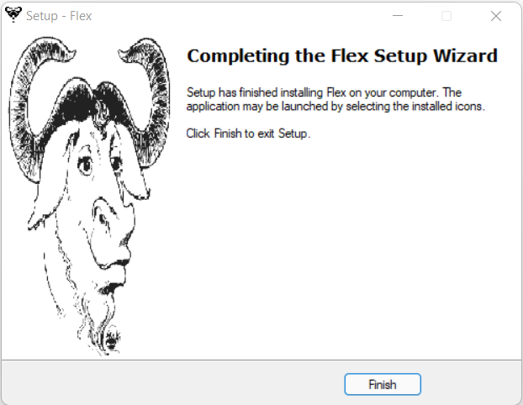

* Setting Environment Variable for FLEX.

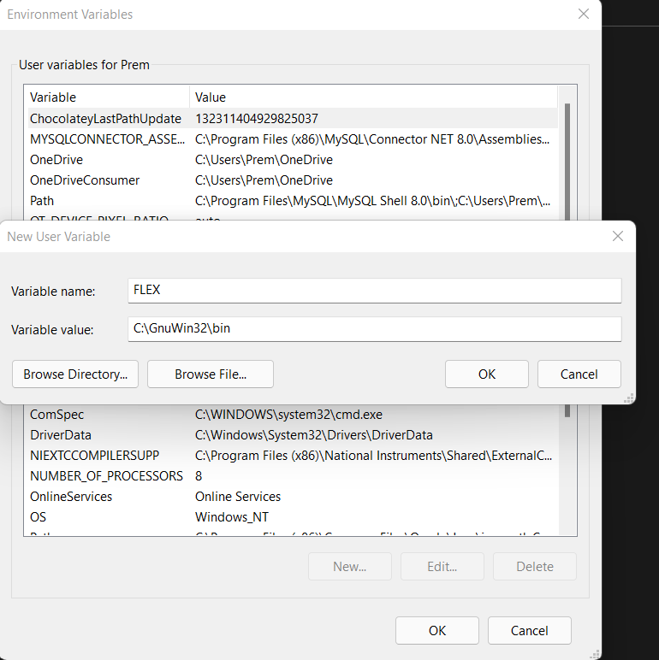

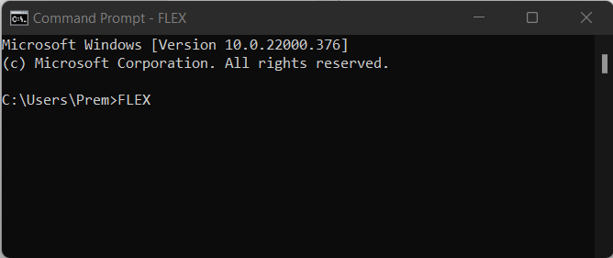

Ques2. Create a C program using FLEX for generating a Lexical Analyzer to identify the following tokens:

Keywords; Examples-for, while, if etc.

Identifier; Examples-Variable name, function name, etc.

Operators; Examples '+', '++', '-' etc.

Literals; (you may identify, INT, FLOAT, REAL)

Separators; Examples ',' ';' etc.

Code:

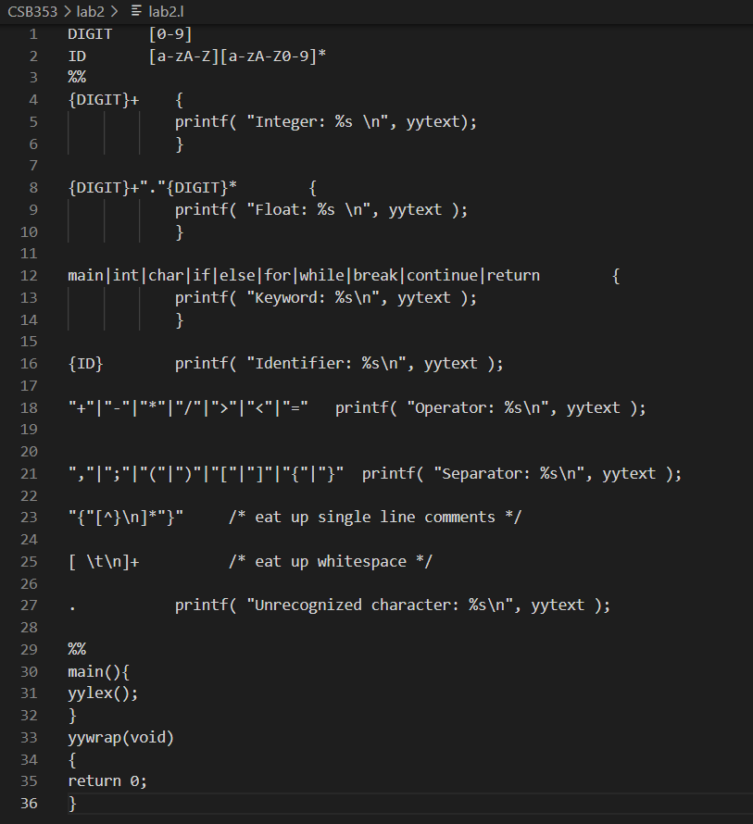

Output:

