**CSB 353: Compiler Design**

**LAB 3**

**Submitted By:**

**Name: PREM KUMAR**

**Roll No: 191210037**

**Branch: CSE**

**Semester: 6 th**

**Submitted To: Dr. Shelly Sachdeva**

Department of Computer Science and Engineering

**NATIONAL INSTITUTE OF TECHNOLOGY DELHI**

2019-2023

Ques 1. Write a program using FLEX to read and validate a mathematical expression and display the result. The result should follow the BODMAS Rule. If the expression is invalid then display as invalid

Code:

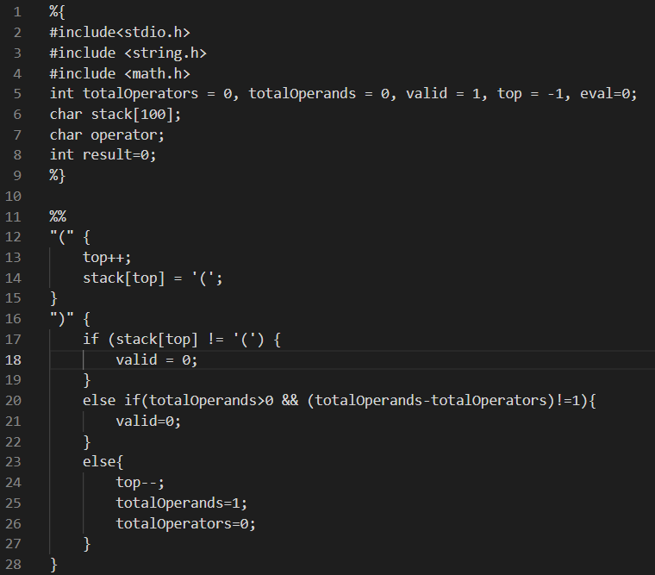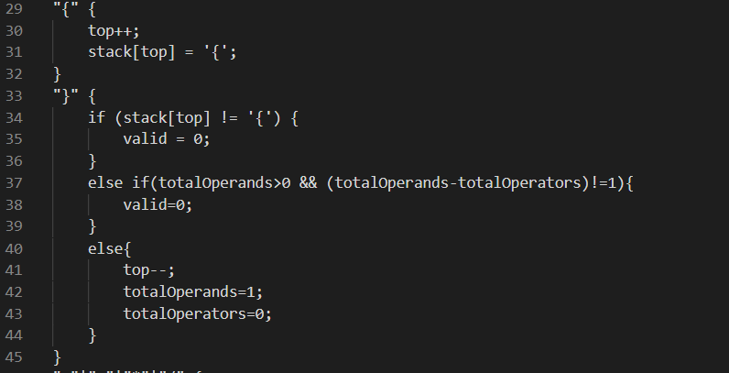

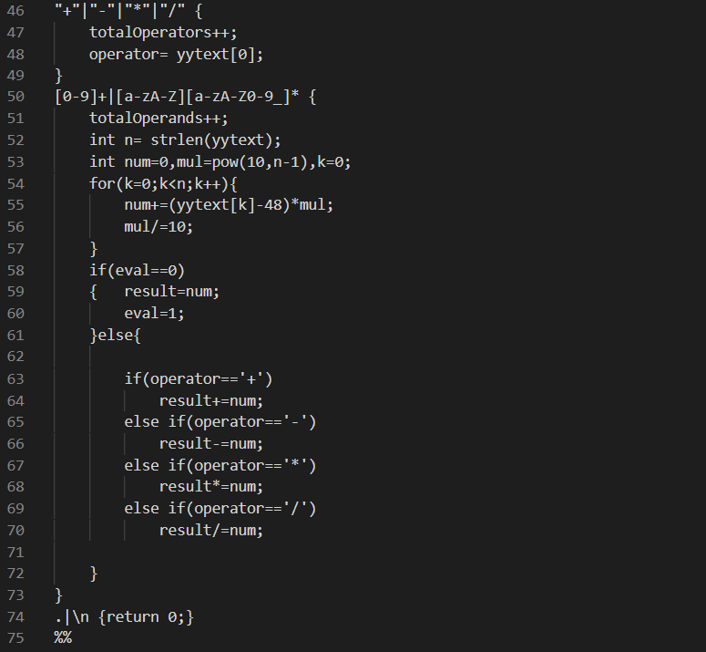

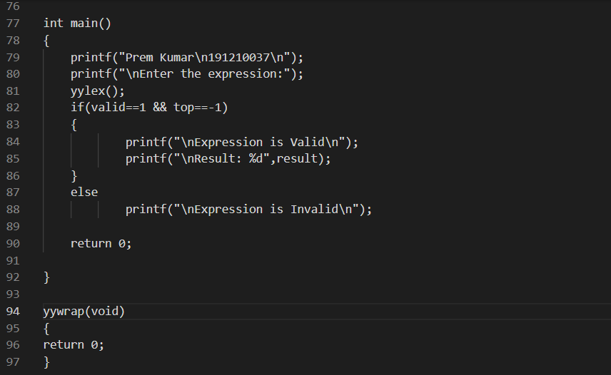

Output:

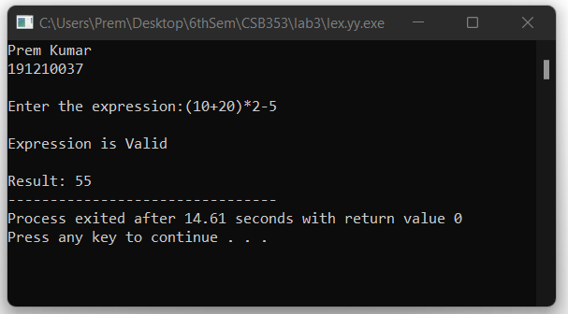

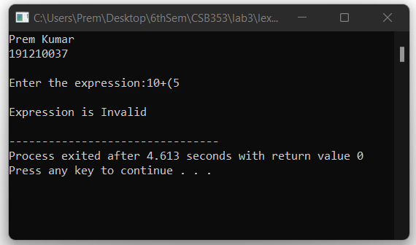

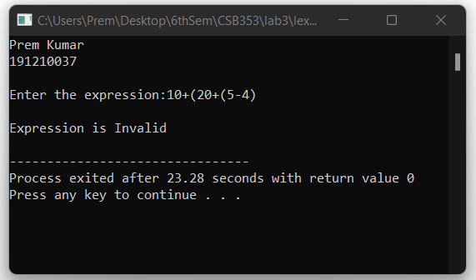

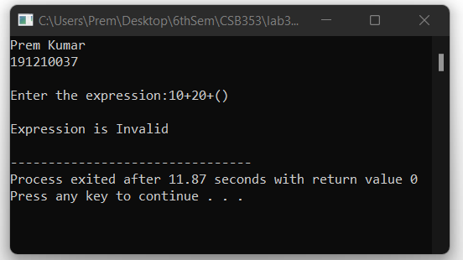

Ques 2. Write a program using FLEX to count the number of:

(a) Lines

(b) Words

(c) Capital Letters

(d) Small Letters

(e) Numbers (10,21)

(f) Digits (0-9)

(g) Special Character

(h) Delimiter

(i) Operator

(j) Relational Operator

(k)Total Characters

Code:

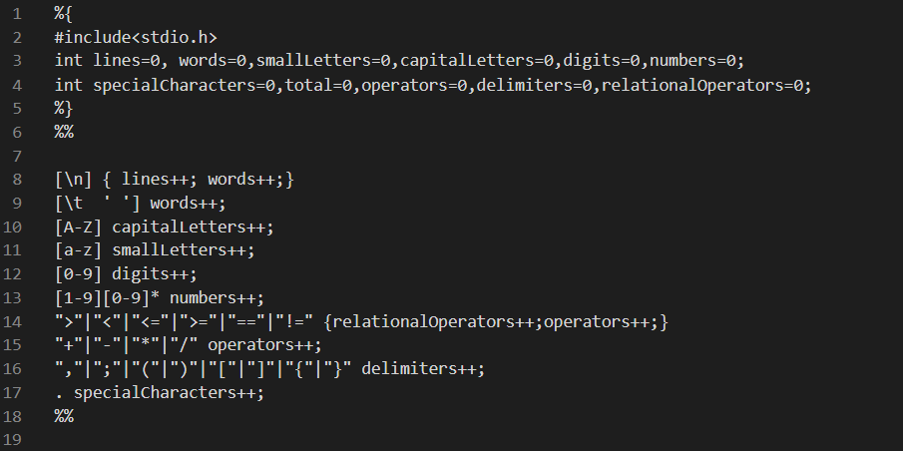

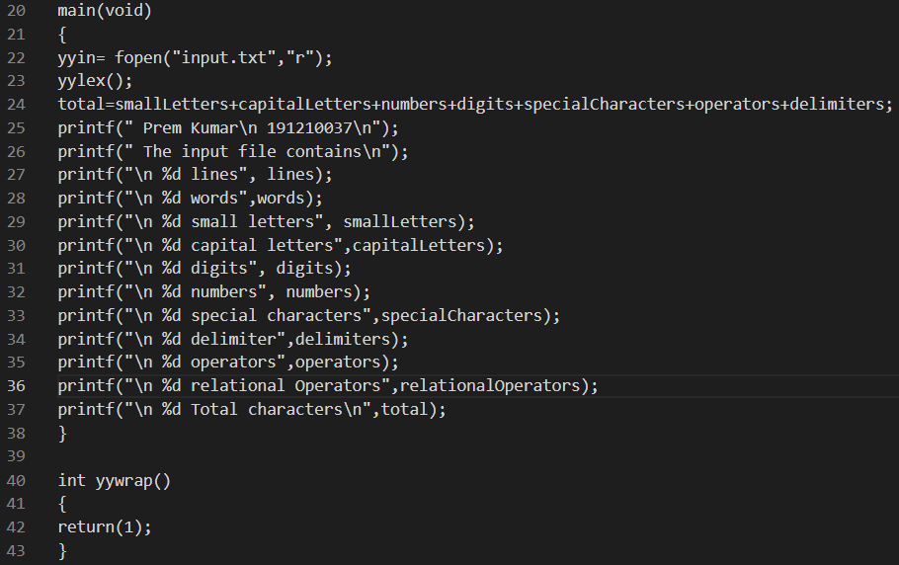

Output:

