**CSB 353: Compiler Design**

**LAB 4**

**Submitted By:**

**Name: PREM KUMAR**

**Roll No: 191210037**

**Branch: CSE**

**Semester: 6 th**

**Submitted To: Dr. Shelly Sachdeva**

Department of Computer Science and Engineering

**NATIONAL INSTITUTE OF TECHNOLOGY DELHI**

2019-2023

Ques 1. Consider the simplest regular expressions which are the strings of text characters with no operators at all like monday tuesday wednesday. These three regular expressions match any occurrences of those character strings in an input text. Design a Scanner that removes every occurrence of the word day in such words.

Code:

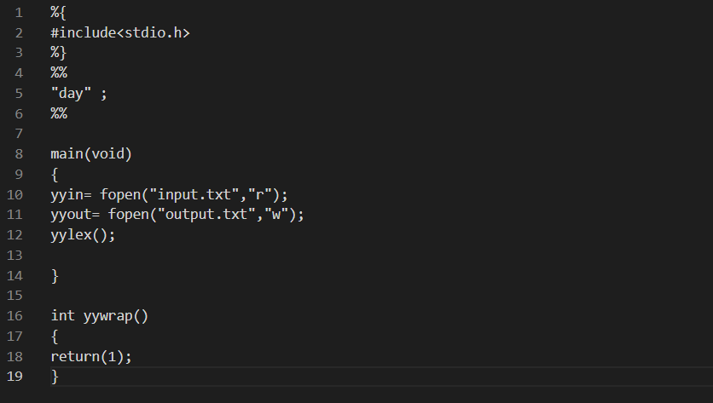

Input:

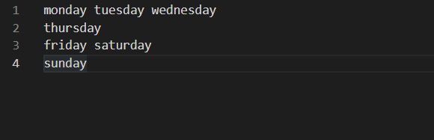

Output:

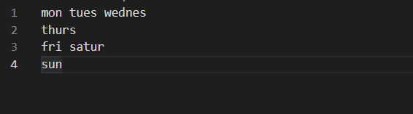

Ques 2. Design a Lexical analyzer which is successfully able to execute the following tasks:

(i) Count the total number of all digit strings in an input text

(ii) Print the running total of the number of digit strings

(iii) Print out each one as soon as it is found.

Code:

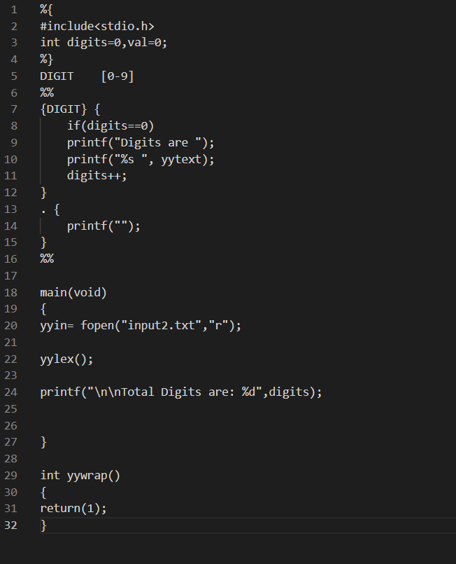

Input:

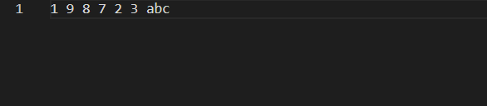

Output:

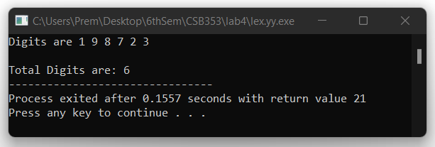

Ques 3. Design a Lexical analyzer which is successfully able to execute the following tasks:

(i) Count the total number of all digit strings in an input text

(ii) Print the running total of the number of digit strings

(iii) Print out each one as soon as it is found.

Code:

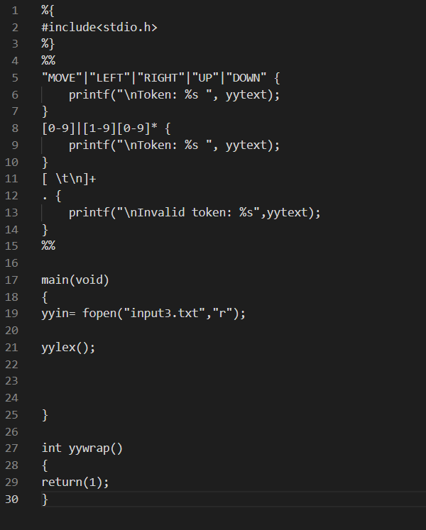

Input:

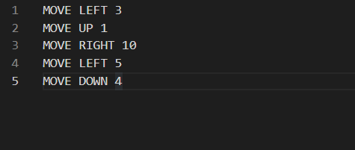

Output:

