**CSB 353: Compiler Design**

**LAB 7**

**Submitted By:**

**Name: PREM KUMAR**

**Roll No: 191210037**

**Branch: CSE**

**Semester: 6 th**

**Submitted To: Dr. Shelly Sachdeva**

Department of Computer Science and Engineering

**NATIONAL INSTITUTE OF TECHNOLOGY DELHI**

2019-2023

Ques 1. Write a C program to find First and Follow for all non-terminals.

Code:

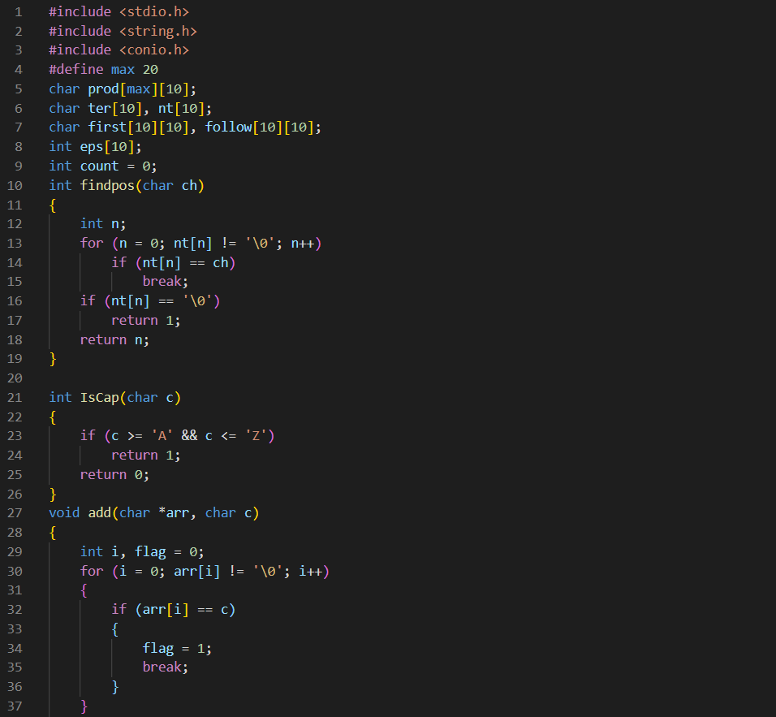

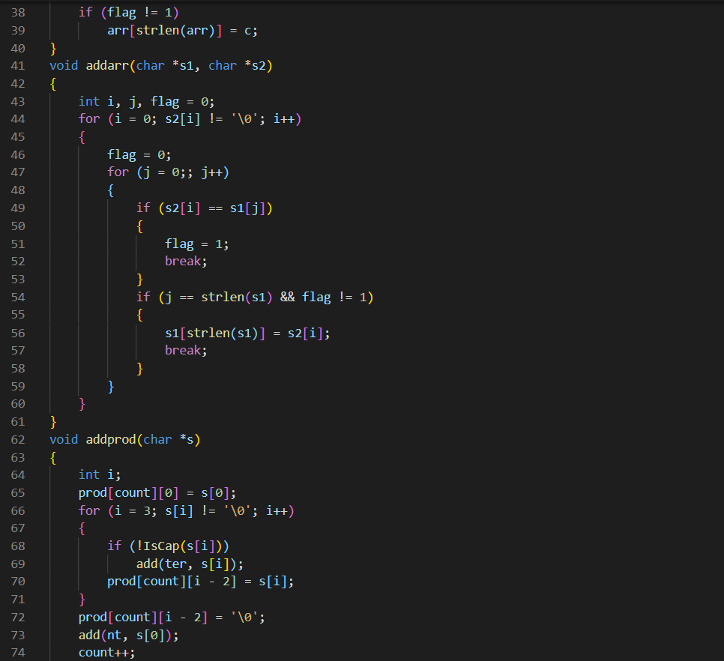

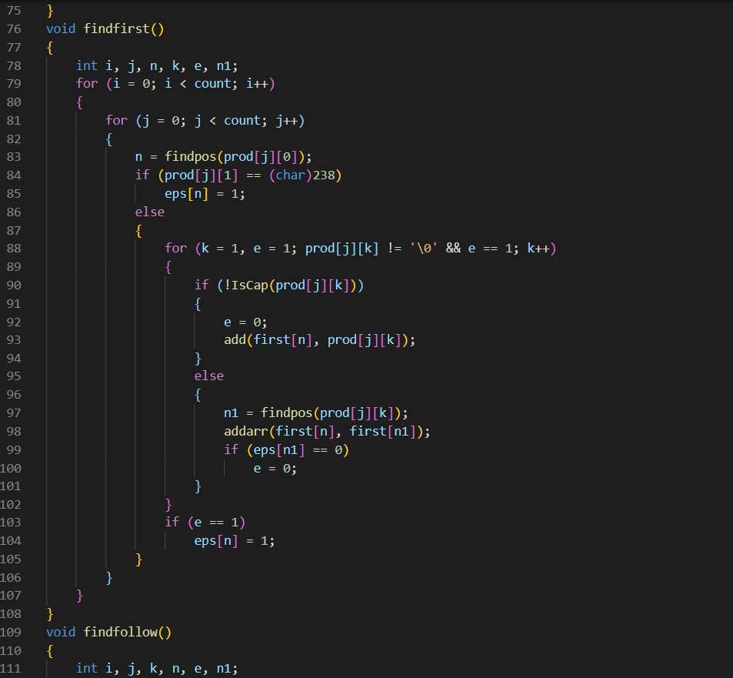

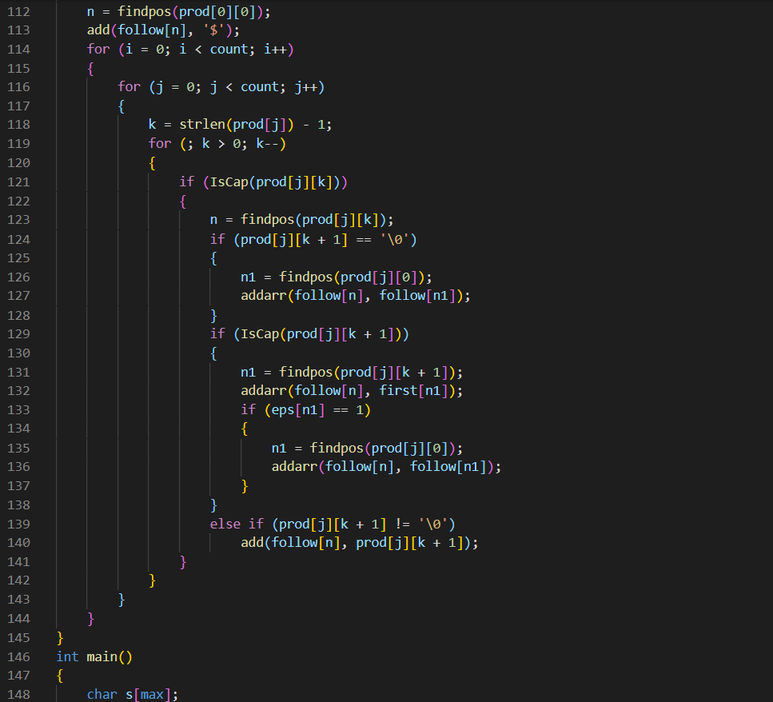

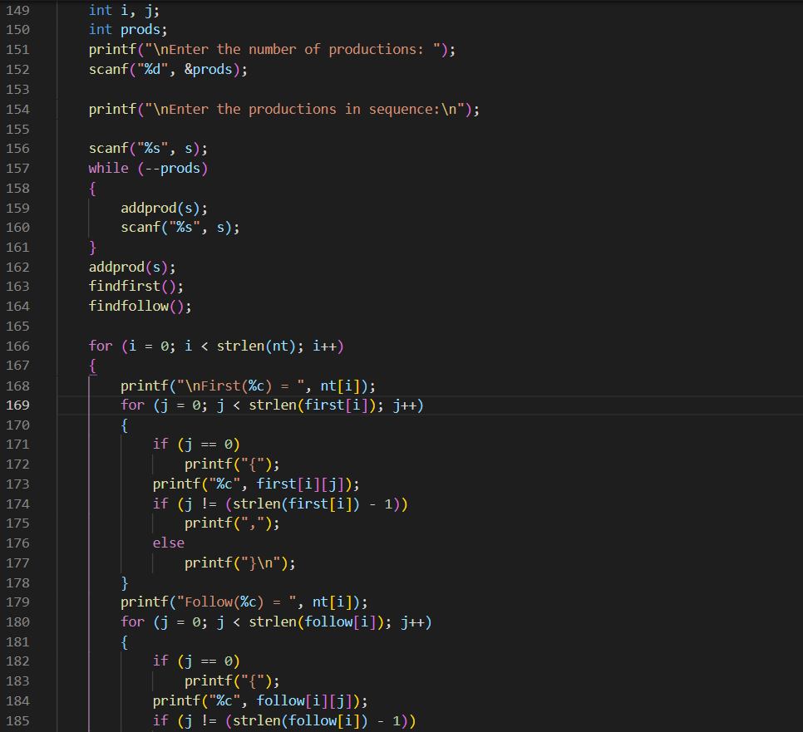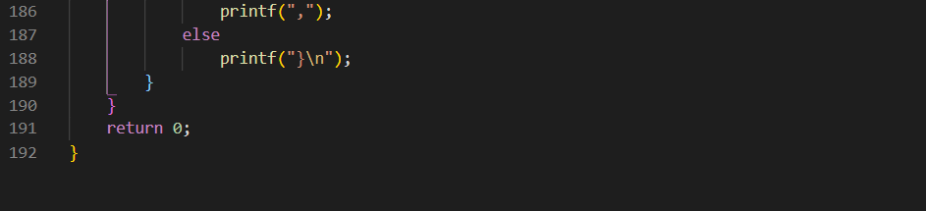

Output:

