**CSB 353: Compiler Design**

**LAB 8**

**Submitted By:**

**Name: PREM KUMAR**

**Roll No: 191210037**

**Branch: CSE**

**Semester: 6 th**

**Submitted To: Dr. Shelly Sachdeva**

Department of Computer Science and Engineering

**NATIONAL INSTITUTE OF TECHNOLOGY DELHI**

2019-2023

Ques 1. Download and Install Yacc Tool on your system and prepare a lab manual.

1. Download Yacc Tool from <https://yacc.software.informer.com/download/>.

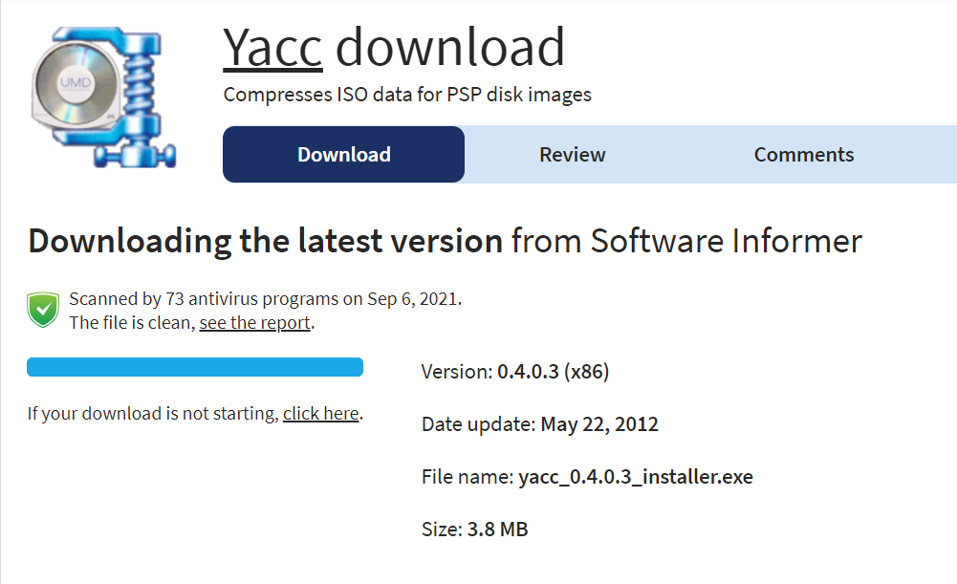

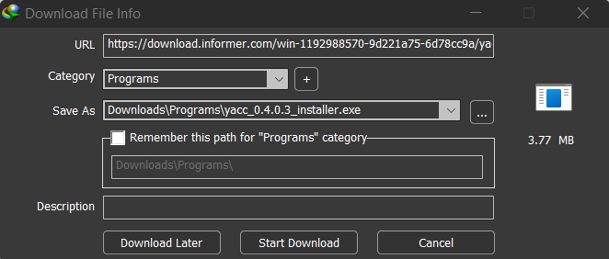

1. Run the exe file and install Yacc tool

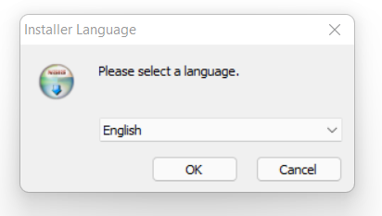

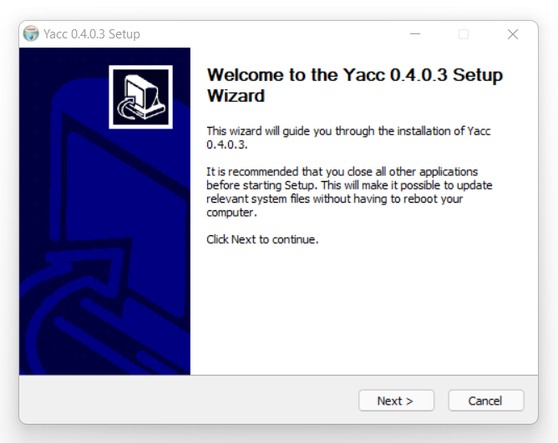

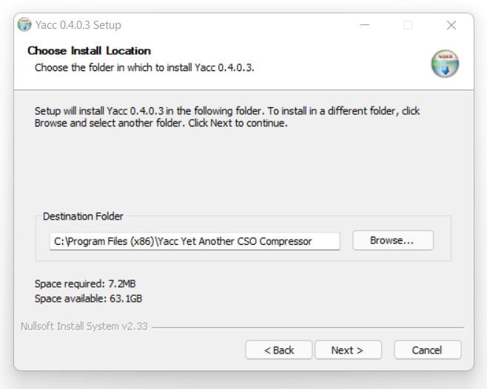

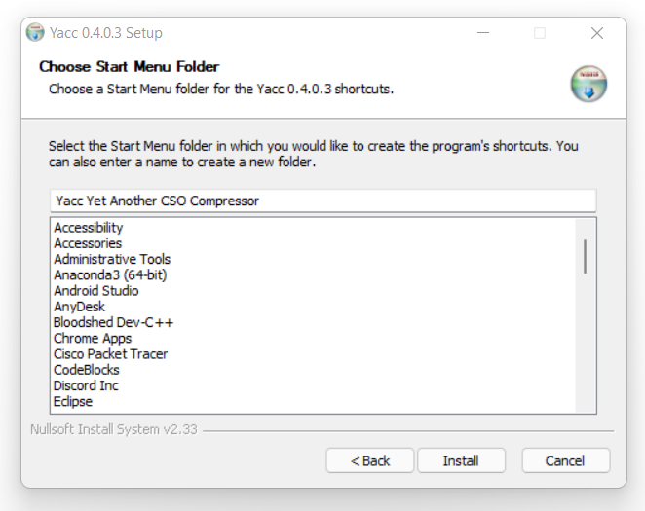

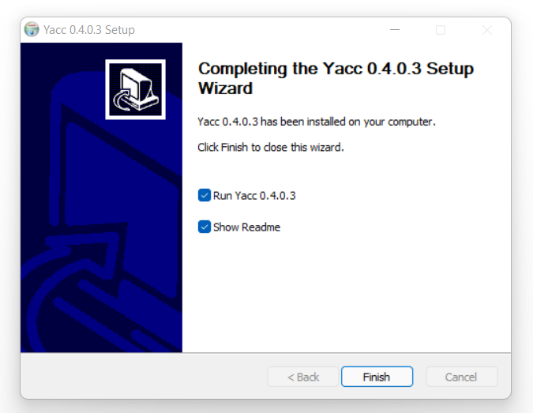

1. Run the Yacc tool

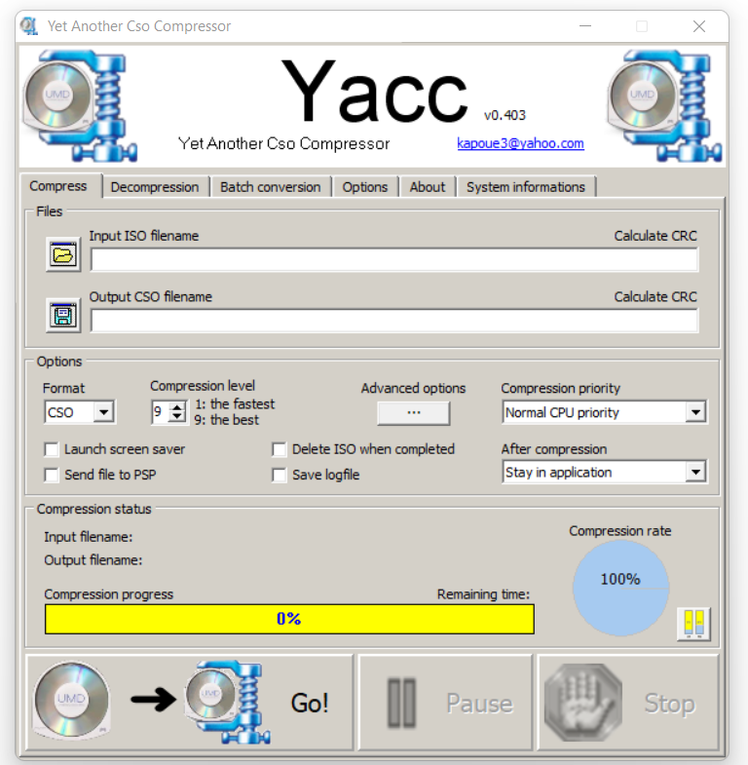

Ques 2. Write a Yacc program to check if entered statement is a valid arithmetic

expression.

Code:

* validExpression.l

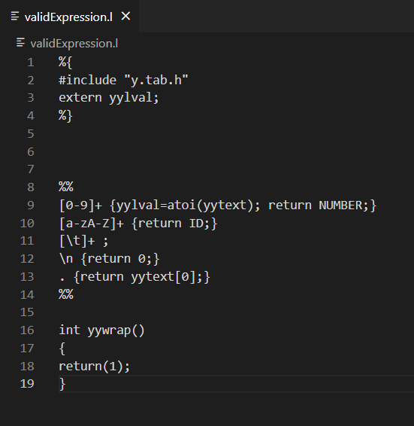

* validExpression.y

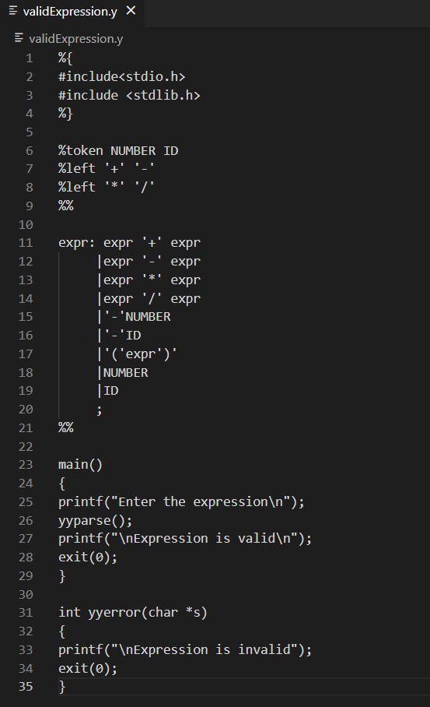

Output:

