**CSB 353: Compiler Design**

**LAB 9**

**Submitted By:**

**Name: PREM KUMAR**

**Roll No: 191210037**

**Branch: CSE**

**Semester: 6 th**

**Submitted To: Dr. Shelly Sachdeva**

Department of Computer Science and Engineering

**NATIONAL INSTITUTE OF TECHNOLOGY DELHI**

2019-2023

Ques 1. Design a grammar for a declarative statement for C program. Further, write a Yacc program to check if entered statement is a valid declarative statement according to the grammar generated.

Code:

* prog1.l (Lex File)

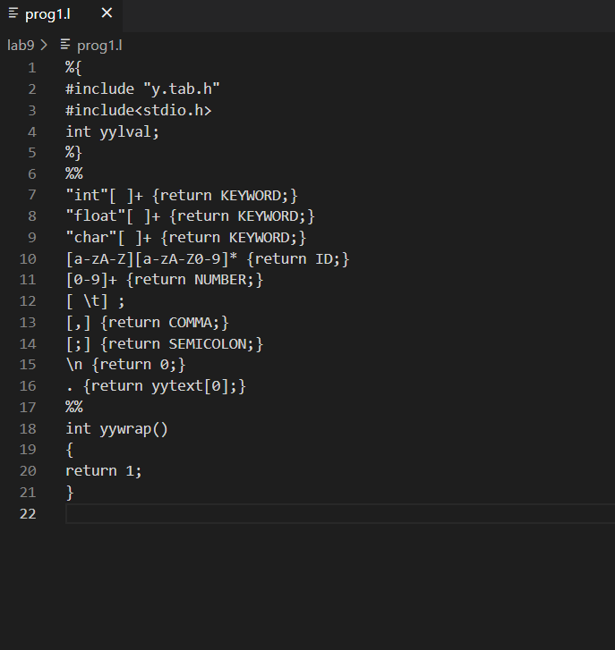

* prog1.y (Yacc File)

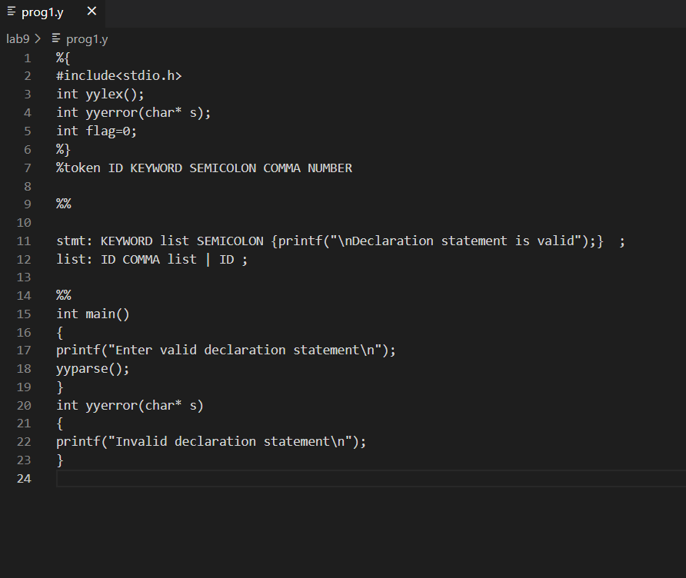

Output:

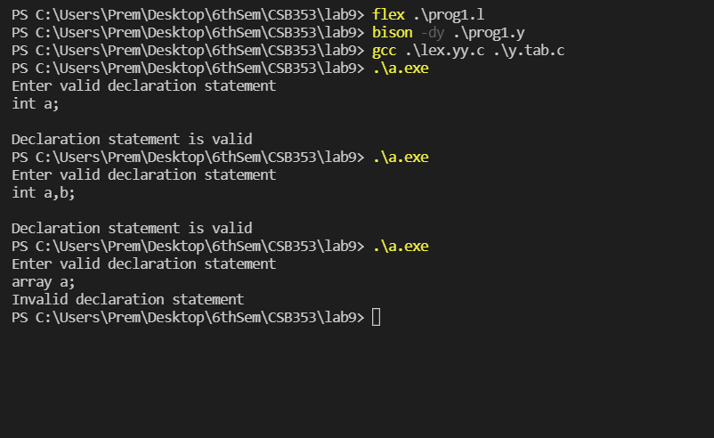

Ques 2. Design a grammar for a relational expression of C language. Further, write a Yacc program to check if entered statement is a valid relational expression according to the grammar generated.

Code:

* prog2.l (Lex File)

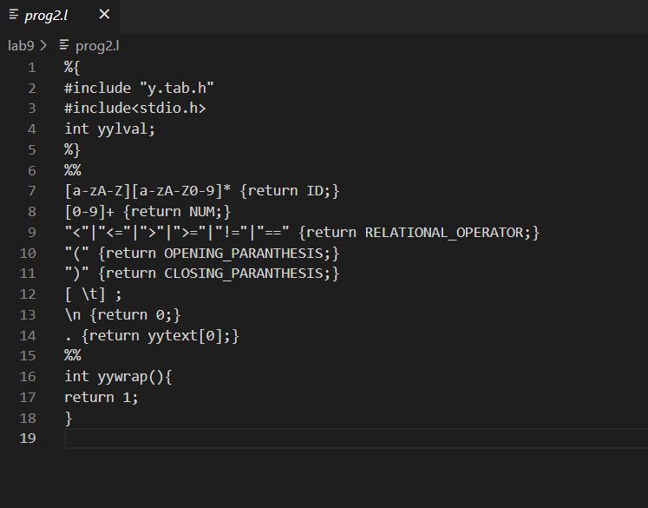

* prog2.y (Yacc File)

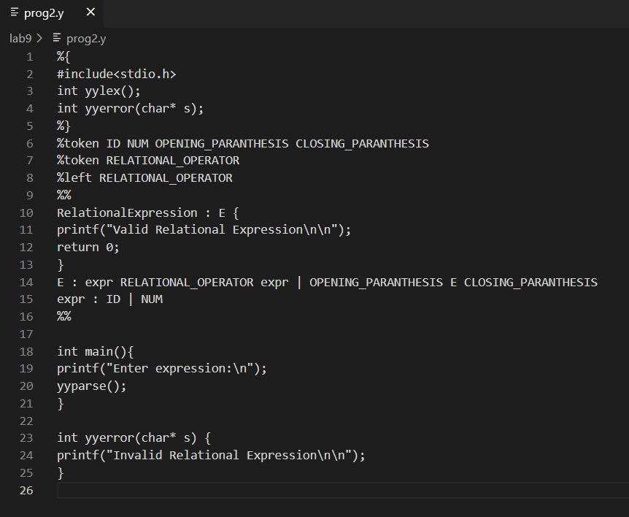

Output:

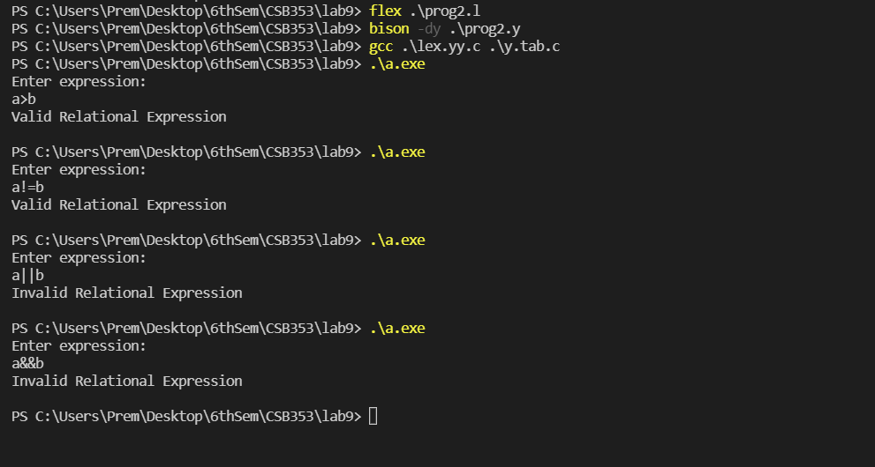

Ques 3. Design a grammar for a logical expression of C langauge. Further, write a Yacc program to check if entered statement is a valid logical expression according to the grammar generated.

Code:

* prog3.l (Lex File)

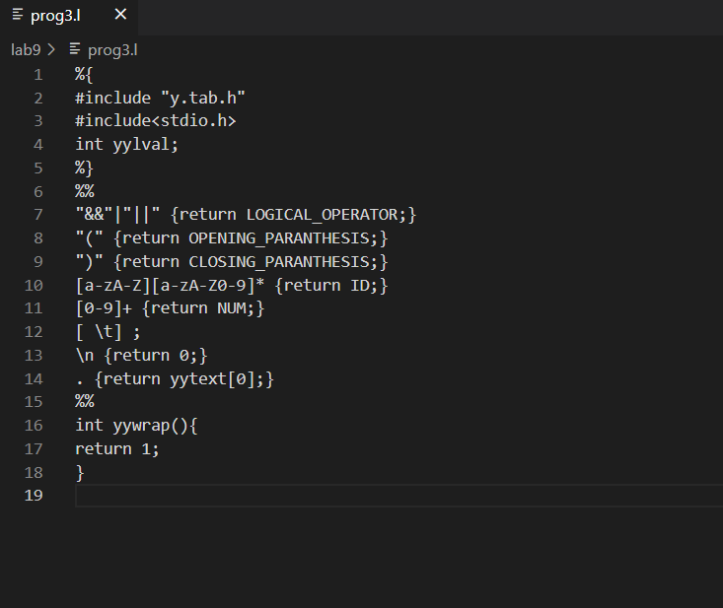

* prog3.y (Yacc File)

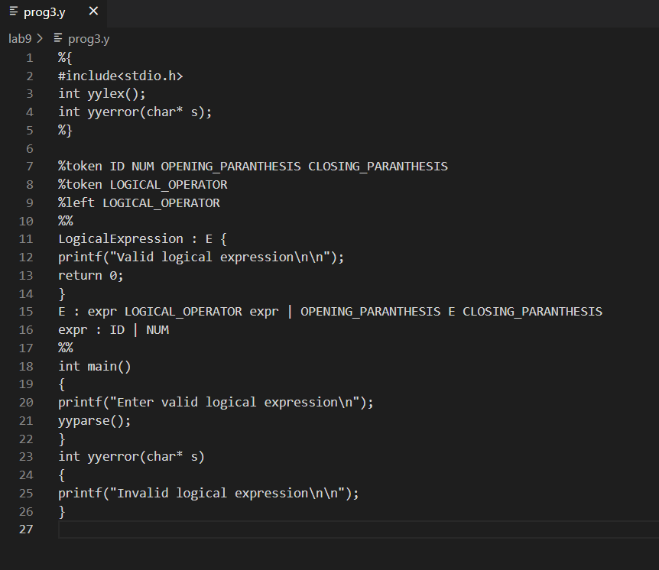

Output:

