**Cody Buckle**

**PHP**

**Lab 1**

**9/15/19**

**Exercise 1-2**

1. false.
2. 23
3. false.
4. true.
5. 5
6. false.
7. False.

**Exercise 1-3**

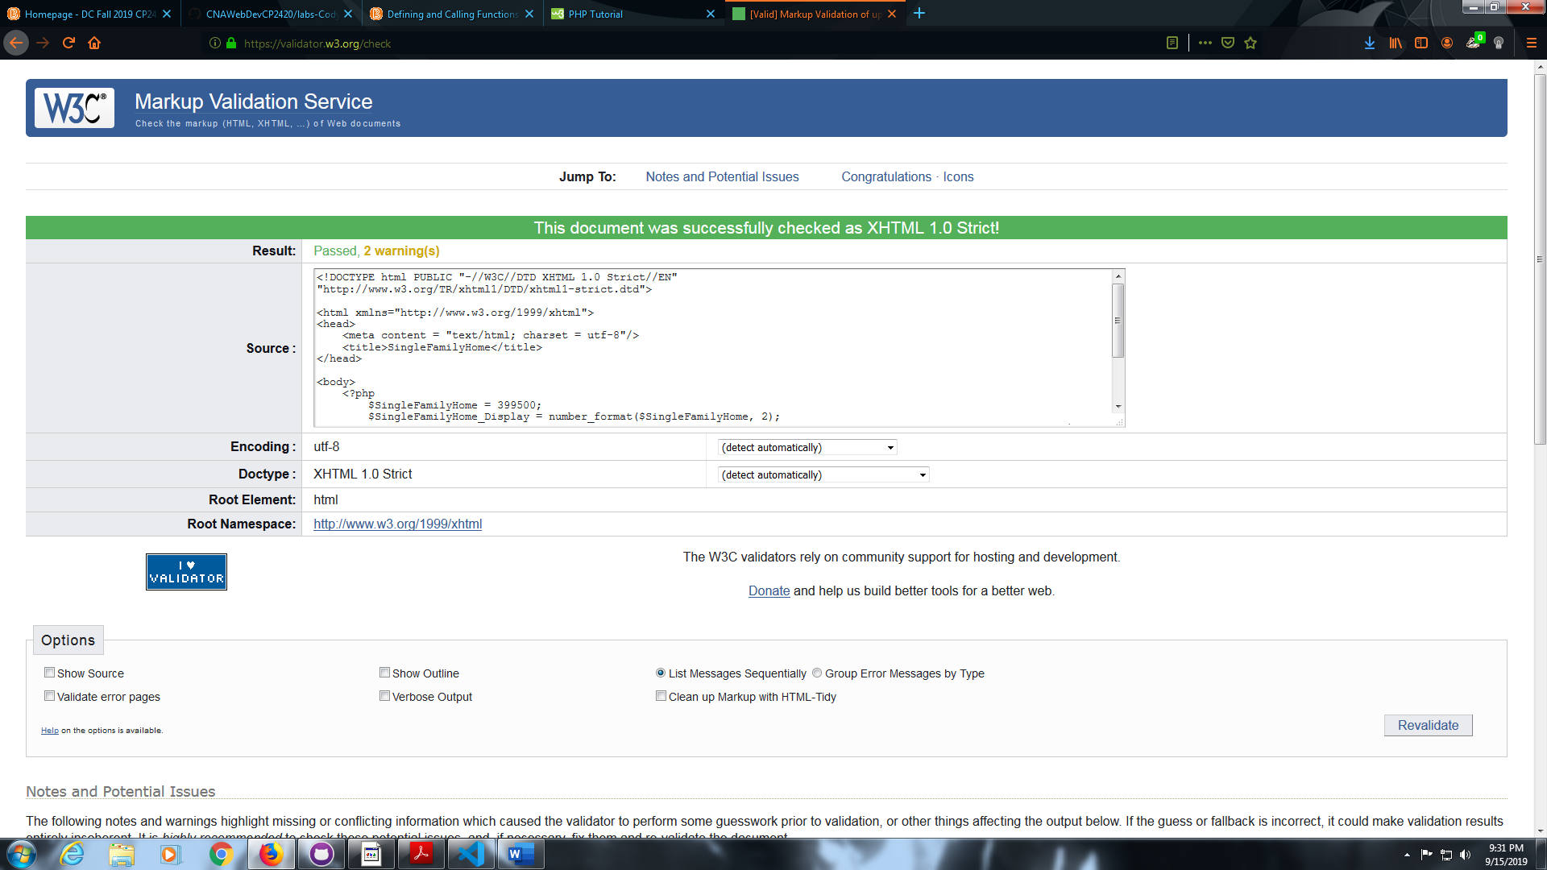

**Exercise 1-4**

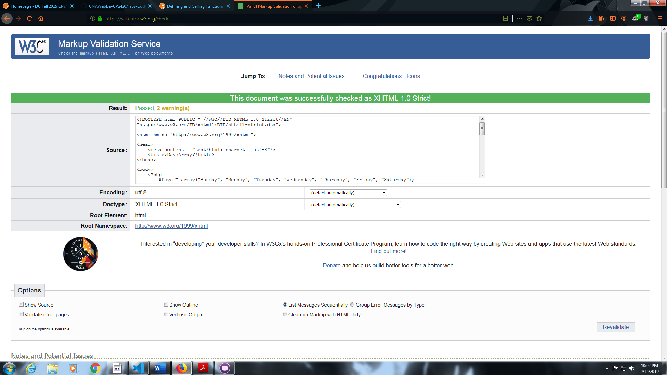

**Exercise 1-5**

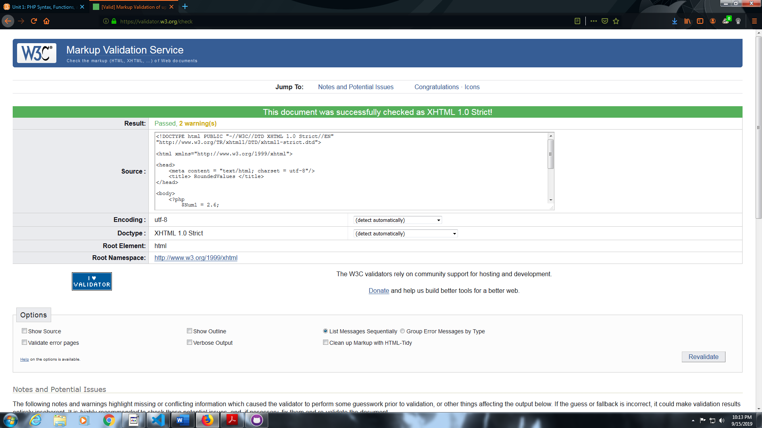

**Exercise 1-6**

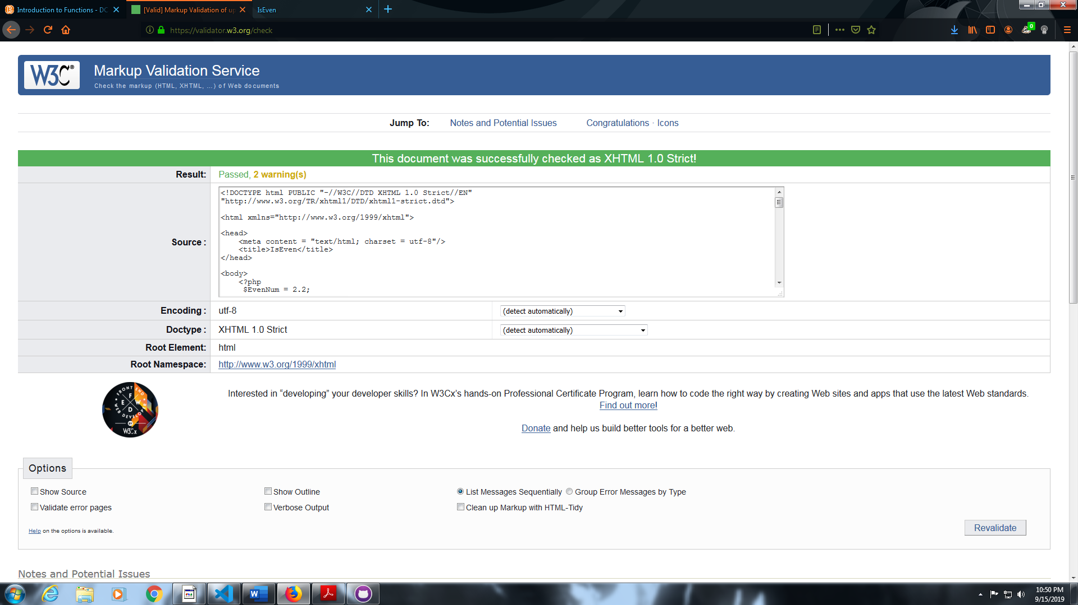

**Exercise 2-1**

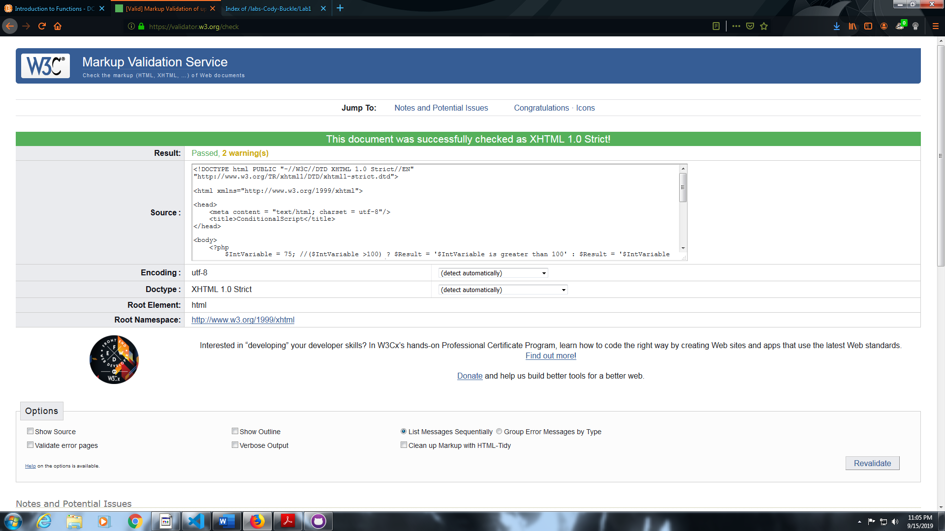

**Exercise 2-2**

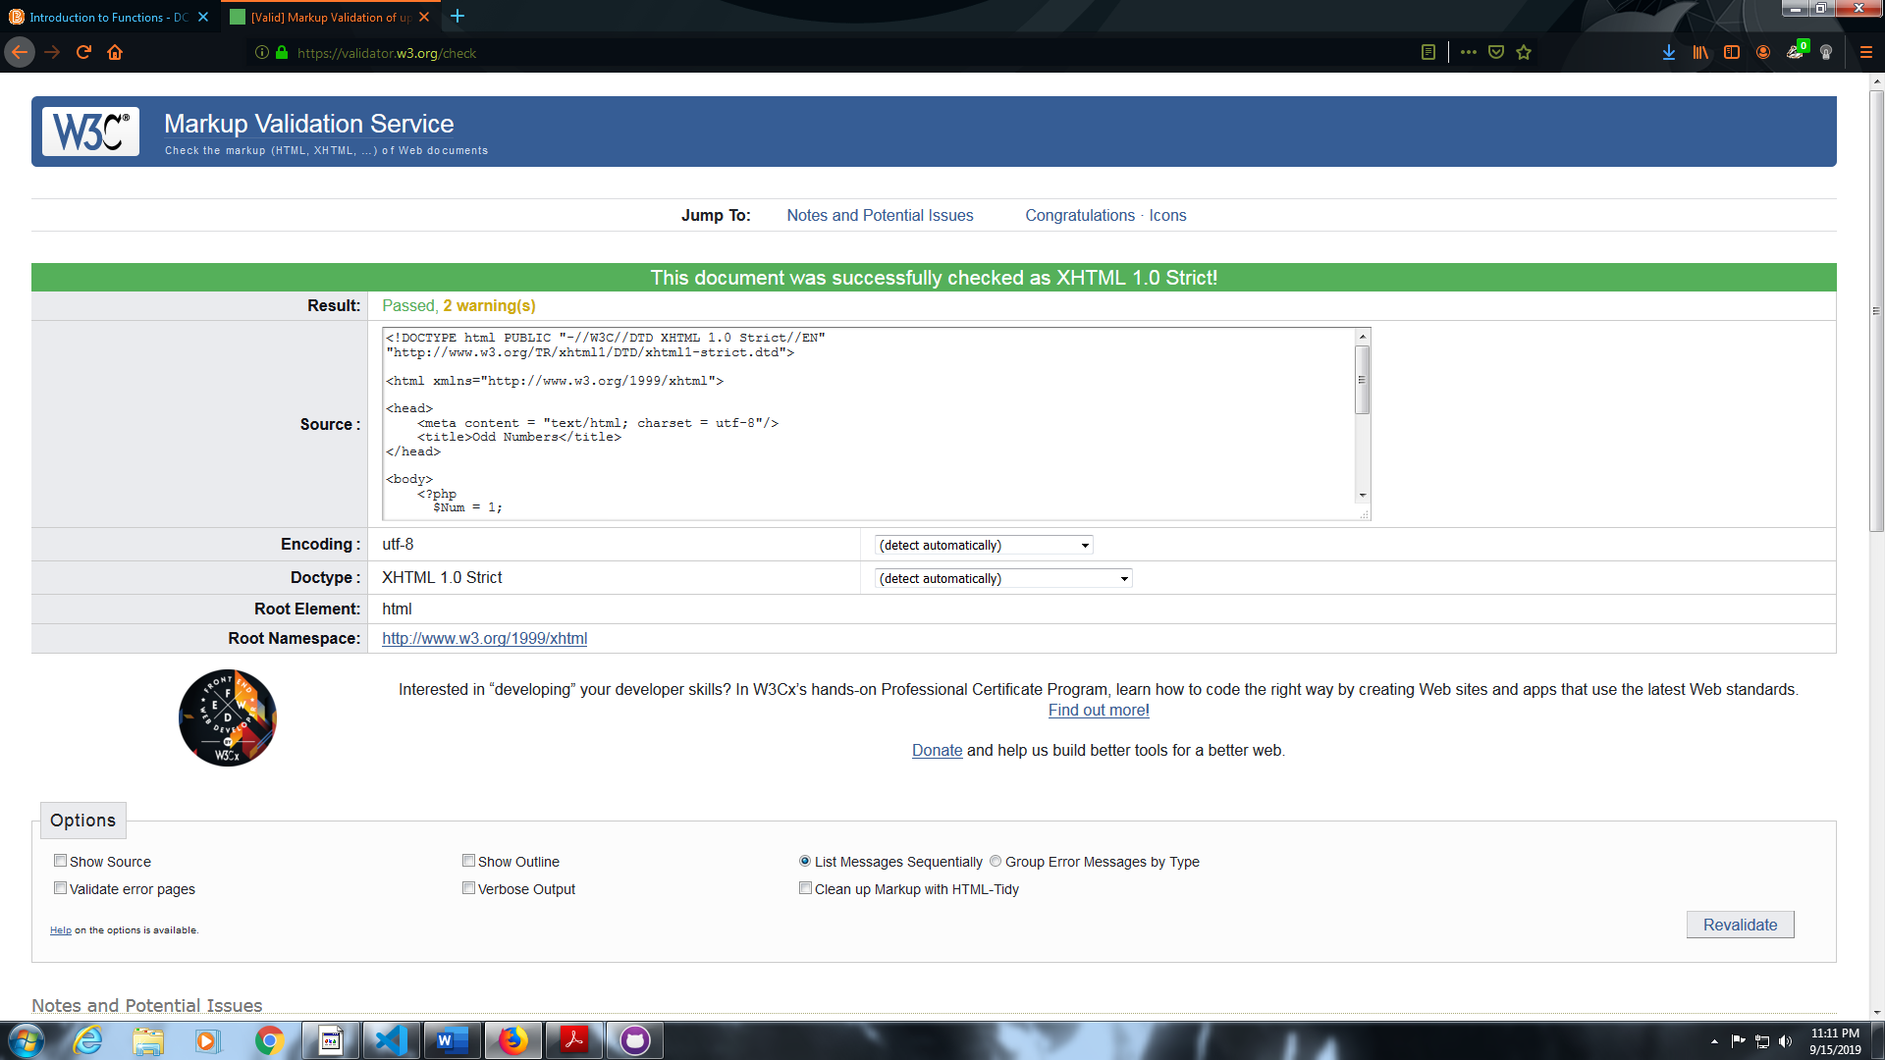

**Exercise 2-4**

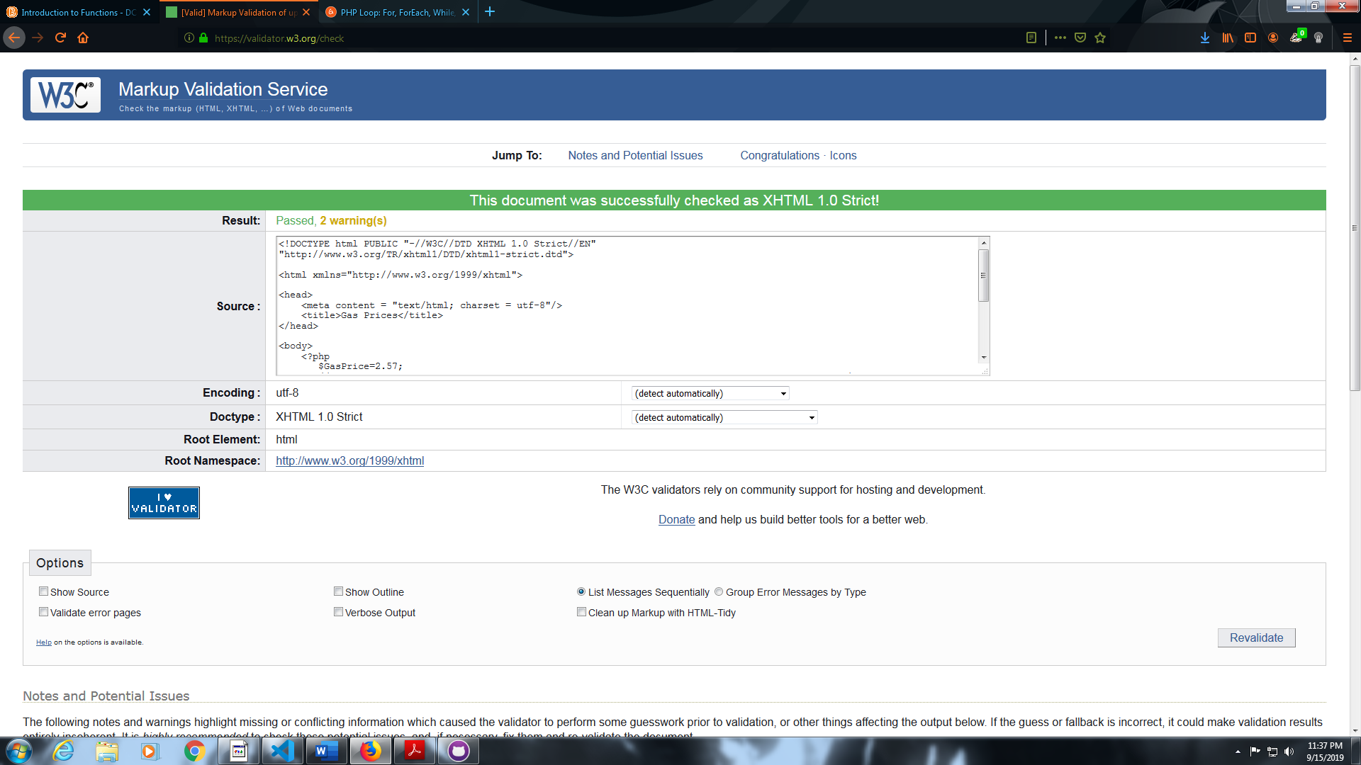

**Exercise 2-6**

