Import instructions:

1) Start up the Sling instance. If this is the local Sling instance, go to the directory where your Sling instance is. Run the following command: java -Xmx384M -jar org.apache.sling.launchpad-6-standalone.jar

This should be the result when Sling has successfully started.



2) Open another Terminal/Command Prompt window. Go to the directory that contains the Sling instance. Use curl on the Command Prompt/Terminal and specify the file name of the document as well as the destination path for storing the elements. If the document contains a reference to an external document for global rules, please use the externalFile attribute with the file name of the external document.

Command to import:

curl –v –X POST –F”file=@<document path>” –F”path=<jackrabbit repository path>” –F”externalFile=@<document path>” –u <sling username>:<sling password> <sling domain path>

Example with the use of external rules documents:

curl -v -X POST -F"file=@translate2xml.xml" -F"path=/content/translate2xml" -F"externalFile=@translate2xmlrules.xml" -u admin:admin http://localhost:8080/bin/its/import

Example without the use of external rules documents;

curl -v -X POST -F"file=@translate7xml.xml" -F"path=/content/translate7xml" -u admin:admin http://localhost:8080/bin/its/import

This should be the response if imported correctly.

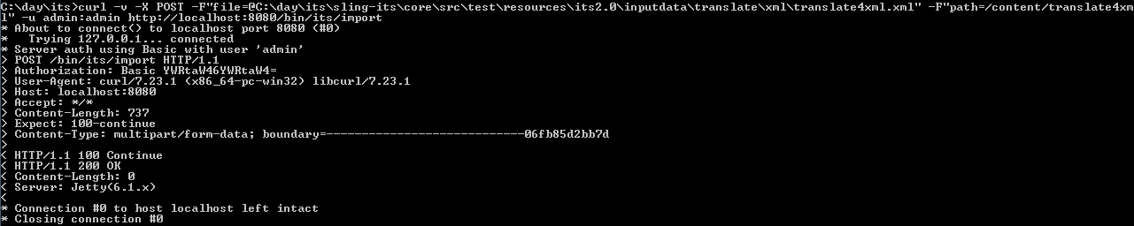

3) The final step to verify if the document is truly imported correctly. Open the Sling explorer. If this is the local instance, it should be something like <http://localhost:8080/.explorer.html>. From the Sling explorer, check the node below the path you specified to import the xml/html nodes to. If the curl command’s path attribute was “/content/translate4xml”, you must check the nodes below “/content/translate4xml” to verify if all the nodes are populated. The second place to check is to check under “/etc/its” to verify if all the global rules are also imported correctly; however, this requires the imported document to include a sling:resourceType.

Example:

curl -v -X POST -F"file=@translate7xml.xml" -F"path=/content/translate7xml" -u admin:admin http://localhost:8080/bin/its/import

Site admin should look like the following:

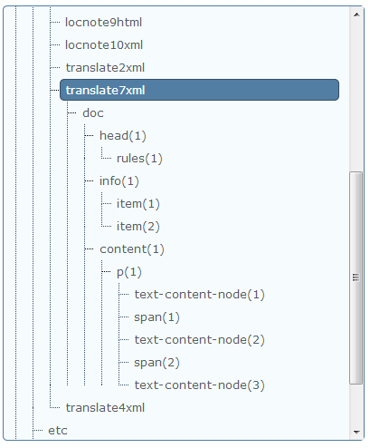

Export instructions:

1) Once the document is imported, you can test exporting it. So during the import process, there was a path attribute with the destination of where all the document nodes should be stored. Use that path once again but attach the “its” selector and the file extension.

Example:

Import’s command was: curl -v -X POST -F"file=@translate7xml.xml" -F"path=/content/translate7xml" -u admin:admin http://localhost:8080/bin/its/import

So export path should be like:

<http://localhost:8080/content/translate7xml.its.xml>

The document should be relatively similar to the imported document. The biggest difference is for documents that contain references to an external document for global rules. Those will be embedded into the document during the export process instead.