Software Installation Guide

1) Install Apache Maven 3.0.5 from <http://maven.apache.org/download.cgi>

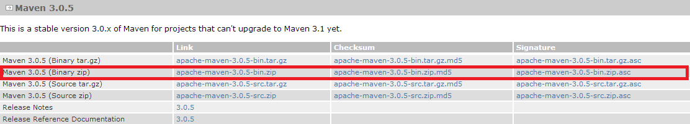

2) Install Java 6 JDK from <http://www.oracle.com/technetwork/java/javasebusiness/downloads/java-archive-downloads-javase6-419409.html>

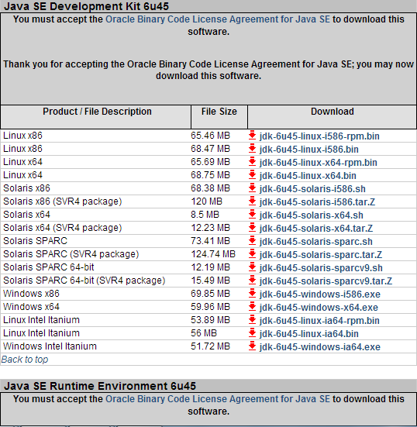

3) Download Git from <http://git-scm.com/downloads>

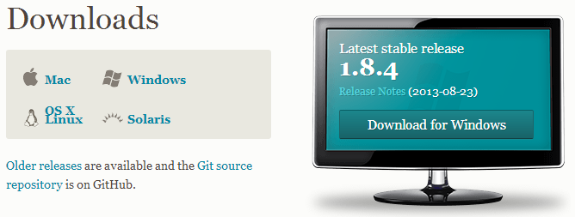

4) If you are on a Windows machine, please run Git Bash. If you are on a Mac machine, please open the terminal. Please run the following two commands and switch out the name and email with your name and adobe email address.

$ git config --global user.name "John Doe"

$ git config --global user.email johndoe@example.com

This is required in order to push code into the Git Repository. For more information, look here: <http://git-scm.com/book/en/Getting-Started-First-Time-Git-Setup>

5) Using the same window, we will need to get a new ssh key. Type the following command into the terminal/Git Bash window and replace “your_email@example.com” with your Adobe email address:

$ ssh-keygen –t rsa –C “your_email@example.com”

There should be a prompt asking for a passphrase. That passphrase is essentially the password in order to push code into the master git repository. Type in whatever you think is best as a passphrase.

6) Now copy the public ssh key. You can use the command below to do so.

$ clip < ~/.ssh/id_rsa.pub

7) Go to <https://git.corp.adobe.com> and go to your Account Settings.

8) Go to SSH Keys in the left navigation.

9) Click on Add SSH key.

10) Paste in the public ssh key that was generated from step 5.

For more information from Step 5 to Step 10, it can be found here: <https://help.github.com/articles/generating-ssh-keys>

11) Download Eclipse from <http://www.eclipse.org/downloads/>

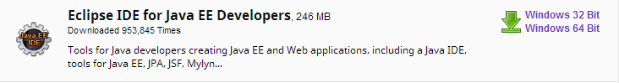

12) Download a fresh instance of sling from <http://sling.apache.org/downloads.cgi>

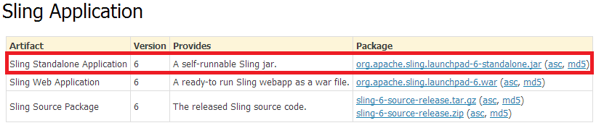

13) Download curl from <http://curl.haxx.se/download.html>. This is only necessary for Windows as curl is already installed for Macintosh.