Local Set up

1) Open the terminal if you are on a Mac machine or open the Command Prompt if you are on a Windows machine. Go to the directory where you downloaded Sling jar file.

2) Run the following command to start Sling: java -Xmx384M -jar org.apache.sling.launchpad-6-standalone.jar

This should be the result when Sling has successfully started.



3) Go to your browser and go to the git repository for the sling-its project. Go here, <https://git.corp.adobe.com/MCITeam/sling-its> (if the url has not been changed). Copy the ssh path listed in the project. This is required in order to check-out/clone a copy of the source code on to your local instance.

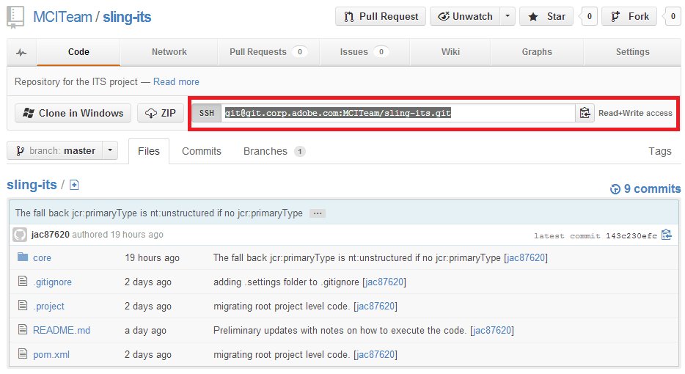

4) Open Eclipse.

5) If you do not have the Git Repository Exploring Perspective in the upper right hand corner, please click on Open Perspective and select Git Repository Exploring.



6) Go to the Git Repository Exploring and click on “Clone a Git Repository and the clone to this view”



7) The ssh path from step 3 should be pasted into the URI textfield. Subsequently, various fields will be filled out. Click Next.

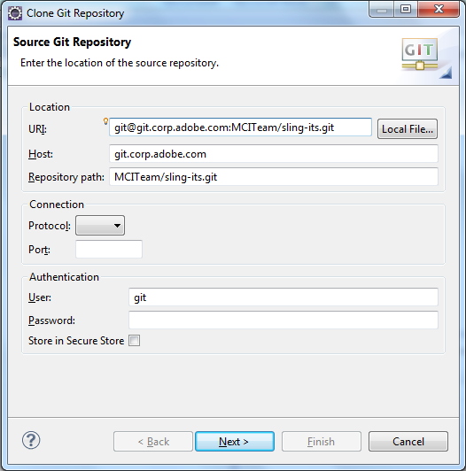

8) Click Next when you reach the Branch Selection Window.

9) Under Directory, select the directory where you want to save the repository. Make sure to check “Import all existing projects after clone finishes”. Click Finish afterwards.

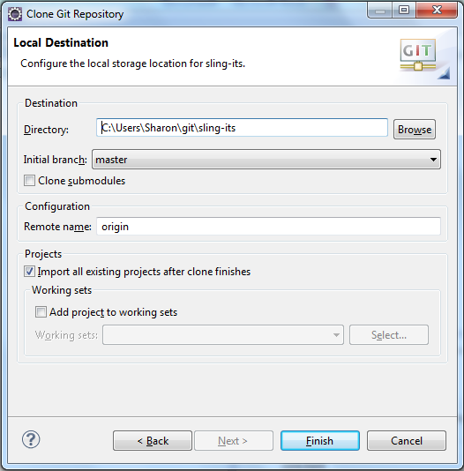

By now, you should have all the code from the Sling ITS project in Eclipse.

10) Go to the Java EE perspective.



11) Go to the Project Explorer and right click on the sling-its project. Go down to Run As and select “2 Maven Build…”

12) Fill in “Goals” field with “clean install”. Go to Add (Adding parameters will need to be done three times). Put in the following parameters and values.

Name: sling.url

Value: http://localhost:8080

Name: sling.user

Value: admin

Name: sling.password

Value: admin.

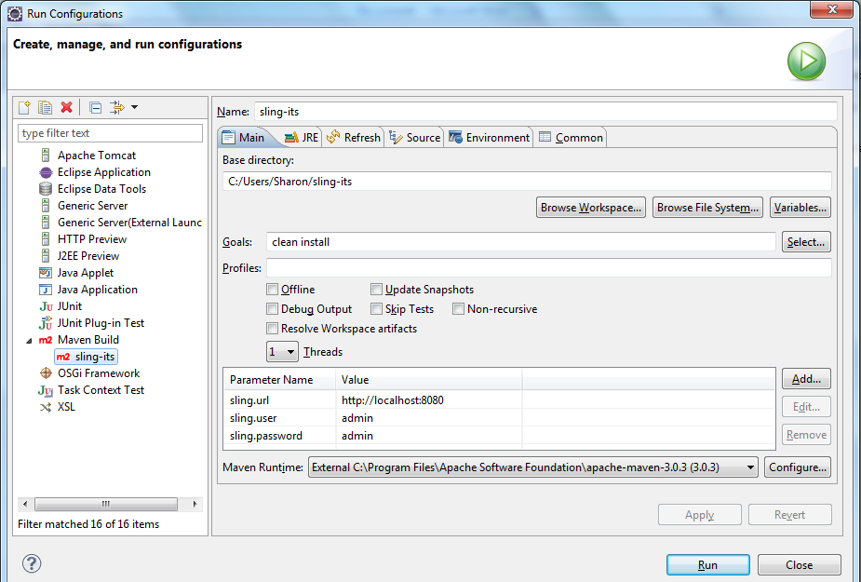

13) Click Run.

14) Congratulations! The code has been deployed to your local instance of Sling. To verify, go to <http://localhost:8080/system/console/bundles> (Username and password should be admin) and scroll down until you see the newly deployed bundle.

