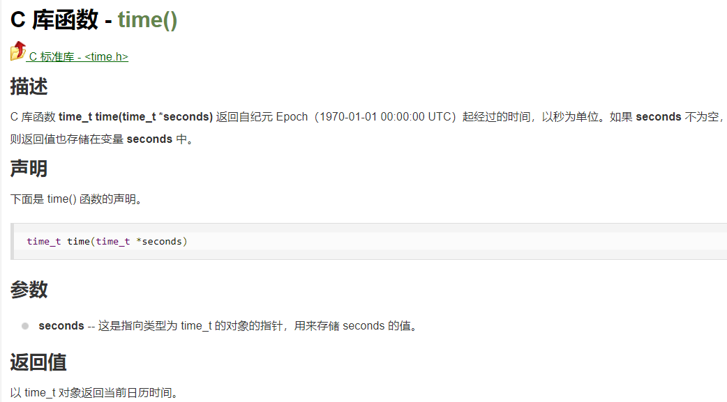

#include <stdio.h>

#include <time.h>

int main ()

{

time_t seconds;

seconds = time(NULL);

printf("自 1970-01-01 起的小时数 = %ld\n", seconds/3600);

return(0);

}

