**Transport Module**

* The commuter should be able to pay fare using his biometric for authentication, the fare paid would be deducted from his account balance and a receipt issued showing his balance.
* 通勤者应该能够用他的生物识别身份支付费用，从他的账户余额中扣除支付的费用，以及一张显示他的余额的收据。

**Bank Module**

a)

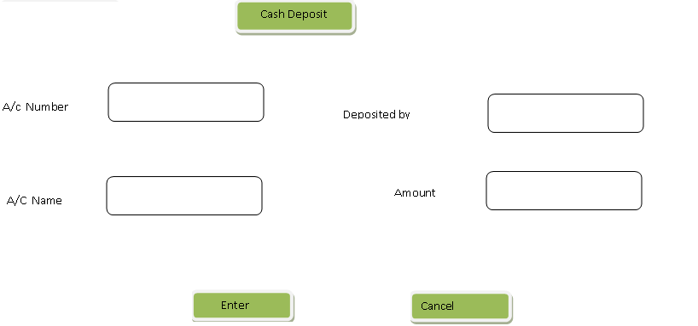

b) Account statement

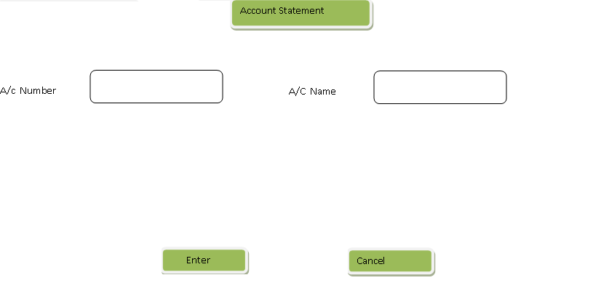

c) During bank customer registration capture two or more fingers.