

User Guide:

Help and documentation

(1.2.7)

Table of contents
- Introduction
- License
- Installation
  - Download
  - Available operating systems
  - Windows distribution
  - MacOS distribution
  - Linux distribution
- Getting Started
- Modules
  - Relation Tables Module
    - RELS CREATOR
  - Basic Modules
    - LEVEL CREATOR
    - LEVEL CALIBRATOR
    - INTEGRATE
    - NORCOMBINE
    - RATIOS
    - SBT
  - Compound Modules
    - WSPP-SBT
    - WSPPG-SBT
    - WPP-SBT
    - WPPG-SBT
  - Report Modules
    - REPORT
    - SANSON
  - Special Parameters
    - Keywords for the Task-Tables
    - Multiple samples
    - Asterisk is our jack of all trades
    - More params
    - Filter (for REPORT and SANSON)
- Sample Workflows with Application to Case Studies
  - Workflow 1: One-step quantification in a labeled experiment
  - Workflow 2: Step-by-step quantification and sample combination in a labeled experiment
  - Workflow 3: Quantification of posttranslationally modified peptides in a labeled experiment
  - Workflow 4: Label-free quantification
- Executing a workflow template
- Creating the identification/quantification file from proteomics pipelines
  - Preparing the ID-q file from Proteome Discoverer output
  - Preparing the ID-q file from MaxQuant output
  - Preparing the ID-q file from Trans-Proteomic Pipeline output
  - Preparing the ID-q file from FragPipe output
- Adapting the results from proteomics pipelines for iSanXoT
- References

Introduction
iSanXoT is a standalone application for statistical analysis of mass spectrometry-based quantitative proteomics data. iSanXoT builds upon SanXoT [1], our previous publicly available implementation of the weighted spectrum, peptide, and protein (WSPP) statistical model [2] using the Generic Integration Algorithm (GIA) [3].
iSanXoT executes several kind of workflows for quantitative high-throughput proteomics, systems biology and the statistical analysis, integration and comparison of experiments.
iSanXoT was developed by the Cardiovascular Proteomics Lab/Proteomic Unit at The National Centre for Cardiovascular Research (CNIC, https://www.cnic.es).

Download
The multiple releases are available in the "release" section, located in the following link:
https://github.com/CNIC-Proteomics/iSanXoT/releases

Installation

Available operating systems
iSanXoT maintains the following operating systems and architectures and may add additional ones in the future:
Windows 10 Pro (x64)
MacOs High Sierra (10.13.6)
Ubuntu 20.04 (x64)
For more details, read the “Installation” section in the iSanXoT wiki:
https://github.com/CNIC-Proteomics/iSanXoT/wiki/Installation

Getting Started
This chapter describes iSanXoT’s graphical user interface and how to set up an analysis with iSanXoT.
For more details, read the “Getting Started” section in the iSanXoT wiki:
https://github.com/CNIC-Proteomics/iSanXoT/wiki/Getting_started

Modules
The iSanXoT desktop application houses a number of modules based on the SanXoT software package [1]. The information required to setup and execute every module is provided in a task-table.
There are four types of modules:
- Relation tables is a module that creates the relation tables used by the iSanXoT modules.
- The Basic modules call the individual scripts included in the SanXoT software package [1].
- The Compound modules perform a sequence of consecutive integrations based on the weighted spectrum, peptide and protein (WSPP) statistical model [2] and the systems-biology triangle (SBT) algorithm [3].
- Finally, there are two Reports: REPORT generates report files displaying the quantitative results produced by the above Basic and Composite modules when a workflow is executed; SANSON generates a similarity graph showing relationships between functional categories on the basis of the protein elements they share.
For more details, read the “Modules” section in the iSanXoT wiki:
https://github.com/CNIC-Proteomics/iSanXoT/wiki/Modules

Input Adaptor
The iSanXoT Input Adaptor offers users the possibility to either provide their own Identification/Quantification file, which contains the identification and quantification data, or have the Input Adaptor prepare this file from the results obtained using any of the mainstream proteomics pipelines.
For further details, read the “Input Adaptor” section in the iSanXoT wiki:
https://github.com/CNIC-Proteomics/iSanXoT/wiki/Input_adaptor

Sample Workflows
We describe in detail four sample workflows that illustrate the capacity of iSanXoT to statistically ascertain abundance changes in both multiplexed, isotopically labeled [3-5] and label-free [6] proteomics experiments.
- Workflow 1: One-step quantification in a labeled experiment ()
- Workflow 2: Step-by-step quantification and sample combination in a labeled experiment.
- Workflow 3: Quantification of posttranslationally modified peptides in a labeled experiment.
- Workflow 4: Label-free quantification.
For further details, read each section in the iSanXoT wiki.

More Documents
User Guide (v1.2.7):
https://github.com/CNIC-Proteomics/iSanXoT/wiki/docs/user_guides/User_Guide_iSanXoT-1.2.7.pdf
Presentations:
- WSPP demo:
https://github.com/CNIC-Proteomics/iSanXoT/wiki/docs/presentations/WSPP_Demo_iSanXoT_1.0.X.pdf
- Input Adaptor demo:
https://github.com/CNIC-Proteomics/iSanXoT/wiki/docs/presentations/Input_Adaptor_iSanXoT_1.0.X.pdf

License
This application is licensed under a Creative Commons Attribution-NonCommercial-NoDerivs 4.0 Unported License.
https://creativecommons.org/licenses/by-nc-nd/4.0/

You are free to:
Share - copy and redistribute the material in any medium or format.
The licensor cannot revoke these freedoms as long as you follow the license terms.

Under the following terms
https://github.com/CNIC-Proteomics/iSanXoT/wiki/License

Installation

Download
The multiple releases are available in the "release" section, located in the following link:
https://github.com/CNIC-Proteomics/iSanXoT/releases

Available operating systems
iSanXoT maintains the following operating systems and architectures and may add additional ones in the future:
- Windows 10 Pro (x64)
- MacOs High Sierra (10.13.6)
- Ubuntu 20.04 (x64)

Windows distribution
The iSanXoT Windows distribution is packaged in a NSIS Launcher (exe file).
Download the exe Launcher: iSanXoT_Launcher_1.X.X.win32-x64.exe
Double-click the Launcher file; the Installer window will show up:
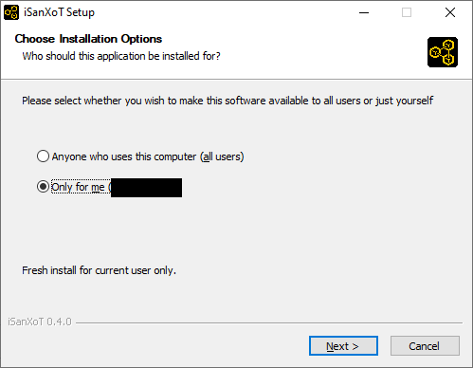
WARNING: Windows Defender SmartScreen might show a prompt suggesting that you cancel the installation; in such case click “More info” and then select the “Run anyway” option.
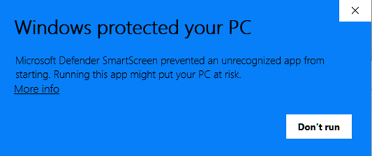
Then, you can choose the iSanXoT installation folder:
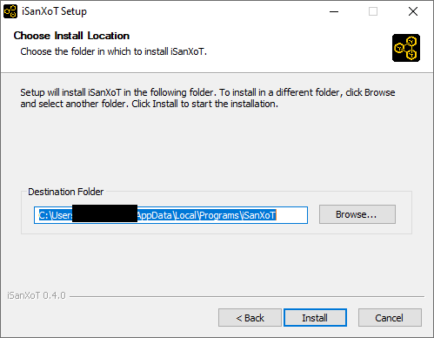
Wait while iSanXoT is being installed.
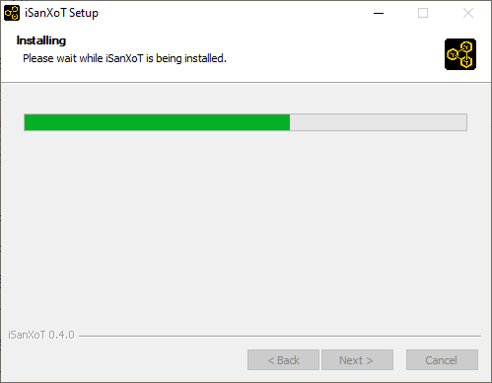
Once the installation has been completed, you are ready to run.
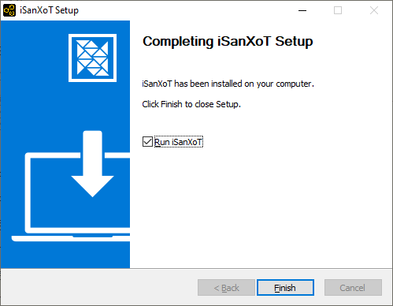

MacOS distribution
The iSanXoT MacOS distribution is packaged in a DMG container.
Download the DMG file: iSanXoT_Launcher_1.X.X.darwin-x64.dmg
Double-click the DMG file, then a Finder window will show up. This window will usually display iSanXoT’s installer icon and a shortcut to the Applications folder, together with some sort of linking arrow:
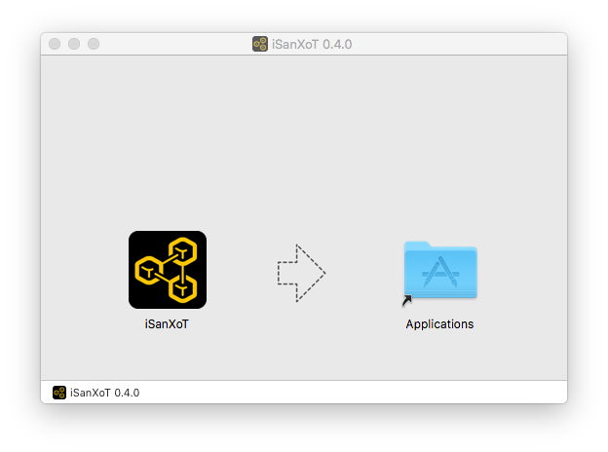
Simply drag the iSanXoT icon to your Applications folder...
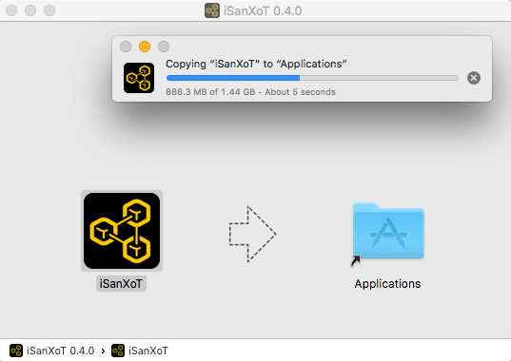
and you're done: the iSanXoT application is now installed.

Linux distribution
The iSanXoT Linux distribution is packaged in an AppImage.
Download the AppImage: iSanXoT_Launcher_1.X.X.linux-x86_64.AppImage
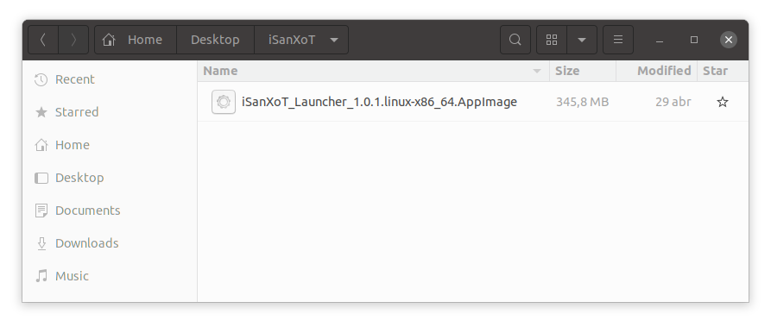
The AppImage file is just the application's compressed image. When executed, the application is mounted in a temporal folder. However, for the correct behaviour, the application has to be extracted to the "squashfs-root" folder in the current working directory using:
./iSanXoT_Launcher_1.X.X.linux-x86_64.AppImage --appimage-extract

Then, launch the iSanXoT application using:

squashfs-root/AppRun

Getting Started

This chapter describes iSanXoT’s graphical user interface and how to set up an analysis with iSanXoT.

Opening the iSanXoT application
To open the iSanXoT application:
- In Windows: from the Start menu choose Programs > iSanXoT; or double-click the iSanXoT desktop icon.
- In MacOS: double-click the iSanXoT icon from the Applications folder.
- In Linux: from the AppImage file.
The contents are extracted to the "squashfs-root" directory in the current working directory using:
./iSanXoT_Launcher_1.x.linux-x86_64.AppImage --appimage-extract
Now you can launch the iSanXoT application:
squashfs-root/AppRun [...]

Installing required packages
The first time iSanXoT is run a window will show up displaying a progress bar to inform you about the percentage of packages that have been installed. These packages contain the libraries required by iSanXoT’s backend, and are installed the first time you open the application.
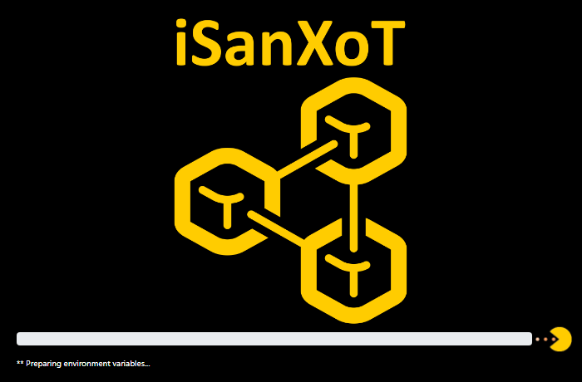
Figure 1. Installation window.

Closing the iSanXoT application
WARNING: If valid changes were made to your project, make sure to save it before quitting iSanXoT, as any changes will be lost otherwise (you won’t be prompted for saving upon closing).
To close the iSanXoT application:
In Windows and Linux: choose Project > Exit, or click the X in the upper right corner of the main iSanXoT window.
In Mac: choose iSanXoT (menu) > Exit, or click the red X in the upper left corner of the main iSanXoT window.
A dialog window will show up asking you to confirm the application closing. Click “Yes” if you really want to quit iSanXoT.

iSanXoT Projects
An iSanXoT project is primarily a container used to structure the data coming from your input file(s) and your workflow. The input file contains the identification and quantification data (for further details see the Input Adaptor Section). These fully-customisable workflows can perform quantitative proteomics analysis, systems biology analysis, and comparison and merging of experimental data from technical or biological replicates.
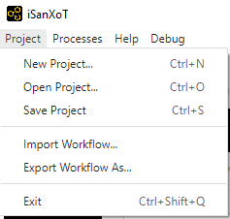
Figure 2. Project menu.

Creating a new project
Creating a project is the first step when conducting an analysis with iSanXoT. By selecting Project > New Project a window will show up where you can provide a name for the project as well as select a project folder where iSanXoT output files will be stored.
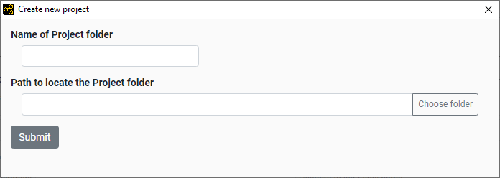
Figure 3. Window that creates a new project.

Opening a project
By selecting Project > Open Project as a folder selection dialog box shows up that allows the user to indicate the location of an already existing project folder to be opened by iSanXoT.

iSanXoT Main Window
The iSanXoT main window consists of an overhead menu, adaptor and module tabs, and content and execution panels (Figure 4).

Menu
The Menu contains the following items:
- Project: Allows operations related to projects and workflows.
- Processes: Links to real-time display of the processes currently in execution by iSanXoT (see Running Processes Section).
- Help: Houses the different Sections of iSanXoT help.

Content tabs
- Five tabs are displayed in iSanXoT’s project page. The Input tab displays the Project folder, where iSanXoT output files are stored, as well as the Identification file used in the project (see Input Adaptor Section). The remaining four tabs give access to iSanXoT modules: Relation Tables, Basic Modules, Compound Modules, and Report Modules.
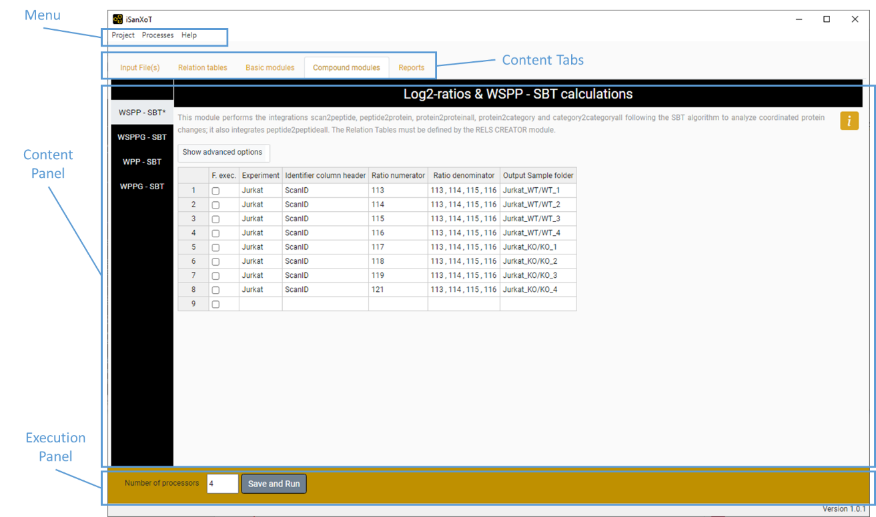
Figure 4. Main View of iSanXoT.

Content panel
This panel houses the elements of the Input and Modules tabs, which can be accessed through the sidebar menu showing on the left side of the panel. A title and a brief description of the Input/Module element is provided, as well as help icon linking to additional information on the specific Input element or Module selected.

Execution panel
The execution panel, located on the bottom of the main window, allows the user to indicate the number of processors to be used by iSanXoT, 4 by default. The Start button launches the execution of the workflow shaped by the Input elements and Modules.

Importing and Exporting Workflows
A project is shaped by a workflow that instructs iSanXoT how to process the data provided by the input file(s). While the whole project, including workflow and data, can be saved as indicated below (see the Saving a project section), there is a way to import and export just the workflow structure using iSanXoT menu (Figure 2).

Import Workflow
This option allows to import the task-tables of a workflow. For that, you have to provide the folder where the workflow is saved.

Export Workflow
The export workflow saves the task-tables of a workflow in the folder indicated by the user.

Executing a Project
Once your project contains all the necessary input data and workflow elements, you can execute the workflow by clicking “Save and Run” in the “Execution panel” after indicating the number of processors to be allocated for iSanXoT (see Execution panel above).
Bear in mind that every time you click the “Save and Run” button to execute a workflow, the project is first validated for consistency and saved. To save a project without executing it, you must use the appropriate menu item as explained in the next Section.

Saving a project
The Project > Save Project option saves your project, which contains the input data and the workflow elements, to the “Project folder”. The project files are saved in the “.isanxot” folder. WARNING: Do not manipulate or delete the information stored in the “.isanxot” folder; you risk losing your project.
Whenever iSanXoT is prompted to save a project, the corresponding workflow is first validated for consistency and won’t be saved when failed. Neither will the workflow execute if it has not been validated previously.
As well as the “.isanxot” folder, the following folders are necessary to shape your project:
- Exps, to store the files created by the Input Data adapters.
- Jobs, to store the sample folders of your workflow.
- Rels, to store the Relation Tables created by the RELS CREATOR module (see below).
- Reports, to store the Report files created by the REPORT module (see below).
- Stats, to store statistical data.
- Logs, to store the workflow execution log files.

Running Processes
When workflow execution successfully starts, a new window shows up displaying information about the processes currently running:
- The Project logs table shows project execution status. Several project executions can be monitored here, and the user must click a row to have the corresponding workflow logs displayed (see below).
- Workflow logs table displays status for the jobs set up in the workflow modules. If you click on a row you will see the trace log of the involved jobs (unless the job status is “cached”).
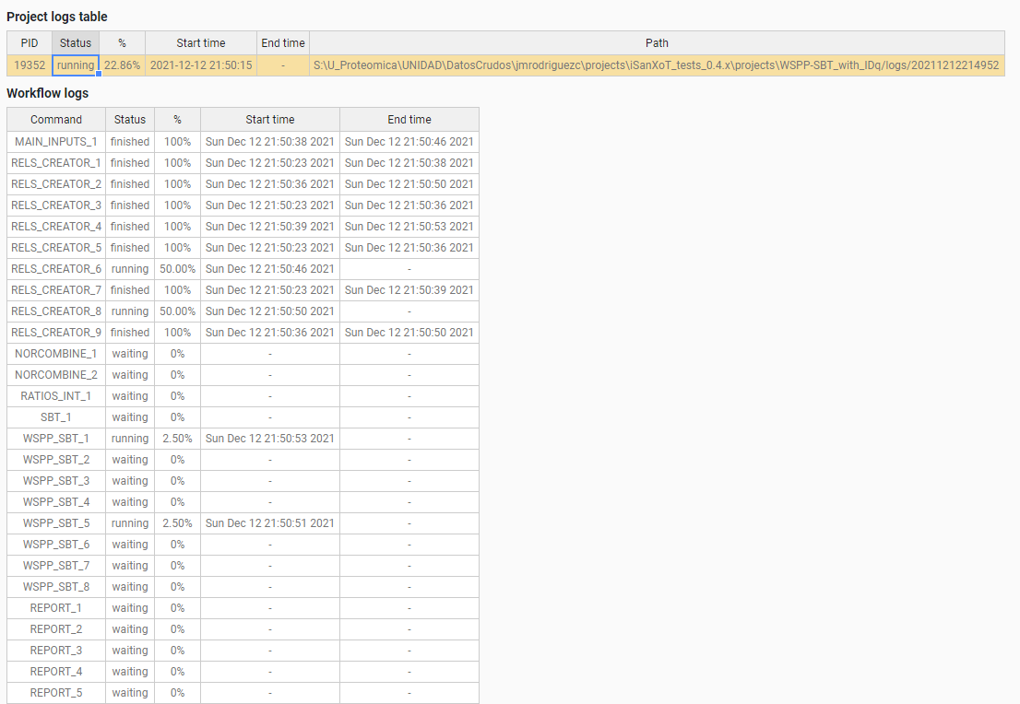
Figure 5. View of running processes.
The running processes window can be also reached from the menu by selecting the “Processes > Main page” option.

Modules
The iSanXoT desktop application houses a number of modules based on the SanXoT software package [1]. The information required to setup and execute every module is provided in a task-table.
There are four types of modules:
- Relation tables is a module that creates the relation tables used by the iSanXoT modules.
- The Basic modules call the individual scripts included in the SanXoT software package [1].
- The Compound modules perform a sequence of consecutive integrations based on the weighted spectrum, peptide and protein (WSPP) statistical model [2] and the systems-biology triangle (SBT) algorithm [3].
- Finally, there are two Reports: REPORT generates report files displaying the quantitative results produced by the above Basic and Composite modules when a workflow is executed; SANSON generates a similarity graph showing relationships between functional categories on the basis of the protein elements they share.

Relation tables module

RELS CREATOR
This module generates relation tables (RT) from tab-separated values (TSV) files. Relation tables, which are TSV files relating lower level identifiers (e.g. peptides) to the corresponding higher level elements (e.g. proteins), are required for module execution. For this reason, the naming convention for the file indicated under “Relation Table to be created” in the RELS CREATOR task table is lower level + “2” + higher level; e.g. whether an integration is from the “peptide” level to the “protein” level, a relation table called “peptide2protein” will be necessary.
The fields showing in the RELS CREATOR task table are (Figure 6):
- Forced execution: This checkbox field indicates whether to force the execution or not.
- Relation Table to be created specifies relation table filenames. As commented above, the naming convention for these files is lower level + “2” + higher level; e.g. whether an integration is from the “peptide” level to the “protein” level, a relation table called “peptide2protein” will be necessary.
- Column name of Lower level is the column header that designates which elements from the indicated file (see below) will be taken as lower level elements in the resulting relation table.
- Column name of Higher level is the column header that designates which elements from the indicated file (see below) will be taken as higher level elements in the resulting relation table.
- Column name of 3rd column is the column header that designates which elements from the indicated file (see below) will be taken as third column elements in the resulting relation table.
- Table from which RT is extracted is the full path name for the TSV file to be used to build the relation tables. If the cell is empty, the Input file (ID-q.tsv) is applied for iSanXoT workflow.
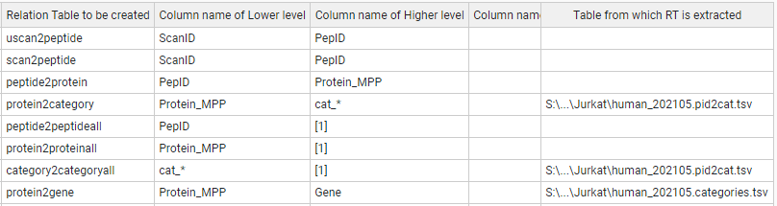
Figure 6. A sample Task-Table in the example of RELS CREATOR module.

Basic modules

LEVEL CREATOR
This module creates levels, which are TSV files containing identifiers, log₂-ratio values and statistical weight values. The data are extracted from the Identification/Quantification file (see Input Adaptor section).
The following fields are displayed in the LEVEL CREATOR task table (Figure 7):
- Forced execution: This checkbox field indicates whether to force the execution or not.
- Experiment is the column header that designates which elements from the Identification file will be used to create the level indicated.
- Identifier column header is the identification file column header that unambiguously identifies the scans.
- Ratio numerator column specifies which column header from the identification file designates the quantitative values to be used as a numerator for the log₂-ratio calculation.
- Ratio denominator column(s) specifies which column header from the identification file designates the quantitative values to be used as a denominator for the log₂-ratio calculation.
- Level to be created designates the level name.
- Output Sample folder indicates the name of the folder where the level data file will be saved.
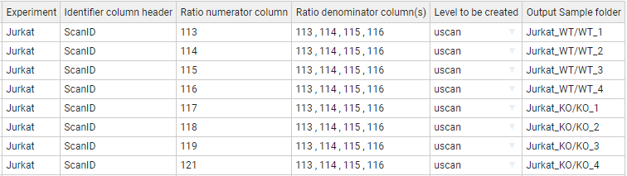
Figure 7. A sample task-table in the LEVEL CREATOR module.

LEVEL CALIBRATOR
This module calibrates the above-described levels using the “Klibrate” program included in the SanXoT software package [1]. To perform the calibration, two parameters (weight constant and variance) are iteratively calculated using the Levenberg-Marquardt algorithm (for more details see the information about “Klibrate” in the SanXoT software package [1]).
The output calibrated level contains new statistic weight values for the identifier and log₂-ratio elements displayed in the uncalibrated level data file. This is necessary for the levels to be used as inputs to the INTEGRATE module.

Standard parameters
The fields to be completed in this module are (Figure 8):
- Forced execution: This checkbox field indicates whether to force the execution or not.
- Sample folder(s) indicates the name(s) of the folder(s) containing the uncalibrated data file(s) that were previously generated by the LEVEL CREATOR module.
- Lower level for integration indicates which lower level elements are to be used in the integration carried out for the calibration.
- Higher level for integration indicates which higher level elements are to be used in the integration carried out for the calibration.
- Name of calibrated level is the name for the output data file containing the new, calibrated statistical weight values.
- Output Sample folder specifies the name of the folder where the output data file containing the new, calibrated statistical weight values will be saved. If the cell is empty, the output sample folder is the given “Sample folder” (second column).
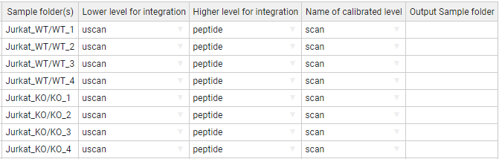
Figure 8. A sample task table in the LEVEL CALIBRATOR module.

Advanced parameters
The LEVEL_CALIBRATOR module accepts the following additional parameters (Figure 9):
To perform the calibration two parameters, have to be calculated: the k (weight constant), and the variance.
- K-constant sets a forced value for the k-constant. Using this parameter, the introduced value is forced as K-constant.
- Var(x) sets a forced value for the variance. Using this parameter, the introduced value is forced as the variance.
- More params allows adding more parameters to the internal programs of the module. For more details see More params in the “Special Parameters” Section.
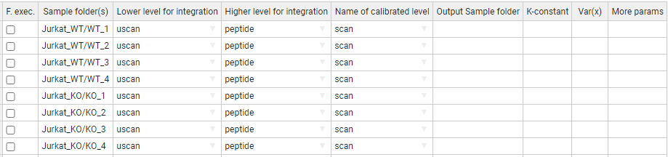
Figure 9. A task-table displaying advanced parameters for the LEVEL CALIBRATOR module.

INTEGRATE
The INTEGRATE module performs statistical calculations based on the WSPP model by iteratively applying the generic integration algorithm (GIA) [3] on calibrated data files (Figure 10).
Integrations are carried out from lower level data to higher level data (e.g. from the peptide level to the protein level and from the protein level to the gene level).
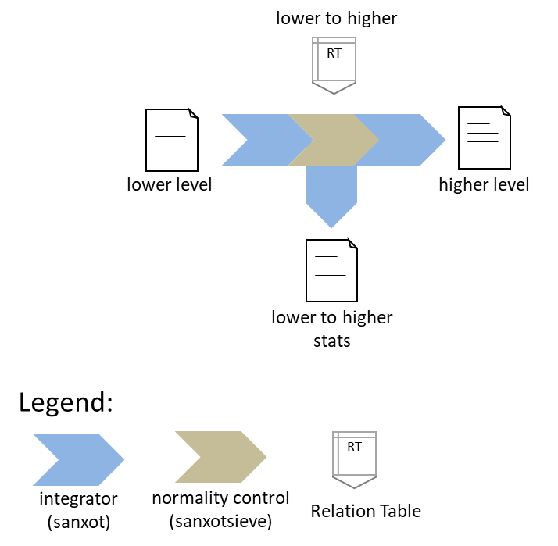
Figure 10. Schematic representation of the INTEGRATE module. The integration is carried out from any lower level to any higher level using the programs “SanXoT” and “SanXoTSieve” and the generic integration algorithm (GIA).

More in detail, the INTEGRATE module needs two TSV files as inputs:
- A data file containing three data columns: identifier (a text string that is used to unambiguously identify the low level elements), quantitative value (log₂-ratio of the two measurements to be compared) and statistical weight (a parameter that measures the accuracy of the quantitative value).
- A relation table, which links the lower level identifiers to those in the higher level. This file contains two columns: higher level identifiers on the left and lower level identifiers on the right.
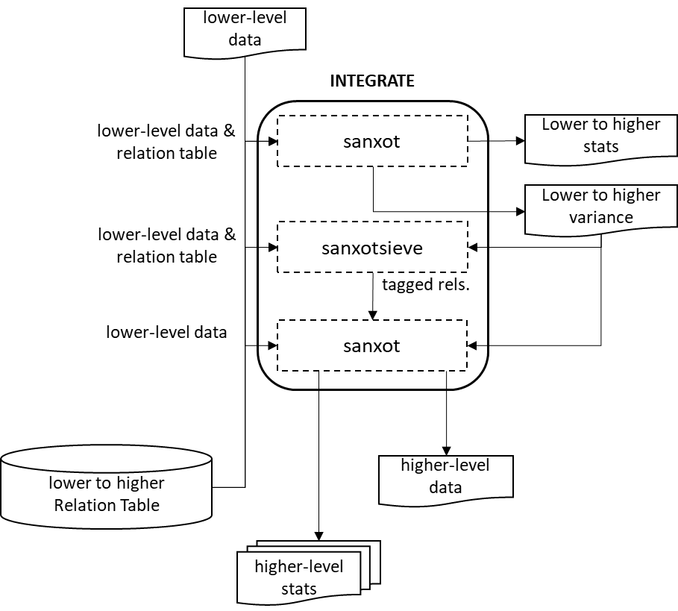
Figure 11. The INTEGRATE module flowchart. A first integration is done with “SanXoT” that calculates the variance; then “SanXoTSieve” removes outliers tagging them in a new relation table; finally, a second integration is done with “SanXoT” using the variance calculated.

For every integration, the SanXoT program calculates the general variance using a robust iterative method. Then SanXoTSieve is used to tag outlier elements [2] by assessing the probability that a lower level element be a significant outlier of the standardized (i.e. N(0,1)) log₂-ratio distribution. The most extreme outliers are thus removed sequentially and the integration repeated until all outliers below a user-defined false discovery rate (FDR) threshold have been removed. Finally, a second integration is carried out by SanXoT using the variance calculated in the first integration and discarding the outliers tagged in the new relation table (Figure 11).
The output data files generated by INTEGRATE contain the quantitative data for the higher level and can be used as inputs to other modules; in addition, each integration generates several additional files which contain information about the integration. For further details see SanXoT documentation [1].

Standard parameters
The parameters to be provided in the INTEGRATE module task table are (Figure 12):
- Forced execution: This checkbox field indicates whether to force the execution or not.
- Sample folder(s) indicates the names of the folder(s) where the lower level data file is located.
- Lower level indicates the name of the lower level data file to be used. This file contains three data columns: identifier, quantitative value and statistical weight.
- Higher level indicates the name of the higher level to which the lower level elements will be integrated.
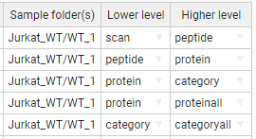
Figure 12. A sample task-table in the INTEGRATE module.

Advanced parameters
The INTEGRATE module accepts the following additional parameters (Figure 13):
- Output Sample folder is the name of the folder where the level data and statistics are saved.
- Tag is a text label that indicates which elements from the lower level are integrated into the higher level. The tags must be specified in the third column of the corresponding Relation Table. This allows the user to discard elements for integration without needing to eliminate them from the Relation Table. Thus, if the label “marked” is used as a Tag, only the lower level elements containing the label marked in the third column of the lower_level2higher_level Relation Table will be integrated. Logical operators can also be used in the Tag field to make complex decisions.

Tag is a parameter to distinguish groups to perform the integration. For instance, if the user specifies “marked” the elements containing the label “marked” in the third column of the “lower_level2higher_level” Relation Table will be included in (or discarded from) the integration.
The tag can be used by inclusion, such as "mod" or by exclusion, putting first the "!" symbol, such as "!mod". Tags should be included in a third column of the relations file.

Different tags can be combined using logical operators "and" (&), "or" (|), and "not" (!), and parentheses. Some examples:
!out&mod
!out&(dig0|dig1)
(!dig0&!dig1)|mod1
mod1|mod2|mod3

Warning: Unless specified otherwise by the user, by default iSanXoT eliminates outliers from the lower level according to an FDR<1% threshold.
iSanXoT automatically adds the tag “out” in the third column of the relation table to label outliers, so that they are not integrated. It is not thus recommended to use this tag for other purposes.

Note that although the discarded elements will not be included in calculations, the parameter Z will be calculated and tabulated in the corresponding output (outStats) file.

For further details see SanXoT wiki
(https://www.cnic.es/wiki/proteomica/index.php/SanXoT_software_package).

- FDR is an FDR threshold other than the default value (0.01, i.e. 1%) for outlier removal. If “0” is specified as the FDR value, then no outliers will be discarded.
- Var(x) sets a fixed value for the variance. The default value (blank) means that the variance will be iteratively calculated based on the Levenberg-Marquardt algorithm in the first Lower level-to-Higher level integration.
- More params allows adding more parameters to the internal programs of the module. For more details see More params in the “Special Parameters” Section.
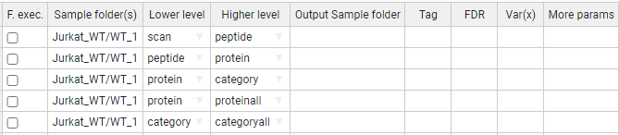
Figure 13. A sample task-table displaying advanced parameters for the INTEGRATE module.

NORCOMBINE
The NORCOMBINE module combines technical or biological replicates (Figure 14). For example, NORCOMBINE can be used to merge the protein level data from 4 individual patients and 4 individual controls into a patient- and a control level protein dataset, respectively.
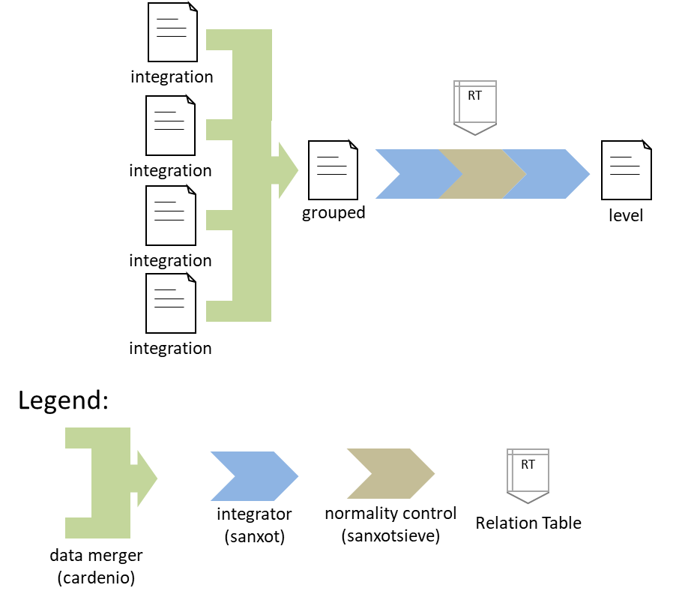
Figure 14. Schematic representation of the NORCOMBINE module used to combine technical or biological replicates.

Experiment merging relies on the “Cardenio” program from the SanXoT software package [1], which is used to generate merged data files and relation tables that are later integrated to the grouped level using “SanXoT” and “SanXoTSieve” (Figure 14).

NORCOMBINE requires the user to specify which lowerNorm files contain the necessary data for the samples to be combined. These lowerNorm files, previously generated by the INTEGRATE module, display the lower level identifiers on the left, followed by the corresponding centred log₂-ratio values (i.e. the values obtained after subtracting the high level value) in the second column, and either the integration statistical weight (in the case of lowerNormV) or the variance (for lowerNormW). The SanXoT program “Cardenio” [1] is then used to generate merged data files and relation tables that are later integrated to the grouped level using “SanXoT” and “SanXoTSieve” (Figure 15).
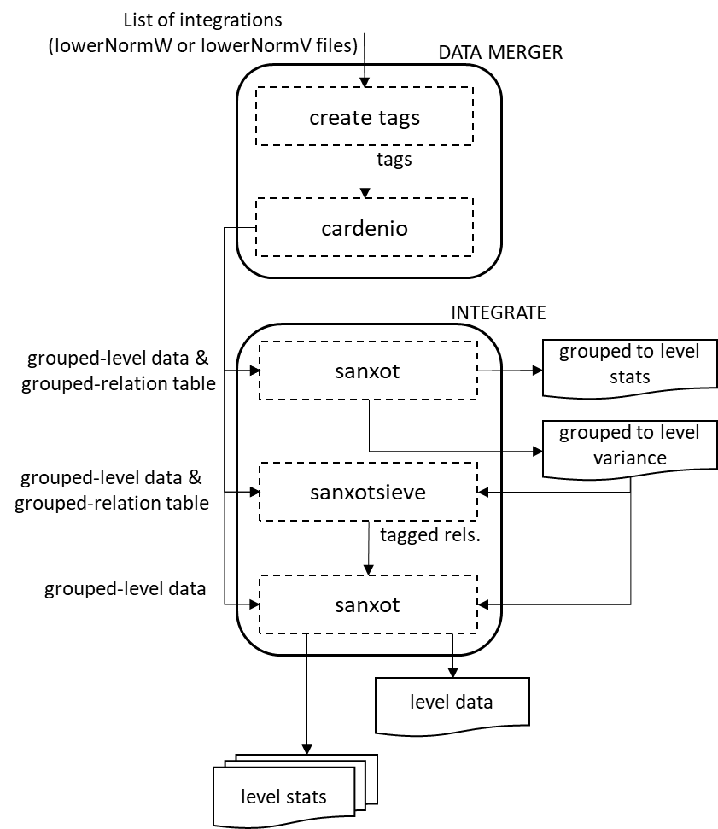
Figure 15. The NORCOMBINE module flowchart.

Standard parameters
The default NORCOMBINE module task table shows the following fields (Figure 16):
- Forced execution: This checkbox field indicates whether to force the execution or not.
- Sample folders indicates the names of the folder(s) containing the lower level data (samples) to be combined.
- Level indicates the type of elements to be combined (e.g. peptides or proteins).
- Norm specifies the normalization scheme to be used in the integrations.
- lowerNorm specifies the type of lowerNorm file (see above) to be used.
- Output Sample folder is the name of the folder where the grouped level data and statistics are saved.
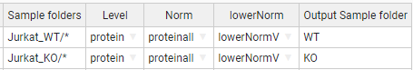
Figure 16. A sample task-table in the NORCOMBINE module. In this case, the asterisk wildcard has been used to select multiple sample folders.

Advanced parameters
The NORCOMBINE module accepts the following additional parameters (Figure 17):
- Tag is a text label that indicates which elements from the lower level are integrated into the higher level. The tags must be specified in the third column of the corresponding Relation Table. This allows the user to discard elements for integration without needing to eliminate them from the Relation Table. Thus, if the label “marked” is used as a Tag, only the lower level elements containing the label marked in the third column of the lower_level2higher_level Relation table will be integrated. Logical operators can also be used in the Tag field to make complex decisions.
By default, iSanXoT eliminates outliers from the lower level according to an FDR<1% threshold.
For further details, read the Advanced Parameters for the INTEGRATE module.
- FDR is an FDR threshold other than the default value (0.01, i.e. 1%) for outlier removal. If “0” is specified as the FDR value, then no outliers will be discarded.
- Var(x) sets a fixed value for the variance. The default value (blank) means that the variance will be iteratively calculated based on the Levenberg-Marquardt algorithm.
- More params allows adding more parameters to the internal programs of the module. For more details see More params in the “Special Parameters” Section.
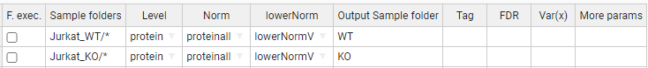
Figure 17. A sample task table with advanced parameters in the NORCOMBINE module.

RATIOS
This module prepares the data file and relation table required as a first step in the calculation of a ratio defined by the user (e.g KO vs WT). For that, the new log₂-ratio is calculated as the difference between numerator and denominator values, whereas the corresponding statistical weight is assessed according to the method indicated by the user in the V Method filed of the RATIOS task table (Figure 18 and Figure 19):
- max uses the maximum value between the numerator and denominator statistical weight value.
- form uses the value resulting from 1/(1/Vn + 1/Vd), where Vn and Vd are the statistical weight value for the numerator and the denominator, respectively.
- avg uses the average value between the numerator and denominator statistical weight value.
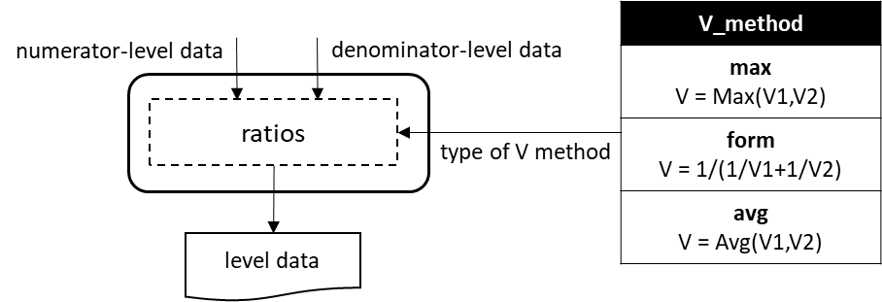
Figure 18. The RATIOS module flowchart.

The RATIOS module task table displays the following parameter fields (Figure 19):
- Forced execution: This checkbox field indicates whether to force the execution or not.
- Ratio numerator column specifies the name of the folder containing the quantitative value to be used as a numerator for the new log₂-ratio calculation.
- Ratio denominator column(s) specifies the name of the folder(s) containing the quantitative values to be used as a denominator for the new log₂-ratio calculation. The sample folders have to be separated by comma.
- Level designates the level (i.e. peptide, protein, gene or category) at which the ratio is to be calculated.
- Output Sample folder indicates the name of the folder where the resulting log₂-ratio and statistical weight values will be saved (e.g. KO_vs_WT).
Figure 19. A sample task-table in the RATIOS module.

SBT
This module is based on the Systems Biology Triangle (SBT) algorithm [3], which performs an integration between the lower and the higher levels using the variance previously obtained in an integration between the lower and an intermediate level (Figure 20). Usually the SBT module is applied to carry out the protein-to-grand mean integration using the variance associated with the protein-to-category integration.

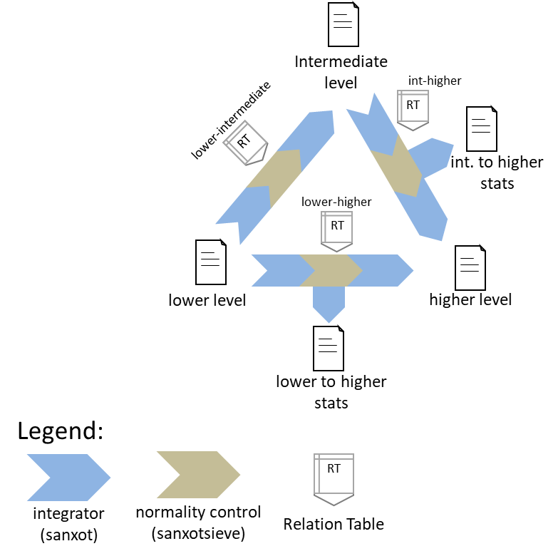
Figure 20. Schematic representation of the SBT module.

Standard parameters
The standard parameters to be entered in the SBT module task table are (Figure 21):
- Forced execution: This checkbox field indicates whether to force the execution or not.
- Sample folder(s) indicates the name of the folder(s) where the lower level data are located.
- Lower level indicates the name of the lower level (e.g. protein).
- Intermediate level indicates the name of the intermediate level (e.g. category).
By default, the higher level is the grand mean of the lower level elements.
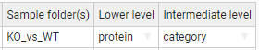
Figure 21. A sample task table in the SBT module.

Advanced parameters
This module accepts the following additional parameters (Figure 22):
- Output Sample folder indicates an alternative folder to store the resulting log₂-ratio and statistical weight values other than “Sample folder(s)”.
- Lower-Higher level and Int(ermediate)-Higher level specify an alternative higher level other than the grand mean of the lower level elements.
- Low(er)-to-Int(ermediate) Tag and Int(ermediate)-to-Hig(her) are the text label that indicates which elements from the lower level are integrated into the intermediate level, and the intermediate level are integrated into higher level. The tags must be specified in the third column of the corresponding Relation Table. This allows the user to discard elements for integration without needing to eliminate them from the Relation Table. Thus, if the label “marked” is used as a Tag, only the lower level elements containing the label marked in the third column of the lower_level2intermediate_level and intermediate_level2higher_level Relation Tables will be integrated. Logical operators can also be used in the Tag field to make complex decisions.
By default, iSanXoT eliminates outliers from the lower level according to an FDR<1% threshold.
For further details, read the Advanced Parameters for the INTEGRATE module.
- Low(er)-to-Int(ermediate) FDR and Int(ermediate)-to-Hig(her) FDR determine an FDR threshold other than the default value (0.01, i.e. 1%) for outlier removal in the lower level-to-intermediate level and intermediate level-to-higher level integration, respectively. If “0” is specified as the FDR value, then no outliers will be discarded.
- Low(er)-to-Int(ermediate) Var(x) and Int(ermediate)-to-Hig(her) Var(x) indicate the variance to be used in the lower level-to-intermediate level and intermediate level-to-higher level integration, respectively, as an alternative to the variance calculated in the lower level-to-intermediate level integration.
- More params allows adding more parameters to the internal programs of the module. For more details see More params in the “Special Parameters” Section.
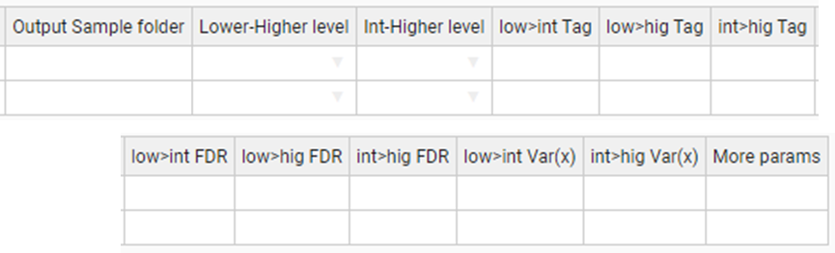
Figure 22. A sample task table with advanced parameters in the SBT module.

Compound modules

The Compound modules perform a sequence of consecutive integrations based on the WSPP statistical model [2] and the SBT algorithm [3]. In addition, each module creates the initial level and calibrate this initial level. The WSPP-SBT and WSPPG-SBT modules create and calibrate the “scan” level; and the WPP-SBT and WPPG-SBT create and calibrate the “peptide” level.

WSPP-SBT
The WSPP-SBT module performs the following integrations: scan-to-peptide, peptide-to-protein, protein-to-category, protein-to-proteinall, and category-to-categoryall. In addition, the SBT algorithm is used to calculate the variance associated to the protein-to-category integration, which is applied to the protein-to-proteinall integration.

Standard parameters
The standard parameters required by the WSPP-SBT module are (Figure 23):
- Forced execution: This checkbox field indicates whether to force the execution or not.
- Experiment is the column header that designates which elements from the Identification file will be used in the starting scan-to-peptide integration.
- Identifier column header is the identification file column header that unambiguously identifies the scans.
- Ratio numerator specifies which identification file column header designates the quantitative values to be used as a numerator for the log₂-ratio calculation.
- Ratio denominator specifies which identification file column header designates the quantitative values to be used as a denominator for the log₂-ratio calculation.
- Output Sample folder: indicates the name of the folder where the resulting data files will be saved.
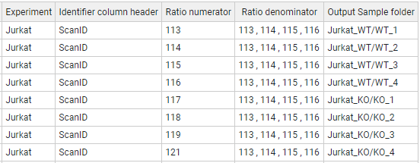
Figure 23. A sample task table in the WSPP-SBT, WSPPG-SBT, WPP-SBT, and WPPG-SBT modules.

Advanced parameters
The WSPP-SBT module accepts the following advanced parameters (Figure 24):
- p>q Tag, p>a Tag, c>a Tag are the text label that indicates which elements from the lower level (“p” and “c”) are integrated into the higher level (“q” and “a”). The tags must be specified in the third column of the corresponding Relation Table. This allows the user to discard elements for integration without needing to eliminate them from the Relation Table. Thus, if the label “marked” is used as a Tag, only the lower level elements containing the label marked in the third column of the lower_level2higher_level Relation table will be integrated. Logical operators can also be used in the Tag field to make complex decisions.
By default, iSanXoT eliminates outliers from the lower level according to an FDR<1% threshold.
For further details, read the Advanced Parameters for the INTEGRATE module.
- s>p FDR, p>q FDR, q>c FDR establish an FDR threshold other than 0.01 (1%) for outlier removal in the integrations scan-to-peptide, peptide-to-protein, and protein-to-category, respectively. If FDR = 0 is selected, then the outliers are not discarded.
- s>p Var(x), p>q Var(x), q>c Var(x) set a fixed value for the variance in the integrations scan-to-peptide, peptide-to-protein, and protein-to-category, respectively. By default, the variance will be iteratively calculated based on the Levenberg-Marquardt algorithm in the first lower level-to-higher level integration (Figure 10).
- More params allows adding more parameters to the internal programs of the module. For more details see More params in the “Special Parameters” Section.
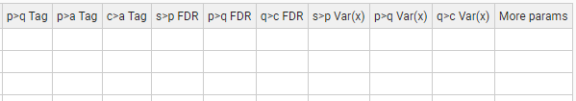
Figure 24. Task-Table with advanced parameters in the WSPP-SBT module.

WSPPG-SBT
The WSPPG-SBT module performs the following integrations: scan-to-peptide, peptide-to-protein, protein-to-gene, gene-to-category, gene-to-geneall, and category-to-categoryall. In addition, the SBT algorithm is used to calculate the variance associated to the gen-to-category integration, which is applied to the gen-to-geneall integration.

Standard parameters
The standard parameters required by the WSPPG-SBT module are (Figure 23):
- Forced execution: This checkbox field indicates whether to force the execution or not.
- Experiment is the column header that designates which elements from the Identification file will be used in the starting scan-to-peptide integration.
- Identifier column header is the identification file column header that unambiguously identifies the scans.
- Ratio numerator specifies which identification file column header designates the quantitative values to be used as a numerator for the log₂-ratio calculation.
- Ratio denominator specifies which identification file column header designates the quantitative values to be used as a denominator for the log₂-ratio calculation.
- Output Sample folder: indicates the name of the folder where the resulting data files will be saved.

Advanced parameters
The WSPPG-SBT module accepts the following advanced parameters (Figure 25):
- p>q Tag, q>g Tag, p>a Tag, c>a Tag are the text label that indicates which elements from the lower level (“p”, “q” and “c”) are integrated into the higher level (“q”, “g” and “a”). The tags must be specified in the third column of the corresponding Relation Table. This allows the user to discard elements for integration without needing to eliminate them from the Relation Table. Thus, if the label “marked” is used as a Tag, only the lower level elements containing the label marked in the third column of the lower_level2higher_level Relation table will be integrated. Logical operators can also be used in the Tag field to make complex decisions.
By default, iSanXoT eliminates outliers from the lower level according to an FDR<1% threshold.
For further details, read the Advanced Parameters for the INTEGRATE module.
- s>p FDR, p>q FDR, q>g FDR, g>c FDR establish an FDR threshold other than 0.01 (1%) for outlier removal in the following integrations: scan-to-peptide, peptide-to-protein, protein-to-gene, and gene-to-category, respectively. If FDR = 0 is selected, then the outliers are not discarded.
- s>p Var(x), p>q Var(x), q>g Var(x), g>c Var(x) set a fixed value for the variance in the integrations: scan-to-peptide, peptide-to-protein, protein-to-gene, and gene-to-category, respectively. By default, the variance will be iteratively calculated based on the Levenberg-Marquardt algorithm in the first lower level-to-higher level integration (Figure 10).
- More params allows adding more parameters to the internal programs of the module. For more details see More params in the “Special Parameters” Section.
Figure 25. Task-table with advanced parameters in the WSPPG-SBT module.

WPP-SBT
The WPP-SBT module performs the integrations peptide-to-protein, protein-to-category, protein-to-proteinall and category-to-categoryall. In addition, the SBT algorithm is used to calculate the variance associated to the protein-to-category integration, which is applied to the protein-to-proteinall integration.

Standard parameters
The standard parameters required by the WPP-SBT module are (Figure 23):
- Forced execution: This checkbox field indicates whether to force the execution or not.
- Experiment is the column header that designates which elements from the Identification file will be used in the starting scan-to-peptide integration.
- Identifier column header is the identification file column header that unambiguously identifies the scans.
- Ratio numerator specifies which identification file column header designates the quantitative values to be used as a numerator for the log₂-ratio calculation.
- Ratio denominator specifies which identification file column header designates the quantitative values to be used as a denominator for the log₂-ratio calculation.
- Output Sample folder: indicates the name of the folder where the resulting data files will be saved.

Advanced parameters
The WPP-SBT module accepts the following advanced parameters (Figure 26):
- p>q Tag, p>a Tag, c>a Tag are the text label that indicates which elements from the lower level (“p” and “c”) are integrated into the higher level (“q” and “a”). The tags must be specified in the third column of the corresponding Relation Table. This allows the user to discard elements for integration without needing to eliminate them from the Relation Table. Thus, if the label “marked” is used as a Tag, only the lower level elements containing the label marked in the third column of the lower_level2higher_level Relation Table will be integrated. Logical operators can also be used in the Tag field to make complex decisions.
By default, iSanXoT eliminates outliers from the lower level according to an FDR<1% threshold.
For further details, read the Advanced Parameters for the INTEGRATE module.
- p>q FDR, q>c FDR establish an FDR threshold other than 0.01 (1%) for outlier removal in the peptide-to-protein and protein-to-category integrations, respectively. If FDR = 0 is selected, then the outliers are not discarded.
- p>q Var(x), q>c Var(x) set a fixed value for the variance in the peptide-to-protein and protein-to-category integrations, respectively. By default, the variance will be iteratively calculated based on the Levenberg-Marquardt algorithm in the first lower level-to-higher level integration (Figure 10).
- More params allows adding more parameters to the internal programs of the module. For more details see More params in the “Special Parameters” Section.
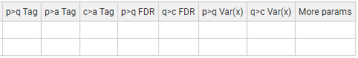
Figure 26. Task-table with advanced parameters in the WPP-SBT module.

WPPG-SBT
The WPPG-SBT module performs the integrations peptide-to-protein, protein-to-gene, gene-to-category, gene-to-geneall, and category-to-categoryall. In addition, the SBT algorithm is used to calculate the variance associated to the gene-to-category integration, which is applied to the gene-to-geneall integration.

Standard parameters
The standard parameters required by the WPPG-SBT module are (Figure 23):
- Forced execution: This checkbox field indicates whether to force the execution or not.
- Experiment is the column header that designates which elements from the Identification file will be used in the starting scan-to-peptide integration.
- Identifier column header is the identification file column header that unambiguously identifies the scans.
- Ratio numerator specifies which identification file column header designates the quantitative values to be used as a numerator for the log₂-ratio calculation.
- Ratio denominator specifies which identification file column header designates the quantitative values to be used as a denominator for the log₂-ratio calculation.
- Output Sample folder: indicates the name of the folder where the resulting data files will be saved.

Advanced parameters
The WPPG-SBT module accepts the following advanced parameters (Figure 27):
- p>q Tag, q>g Tag, p>a Tag, q>a Tag, c>a Tag are the text label that indicates which elements from the lower level (“p”, “q” and “c”) are integrated into the higher level (“q”, “g” and “a”). The tags must be specified in the third column of the corresponding Relation Table. This allows the user to discard elements for integration without needing to eliminate them from the Relation Table. Thus, if the label “marked” is used as a Tag, only the lower level elements containing the label marked in the third column of the lower_level2higher_level Relation table will be integrated. Logical operators can also be used in the Tag field to make complex decisions.
By default, iSanXoT eliminates outliers from the lower level according to an FDR<1% threshold.
For further details, read the Advanced Parameters for the INTEGRATE module.
- p>q FDR, q>g FDR, g>c FDR establish an FDR threshold other than 0.01 (1%) for outlier removal in the integrations peptide-to-protein, protein-to-gene, and gene-to-category, respectively. If FDR = 0 is selected, then the outliers are not discarded.
- p>q Var(x), q>g Var(x), g>c Var(x) set a fixed value for the variance in the integrations peptide-to-protein, protein-to-gene, and gene-to-category, respectively. By default, the variance will be iteratively calculated based on the Levenberg-Marquardt algorithm in the first lower level-to-higher level integration (Figure 10).
- More params allows adding more parameters to the internal programs of the module. For more details see More params in the “Special Parameters” Section.
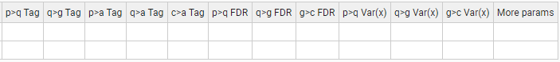
Figure 27. Task-table with advanced parameters in the WPPG-SBT module.

Reports modules

REPORT
The REPORT module allows the collection of the statistical variables (n, tags, Xinf, Vinf, Xsup, Vsup, Z, and FDR) from the different integrations performed into result tables.

Standard parameters
The standard parameters showing in the REPORT task table are (Figure 28):
- Forced execution: This checkbox field indicates whether to force the execution or not.
- Sample folder(s) indicates the name(s) of the folder(s) where the values of the statistical variables to be retrieved are located.
- Lower level indicates the starting level (i.e. peptide, protein, or category) for the integration whose statistical variables are to be reported.
- Higher level indicates the ending level for the integration whose statistical variables are to be reported.
- Reported vars specifies which statistical variables will be reported. The available variables are n, tags, Xinf, Vinf, Xsup, Vsup, Z, FDR, X’inf and Winf.
- Output report is the report filename (without extension).
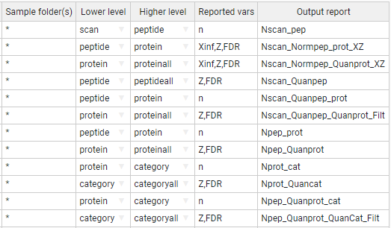
Figure 28. A sample task table in the REPORT module.

For instance, the first row of the task table shown in Figure 28 prompts the REPORT module to read the variable “n” from the scan2peptide_outStats.tsv file that contains the statistical outcome from the scan-to-peptide integration (the asterisk wildcard character in Sample folder(s) causes REPORT to retrieve the “n” variable from every sample). These “n” values are written to a report file named “Nscan_pep” that is stored in the project “reports” folder.
The second row instructs the module to read the variables “Xinf”, “Z” and “FDR” from the statistical outcome of the peptide-to-protein integration (once again for every sample). These values are written to a report file named “Nscan_Normpep_prot_XZ”.

Advanced parameters
The REPORT module accepts the following advanced parameters (Figure 29):
- Level names to show allows the user to restrict the elements to be written to the Output report to those from the Lower level or the Higher level. Both levels are used by default.
- Merge with report designates the file whose Reported vars will be incorporated into the Output report after intersection with the latter file.
- Add columns from relation table appends Lower level elements, extracted from the relation table designated, to the Output report. It is possible to indicate multiple relation tables separated by a comma.
- Filter allows to filter the data to be transferred to the Output report based on the Reported vars (n, Z, FDR, etc.). For more details, see Filter in the “Special Parameters” Section.
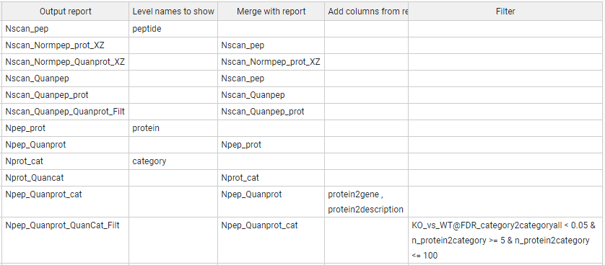
Figure 29. A sample task-table with advanced parameters in the REPORT module.

The reports indicated under Output report and Merge with report are merged according to the column header that they share. Thus, the REPORT task table shown in Figure 30 will cause the module to incorporate the number of scans per peptide, displayed in the report “Nscan_pep”, to the report “Nscan_Normpep_prot_XZ”, as these two reports share the lower level elements showing under the “peptide” header.
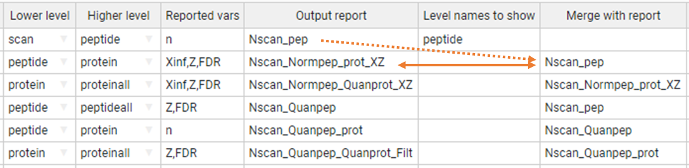
Figure 30. Report merging in the REPORT module. The first task table row creates a report file (“Nscan_pep”) with the (n)umber of scans per peptide. The second row creates a report file called “Nscan_Normpep_prot_XZ” that contains, apart from the variables “Xinf”, “Z”, and “FDR” coming from the peptide-to-protein integration, the (n)umber of scans per peptide previously stored in the “Nscan_pep” report, as these two reports share the lower level elements showing under the “peptide” header.

In addition, it is possible to incorporate additional data from one or more relation tables into the reports (Figure 31). When a given Relation Table is indicated under Add columns from relation table, the REPORT module will first attempt to incorporate to the Output report (“Npep_Quanprot_cat” in the example) the elements related to the Lower level (“protein” in this case) elements in the relation table. If the Lower level elements are missing in the relation table, then REPORT will try to incorporate the elements related to the Higher level (“category” in this case) instead. If neither the Lower level nor the Higher level can be found in the relation table, then no action is performed.
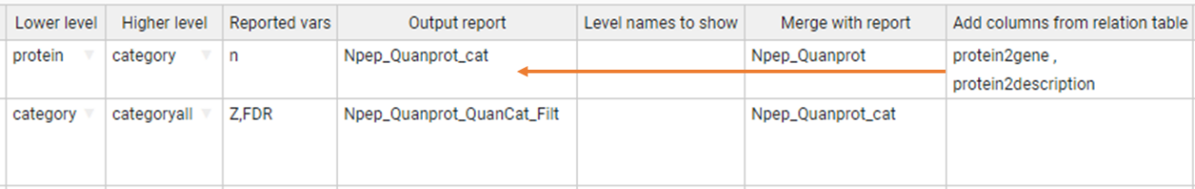
Figure 31. Adding data from relation tables into the report files. The relation table “protein2gene” contains a column with protein identifiers under the “protein” header and another column with the corresponding gene name under the “gene” header, whereas the relation table “protein2description” contains, apart from the “protein” elements, a column with the corresponding protein description. The first task table row will prompt REPORT to incorporate the gene names and protein descriptions contained in the relation tables to the report file “Npep_Quanprot_cat” report file, as “protein” is the Lower level they all three shares.

Finally, the report data can be filtered performing logical operations with the Reported vars in the Filter field. For instance, in the report task table displayed in Figure 32:
- n_protein2category <= 100, filters out from the report the variables Z and FDR for the category-to-categoryall integration when the (n)umber of proteins per category is greater than 100.
- n_protein2category >= 5 & n_protein2category <= 100 retrieves the variables Z and FDR for the category-to-categoryall integration when the (n)umber of proteins per category is in the [5, 100] range.
- KO_vs_WT@FDR_category2categoryall < 0.05, retrieves the variables Z and FDR for the category-to-categoryall integration provided that the FDR corresponding to the “KO_vs_WT” samples is less than 0.05.
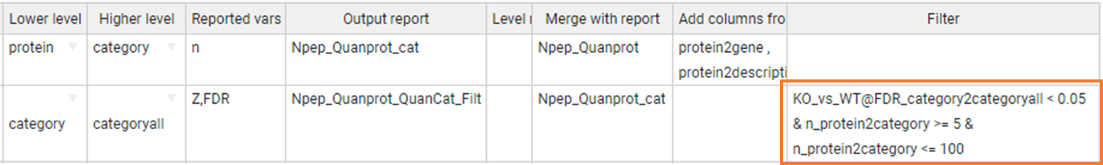
Figure 32. Filtering the report data.

The compound variables shown in the Filter field on Figure 32 follow the structure Reported var_integration, like “n_protein2category”. Such filter applies to all samples.
However, the filter “KO_vs_WT@FDR_category2categoryall” is applied based on the variable “FDR” from the category-to-categoryall integration, but only to the “KO_vs_WT” sample. Moreover, the filter “WT1,WT2@FDR_category2categoryall” is applied to the “WT1” and “WT2” samples.

SANSON
The SANSON module generates a similarity graph showing the relationship between functional categories based on their protein components.

Standard parameters
The standard parameters to be provided for this module are (Figure 33):
- Forced execution: This checkbox field indicates whether to force the execution or not.
- Sample folder(s) indicates the names of the folder(s) where the lower level data file is located.
- Lower level indicates the name of the lower level elements (“protein” in this case) to be used.
- Higher level indicates the name of the higher level (“category” in this case) to which the lower level elements will be integrated.
- Output Sample folder designates a folder other than Sample folder(s) where the results will be saved.
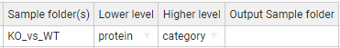
Figure 33. A sample task table in the SANSON module.

Advanced parameters
The SANSON module accepts the following additional parameters (Figure 34):
- Lower norm specifies the normalization scheme to be used with the lower level elements. The default value is included the normalization of lower level to all.
- Higher norm specifies the normalization scheme to be used with the higher level elements. The default value is included the normalization of higher level to all.
- Tag is a text label that indicates which elements from the lower level are integrated into the higher level. The tags must be specified in the third column of the corresponding Relation Table. This allows the user to discard elements for integration without needing to eliminate them from the Relation Table. Thus, if the label “marked” is used as a Tag, only the lower level elements containing the label marked in the third column of the lower_level2higher_level Relation table will be integrated. Logical operators can also be used in the Tag field to make complex decisions.
By default, iSanXoT eliminates outliers from the lower level according to an FDR<1% threshold.
For further details, read the Advanced Parameters for the INTEGRATE module.
- Filter allows to filter the data based on the FDR and number of proteins. For more details, see Filter in the “Special Parameters” Section.
Figure 34. A sample task-table with advanced parameters in the SANSON module.

Special parameters

Multiple samples
The “Sample folder(s)” field of the different module task tables admit multiple samples. For instance, let's consider the samples created with the following LEVEL CREATOR task table:
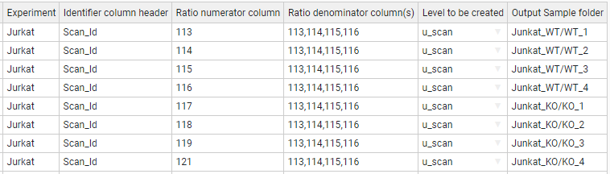
We can include multiple samples separated by a comma, for example, in the INTEGRATE module task table:
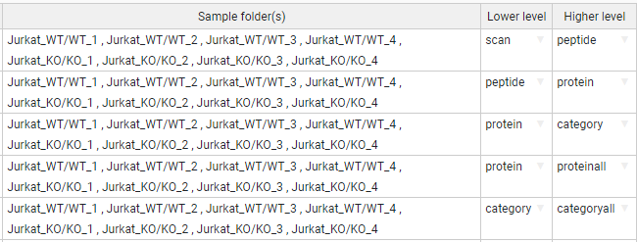

Asterisk is our jack of all trades
The module task tables admit the usage of the asterisk symbol as a wildcard character. Let’s once more consider the samples created with the following LEVEL CREATOR task table:
Each row calculates a ratio that is saved to the corresponding Output Sample folder. Thus, the ratio of 113 to the mean of 113, 114, 115, and 116 is saved to the “Jurkat_WT/WT_1” folder; the 114 to the mean of 113, 114, 115 ratios is saved to “Jurkat_WT/WT_2”, and so on. One way to create the task table of the INTEGRATE module could be the following, where each row represents an integration for a given sample:
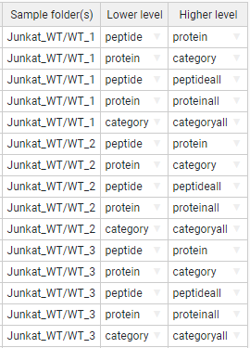
However, this task table can be simplified applying the asterisk wildcard. For instance, the task-table below allows to indicate multiple sample folders, namely every folder starting with “Jurkat_WT/” or “Jurkat_KO/”.
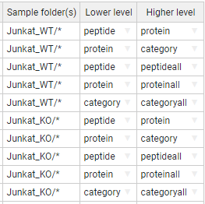
We can reduce this expression even more using just an asterisk: the first row of the following task table performs the integrations peptide-to-protein, protein-to-category, peptide-to-peptideall, protein-to-proteinall, and category-to-categoryall in every sample folder defined with LEVEL CREATOR.
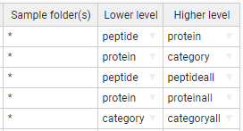

Multiple samples in the inputs and outputs
In the cases we have multiple input samples separated by comma but we want to save the results in another output sample folder, we indicate them in the same way giving the output folders separated by comma. It is required to provide the same number of folders:
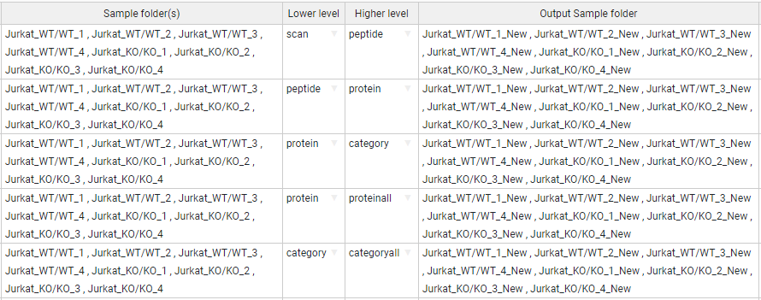
In the same way happens with the asterisk character (jack of all trades). In the “Output Sample folder(s)” we can add a suffix in the input samples. The following task-table illustrate that the output sample folders would be contain the “_New” suffix:
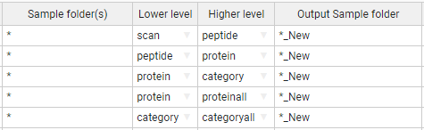
In addition, we can rename the subfolder adding the new name in the “Output Sample folder(s)” or add a new subfolder:
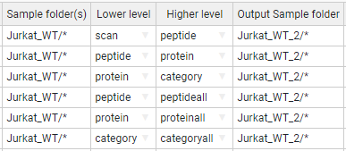

More params
Some modules accept a column parameter in the Task-Table called “More params”. This column allows you to provide advanced parameters for the SanXoT programs [1]. The program descriptions are in the following wiki link:
https://www.cnic.es/wiki/proteomica/index.php/SanXoT_software_package

The iSanXoT module are composed by several programs of SanXoT. For this reason, the “More params” of a module accepts the advanced parameters of composed programs indicated by a name.
For example,
INTEGRATE:
"sanxot1": " -m 300 -g ", "sanxot2": "-s --sweepdecimals=2.5"
In above example the first “sanxot” program that compose the INTEGRATE module, receives the “-m 300 -g” as parameter, and the second “sanxot” receives also the parameter "-s --sweepdecimals=2.5".
WSPP-SBT:
"p2q_sanxot2": " -m 100 -s ", "q2a_sanxot1": "-m 100"
In this example, the WSPP-SBT module has multiple integrations: scan-to-peptide, peptide-to-protein, etc. For more information, see the WSPP-SBT section. Thus, the second “sanxot” program of peptide-to-protein (q) integration will receive the parameter “-m 100 -s”, and then, the first “sanxot” of protein (q)-to-proteinall (a) integration will receive the “-m 100”.

The program names for each Module
INTEGRATE: sanxot1, sanxotsieve, sanxot2
NORCOMBINE: create_exp_tags, cardenio, sanxot1, sanxotsieve, sanxot2
SBT: l2i_sanxot1, l2i_sanxotsieve, l2i_sanxot2, i2h_sanxot1, i2h_sanxotsieve, i2h_sanxot2, l2h_sanxot1, l2h_sanxotsieve, l2h_sanxot2
WSPP_SBT: level_creator, klibrate, s2p_sanxot1, s2p_sanxotsieve, s2p_sanxot2, p2q_sanxot1, p2q_sanxotsieve, p2q_sanxot2, q2c_sanxot1, q2c_sanxotsieve, q2c_sanxot2, p2a_sanxot1, p2a_sanxotsieve, p2a_sanxot2, q2a_sanxot1, q2a_sanxotsieve, q2a_sanxot2, c2a_sanxot1, c2a_sanxotsieve, c2a_sanxot2
WSPPG_SBT: level_creator, klibrate, s2p_sanxot1, s2p_sanxotsieve, s2p_sanxot2, p2q_sanxot1, p2q_sanxotsieve, p2q_sanxot2, p2g_sanxot1, p2g_sanxotsieve, p2g_sanxot2, q2g_sanxot1, q2g_sanxotsieve, q2g_sanxot2, g2c_sanxot1, g2c_sanxotsieve, g2c_sanxot2, p2a_sanxot1, p2a_sanxotsieve, p2a_sanxot2, q2a_sanxot1, q2a_sanxotsieve, q2a_sanxot2, g2a_sanxot1, g2a_sanxotsieve, g2a_sanxot2, c2a_sanxot1, c2a_sanxotsieve, c2a_sanxot2
WPP_SBT: level_creator, klibrate, p2q_sanxot1, p2q_sanxotsieve, p2q_sanxot2, q2c_sanxot1, q2c_sanxotsieve, q2c_sanxot2, p2a_sanxot1, p2a_sanxotsieve, p2a_sanxot2, q2a_sanxot1, q2a_sanxotsieve, q2a_sanxot2, c2a_sanxot1, c2a_sanxotsieve, c2a_sanxot2
WPPG_SBT: level_creator, klibrate, p2q_sanxot1, p2q_sanxotsieve, p2q_sanxot2, p2g_sanxot1, p2g_sanxotsieve, p2g_sanxot2, q2g_sanxot1, q2g_sanxotsieve, q2g_sanxot2, g2c_sanxot1, g2c_sanxotsieve, g2c_sanxot2, p2a_sanxot1, p2a_sanxotsieve, p2a_sanxot2, q2a_sanxot1, q2a_sanxotsieve, q2a_sanxot2, g2a_sanxot1, g2a_sanxotsieve, g2a_sanxot2, c2a_sanxot1, c2a_sanxotsieve, c2a_sanxot2

Filter (for REPORT and SANSON)
The REPORT module and SANSON module accept a Filter parameter. This parameter filters the data based on some variables depending on the module.
In the case of REPORT module, the filtered variables are the Reported vars: n, Z, FDR, etc. For instance:
FDR_category2category < 0.05) & (n_protein2category >=5) & (n_protein2category <= 100)
For the SANSON module, the filtered variables are FDR and the related number (n_rel). For example:
([FDR] < 0.05) & ([n_rel] >= 10) & ([n_rel] <= 100)
Different variables can be combined using the comparisons: >=, <=, !=, <>, ==, >, <; and using logical operators “and” (&), “or” (||), and “not” (!).

Sample Workflows with Application to Case Studies
We describe below in detail four sample workflows that illustrate the capacity of iSanXoT to statistically ascertain abundance changes in both multiplexed, isotopically labeled [3-5] and label-free [6] proteomics experiments.

Workflow 1: One-step quantification in a labeled experiment

Experimental
The identification and quantification data from García-Marqués et al. [3] were used to illustrate workflow 1 performance. This study characterizes the molecular alterations that take place along time when vascular smooth muscle cells (VSMCs) are treated with angiotensin-II (AngII). Cells were incubated with AngII for 0, 2, 4, 6, 8, and 10 h; after protein extraction and digestion, the resulting peptides were isobarically labelled with iTRAQ 8-plex reagents, mixed appropriately and analyzed by liquid chromatography-tandem mass spectrometry (LC-MS/MS). Protein identification was achieved by database searching against target and decoy sequences using Proteome Discoverer 1.4 (Thermo Fisher Scientific; see Section 3 below to learn how these data are adapted to be used with iSanXoT). The false discovery rate (FDR) for peptide identification was calculated using the refined method [7].

Workflow operation
Workflow 1 is made up of the compound module WSPP-SBT and the basic module REPORT (Figure 35A). The WSPP-SBT performs a sequence of consecutive integrations based on the WSPP statistical model [2] and the SBT algorithm [3].
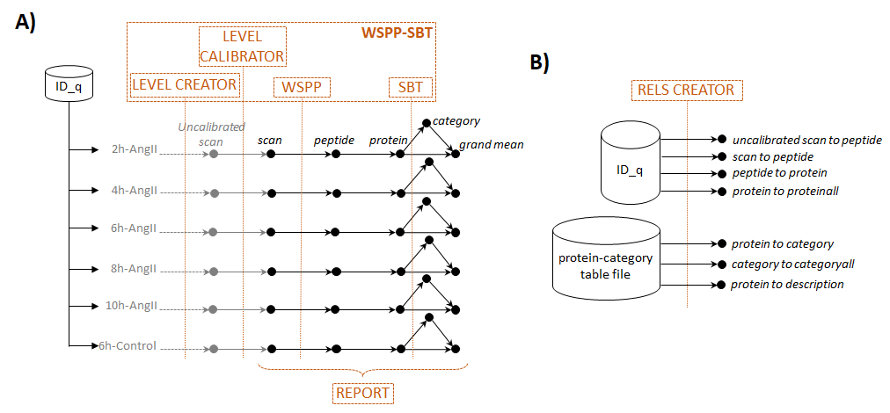
Figure 35. Scheme of workflow 1 (one-step quantification in a labeled experiment) showing module components: WSPP-SBT and REPORT (A) and RELS CREATOR (B).

The WSPP-SBT module starts with the creation of the log2 ratios at the scan (or spectrum) level. These log2 ratios are calculated using the numerator and denominator values indicated in the module task table (Figure 36) and subsequently calibrated to account for the variability associated with LC-MS/MS measurements, after which the scan-to-peptide and peptide-to-protein integrations are carried out.
Figure 36. The WSPP-SBT task table for workflow 1.

Then the SBT (systems biology triangle) algorithm is applied for the detection of functional category changes originated by the coordinated behaviour of proteins (Figure 35A). For that, the algorithm first calculates the variance of the protein-to-category integration, which is then applied to the protein-to-protein grand mean (hereinafter referred to as protein-to-proteinall) integration, and finally performs the category-to-category grand mean (hereinafter referred to as category-to-categoryall) integration. All these integrations created by the WSPP-SBT module are saved in the indicated Output Sample folder.
Every integration step needs a relation table that links lower- to higher-level elements. This text file is created by the RELS CREATOR module (Figure 35B and Figure 37).
Figure 37. The RELS CREATOR task table for workflow 1.

Thus, the peptide2protein relation table (Figure 38A) is a text file linking the peptides identified to the proteins they come from. The elements of the protein2category relation table (Figure 38B) were retrieved from a text file containing functional annotations for mouse proteins gathered from several protein function databases (Figure 37), as described by the authors [3].
Figure 38. Excerpt from the peptide2protein (A) and protein2category (B) relation tables that link peptides to proteins and proteins to categories, respectively.

The REPORT module is used in this workflow to collect the following statistical variables for all samples (2h-AngII, 4h-AngII, 6h-AngII, 6h-Control, 8h-AngII, and10h-AngII), as prompted by the asterisk (Figure 39). The asterisk symbol is used in the task tables as a wildcard character. For further details, consult the iSanXoT wiki (https://github.com/CNIC-Proteomics/iSanXoT/wiki). The simple options used in this workflow are the following:
- Number of peptides per protein (n), obtained from the peptide-to-protein integration;
- Mean-corrected protein log2 ratios expressed in units of standard deviation (Z), calculated from the protein-to-proteinall integration;
- False Discovery Rate (FDR) values indicating which Z values stand out as outliers in the protein-to-proteinall integration.
- Number of proteins per category (n), obtained from the protein-to-category integration;
- Mean-corrected category log2 ratios expressed in units of standard deviation (Z), calculated from the category-to-categoryall integration;
- False Discovery Rate (FDR) values indicating which Z values stand out as outliers in the category-to-categoryall integration.

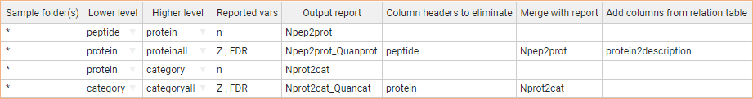
Figure 39. The REPORT task table for workflow 1.

The following advanced options of the REPORT module have been used in this workflow (Figure 39):
- Merge with report designates the report file whose variables will be incorporated into the current report on the basis of their element identifiers. Thus, the Npep2prot_Quanprot report is first populated with the Z values of the protein-to-proteinall integration, and then added the number of peptides per protein coming from the Npep2prot report (Figure 39). This is possible because the protein level is present in both the Npep2prot and Npep2prot_Quanprot reports.
- Column headers to eliminate restricts the elements to be written to the Output reports Npep2prot_Quanprot and Nprot2cat_Quancat to those from the protein and category level, respectively. This prevents data duplication upon merging with the Npep2prot and Nprot2cat reports, as these contain also the peptide and protein level, respectively (Figure 39).
- Add columns from relation table appends a column with the description of the protein to the Npep2prot_Quanprot report. Again, this is possible because the protein level is present in both the Npep2prot_Quanprot report and the protein2description relation table (Figure 39).
Figure 40. Relative abundance of proteins (Zq, Left) and functional categories (Zc, Right) retrieved from the Npep2prot_Quanprot and Nprot2cat_Quancat reports, respectively, generated with the REPORT module of Workflow1 (Figure 39).

As previously shown with SanXoT [2], iSanXoT workflow 1, based on the WSPP-SBT and the REPORT modules, reveals a slight tendency to increased protein abundance over time. In addition, the SBT module reveals that the categories found altered at 4, 8, and 10 h, but not those at 2 h, were essentially the same that were altered at 6 h (Figure 40).

Workflow execution
The workflow template and input files that are needed to execute this workflow can be downloaded from
https://github.com/CNIC-Proteomics/iSanXoT/wiki/studies/cases/templates/WSPP-SBT.zip
See the Executing a workflow template Section below for detailed instructions.

Workflow 2: Step-by-step quantification and sample combination in a labeled experiment

Experimental
We have applied workflow 2 to quantitative data obtained by González-Amor et al. [5] in their study of the contribution of interferon-stimulated gene 15 (ISG15) to vascular damage associated with hypertension. Protein extracts from mouse aortic tissue (16 samples from eight individuals:
two WT-Control, two ISG15-KO, two WT+AngII, and two ISG15-KO+AngII) were trypsin-digested, after which the resulting peptides were isobarically labelled using iTRAQ 8-plex and distributed in two labeled experiments that were analyzed by LC-MS/MS. Protein identification
was achieved by database searching against target and decoy sequences using Proteome Discoverer 2.1 (Thermo Fisher Scientific; see Section 3 below to learn how these data are adapted to be used with iSanXoT). The FDR for peptide identification was calculated using the refined method [7].
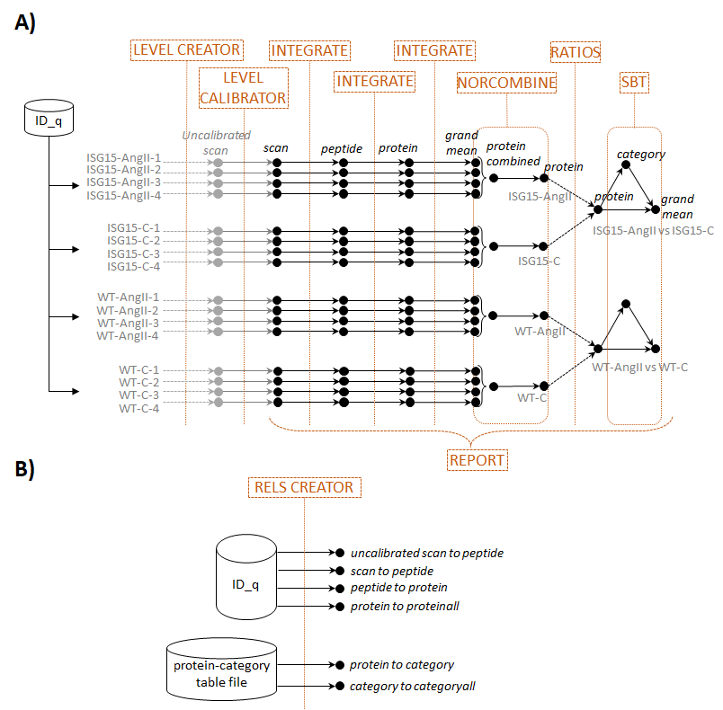
Figure 41. Scheme of workflow 2 (step-by-step quantification and sample combination in a labeled experiment) showing module components: LEVEL CREATOR, LEVEL CALIBRATOR, INTEGRATE, NORCOMBINE, RATIOS, SBT, and REPORT (A) and RELS CREATOR (B).

Workflow operation
Workflow 2 comprises all six basic modules: LEVEL CREATOR, LEVEL CALIBRATOR, INTEGRATE, NORCOMBINE, RATIOS, and SBT plus the REPORT module (Figure 41). The starting module, LEVEL CREATOR, generates the level files, sample folders and log2 ratios indicated in the corresponding task table (Figure 42).
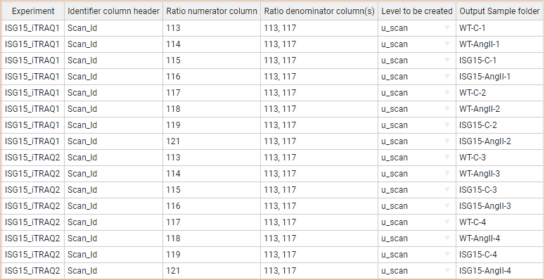
Figure 42. The LEVEL CREATOR task table for workflow 2.

The output level files, u_scan (uncalibrated scan), display element identifiers together with their corresponding log2-ratio and statistical weight values (Figure 43). This uncalibrated weight is the inverse of the variance associated with the log2-ratio, and therefore a higher weight corresponds to a more accurate quantification.
Figure 43. Excerpt from one of the u_scan files generated by workflow 2 LEVEL CREATOR module showing element identifiers (left column), log2 ratios (center column), and statistical weights (right column).

Prior to their integration into a higher level, u_scan levels are calibrated to account for the variability of the LC-MS/MS analysis with the LEVEL CALIBRATOR module, which results in scan calibrated levels with recalculated statistical weights (Figure 44, Top). Then the INTEGRATE module performs the scan-to-peptide, peptide-to-protein and protein-to-proteinall integrations according to the module task table (Figure 44, Bottom). The protein outliers are not discarded in this integration as prompted by the 0 value indicated for the FDR parameter.
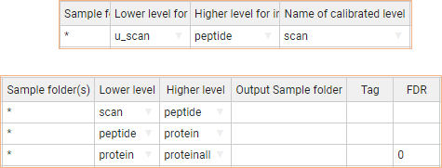
Figure 44 . The LEVEL CALIBRATOR (Top) and INTEGRATE (Bottom) task tables for workflow 2.

Every integration requires a specific relation table linking the corresponding lower- and higher-level elements that is generated by RELS CREATOR (Figure 41B and Figure 45). Thus, the peptide2protein relation table (Figure 45) describes the relationships between the peptide level (i.e. the lower level) and the protein level (i.e. the higher level). Note that the elements of the protein2category relation table were retrieved from a text file containing functional annotations from the Gene Ontology knowledgebase [5].
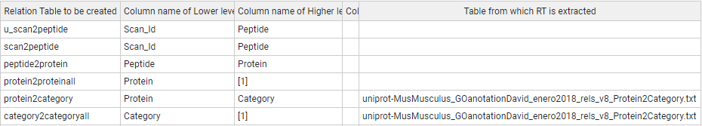
Figure 45. The RELS CREATOR task table for workflow 2.

Next, workflow 2 resorts to the NORCOMBINE basic module (Figure 41A) to combine biological replicates, which results in the four new samples indicated on Figure 46: WT-C, WT-AngII, ISG15-C, and ISG15-AngII. The module task table indicates that samples were combined at the protein level using the proteinall level for normalization. NORCOMBINE also requires the user to specify which lowerNorm files contain the necessary data for the samples to be combined. These lowerNorm files, previously generated by the INTEGRATE module, contain lower-level identifiers along with the corresponding centered log2-ratio values and either the integration statistical weight (in the case of lowerNormV, as chosen in this workflow) or the variance (for lowerNormW) (Figure 46). NORCOMBINE first generates merged data files and relation tables that are later integrated to the above-described four grouped levels.
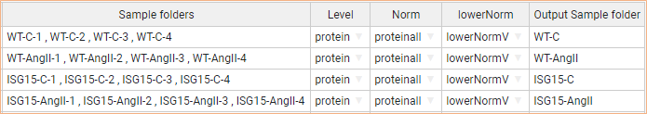
Figure 46. The NORCOMBINE task table for workflow 2.

The four new samples (grouped levels or sample groups) are then used by the RATIOS basic module to calculate two ratios: WT-AngIIvsWT-C, where wild-type AngII-treated animals are compared to controls; and ISG15-AngIIvsISG15-C, where ISG15 AngII-treated animals are compared to controls (Figure 47). The module calculates the new log2 ratios as the difference between Ratio numerator and Ratio denominator values, whereas the corresponding statistical weight is assessed according to the V Method indicated in the task table (max in this case, which means the maximum weight between the samples indicated under Ratio numerator and Ratio denominator. The other two choices are avg, the average of the two weights; and form, 1/(1/V_{n} + 1/V_{d}), where V_{n} and V_{d} are the statistical weight of the samples indicated under Ratio numerator and Ratio denominator, respectively).
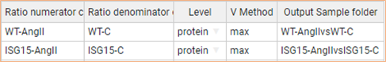
Figure 47. The RATIOS task table for workflow 2.

The last basic module executed in workflow 2, SBT (Figure 48), relies on the systems biology triangle algorithm [3] to perform an integration between the Lower level (protein in this case) and the corresponding grand mean using the variance previously obtained in the integration between the Lower level and an Intermediate level (category in this case, Figure 48). The way it is used here, the SBT module reveals functional category changes originated by the coordinated behaviour of their protein components. The integrations involved, protein-to-category, protein-to-proteinall, and category-to-categoryall, require the relation tables previously generated with RELS CREATOR (Figure 45). As mentioned above, the elements of the protein2category relation table were retrieved from a text file containing functional annotations from the Gene Ontology knowledgebase [3].
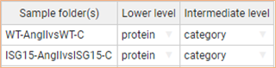
Figure 48. The SBT task table for workflow 2.

Finally, the REPORT module (Figure 49) is used in this workflow to collect the following statistical variables for all samples, namely the 16 individual samples generated with LEVEL CREATOR (e.g. Ind/WT-C-1 and Ind/ISG15-AngII-1, Figure 42), the four combined samples obtained with NORCOMBINE (WT-C, WT-AngII, ISG15-C, and ISG15-AngII, Figure 46), and the two ratio samples created by RATIOS (WT-AngIIvsWT-C and ISG15-AngIIvsISG15-C, Figure 47), as prompted by the asterisk:
- Number of peptides per protein (n), obtained from the peptide-to-protein integration;
- Mean-corrected protein log2 ratios expressed in units of standard deviation (Z), calculated from the protein-to-proteinall integration;
- False Discovery Rate (FDR) values indicating which Z values stand out as outliers in the protein-to-proteinall integration;
- Number of proteins per category (n), obtained from the protein-to-category integration;
- Mean-corrected category log2 ratios expressed in units of standard deviation (Z), calculated from the category-to-categoryall integration;
- False Discovery Rate (FDR) values indicating which Z values stand out as outliers in the category-to-categoryall integration.

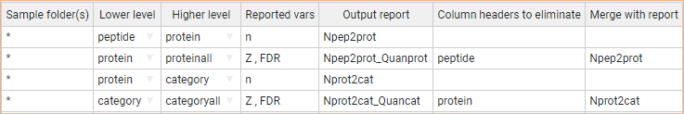
Figure 49. The REPORT task table for workflow 2.

The following advanced options of the REPORT module have been used in this workflow (Figure 49):
- Merge with report designates the report file whose variables will be incorporated into the current report on the basis of their element identifiers. Thus, for example, the Npep2prot_Quanprot report is first populated with the Z values of the protein-to-proteinall integration, and then added the number of peptides per protein coming from the Npep2prot report (Figure 49). This is possible because the protein level is present in both report files.
- Column headers to eliminate restricts the elements to be written to the Output reports Npep2prot_Quanprot and Nprot2cat_Quancat to those from the protein and category level, respectively. This prevents data duplication upon merging with the Npep2prot and Nprot2cat reports, as these contain also the peptide and protein level, respectively (Figure 49).

As previously shown with SanXoT [5], iSanXoT analysis revealed a coordinated alteration of proteins implicated in cardiovascular function, extracellular matrix and remodeling, and vascular redox state in aorta from AngII-infused ISG15-KO mice (Figure 50).
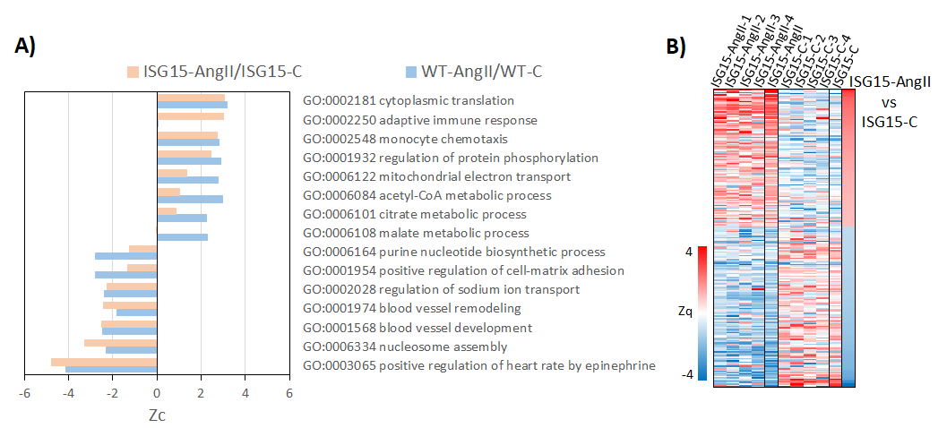
Figure 50. Differential abundance of functional categories (A) and proteins (B) revealed by workflow 2 based on the mean-corrected log2-ratio expressed in units of standard deviation at the category (Zc) and protein (Zq) level, respectively.

Workflow execution
The workflow template and input files that are needed to execute this workflow can be downloaded from
https://github.com/CNIC-Proteomics/iSanXoT/wiki/studies/cases/templates/WSPP_NORCOM_RATIOS_SBT.zip
See the Executing a workflow template Section below for detailed instructions.

Workflow 3: Quantification of posttranslationally modified peptides in a labeled experiment

Experimental
This workflow was used to quantitate Cys-oxidized peptides in mouse embryonic fibroblast (MEF) preparations subjected to chemical oxidation with diamide, an experiment that served to illustrate the comparative performance of on-filter (FASILOX) and in-gel (GELSILOX) approaches to study the thiol redox proteome [4]. MEF samples were incubated with diamide (treated group) or PBS (control group) for 10 min (four biological replicates per condition). The FASP filter was used to carry out the sequential alkylation and reduction steps needed to separately label reduced and oxidized Cys residues, after which the proteins were digested with trypsin and the resulting peptides were isobaricaly labeled with iTRAQ 8-plex and analyzed by LC-MS/MS. Protein identification was achieved with Proteome Discoverer 1.4 (Thermo Fisher Scientific; see Section 3 below to learn how these data are adapted to be used with iSanXoT). The FDR for peptide identification was calculated using the refined method [7].
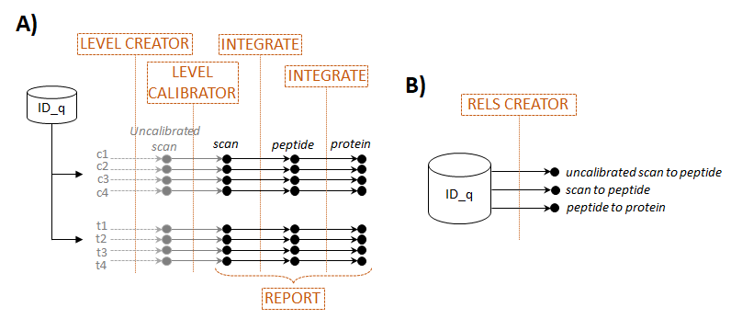
Figure 51. Scheme of workflow 3 (quantification of posttranslationally modified peptides in a labeled experiment) showing module components: LEVEL CREATOR, LEVEL CALIBRATOR, INTEGRATE, and REPORT (A) and RELS CREATOR (B).

Workflow operation
Workflow 3 comprises the basic modules LEVEL CREATOR, LEVEL CALIBRATOR, and INTEGRATE, as well as the RELS CREATOR and REPORT modules (Figure 51). The starting module, LEVEL CREATOR, generates the level files, sample folders and log2 ratios indicated in the corresponding task table (Figure 52).
Figure 52. The LEVEL CREATOR task table for workflow 3.

The output level files, uscan (uncalibrated scan), display element identifiers together with their corresponding log2-ratio and statistical weight values (Figure 53). This uncalibrated weight is the inverse of the variance associated with the log2-ratio, and therefore a higher weight corresponds to a more accurate quantification.
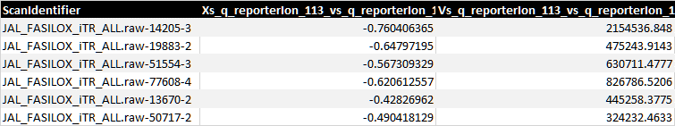
Figure 53. Excerpt from one of the uscan files generated by workflow 3 LEVEL CREATOR module showing element identifiers (left column), log2 ratios (center column) and statistical weights (right column).

Prior to their integration into a higher level, uscan levels are calibrated to account for the variability of the LC-MS/MS analysis with the LEVEL CALIBRATOR module, which results in scan calibrated levels with recalculated statistical weights (Figure 54, Top). Then the INTEGRATE module performs the scan-to-peptide and peptide-to- protein integrations according to the module task table (Figure 54, Bottom). The latter integration will provide the differential abundance of peptides (including posttranslationally modified peptides) regardless of the differential abundance of proteins, and the authors chose not to include the heterogeneous population of Cys-containing peptides for the calculation of variance in the peptide-to-protein integration [4].
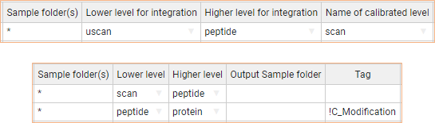
Figure 54. The LEVEL CALIBRATOR (Top) and INTEGRATE (Bottom) task tables for workflow 3.

Thus, the Tag advanced option of the INTEGRATE module task table displays !C_Modification, which means that the peptide (lower level) elements marked with this tag in the peptide2protein relation table (Figure 55) will not be considered in the calculation of the variance in the peptide-to-protein integration. Every integration requires a specific relation table linking the corresponding lower- and higher-level elements that is generated by RELS CREATOR (Figure 51B and Figure 55).
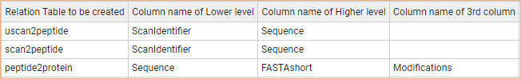
Figure 55. The RELS CREATOR task table for workflow 3.

In particular, the peptide2protein relation table describes the relationships between the peptide level (i.e. the lower level) and the protein level (i.e. the higher level), and in this case includes a third column headed by Modifications where Cys-containing peptides have been tagged with C_Modification (Figure 56). Accordingly, Cys-containing peptides will not be considered for the calculation of variance in the peptide-to-protein integration.
Figure 56. Excerpt from the peptide2protein relation table that links peptides to proteins. Note the use of a third column to tag Cys-containing peptides, which will be later excluded from the calculation of variance in the peptide-to-protein integration.

Finally, the REPORT module is used ion this workflow to collect the statistical variables generated by the peptide-to-protein integration for all eight samples (c1, c2, c3, c4, t1, t2, t3, and t4), as prompted by the asterisk (Figure 57A):
- Number of scans per peptide (n), obtained from the scan-to-peptide integration;
- Peptide log2 ratios expressed in units of standard deviation corrected by the protein mean (Z), calculated from the peptide-to-protein integration;
- False Discovery Rate (FDR) values indicating which Z values stand out as outliers in the integration.

The advanced options of the REPORT module (Figure 57A):
- Merge with report designates the merge of the number of scans per peptide from the Nscan2pep report and the Z values and FDR of the peptide-to-protein that will be saved in the Nscan2pep_Quanpepprot report.
- Column headers columns to eliminate restricts the elements to be written to the Output reports Nscan2pep_Quanpepprot to those from the scan level.

Figure 57B shows the relative abundance of Cys-containing peptides provided by the peptide-to-protein integration.
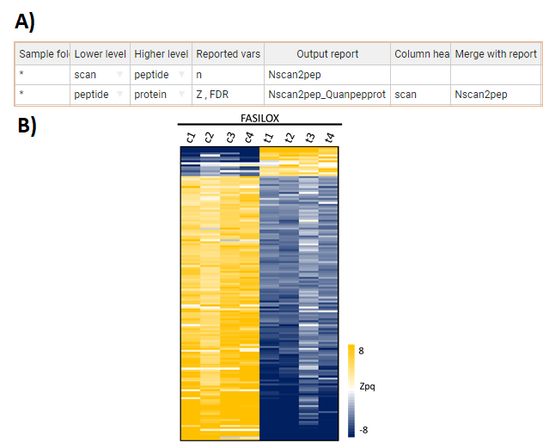
Figure 57. (A) The REPORT module task table for workflow 3. (B) Relative abundance of Cys-containing peptides in MEF samples measured by peptide log2 ratios expressed in units of standard deviation corrected by the protein mean (Zpq).

Workflow execution
The workflow template and input files that are needed to execute this workflow can be downloaded from
https://github.com/CNIC-Proteomics/iSanXoT/wiki/studies/cases/templates/WSPP_PTM.zip
See the Executing a workflow template Section below for detailed instructions.

Workflow 4: Label-free quantification

Experimental
This workflow has been applied to quantitative data obtained in a multicenter study aimed at evaluating different bioinformatics tools [6]. The authors generated two hybrid proteome samples consisting of tryptic digests of human, yeast and Escherichia coli proteins mixed in two different defined proportions (13:3:4 for a samples and 13:6:1 for b samples). Quadruplicate peptide samples were analyzed by LC-MS/MS, after which peptide identification and quantification were carried out with MaxQuant [8], among other software packages (see Section below to learn how these data are adapted to be used with iSanXoT).
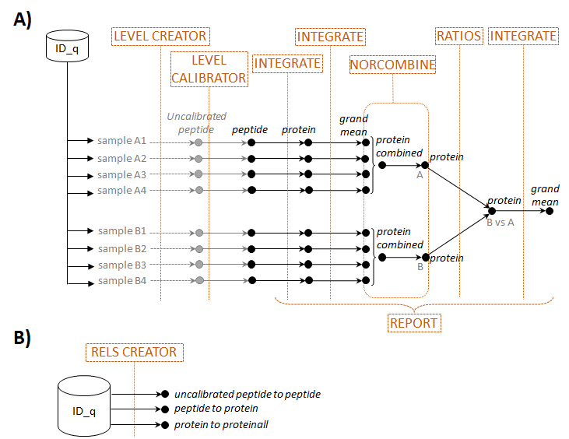
Figure 58. Scheme of workflow 4 (label-free quantification) showing module components: LEVEL CREATOR, LEVEL CALIBRATOR, INTEGRATE, NORCOMBINE, and REPORT (A) and RELS CREATOR (B).

Workflow operation
Workflow 4 includes the basic iSanXoT modules LEVEL CREATOR, LEVEL CALIBRATOR, INTEGRATE, NORCOMBINE, and RATIOS along with the REPORT and RELS CREATOR modules (Figure 58). The starting module, LEVEL CREATOR, generates the level files, sample folders and log2 ratios indicated in the corresponding task table (Figure 59) based on the quantitative data at the peptide level obtained with MaxQuant for replicate a and b samples. To calculate the log2-ratio denominator, first the averages of the four a and the four b samples are calculated separately (as indicated by the square brackets), then the average of the two average values is calculated (as indicated by the comma).
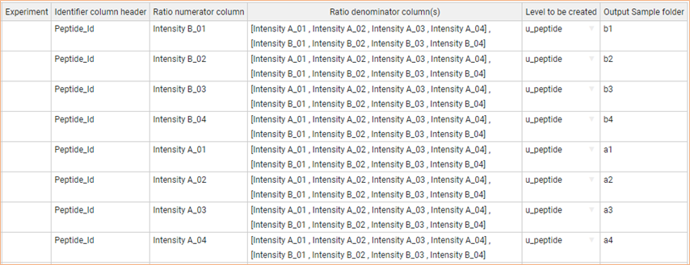
Figure 59. The LEVEL CREATOR task table for workflow 4.

This ensures that no log2-ratio is calculated when all four values are missing in either the a or the b sample group. The eight u_peptide (uncalibrated peptide) output level files display element identifiers together with their corresponding log2-ratio and statistical weight values (Figure 60).
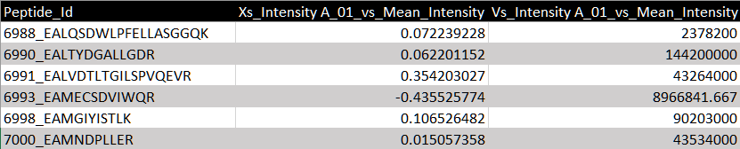
Figure 60. Excerpt from one of the u_peptide files generated by workflow 4 LEVEL CREATOR module showing element identifiers (left column), log2 ratios (center column) and statistical weights (right column).

This uncalibrated weight is the inverse of the variance associated with the log2-ratio, and therefore a higher weight corresponds to a more accurate quantification. Prior to their integration into a higher level, u_peptide levels are calibrated with the LEVEL CALIBRATOR module, which results in peptide calibrated levels with recalculated statistical weights (Figure 61, Top). Then the INTEGRATE module performs the peptide-to-protein and protein-to-proteinall integrations according to the module task table (Figure 61, Bottom).
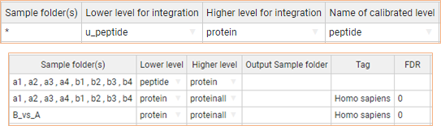
Figure 61. The LEVEL CALIBRATOR (Top) and INTEGRATE (Bottom) task tables for workflow 4.

Every integration requires a specific relation table linking the corresponding lower- and higher-level elements that is generated by RELS CREATOR (Figure 58B and Figure 62); for instance, the peptide2protein relation table mentioned describes the relationships between the peptide level (i.e. the lower level) and the protein level (i.e. the higher level).
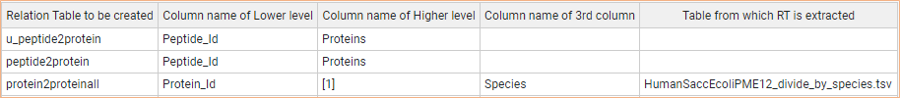
Figure 62. The RELS CREATOR task table for workflow 4.

As mentioned above, replicate a and b samples contain different proportions of yeast and Escherichia coli peptides (3:4 and 6:1, respectively) and the same proportion of human peptides; for this reason, only human proteins were considered in the calculation of the variance for the protein-to-proteinall integrations, as indicated by the Tag parameter used in the INTEGRATE task table (Figure 61, Bottom; note that no outliers were removed in this integration as prompted by the 0 value indicated for the FDR parameter). Accordingly, the protein2proteinall relation table required by this integration includes a third column headed by Species where proteins have been tagged with their corresponding species (Figure 63). This relation table was built based on the file HumanSaccEcoliPME12_...‌‌‌_species.tsv.
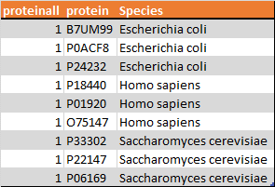
Figure 63. Excerpt from the protein2proteinall workflow 4 relation table that links proteins to a constant value representing the protein grand mean. Note the use of a third column to tag proteins with their corresponding species for later species-specific protein-to-proteinall integration.

Next, the four individual replicate a (a1, a2, a3, and a4) and b (b1, b2, b3, and b4) samples initially generated with LEVEL CREATOR (Figure 59) are combined into samples A and B, respectively, using the NORCOMBINE basic module (Figure 64, Top). The module task table indicates that samples were combined at the protein level using the proteinall level for normalization. NORCOMBINE also requires the user to specify which lowerNorm files contain the necessary data for the samples to be combined. These lowerNorm files, previously generated by the INTEGRATE module (Figure 61, Bottom), contain lower-level identifiers along with the corresponding centered log2-ratio values and either the integration statistical weight (in the case of lowerNormV, as chosen in this workflow) or the variance (for lowerNormW) (Figure 64, Top). NORCOMBINE first generates merged data files and relation tables that are later integrated to the above-described combined samples A and B.
To compared these two samples, first new log-2 ratios and statistical weights are calculated using the RATIOS basic module (Figure 64, Bottom), after which a protein-to-proteinall integration is carried out for the newly-generated B_vs_A sample (Figure 61, Bottom).
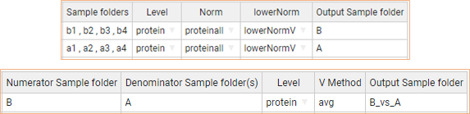
Figure 64. The NORCOMBINE (Top) and RATIOS (Bottom) task tables for workflow 4.

Finally, the REPORT module (Figure 65) is used in this workflow to collect variables for all the samples involved (as prompted by the asterisk), namely the eight individual samples generated with LEVEL CREATOR (a1, a2, a3, a4, b1, b2, b3, and b4; Figure 59), the combined samples A and B obtained with NORCOMBINE (Figure 64, Top), and the B_vs_A sample generated by RATIOS (Figure 64, Bottom). The following variables were considered:
- Number of peptides per protein (n), obtained from the peptide-to-protein integration;
- Protein log2 ratios (Xinf), calculated from the protein-to-proteinall integration;
- Protein grand mean (Xsup), calculated from the protein-to-proteinall integration;
- FDR values indicating which Z values stand out as outliers in the protein-to-proteinall integration;
- Species information (tags) showing in the protein-to-proteinall integration output file.

Figure 65. The REPORT module task table for workflow 4.

The following advanced options of the REPORT module have been used in this workflow (Figure 65):
- Merge with report designates the report file whose variables will be incorporated into the current report on the basis of their element identifiers. Thus, the Npep2prot_Quanprot report is first populated with the Xinf, Xsup, FDR and tags values of the protein-to-proteinall integration, and then added the number of peptides per protein coming from the Npep2prot report (Figure 65). This is possible because the protein level is present in both reports;
- Column headers to eliminate restricts the elements to be written to the corresponding Output report to those from the protein level (lower level; both lower and higher levels are used unless otherwise stated). This prevents data duplication when Npep2prot_Quanprot and Npep2prot reports are merged, as the latter contains also the peptide level.

In agreement with the results reported [6], the combined statistics B_vs_A analysis shows human, yeast and bacterial proteins normally distributed around the expected 0, 1, and -2 mean-corrected log2-ratio (X_{qa} – grand mean, indeed, they are the X_{inf} - X_{sup}) values (corresponding to 1, 2, and 0.25 fold change values) (Figure 66).
Figure 66. Quantification of human (orange), yeast (grey) and bacterial (blue) proteins according to the combined statistics B_vs_A.

Workflow execution
The workflow template and input files that are needed to execute this workflow can be downloaded from
https://github.com/CNIC-Proteomics/iSanXoT/wiki/studies/cases/templates/WPP_LabelFree.zip
See the Executing a workflow template Section below for detailed instructions.

Importing a workflow template

To illustrate how to execute the workflows created with iSanXoT, we shall make use of the sample workflows described in detail in the previous Section. Start by downloading, for instance, workflow 1 template and input files from the iSanXoT wiki (https://github.com/CNIC-Proteomics/iSanXoT/wiki/studies/workflows/WSPP-SBT.zip). Extract the files included in the compressed archive Then proceed as follows:
- Open the iSanXoT application by double-clicking the application icon (Figure 67).

Figure 67. The iSanXoT startup message.
- Choose New Project from the Project menu (Figure 68).

Figure 68. Create New Project.
- Provide a project name and a project folder, then click the Submit button (Figure 68).
- To import a workflow previously generated with iSanXoT, choose Import Workflow from the Project menu (Figure 69). Choose, for instance, workflow 1 by selecting the root folder where you stored the workflow files.

Figure 69. Importing a preexisting iSanXoT workflow to the newly-created project.
- Now click on Choose identification file to provide an identification/quantification (ID-q) file (Figure 70). The below section shows how to prepare this file based on the output from a variety of proteomics pipelines; but you can try the ID-q.tsv file included in the root folder where you stored workflow 1 files.
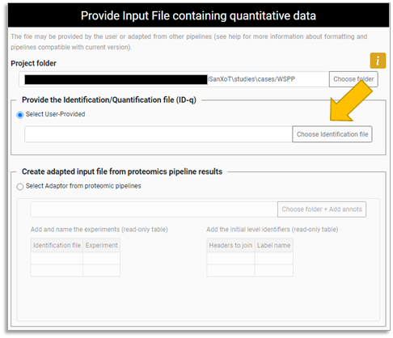
Figure 70. Choosing the identification/quantification (ID-q) file for the newly-created project.
- Bear in mind that any path included in the RELS CREATOR module task table of the workflow imported will need be updated.

Creating the identification/quantification file from proteomics pipelines

iSanXoT requires an identification/quantification file (ID-q.tsv) containing identified features together with their quantitative values and the experiment they originate from whether there is more than one experiment. This tab-separated values ID-q file must fulfill:
- Features (scan, peptide, protein, etc.) are unequivocally referenced using a unique identifier;
- Quantitative values for the features are displayed across columns;
- Experiments are specified in a column field headed by Experiment whether there is more than one experiment.

In this Section we shall describe how to prepare the ID-q.tsv file based on data obtained with the four most popular proteomics pipelines.

Table 1 . Column headers from the tested proteomic pipelines that are needed for the input idnetification/quantification file (ID-q.tsv). (*) Redundant proteins. You have to select your main protein. (**) Provide the experiment names in the case of multiple experiments.
 |  |  | Id_q.txt column headers
 |  |  | Features |  |  | Quantitation | Experiment
Proteomic pipeline | Experiment type | File type | Scan | Peptide | Protein
Proteome Discoverer (version 2.5) | label free | _PSMs.txt | Spectrum file + First Scan + Charge | Sequence + Modifications | Protein Accessions (*) | Intensity | Experiment names (**)
 | isotopically labelled | _PSMs.txt | Spectrum file + First Scan + Charge | Sequence + Modifications | Protein Accessions (*) | Abundance: Channel identifier | Experiment names (**)
MaxQuant (version 1.6.5.0) | label free | peptides.txt | Id | Sequence | Leading razor protein | Intensity sample | Experiment names (**)
 | isotopically labelled | msmsScans.txt | Raw file + Scan number + Charge | Sequence + Modifications | Proteins (*) | Reporter intensity sample | Experiment names (**)
Trans-Proteomics Pipeline (version 6.0.0) | label free | pepXML file | spectrum | peptide | proteins (*) | precursor_intensity | Experiment names (**)
 | isotopically labelled | pepXML file | spectrum | peptide | proteins (*) | Channel identifier | Experiment names (**)
Fragpipe (version 1.8.1) | label free | psm.tsv | Spectrum | Modified Peptide | Protein | Intensity | Experiment names (**)
 | isotopically labelled | psm.tsv | Spectrum | Modified Peptide | Protein | Channel identifier | Experiment names (**)

Preparing the ID-q file from Proteome Discoverer output
In the case of Proteome Discoverer version 2.5 [9], the quantitative data required to prepare the ID-q file are extracted by the Processing workflow nodes Reporter Ions Quantifier (for labelled experiments) and Minora Feature Detector (for label-free experiments). These data are written by the Consensus workflow to a text file suffixed with _PSMs.txt displaying:

Label-free experiments
- PSMs Peptide ID: Unique identifier for each Peptide sequence identified;
- Sequence: Amino acid sequence of the identified peptide;
- Modifications: Post-translational modifications contained within the sequence;
- Protein Accessions: Accession code(s) for the protein(s) to which the peptide sequence is ascribed;
- Intensity: Precursor ion intensity (to be used in label-free experiments).

The unequivocally identifier for a peptide has to be composed by the union of Sequence and Modifications fields.

Labelled experiments
- Spectrum File: Name of the RAW file the spectral MS/MS data was extracted from;
- First Scan: RAW file derived scan number for the MS/MS spectrum;
- Charge: Charge state of the precursor ion;
- PSMs Peptide ID: Unique identifier for each Peptide sequence identified;
- Sequence: Amino acid sequence of the identified peptide;
- Modifications: Post-translational modifications contained within the sequence;
- Protein Accessions: Accession code(s) for the protein(s) to which the peptide sequence is ascribed;
- Abundance: Channel identifier: Reporter ion intensity (to be used in labelled experiments).

In the case of multiple experiments, we recommend the creation of a unique identifier for a Scan is composed by the union of the fields: Spectrum File, First Scan and Charge; otherwise, the PSMs Peptide ID field is enough for the Scan identification. The unequivocally identifier for a peptide has to be composed by the union of Sequence and Modifications fields.

Preparing the ID-q file from MaxQuant output
The way MaxQuant version 1.6.5.0 [8] data are adapted for use with iSanXoT depends on whether they originate from label-free or labelled proteomics experiments:

Label-free experiments
In this case, the necessary data can be found in the peptides.txt file, which is stored in the “…combined/txt” folder:
- Id: Unique, consecutive identifier for each peptide Sequence identified;
- Sequence: Amino acid sequence of the identified peptide;
- Leading razor protein: Identifier of the top scoring protein to which the peptide Sequence is ascribed;
- Intensity + Experiment: Summed up extracted ion current of all isotopic clusters associated with the peptide Sequence identified in the raw files making up Experiment.

Labelled experiments
When dealing with labelled experiments (e.g. iTRAQ- or TMT-based), the necessary data can be found in the msmsScans.txt file, which is stored in the “…combined/txt” folder:
- Raw file: Name of the RAW file from which the MS/MS data were extracted;
- Scan number: MS/MS spectrum number within a given RAW file;
- Charge: Charge state of the precursor ion;
- Sequence: Amino acid sequence of the identified peptide. This parameter is nonblank only when identification was successful.
- Proteins: Identifier(s) of the protein(s) to which the peptide Sequence is ascribed;
- Reporter intensity + n: Intensity of the reporter ion corresponding to sample n.

The msmsScans.txt file lacks the unique identifier that is required in the ID-q file. The user is advised to create this unique identifier by concatenating RAW file, Scan number, and Charge.

Preparing the ID-q file from Trans-Proteomic Pipeline output
Trans-Proteomics Pipeline version 6.0.0 [10] comprises a number of tools (e.g. ASAPRatio, XPRESS and Libra) that allow both label-free and isotopically labelled quantitative data to be saved to a pepXML file. Using the PepXML Viewer application, this file can be exported as a spreadsheet displaying:

Label-free experiments
- Spectrum: Unique identifier for each Peptide sequence identified;
- Peptide: Amino acid sequence of the identified peptide;
- Protein: Identifier of the protein to which the Peptide sequence is ascribed;
- Precursor_intensity: Precursor ion intensity (to be used for label-free quantification).

Labelled experiments
- Spectrum: Unique identifier for each Peptide sequence identified;
- Peptide: Amino acid sequence of the identified peptide;
- Protein: Identifier of the protein to which the Peptide sequence is ascribed;
- Channel identifier: Reporter ion intensity (to be used for isotopic labelling quantification).

Preparing the ID-q file from FragPipe output
Fragpipe version 1.8.1 [11] relies on the Quant (MS1) and Quant (Isobaric) modules to generate a psm.tsv output file that contains the quantitative data obtained from label-free and labelled experiments, respectively:

Label-free experiments
- Spectrum: Unique identifier for each Peptide sequence identified;
- Modified Peptide: Peptide sequence including modifications, modified residues;
- Protein: Identifier of the protein to which the Peptide sequence is ascribed;
- Intensity: Precursor ion intensity (to be used in label-free experiments);
- Channel identifier: Reporter ion intensity (to be used in labelled experiments).

Labelled experiments
- Spectrum: Unique identifier for each Peptide sequence identified;
- Modified Peptide: Peptide sequence including modifications, modified residues;
- Protein: Identifier of the protein to which the Peptide sequence is ascribed;
- Intensity: Precursor ion intensity (to be used in label-free experiments);
- Channel identifier: Reporter ion intensity (to be used in labelled experiments).

Adapting the results from proteomics pipelines for iSanXoT

iSanXoT requires an identification/quantification tab-separated values file (ID-q.tsv) containing identified features together with their quantitative values and the experiment they originate from. Users can either compose this ID-q file manually (see Section above to learn how to do that with data from the four most popular proteomics pipelines) or have it prepared by the iSanXoT Input Adaptor. The latter option is described in this Section.
Figure 71. Selecting an ID-q file in the Input Adaptor main window.

- Open the iSanXoT application, then see Section above to learn how to get to the Input Adaptor main window (Figure 71).
- If you already have an appropriate ID-q file, select the Provide the Identification/Quantification file (ID-q) option, then click on Choose identification file to select the file.
Figure 72. Having the iSanXoT Input Adaptor prepare the ID-q file.
- To have the iSanXoT Input Adaptor prepare the ID-q file from proteomics pipelines results (this works at least with MaxQuant, Trans-Proteomic Pipeline, FragPipe, and Proteome Discoverer), select the Create adapted input file from proteomics pipelines results option, then click on Choose folder + Add anots to select the folder containing the output files (Figure 72). A three-panel window will pop-up (Figure 73).

Figure 73. Adapting results from a proteomics pipeline. In the top panel several output files from Proteome Discoverer have been selected. These PSMs.txt files, which contain identification/quantification data, have been assigned an experiment name (Jurkat) in the middle panel. The bottom panel has been used to create identifiers by concatenating result file headers: ScanID (by concatenating Spectrum File, First Scan and Charge) and pepID (by concatenating Sequence and Modifications).

- The top panel displays the files included in the folder so that you can select one or more result files to be considered by iSanXoT Input Adaptor. Please bear in mind that if several result files are selected, these must necessarily have the same column headers.
- The middle panel is used to set the distribution of data items across experiments according to result filenames.
- The bottom panel allows to create identifiers by concatenating result file headers. It is composed of two interfaces:
  - The headers found on the result files are listed on the left. Header names will be added to the interface on the right as they are selected;
  - The interface on the right displays the header names selected to generate the identifier as well as the identifier name provided by the user.

- Please note that the alphanumeric text that unambiguously identifies the items to be integrated is the only identifier that must be necessarily included in the ID-q file.
- Click the Submit button and the Input Adaptor will start generating the ID-q.tsv file.

References

[1] Trevisan-Herraz M, Bagwan N, Garcia-Marques F, Rodriguez JM, Jorge I, Ezkurdia I, et al. SanXoT: a modular and versatile package for the quantitative analysis of high-throughput proteomics experiments. Bioinformatics. 2019;35(9):1594-6.
[2] Navarro P, Trevisan-Herraz M, Bonzon-Kulichenko E, Nunez E, Martinez-Acedo P, Perez-Hernandez D, et al. General statistical framework for quantitative proteomics by stable isotope labeling. J Proteome Res. 2014;13(3):1234-47.
[3] Garcia-Marques F, Trevisan-Herraz M, Martinez-Martinez S, Camafeita E, Jorge I, Lopez JA, et al. A Novel Systems-Biology Algorithm for the Analysis of Coordinated Protein Responses Using Quantitative Proteomics. Mol Cell Proteomics. 2016;15(5):1740-60.
[4] Bonzon-Kulichenko E, Camafeita E, Lopez JA, Gomez-Serrano M, Jorge I, Calvo E, et al. Improved integrative analysis of the thiol redox proteome using filter-aided sample preparation. J Proteomics. 2020;214:103624.
[5] Gonzalez-Amor M, Garcia-Redondo AB, Jorge I, Zalba G, Becares M, Ruiz-Rodriguez MJ, et al. Interferon stimulated gene 15 pathway is a novel mediator of endothelial dysfunction and aneurysms development in angiotensin II infused mice through increased oxidative stress. Cardiovasc Res. 2021.
[6] Navarro P, Kuharev J, Gillet LC, Bernhardt OM, MacLean B, Rost HL, et al. A multicenter study benchmarks software tools for label-free proteome quantification. Nat Biotechnol. 2016;34(11):1130-6.
[7] Navarro P, Vazquez J. A refined method to calculate false discovery rates for peptide identification using decoy databases. J Proteome Res. 2009;8(4):1792-6.
[8] Tyanova S, Temu T, Cox J. The MaxQuant computational platform for mass spectrometry-based shotgun proteomics. Nat Protoc. 2016;11(12):2301-19.
[9] Orsburn BC. Proteome Discoverer-A Community Enhanced Data Processing Suite for Protein Informatics. Proteomes. 2021;9(1).
[10] Deutsch EW, Mendoza L, Shteynberg D, Slagel J, Sun Z, Moritz RL. Trans-Proteomic Pipeline, a standardized data processing pipeline for large-scale reproducible proteomics informatics. Proteomics Clin Appl. 2015;9(7-8):745-54.
[11] Kong AT, Leprevost FV, Avtonomov DM, Mellacheruvu D, Nesvizhskii AI. MSFragger: ultrafast and comprehensive peptide identification in mass spectrometry-based proteomics. Nat Methods. 2017;14(5):513-20.

