SMARTIE Study Run Guide

The study exists on and is backed-up by GitHub (Link to the repo [here](https://github.com/CNL-R/movingstims)). On the presentation computer, the local copy is here: [C:\Users\lhshaw\Documents\GitHub\movingstims.](../movingstims) You can also access it quickly through the favorites side bar on any explorer window.

**Experiment 1: IE Initial**

Generates auditory and visual psychometric functions for an individual using the method of constant stimuli. Behavioral only. Uses the same set of stimuli for all participants. Run time ~one hour.

Once you have sat your participant down and explained the instruction to them, here are the steps to running this experiment:

1. Make sure the headphones and game controller are plugged in (make sure the green LED on the controller is lit).
2. Navigate to C:\Users\lhshaw\Documents\GitHub\movingstims\IEInitial & click to open the **experiment** file: “IEInitial.exp”.
3. Make sure the presentation window says “IE-Initial” and click on the “Run Button”.
4. Type in the subject ID
5. Press the “Run Scenario” button. The experiment will then run to completion by itself.
6. When the experiment is over, the presentation will give an index error that pops out in a new window. You can exit presentation now.
7. Open “InitialProcess.m”, which is located in the “IEInitial” folder.
8. Press run. MATLAB may prompt you with a dialogue box. If it does, press “Add to Path”. You will then be prompted to choose a .log file. Choose the one titled “*subjectID*_IEInitial”.
9. 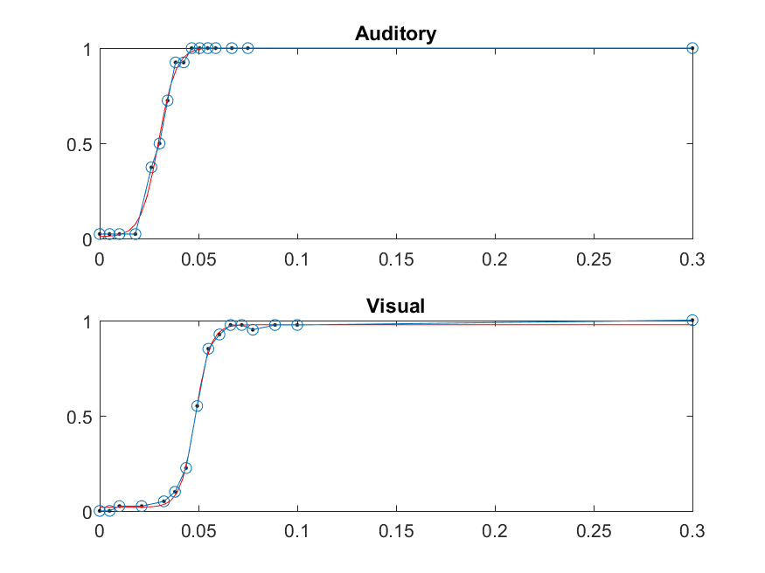The code will output a plot with raw data points (blue) and a sigmoid fit (red). If the plots meet these criteria, the subject may participate in part II of the experiment:
   1. The red sigmoid line reasonably matches the raw blue data points.
   2. The asymptotes are reasonably close to zero and one.
10. If the fit is wonky, then either scrap that participant or ask them to come again for another experiment 1. If you are unsure, ask Eric.

Example of Adequate Psychometric Curves

1. Experiment 1 over! ☺

**Experiment 2: IE Two**

Presents 30-60-90% detectable auditory, visual and audiovisual stimuli to test if there are scalp recording manifestations of Inverse Effectiveness. This is an EEG study. 256 channels. 4 externals (temples and mastoids). Each participant will have a unique stimuli set generated for them.

Once you have capped & gelled your participant, do the following:

1. Open ActiView on the recording computer. Load the config file: “About Actiview” 🡪 “Load Config File” 🡪 Desktop 🡪 configs 🡪 “**SMART-IE_256ch_512hz**”. Make sure all channels are good.
2. If you are NOT running experiment 1 and experiment 2 back to back, go back to “IEProcess.m” from Experiment 1 and run it again. (The rest of the code requires some variables generated from this script).
3. Navigate to C:\Users\lhshaw\Documents\GitHub\movingstims\IETwo and open GenerateStims_Two.m.
4. **IMPORTANT.** Change line 5

basedir='C:\Users\lhshaw\Documents\GitHub\movingstims\IETwo*OldSubjectID*_stims';

to match your current subject ID:

basedir='C:\Users\lhshaw\Documents\GitHub\movingstims\IETwo\***New****SubjectID*_stims';

1. Go to the explorer, and create a new folder named “*SubjectID*_stims”.
2. Press run. If prompted, press “add to path”.
3. Open the IETwo.exp file.
4. 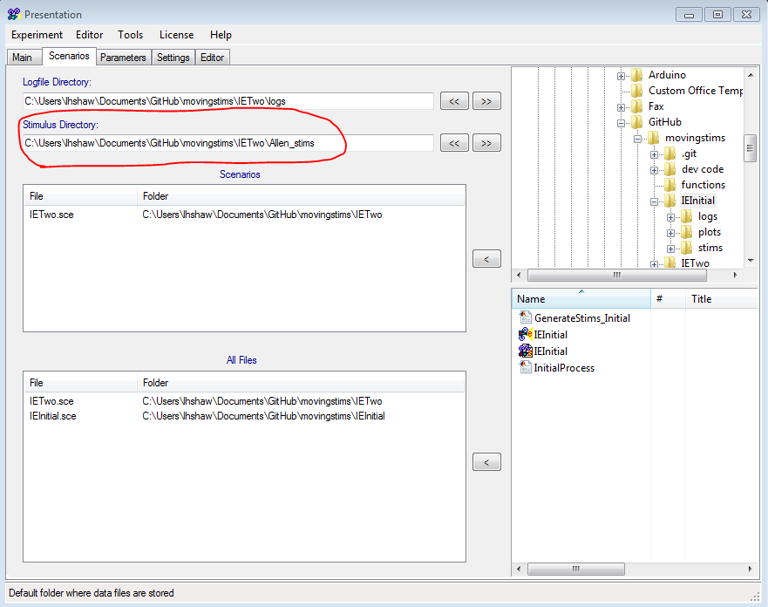**IMPORTANT!!** Navigate to the “scenarios” tab and CHANGE the “Stimulus Directory” to the new folder you just created.
5. The experiment is now ready to run: Press Start File on the Recording Computer. Save the .bdf files on the “SMART-IE” folder on the recording computer.
6. Navigate back to “Main” and press run, enter in the subject ID, and press enter to start the experiment.
7. Make sure Actiview is SAVING EEG data when stimuli are being presented to the subject.
8. Experiment will terminate with a similar error box as in experiment 1. Take the *NewSubjectID_stims* folder you created and MOVE it into the “stims” folder.
9. Clean up your participant and pay them. If you want to take a look at the behavioral data you’ve just collected, open C:\Users\lhshaw\Documents\GitHub\movingstims\IETwo\analysis\Plot_IETwo.m and click run. Choose the log-file experiment 2 just outputted.
10. To backup the data: open GitHub