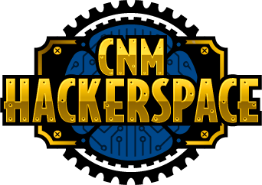

Wizard/Coder/Software Engineer

# Class description

Develops software. Able to work at the typical software development company. Has the ability to make web, phone, Data science, Machine Learning and/or pc applications.

# Subclasses

Illusionist/Web Developer: Web development.

Sorcerer/PC Developer: PC application developer.

Enchanter/Phone App Developer: Phone app development.

Diviner/Data Science: Data science applications development.

Conjurer/Machine Learning: Machine Learning applications development.

# Badges

## Illusionist/Web Developer

### BASIC HTML Badge

#### Description

To earn this badge, build a basic HTML page. You can learn the fundamentals here <https://www.codecademy.com/learn/learn-html>.

You can also learn more about HTML here <https://www.w3schools.com/html/>.

To demonstrate your proficiency, build a web page unique to you. Some ideas include building a page that you can use to show off your skills and proficiencies. The web site should include text, images, multiple pages and links that navigate between the pages. The site should also include Heading (h1, h2, h3) and paragraph (p) tags to make it clear what the structure of the page is.

#### Turn in requirements

Send an email to [rgarner7@cnm.edu](mailto:rgarner7@cnm.edu). Include a link to your application on a shared drive or GitHub. Also include a link to a video, in which, you walk through your code and the application explaining how it works.

### BASIC CSS Badge

#### Description

To earn this badge, add CSS to an HTML page. You can learn the fundamentals here <https://www.codecademy.com/learn/learn-html>.

You can also learn more about HTML here <https://www.w3schools.com/html/>.

To demonstrate your proficiency, build a web page unique to you. Some ideas include building a page that you can use to show off your skills and proficiencies. The web site should include:

1. The title attribute should be set so that the tab in the browser is relevant to the site.
2. The site should have one or more images.
3. Set the alt tag for all elements that need them for accessibility.
4. There should be multiple pages for the site and there should be links that navigate between the pages.
5. Include both links that open in the same page as well as open in a new tab.
6. The site should also include Heading (h1, h2, h3) and paragraph (p) tags to make it clear what the structure of the page is.
7. Include ordered and unordered list. One place to do this is in the site navigation.

#### Turn in requirements

Send an email to [rgarner7@cnm.edu](mailto:rgarner7@cnm.edu). Include a link to your application on a shared drive or GitHub. Also include a link to a video, in which, you walk through your code and the application explaining how it works.