1. Using demand/year of 600, holding cost/unit/year of $5, and fixed order cost/order of $60, reproduce the graph of costs in the lecture slides.

What is the optimal Q?

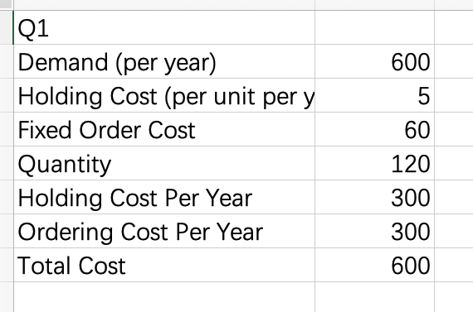

By our calculation the optimal Q is 120.

Suppose management uses the optimal Q for a demand of 600, but demand is actually wrong by +/–10%, either 660 or 540. By what percentage does the cost differ in each case?

The cost differs either 5% or -5% in each cases, which is smaller than 10%

You should see that the percentage change in cost is less than 10%. The point is that the EOQ cost function is rather flat near the optimum. This means the EOQ is relatively robust, so the using the forecast for the EOQ results in a low cost solution even if we forecast demand inaccurately.

2. Using demand/year of 600 and a holding cost/unit/year of $5, create a table to see how the optimal total cost per year varies with the fixed cost per order. Make the fixed order cost range from $1/order to $50/order. Each row in your spreadsheet should have:

demand of 600,

holding cost of $5,

the order cost,

the optimal order quantity,

the total cost/year for the optimal order quantity,

and the savings for reducing the fixed order cost by $1.

电脑屏幕的照片

Create a graph of total cost (vertical axis) versus fixed order cost (horizontal cost).

What is the savings if management works to reduce the order cost from $50 to $49?

The saving is $5.504889036

What is the savings if management works to reduce the order cost from $2 to $1?

The saving is $32.08484458

You should see that the savings increases as the order cost falls. The point is that reducing the fixed order cost has increasing returns. This will be important when we study just-in-time production.

3. Create a simple spreadsheet simulation of random demand as 100\*RAND() for 100 time periods. You don’t have to round it to an integer. Put the period number in column A and the random demand in column B. Assume these are one-period models, so any shortage or leftover is lost at the end of each period.

What is the long-run average demand over an infinite time horizon?

Since the built-in rand function of R is a uniform distribution between 0~1, therefore, the long-run average will be 0.5\*100 = 50

Above the rows of random demand, add a cell with a given stock level. Use the long-run average demand.

In column C, calculate the shortage, in case demand exceeds the stock level. This should never be negative.

In column D, calculate the excess, in case demand exceeds the stock level. This should never be negative.

Now calculate the average shortage and the average leftover. Explain why average shortage and average leftovers are both positive, even though the stock level is the average.

The Average shortage is 11.656 and the average excess is 13.624.

Because if we have the leftovers, we set the shortage as 0 vice versa. Therefore, what we calculate are only the positive value of both shortage and excess. Therefore, the average shortage and leftovers are both positive.

Change the stock level to the 90th percentile, so the service level should be 90%. What is the average shortage? What is the average leftover?

In this case, the average shortage is 0.3584 and the average excess is 42.327.

The point is that for repeated single-period problems, management will always have to plan to manage both shortages and leftovers.

4. Using the EOQ and ROP spreadsheet from the lecture, with the same data, change the desired service level to 50%.

What is the value for the normal distribution z score? Explain what it means in terms of the normal distribution.

The normal distribution z score is 0, which means that the value we calculate has no difference from the mean value of the normal distribution.

What is the safety stock level? Explain why it is what it is, in statistical and business terms.

In terms of business, the safety stock level is the possibility of the conditions that we can deal with for the demand. In another words, we can service our safety stock level possibilities of the demand. Because there is a possibility of safety stock level that the potential demand is smaller than our supply.

In terms of statistics, the safety stock level is the same as one-tailed p-value because at safety stock level, our supply is larger than the possible demand and the cumulative probability of the demand smaller than the supply is our safety stock level.

Using a service level of 90%, what is safety stock with leadtime of 1 day? What is safety stock with leadtime of 10 days?

The safety stock with lead time equals to 1 days is 12.8155157 at 90% service level.

The safety stock with lead time equals to 10 days is 40.52621886 at 90% service level.

Safety stock for leadtime of 10 days is smaller than 10 times safety stock for leadtime of 1 day. Why is this?

Because when we calculate the standard deviation of the demand σ(std if leadtime = 1)for the leadtime of n, the new std equals to √(n\*σ^2) = √n \* σ. And since the service level is the same in two cases and n > √n for n = 10, the leadtime of 10 days is smaller than 10 times that for 1 day.

5. Consider the problem of choosing the amount of oxygen to put on a space flight. Assume mean demand is 100 tanks of oxygen, the standard deviation of demand is 20 tanks, the purchase cost is $90 per tank, and leftover oxygen has no salvage value. You can use a selling price equal to the purchase cost. (We’re minimizing total cost, not maximizing profit, so the expected profit calculations won’t make sense.) Using the Newsvendor spreadsheet from the lecture, think about the problem of providing oxygen to astronauts by changing the cost of a shortage of oxygen.

As the shortage cost increases, how does the service level change?

With the shortage cost increasing, the service level also increases. And it increases by x2/(x2+90) – x1/(x1+90) assuming the previous shortage cost is x1 and current shortage cost is x2, and x2>x1.

What service level would you recommend and why? Suggest a shortage cost.

The service level I recommend is 99.999% and this is because the 0.001% possibility that we run out of oxygen is unavoidable and acceptable. In this case, the shortage cost is $8999910.

Given your selected service level and shortage cost, how many standard deviations above the mean is your commitment quantity?

Given your selected service level and shortage cost, there will be 4.264891 standard deviations above the mean.

Given your results from question 4 above, do you expect leftover oxygen when the astronauts return? Explain. How much leftover oxygen does your model show?

Yes, since we try to avoid more conditions of the oxygen exhaustion, we supply much more oxygen than the mean demand condition. At this condition, our model shows a 85 units of leftover of oxygen.

The Newsvendor model is supposed to minimize cost. How can it minimize cost when management expects so much oxygen to be left over?