Students, by doing this easy exercise you can get 5 points extra credit (like half of a homework assignment).

1. Open the assembly line balancing spreadsheet, attached here. This spreadsheet comes from this video, <https://www.youtube.com/watch?v=pYsXcyNYPjE>

2. Watch the video. The speaker explains the problem and the spreadsheet. You can follow along with the spreadsheet.

3. At the end of the video, he gives the same solution which is in the spreadsheet. But he says that it is not very well balanced. Station 1 has idle time of 6 seconds. Station 2 has idle time of 1 second. Station 3 has idle time of 36 seconds. So the smallest idle time is 1 second and the biggest idle time is 36 seconds.

* Which workstation is the bottleneck in this solution?

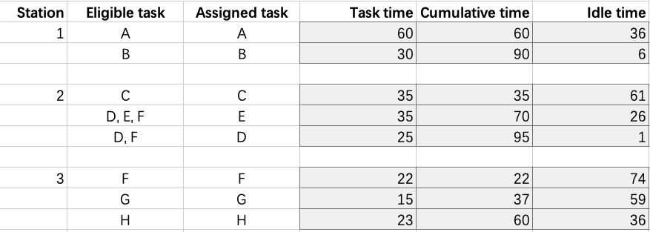

The bottleneck in this solution is workstation 2 since the cumulative task time is the highest here and idle time is the least, which means the other workstation need to wait for workstation 2 to work for the next cycle. Therefore, workstation 2 is the bottleneck in the solution.

* Propose a different assignment of tasks that completes the tasks in a valid order, but where the idle times are closer, so the smallest is larger than 1 second and the biggest is less than 36 seconds. This should be easy!

Here, I first fix the only options(A,B,C,G,H) to the available positions. Then when I decides the order of D,E,F, what I want is to balance the idle time in station 2 and station 3. Therefore, I calculate the mean of cost of time as (245-60-30)/2 = 77.5. And we would like to make both of the cumulative time we assigned to station 2 and 3 close to 77.5 to improve efficiency. As a result, I choose F and D for station 2 and E for station 3. The final assignment of tasks is shown as follows and can also be referred to in the spreadsheet.

* Which workstation is the bottleneck in your solution?

The bottleneck in the new assignment is workstation 1 since the cumulative task time is the highest here and idle time is the least now, which means the other workstation need to wait for workstation 1 to work for the next cycle. Therefore, workstation 1 is the bottleneck in the solution.

To get the 5 points extra credit, email your spreadsheet to me, with an explanation of what you did, before 22 Nov 2022, 3:20 pm.