Jiahao Wu

Fan Chen

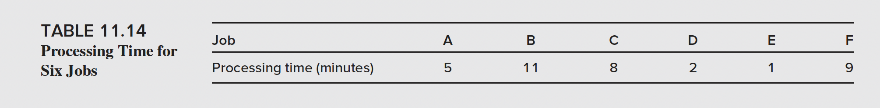

* 1. Consider the jobs displayed in Table 11.14. Assume shortest processing time is used to sequence the jobs.

1. Which job is the fourth to be processed? [11.2]

Job C is the fourth to be processed.

1. What is the flow time of job F (in minutes)? [11.2]

Flow time of job F: 1 + 2 + 5 + 8 + 9 = 25 minutes

1. What is the flow rate of jobs (jobs per minute)? [11.2]

Flow rate of jobs: $\frac{6}{5+11+8+2+1+9}=0.25 jobs/minute$

1. What is the average flow time of jobs in the system? [11.2]

Average flow time of jobs: $\frac{1+3+8+16+25+36}{6}=14.83 minutes$

1. What is the average inventory of jobs in the system? [11.2]

Average inventory of jobs: I = R

手机屏幕截图

* 1. Given the projects displayed in Table 11.15, assume FCFS is used to sequence the jobs.

1. What is the average flow rate of the projects (in projects per hour)? [11.2]

Average flow rate of projects: $\frac{8}{4+1+2+3+6+5+1+0.5}=0.36 projects/hour$

1. What is the average flow time of the projects (in hours)? [11.2]

Average flow time of projects: $\frac{4+5+7+10+16+21+22+22.5}{8}=13.4375 hours$

1. What is the average inventory of the projects (in projects)? [11.2]

Average inventory of projects: I = R $× T=0.36×13.4375=4.8375 projects$

Spreadsheet:

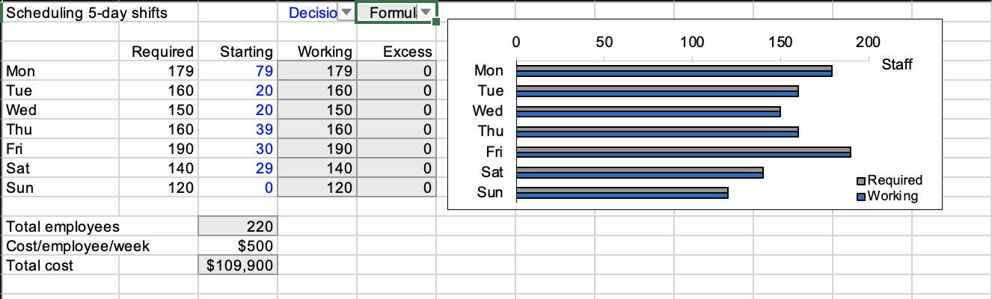

2-machine scheduling problem:

If the task is on machine one, then schedule the job as early as possible.

If the task is on machine two, then schedule the job as late as possible.

Machine one: Grinding

Machine two: Polishing

B is shortest on machine two, so we put B in the end.

E is next shortest on machine two, so we put E in the penultimate position.

C is shortest on machine one, so we put C in the first position.

A is next shortest on machine one, so we put A in the second position.

Finally, we come up with the order: CADEB, since D is last job.

Then, we also calculate the specific time for finishing all these tasks.

Since the polishing work needs to be done after the grinding, we first calculate the process time for grinding, which is the additive time of each job. And for the process time for polishing, we need to consider the two related time: Grinding time for that job and Polishing time for the last job. In this case, we use the later time for the process time.

As a result, if we finish the jobs in the order of CADEB, the total time will be 205 units.