Jiahao Wu

Fan Chen

1. (Car Rental Company) The airport branch of a car rental company maintains a fleet of 50 SUVs. The interarrival time between requests for an SUV is 2.4 hours, on average, with a standard deviation of 2.4 hours. There is no indication of a systematic arrival pattern over the course of a day. Assume that, if all SUVs are rented, customers are willing to wait until there is an SUV available. An SUV is rented, on average, for 3 days, with a standard deviation of 1 day.

a. What is the average number of SUVs parked in the company’s lot? [9.6]

Demand for servers: Service time $× Arrival rate=72 ×\frac{1}{2.4}=30 SUVs$

Average number of SUVs parked in the lot = 50 – 30 = 20 SUVs

b. Through a marketing survey, the company has discovered that if it reduces its daily rental price of $80 by $25, the average demand would increase to 12 rental requests per day and the average rental duration will become 4 days. Is this price decrease warranted? Provide an analysis! [9.6]

Interarrival time = $\frac{24}{12}=2 hours$

Demand for servers: $96 ×\frac{1}{2}=48 SUVs$

Revenue: 48 $× \left(80-25\right)=\$2640$

Revenue: 30 $× 80=\$2400$

2640 > 2400, so the price decrease warranted and valuable.

c. What is the average time a customer has to wait to rent an SUV? Please use the initial parameters rather than the information in part (b). [9.6]

Expected waiting time from textbook exhibit 9.1:

Utilization: U= $\frac{processing time}{interarrival time × number of servers}$

$T_{q}= \frac{72}{50} ×\frac{{0.6}^{\sqrt{2×\left(50+1\right)}-1}}{0.4}×\frac{1^{2}+{0.33}^{2}}{2}=0.019hours$

d. How would the waiting time change if the company decides to limit all SUV rentals to exactly 4 days? Assume that if such a restriction is imposed, the average interarrival time will increase to 3 hours, with the standard deviation changing to 3 hours. [9.6]

2. (Atlantic Video) Atlantic Video, a small video rental store in Philadelphia, is open 24 hours a day, and—due to its proximity to a major business school—experiences customers arriving around the clock. A recent analysis done by the store manager indicates that there are 30 customers arriving every hour, with a standard deviation of interarrival times of 2 minutes. This arrival pattern is consistent and is independent of the time of day.The checkout is currently operated by one employee, who needs on average 1.7 minutes to check out a customer. The standard deviation of this checkout time is 3 minutes, primarily as a result of customers taking home different numbers of videos.

a. If you assume that every customer rents at least one video (i.e., has to go to the checkout), what is the average time a customer has to wait in line before getting served by the checkout employee, not including the actual checkout time (within 1 minute)? [9.5]

$$T_{q}=processing time × \frac{Utilization}{1-utilization} × \frac{CV_{α}^{2}+CV_{p}^{2}}{2}$$

$$T_{q}=1.7×\frac{0.85}{0.15} ×\frac{1^{2}+{(\frac{3}{1.7})}^{2}}{2}=19.82mins$$

b. If there are no customers requiring checkout, the employee is sorting returned videos, of which there are always plenty waiting to be sorted. How many videos can the employee sort over an 8-hour shift (assume no breaks) if it takes exactly 1.5 minutes to sort a single video? [9.5]

Utilization for sorting the video: 1 – 0.85 = 0.15

Number of videos can be sorted: $\frac{0.15×8×60}{1.5}=48 videos$

c. What is the average number of customers who are at the checkout desk, either waiting or currently being served (within 1 customer)? [9.5]

Average number of customers waiting in line: I = R $× T_{q}=0.5 ×19.82=9.91≈10$

Average number of customers being served: 0.85

Average number of customers who are at the checkout desk: 9.91+0.85=10.76 $≈11$

d. Now assume for this question only that 10 percent of the customers do not rent a video at all and therefore do not have to go through checkout. What is the average time a customer has to wait in line before getting served by the checkout employee, not including the actual checkout time (within 1 minute)? Assume that the coefficient of variation for the arrival process remains the same as before. [9.5]

$$T_{q}=1.7×\frac{0.77}{0.23} ×\frac{1^{2}+{(\frac{3}{1.7})}^{2}}{2}=11.71mins$$

e. As a special service, the store offers free popcorn and sodas for customers waiting in line at the checkout desk. (Note: The person who is currently being served is too busy with paying to eat or drink.) The store owner estimates that every minute of customer waiting time costs the store 75 cents because of the consumed food. What is the optimal number of employees at checkout? Assume an hourly wage rate of $10 per hour. [9.8]

$${Two employees: T}_{q}= \frac{1.7}{2} ×\frac{{0.425}^{\sqrt{2×\left(2+1\right)}-1}}{0.575}×\frac{1^{2}+{(\frac{3}{1.7})}^{2}}{2}=0.88mins$$

Total cost: 0.75 $×30×0.88+10×2=\$39.8/hour$

Three employees: $T_{q}= \frac{1.7}{3} ×\frac{{0.28}^{\sqrt{2×\left(3+1\right)}-1}}{0.72}×\frac{1^{2}+{(\frac{3}{1.7})}^{2}}{2}=0.162mins$

Total cost: 0.75 $×30 ×0.162+10×3=\$33.645/hour$

Four employees: $T_{q}= \frac{1.7}{4} ×\frac{{0.2125}^{\sqrt{2×\left(4+1\right)}-1}}{0.7875}×\frac{1^{2}+{(\frac{3}{1.7})}^{2}}{2} 0.039mins$

Total cost: 0.75 $×30×0.039+10× 4=\$40.8775/hour$

So, three employees would be optimal, because when the number of employees reach at 4 or above 4, the total cost would at least bigger than 40, which is > $33.645/hour.

3. (Loss System) Flow units arrive at a demand rate of 55 units per hour. It takes, on average,

six minutes to serve a flow unit. Service is provided by seven servers.

1. What is the probability that all seven servers are utilized?

表格

45.6% chance that all seven servers are utilized.

1. How many units are served every hour?

0.498 units/min = 29.88 units/hour

c. How many units are lost every hour?

0.418 units/min = 25.08 units/hour

4.(Gas Station) Consider the situation of Mr. R. B. Cheney, who owns a large gas station on a highway in Vermont. In the afternoon hours, there are, on average, 1,000 cars per hour passing by the gas station, of which 2 percent would be willing to stop for refueling. However, since there are several other gas stations with similar prices on the highway, potential customers are not willing to wait and bypass Cheney’s gas station. The gas station has six spots that can be used for filling up vehicles and it takes a car, on average, five minutes to free up the spot again (includes filling up and any potential delay caused by the customer going inside the gas station).

a. What is the probability that all six spots are taken?

0.8% chance that all six spots are taken.

b. How many customers are served every hour?

0.331 customers/minute = 19.86 customers/hour.

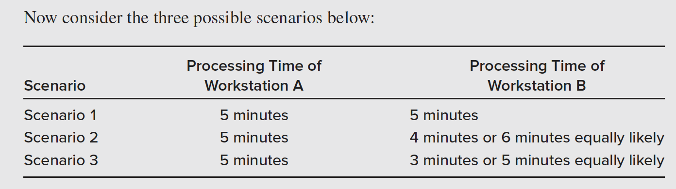

1. Which of the three scenarios will have, on average, the highest flow rate?

Scenario 1: $\frac{1}{5}=0.2$ unit/min

Scenario 2: $\frac{1}{5}=0.2unit/\min{or \frac{1}{6}=0.17 unit/min}$

$$\frac{0.2+0.17}{2}=0.185unit/min$$

Scenario 3: $\frac{1}{5}=0.2unit/min$

Scenarios 1 and 3 would have highest flow rate/

b. Which of the three scenarios will have, on average, the lowest flow time?

Average flow time 1: 5+5=10 minutes

Average flow time 2: $\frac{9+11}{2}=10 minutes$

Average flow time 3: $\frac{8+10}{2}=9minutes$

Thus, scenario 3 would have the lowest flow time.