Pawnshop Management System

**Software Requirements Specification**

Version 1.0

Danang, Sep 2016

**TABLE OF CONTENTS**

**TABLE OF CONTENTS** 2

1. DOCUMENT HISTORY 3

2. REFERENCE DOCUMENTS 3

3. DISTRIBUTION LIST AND APPROVALS 3

4. INTRODUCTION 3

4.1 Purpose 3

4.2 In Scope 3

5. OVERVIEW 4

5.1 Actors 4

5.2 System Use Case Diagram 4

5.3 System Pages Flow 8

6. Functional Description 9

6.1 Login: 9

6.2 Airlines Information Maintenance 9

6.3 Project/Contract Information Maintenance 15

7. NON-FUNCTIONAL REQUIREMENTS AND OTHERS 31

Performance 31

Scalability 31

Security 32

Infrastructure 32

Browser 32

Reliability 32

Purchased Components 32

Interfaces 32

Extensibility 32

Assumptions 32

8. APPENDIX 33

# DOCUMENT HISTORY

|  |  |  |
| --- | --- | --- |
| **Date** | **Summary of Changes** | **Version** |
| 27/09/2016 | Các thông tin về dự án | 1.0 |
|  |  |  |
|  |  |  |

# REFERENCE DOCUMENTS

|  |  |
| --- | --- |
| **Document Name** | **Description** |
|  |  |
|  |  |
|  |  |
|  |  |
|  |  |
|  |  |
|  |  |

# DISTRIBUTION LIST AND APPROVALS

This document is distributed to the following stakeholders to get their valuable comments and corrections.

|  |  |
| --- | --- |
| **Name** | **Title** |
|  |  |
|  |  |
|  |  |
|  |  |
|  |  |
|  |  |
|  |  |
|  |  |
|  |  |

# INTRODUCTION

## Purpose

Tài liệu mô tả một cách đầy đủ, toàn diện các yêu cầu của phần mêm-đó là các yêu cầu chức năng, phi chức năng, các ràng buộc về mặt thiết kế…

Tài liệu SRS mô tả các yêu cầu của phần mềm đối với toàn bộ hệ thống, và đối với từng hệ thống con. Cấu trúc giới thiệu trong tài liệu này là cấu trúc điển hình dùng cho các dự án áp dụng mô hình use-case (**use-case modeling**). Vì vậy, tài liệu sẽ trình bày các use case, mô tả cho các use case và các đặc tả bổ sung, cũng như các thông tin hỗ trợ khác

## In Scope

Phần mềm “Hệ thống quản lý tiệm cầm đồ” cung cấp các chức năng quản lý mọi hoạt động xảy ra trong tiệm cầm đồ, bao gồm: quản lý danh sách khách hàng, quản lý tài sản khách hàng cầm cố, quản lý tài sản khách hàng cầm cố, quản lý hợp đồng cầm cố, quản lý lãi suất cho cầm cố, quản lý hóa đơn và báo cáo.

Phần mềm tập trung hướng vào các đối tượng có kinh doanh cầm đồ, cụ thể là các chủ doanh nghiệp cầm đồ giúp cho việc quản lý chặt chẽ và thống nhất trong mọi hoạt động.

# OVERVIEW

## Actors

Diagram bên dưới mô tả tất cả các actors của “Hệ thống quản lý tiệm cầm đồ”.Một actor đại diện cho 1 User Role, hiện tại chúng ta có tài khoản “Chủ tiệm cầm đồ”.Tài khoản này có sở hữu những actions trong khi truy cập vào hệ thống,dựa trên quyền của nó.”Chủ tiệm cầm đồ” có các quyền để them mới, cập nhật và xóa các bản ghi trong các tính năng, chỉ có “Chủ tiệm cầm đồ” có thể truy cập hệ thống.

.

|  |  |
| --- | --- |
| **Actor** | **Description** |
| Chủ tiệm cầm đồ | Có quyền xem, thêm mới, cập nhật và xóa dữ liệu trong tất cả các modules . |
|  |  |

## System Use Case Diagram

Sơ đồ dưới đây cung cấp một bức trang tổng thể về các nhóm chức năng, Actors của dự án. Những chức năng của dự án sẽ được chia dựa vào sơ đồ “Use case” bên dưới:

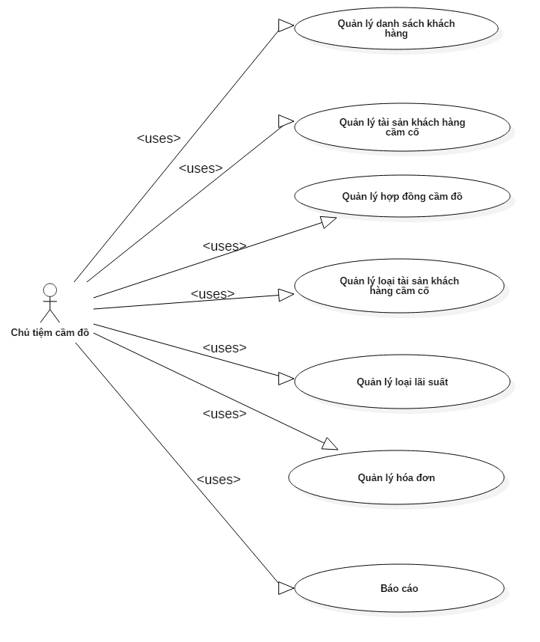

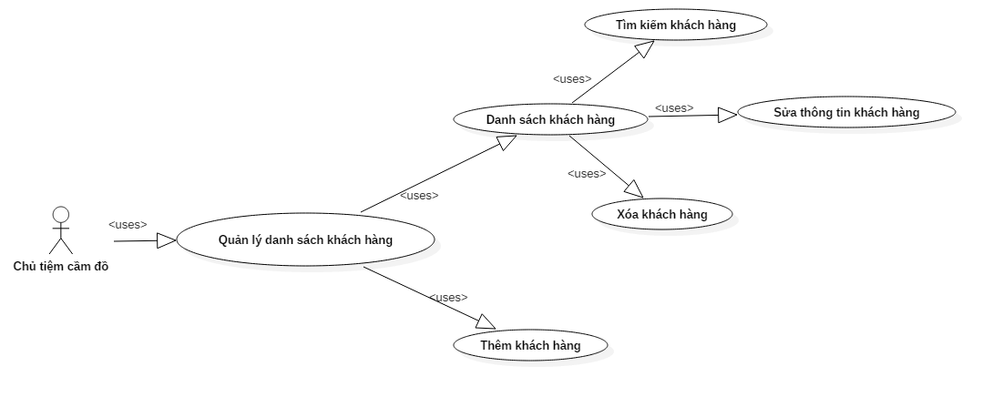

### Quản lý danh sách khách hàng - Use Case Diagram

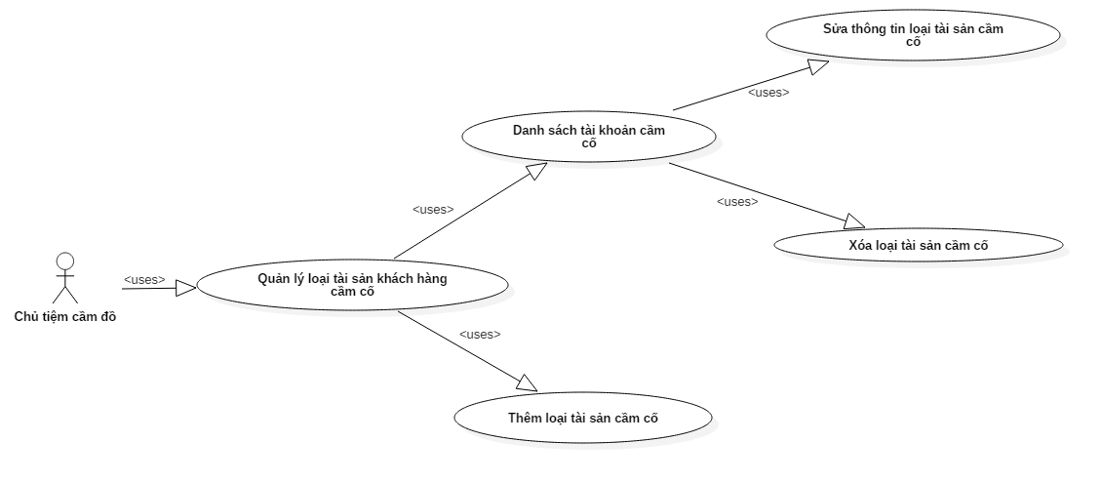

### Quản lý tài sản khách hàng cầm cố - Use Case Diagram

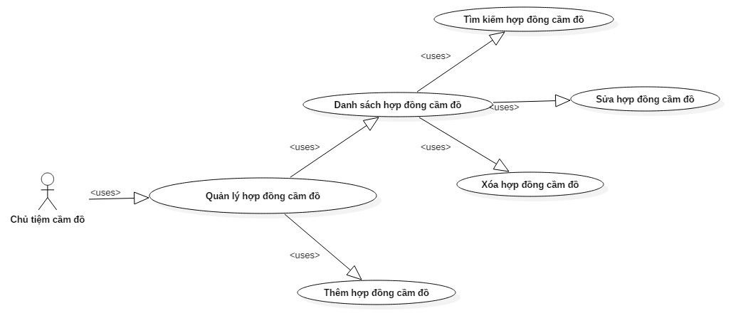

### Quản lý hợp đồng cầm đồ - Use Case Diagram



### Quản lý loại tài sản khách hàng cầm cố - Use Case Diagram

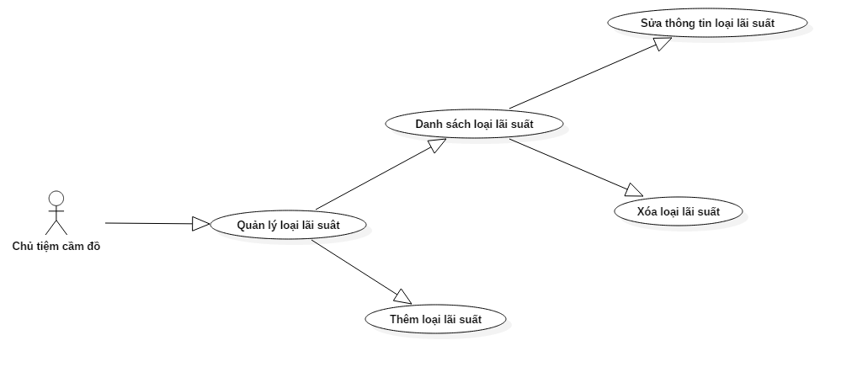

### Quản lý loại lãi suất - Use Case Diagram

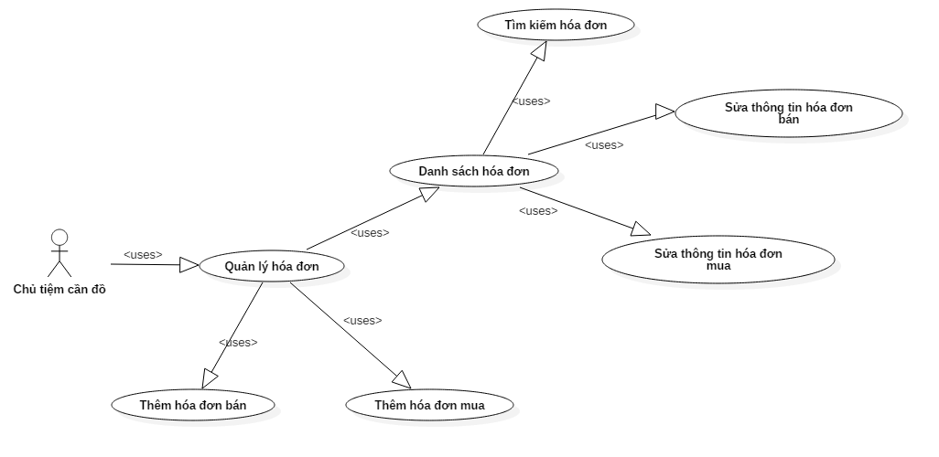

### Quản lý tài hóa đơn - Use Case Diagram

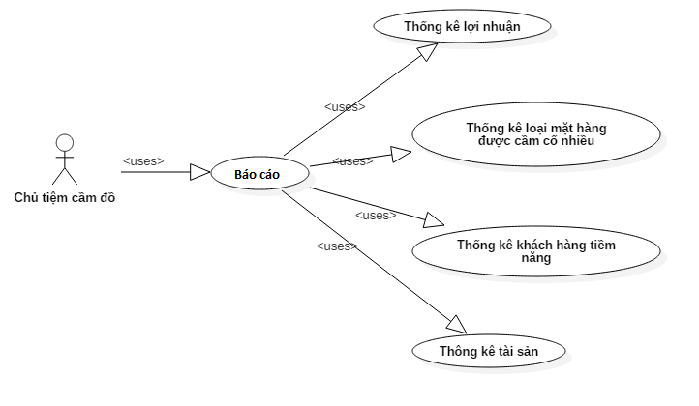

### Báo cáo - Use Case Diagram

## System Pages Flow



# Functional Description

## Login:

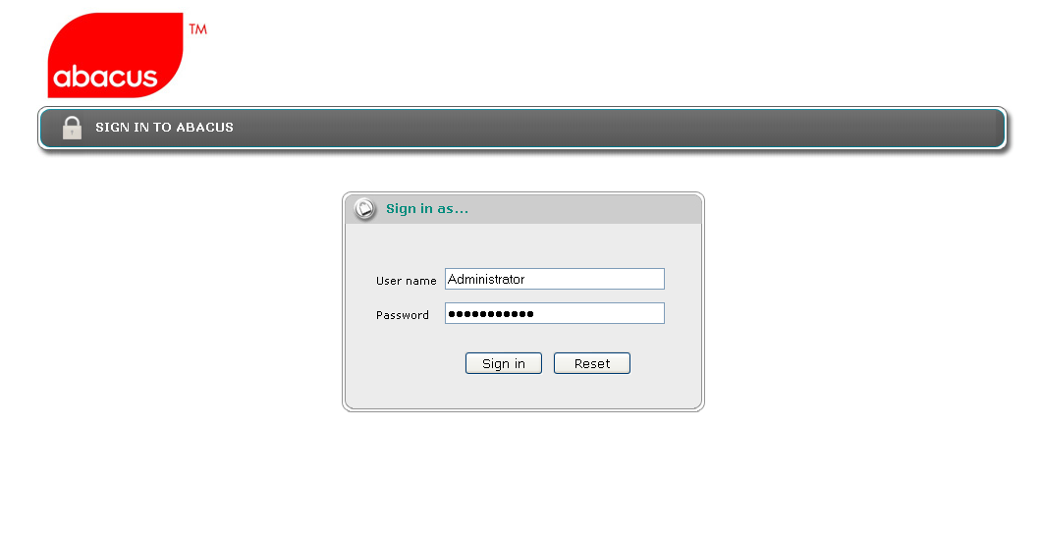

User Account ID and Password must be active directory authenticated.

The system needs to provide a login page for user to enter user id and password. System needs to validate the user id and password against Customer active directory server. Two active directory servers host name will be provided; one is primary server and the other, secondary server. The system needs to authenticate using the primary server first. If it fails due to primary server unavailability, the system will authenticate using the secondary server.

If the account can’t be found in any server, then the system throws an error message:

“Invalid user name. Please re-enter.Customer”

When executing login, the system needs to validate user account to check if it is existing in the JAVA01Resource Management System or not (user account is stored in User Account Maintenance and assigned role). If yes, then the application will lead user to default screen of JAVA01Resource Management System: View Active Project/Contract Schedule.

If not, then the application throws an error message:

“You are not authorised to use this application. Please contact the application administrator.”

## Airlines Information Maintenance

|  |  |
| --- | --- |
| Use Case Name | Airlines Information Maintenance |
| Use Case ID | JAVA01002 |
| High Level Requirement Ref | All general airlines information is queried from the DB and displayed on the screen. All Administrators and Normal User Accounts can view list of airlines, add new airlines information and update existing records. |
| Actor | Administrator, Normal User Account. |
| Description | This use case allows users to view/add new/edit airline. |
| Trigger | NA |
| Pre-condition | User has already successfully logged onto the system. |
| Post-processing |  |

### Screen Design

#### Airlines Information Maintenance - Filter



|  |  |  |  |  |  |
| --- | --- | --- | --- | --- | --- |
| **Screen** | Airlines Information Maintenance – Filter | | | | |
| **Description** | | Display query screen to filter displayed results. “All” value is set by default; the system displays all airlines information from the DB, on the screen. Then users can choose to display any airline information, by choosing value in dropdown lists of Airline Name. | | | |
| **Screen Access** | | Users click on menu **Configuration -> Airlines Information Maintenance** | | | |
| **Screen Content** | | | | | |
| **Item** | | **Type** | **Data** | **Description** | |
| Airline Name | | Dropdown list - Alpha numeric (5) | Default: All  Lookup from AIRLINE.NAME - AIRLINE.CODE, ordered by AIRLINE.NAME | * Display both name and code but name first, value is code. * User can type for searching, for example: user can type ‘S’ in the dropdown list and the system will show all airlines that started by ‘S’. | |
| **Screen Actions** | | | | | |
| **Action Name** | | **Description** | | **Success** | **Failure** |
| Filter | | List of all airlines will be ordered by AIRLINE.NAME.  When users choose any value in the above dropdown list and click Filter button then the system returns data of that airline. | | Display general data of inputted Airline code (data is selected from table AIRLINE). | Displays message “No data found.” in the Message Area. |
|  | |  | |  |  |

#### Airlines Information Maintenance - List

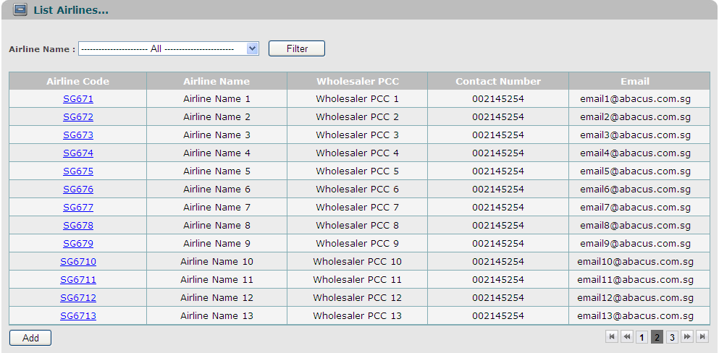

|  |  |  |  |  |  |  |
| --- | --- | --- | --- | --- | --- | --- |
| **Screen** | Airlines Information Maintenance – List | | | | | |
| **Description** | | Display all airlines information, base on Airline Code. | | | | |
| **Screen Access** | | Users click on menu **Configuration -> Airlines Information Maintenance** | | | | |
| **Screen Content** | | | | | | |
| **Item** | | **Type** | **Data** | | **Description** | |
| Airline Code | | Link - Alpha numeric (5) | Lookup from AIRLINE.CODE | | For users that are Administrators or Normal User Accounts, then airline code will be displayed as links, allow users to click on them, and go to “Update” screen. | |
| Airline Name | | Label - String (45) | Lookup from AIRLINE.NAME | |  | |
| Wholesaler PCC | | Label - Alpha numeric (5) | Lookup from AIRLINE.AGENT_CODE | |  | |
| Contact Number | | Label - Number (15) | Lookup from AIRLINE.CONTACT_NUMBER | | Phone number of the airline. | |
| Email | | Label - String (50) | Lookup from AIRLINE.EMAIL | | Email of the airline. | |
| Add | | Button |  | | For users that are Administrators or Normal User Account, then this button will be displayed, allow users to click on, and go to “Add” screen. | |
| **Screen Actions** | | | | | | |
| **Action Name** | | **Description** | | **Success** | | **Failure** |
| Update | | * If the user logged in is Administrator or Normal User Account, then airline codes are displayed as links. * The user clicks on the link, then the system leads the user to “Update” screen. | | “Update” screen is displayed. | |  |
| Add | | * This button is only displayed if logged in user is Administrator or Normal User Account. | | “Add” screen is opened. | |  |

#### Airlines Information Maintenance – Update

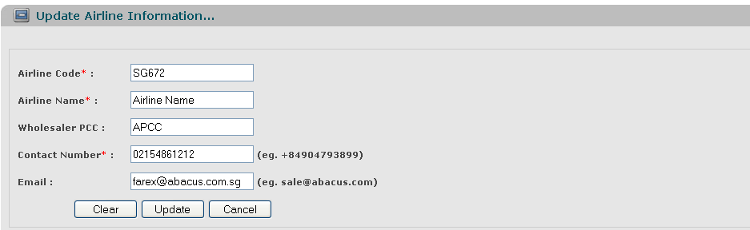

|  |  |  |  |  |  |
| --- | --- | --- | --- | --- | --- |
| **Screen** | Airlines Information Maintenance – Update. | | | | |
| **Description** | | Allow Administrator and Normal User Account to update existing records. | | | |
| **Screen Access** | | Users click on the links of Airline Code. | | | |
| **Screen Content** | | | | | |
| **Item** | | **Type** | **Data** | | **Description** |
| Airline Code | | Text field - Alpha numeric (5) | Default data is looked up from previous screen.  After changed, will be updated into AIRLINE.CODE | | This field is mandatory.  A sequence number that auto generated by database will be used as foreign key to join primary table and reference table.  So that, when we update value of any item in the main table, then that value can be referenced by other tables using foreign key. |
| Airline Name | | Text field -String (45) | Default data is looked up from previous screen.  After changed, will be updated into AIRLINE.NAME | | This field is mandatory. |
| Wholesaler PCC | | Text field - Alpha numeric (5) | Default data is looked up from previous screen.  After changed, will be updated into AIRLINE.AGENT_CODE | |  |
| Contact Number (Eg. +84904793899) | | Text field - Number (15) | Default data is looked up from previous screen.  After changed, will be updated into AIRLINE.CONTACT_NUMBER | | This field is mandatory. |
| Email (Eg. chittp@fsoft.com.vn) | | Text field - String (50) | Default data is looked up from previous screen.  After changed, will be updated into AIRLINE.EMAIL | |  |
| Clear | | Button |  | | Clear all inputted data. |
| Update | | Button |  | | Submit data. |
| Cancel | | Button |  | | Cancel update. |
| **Screen Actions** | | | | | |
| **Action Name** | | **Description** | | **Success** | **Failure** |
| Update | | Updated data will be saved into the DB. | | Back to the “List” screen with updated record on the list.  If the user chooses to update an airline from the list of all airlines, then when go back to the list from update, the updated record will be focused on. | Display message “The selected record has been removed by someone.”  Display message “The selected record has been changed by another user! Please refresh to get the latest data for your update.”    Display message: “Database connection error.”  Display message:  “Airline Code must be entered.”  Display message:  “Airline Code must be in the format of alpha numeric”.  Display message “The airline code exists in the system. Please enter a new airline code.”  Display message:  “Airline Name must be entered.”  Display message:  “Wholesaler PCC must be in the format of alpha numeric”.  Display message:  “Contact Number must be entered.”  Display message:  “Contact Number must be a number and in the format of: +650123456.”  Display message:  “Email must be in the format of abc@def.com.” |
| Clear | | Clear inputted data and reset to the previous data. | | Display “Update” screen with the previous data. |  |
| Cancel | | Close “Update” screen and return to the list. | | Return to the “List” screen (previous list before going to “Update” screen). |  |

#### Airlines Information Maintenance – Add

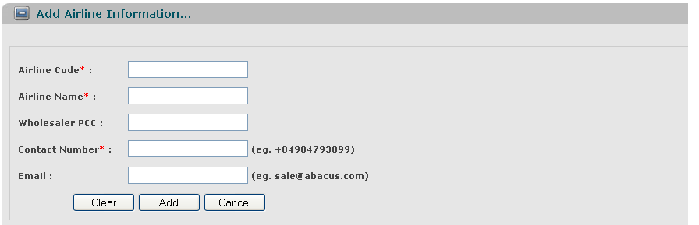

|  |  |  |  |  |  |
| --- | --- | --- | --- | --- | --- |
| **Screen** | Airlines Information Maintenance – Add | | | | |
| **Description** | | Allow Administrator and Normal User Account to add new airlines. | | | |
| **Screen Access** | | Users click on the button Add. | | | |
| **Screen Content** | | | | | |
| **Item** | | **Type** | **Data** | | **Description** |
| Airline Code | | Text field – Alpha numeric (5) | Inserted into AIRLINE.CODE | | This field is mandatory. |
| Airline Name | | Text field – String (45) | Inserted into AIRLINE.NAME | | This field is mandatory. |
| Wholesaler PCC | | Text field – Alpha numeric (5) | After being inputted, inserted into AIRLINE.AGENT_CODE | |  |
| Contact Number (Eg. +84904793899) | | Text field – Number (15) | Inserted into AIRLINE.CONTACT_NUMBER | | This field is mandatory. |
| Email (Eg. [chittp@fsoft.com.vn](mailto:chittp@fsoft.com.vn)) | | Text field – String (50) | Inserted into AIRLINE.EMAIL | |  |
| Clear | | Button |  | | Clear all inputted data. |
| Add | | Button |  | |  |
| Cancel | | Button |  | | Cancel to add new and back to “List” screen. |
| **Screen Actions** | | | | | |
| **Action Name** | | **Description** | | **Success** | **Failure** |
| Submit | | Inputted data will be saved into the DB. | | Back to the “List” screen with new record on the List (default list with all data).  When go back to the list from “Add” screen, the new record will be focused on. | Display message: “Database connection error.”  Display message “The airline code exists in the system. Please enter a new airline code.”  Display message:  “Airline Code must be entered.”  Display message:  “Airline Code must be in the format of alpha numeric”.  Display message:  “Airline Name must be entered.”  Display message:  “Wholesaler PCC must be in the format of alpha numeric”.  Display message:  “Contact Number must be entered.”  Display message:  “Contact Number must be a number and in the format of: +650123456.”  Display message:  “Email must be in the format of [abc@def.com](mailto:abc@def.com).” |
| Clear | | Clear inputted data. | | Display “Add” screen with blank data. |  |
| Cancel | | Close “Add” screen. | | Return to the “List” screen (default list with all data). |  |

## Project/Contract Information Maintenance

|  |  |
| --- | --- |
| Use Case Name | Project/Contract Information Maintenance |
| Use Case ID | JAVA01004 |
| High Level Requirement Ref | Displays all projects/contracts in the system, on the screen; should be sorted by contract number. |
| Actor | Administrator, Normal User Account. |
| Description | This use case allows users to view/add new/edit project/contract. |
| Trigger | NA |
| Pre-condition | User has already successfully logged onto the system |
| Post-processing |  |

### Screen Design

#### Project/Contract Information Maintenance - Filter

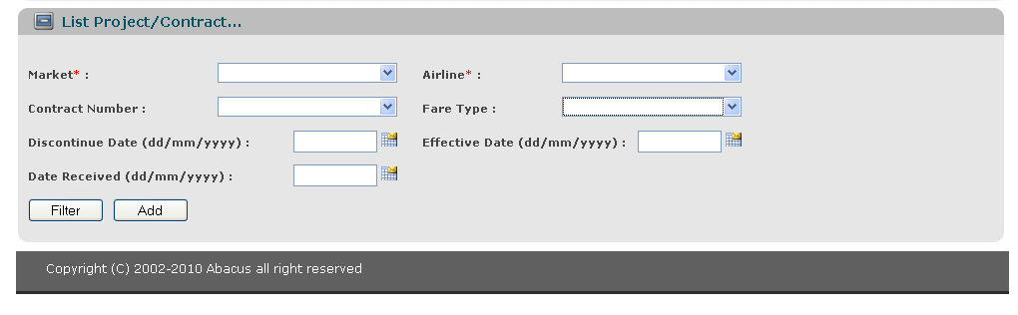

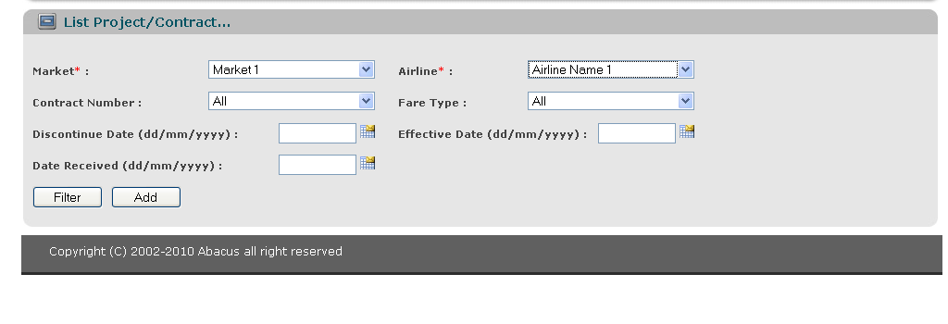

|  |  |  |  |  |  |  |
| --- | --- | --- | --- | --- | --- | --- |
| **Screen** | Project/Contract Information Maintenance – Filter | | | | | |
| **Description** | | Display query screen to filter displayed results. “Blank” value is set by default for all filters. No data is displayed. Then users can choose to display any project/contract information, by choosing value in dropdown lists of Market/Airline/Contract Number/Fare Type/Date Received/Effective Date/Discontinue Date.   1. If user only inputs Discontinue Date -> the system will display all contracts that have Discontinue Date earlier than or equals to inputted < Discontinue Date > 2. If user only inputs Effective Date - > the system will display all contracts that have Effective Date later than or equals to < Effective Date > 3. If user doesn’t input any Date -> the system will display all contracts. 4. If user inputs both Discontinue Date and Effective Date ->the system will display all contracts that have Effective Date and Discontinue Date between [Effective Date, Discontinue Date] 5. If user only inputs Date Received then the system will display all contracts that have Date Received equals to < Date Received > | | | | |
| **Screen Access** | | Users click on menu **Configuration -> Project/Contract Information Maintenance** | | | | |
| **Screen Content** | | | | | | |
| **Item** | | **Type** | **Data** | | **Description** | |
| Market | | Dropdown list – String (50) | Default: Blank  Lookup from COUNTRY.NAME, ordered by COUNTRY. NAME | | User can type free text to search for country.  Because of issue with performance when loading data, we don’t display all countries at the same time. | |
| Airline | | Dropdown list - Alpha numeric (5) | Default: Blank  Lookup from AIRLINE.NAME - AIRLINE.CODE, ordered by AIRLINE.NAME (store AIRLINE.CODE) | | Display both code and name but value stored is AIRLINE.CODE  User can type free text to search for airline.  Because of issue with performance when loading data, we don’t display all airlines at the same time. | |
| Contract Number | | Dropdown list - Alpha numeric (20) | Default: Blank  Lookup from CONTRACT.CONTRACT_NUMBER, ordered by CONTRACT.CONTRACT_NUMBER | | Value stored is CONTRACT.CODE  User can type free text to search for contract number.  “All” will be stored as a value, allow user to choose to collect data of all contracts.  All Contract Numbers will be corresponding displayed after user chooses any Market and Airline (the system will execute filtering whenever both Market and Airline inputted). | |
| Fare Type | | Dropdown list - String (1) | Default: Blank  Lookup from FARE_TYPE.NAME - FARE_TYPE.CODE and displayed in dropdown list, ordered by FARE_TYPE.NAME | | User can type free text to search for fare type.  “All” will be stored as a value, allow user to choose to collect data of all fare types.  All Fare Types will be displayed after user chooses any Market and Airline (Fare Type is not belong to any Market or Airline and the system will execute filtering whenever both Market and Airline inputted). | |
| Date Received | | Text field – Date (Date Picker) |  | |  | |
| Effective Date (dd/mm/yyyy) | | Text field – Date (Date Picker) |  | |  | |
| Discontinue Date (dd/mm/yyyy) | | Text field – Date (Date Picker) |  | |  | |
|  | |  |  | |  | |
| **Screen Actions** | | | | | | |
| **Action Name** | | **Description** | | **Success** | | **Failure** |
| Filter | | List of all contracts will be ordered by Contract Number.  When users choose any value in the above four dropdown lists/enter or pick any date in Date Picker, then click Filter button, the system returns data of that Contract Number/Airline. | | Display general data of inputted Market/Airline/Contract Number/Fare Type/Date Received/Effective Date/Discontinue Date (data is selected from table CONTRACT). | | Displays message “No data found.” in the Message Area.  Display message “Please select Market to filter.”  Display message “Please select Airline to filter.”  Display message:  “Date Received must be a Date type.”  Display message:  “Effective Date must be a Date type.”  Display message:  “Discontinue Date must be a Date type.”  Display message:  “Discontinue Date must be later than or equals to Effective Date.” |
|  | |  | |  | |  |

#### Project/Contract Information Maintenance – List

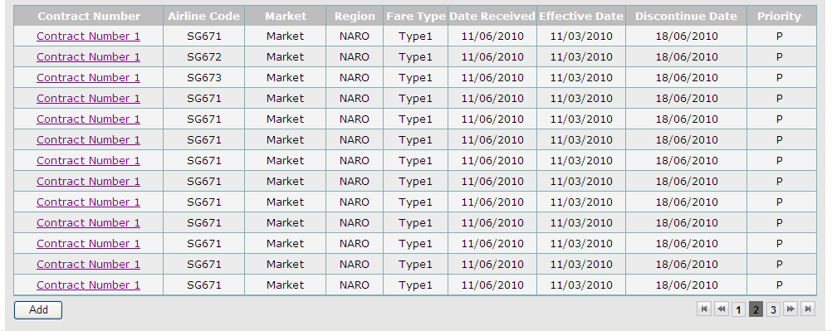

|  |  |  |  |  |  |  |
| --- | --- | --- | --- | --- | --- | --- |
| **Screen** | Project/Contract Information Maintenance – List | | | | | |
| **Description** | | Display all projects/contracts information, base on Market/Airline/Contract Number/Fare Type/Date Received/Effective Date/Discontinue Date. | | | | |
| **Screen Access** | | Users click on menu **Configuration -> Project/Contract Information Maintenance** | | | | |
| **Screen Content** | | | | | | |
| **Item** | | **Type** | **Data** | | **Description** | |
| Contract Number | | Link - Alpha numeric (20). | Lookup from CONTRACT.CONTRACT_NUMBER | | For users that are Administrator or Normal Users Account, then Contract Number will be displayed as links, allow users to click on them, and go to “Update” screen. | |
| Airline Code | | Label - Alpha numeric (5) | Lookup from AIRLINE.CODE, link by COUNTRY.AIRLINE_ID = AIRLINE.ID | |  | |
| Market | | Label - String (50) | Lookup from COUNTRY.NAME, link by COUNTRY.CODE = CONTRACT.COUNTRY_CODE | |  | |
| Region | | Label - String (10) | Lookup from REGION.CODE | | NARO, SARO. | |
| Fare Type | | Label - String (1) | Lookup from FARE_TYPE.NAME | | 'Seasonal', 'Promotion' and 'Corporate'. | |
| Date Received | | Label – Date | Lookup from CONTRACT.DATE_RECEIVED | | The date that contract is received from Agent. | |
| Effective Date | | Label – Date | Lookup from CONTRACT.EFFECTIVE_DATE | | The date that contract is applied. | |
| Discontinue Date | | Label – Date | Lookup from CONTRACT.DISCONTINUE_DATE | | This is a date that states when the fares are discontinuing. NO relationship with the contract end date or so. | |
| Priority | | Label - Number (1) | Lookup from PRIORITY.NAME | | Priority of contract.  0 - Promo  1 - Pt to Pt  2 – Complex | |
| Add | | Button |  | | For users that are Administrators or Normal User Account, then this button will be displayed, allow users to click on, and go to “Add” screen. | |
| **Screen Actions** | | | | | | |
| **Action Name** | | **Description** | | **Success** | | **Failure** |
| Update | | * If the user logged in is Administrator or Normal User Account, then Contract Numbers are displayed as links. * The user clicks on the link, then the system leads the user to “Update” screen. | | “Update” screen is displayed. | |  |
| Add | | * This button is only displayed if logged in user is Administrator or Normal User Account. | | “Add” screen is opened. | |  |

#### Project/Contract Information Maintenance – Update

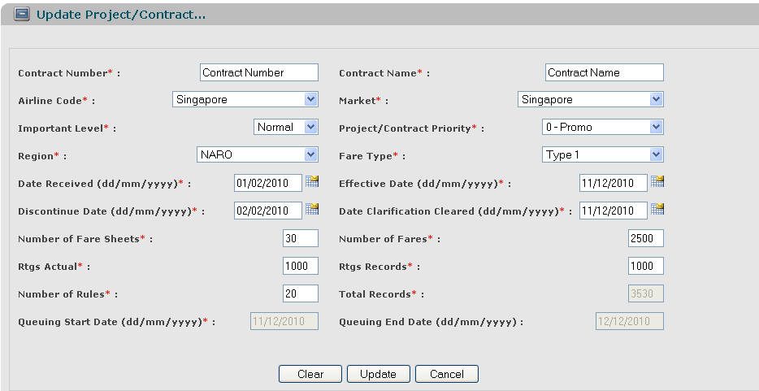

|  |  |  |  |  |  |  |
| --- | --- | --- | --- | --- | --- | --- |
| **Screen** | | Project/Contract Information Maintenance – Update | | | | |
| **Description** | | | Allow Administrator and Normal User Account to update existing records.  For all completed contracts, terminated contracts, user only can view data, can’t edit data. | | | |
| **Screen Access** | | | Users click on the links of Contract Numbers. | | | |
| **Screen Content** | | | | | | |
| **Item** | | | **Type** | **Data** | | **Description** |
| Contract Number | | | Text field - Alpha numeric (20). | Default data is looked up from previous action (getting data from the DB and displaying on the list)  After changed, will be  updated into CONTRACT.CONTRACT_NUMBER | | A sequence number that auto generated by database will be used as foreign key to join primary table and reference table.  So that, when we update value of any item in the main table, then that value can be referenced by other tables using foreign key.  For completed and terminated contracts, this field is label, can’t be edited. |
| Contract Name | | | Text field – String (100) | Default data is looked up from previous action (getting data from the DB and displaying on the list)  After changed, will be  updated into CONTRACT.CONTRACT_NAME | | This field is mandatory.  For completed and terminated contracts, this field is label, can’t be edited. |
| Airline Code | | | Dropdown list - Alpha numeric (5) | Lookup from AIRLINE.NAME - AIRLINE.CODE and displayed in dropdown list, default value is the value of the current record (ordered by AIRLINE.NAME). After being chosen, SEQUENCE NUMBER of selected airline will be updated into CONTRACT.AIRLINE_ID | | Display both code and name but value stored is AIRLINE.CODE  For completed and terminated contracts, this field is label, can’t be edited. |
| Market | | | Dropdown list - String (50) | Lookup from COUNTRY.NAME, displayed as dropdown list, default is the value of the current record (ordered by COUNTRY. NAME). After changed, will be updated into CONTRACT.COUNTRY_CODE. | | This field is mandatory.  For completed and terminated contracts, this field is label, can’t be edited. |
| Important Level | | | Dropdown list | Default value is the value of the selected contract, lookup from CONTRACT.IMPORTANT_LEVEL | | For on-going, future contracts and unassigned contracts, this field is displayed as dropdown list. But for on-going and future contracts, when user chooses to change Important Level in the dropdown list, the system will display a dialog that informs user need to terminate the contracts first and then create new contracts. User can’t change Important Level directly here.  For completed and terminated contracts, this field is label, can’t be edited. |
| Priority | | | Dropdown list - Number (1) | Lookup from PRIORITY.NAME - PRIORITY.CODE and displayed in dropdown list, default value is the value of the current record (ordered by PRIORITY.NAME). After being chosen, inserted into CONTRACT.PRIORITY_CODE | | This field is mandatory.  Display both code and name but value stored is PRIORITY.CODE  For completed and terminated contracts, this field is label, can’t be edited. |
| Region | | | Dropdown list - String (10) | Lookup from REGION.NAME - REGION.CODE and displayed in dropdown list, default value is the value of the current record (ordered by REGION.NAME). After being chosen, SEQUENCE NUMBER of selected region will be updated into CONTRACT.REGION_ID | | This field is mandatory.  Display both code and name but value stored is REGION.CODE  For completed and terminated contracts, this field is label, can’t be edited. |
| Fare Type | | | Dropdown list - String (1) | Lookup from FARE_TYPE.NAME - FARE_TYPE.CODE and displayed in dropdown list, default value is the value of the current record (ordered by FARE_TYPE.NAME). After being chosen, update into CONTRACT.FARE_TYPE | | This field is mandatory.  Display both code and name but value stored is FARE_TYPE.CODE  For completed and terminated contracts, this field is label, can’t be edited. |
| Date Received (dd/mm/yyyy) | | | Text field – Date (Date Picker) | Default data is looked up from previous action (getting data from the DB and displaying on the list)  After changed, will be  updated into CONTRACT.DATE_RECEIVED | | This field is mandatory.  The date when Customer received the fares from clients.  For completed and terminated contracts, this field is label, can’t be edited. |
| Effective Date (dd/mm/yyyy) | | | Text field – Date (Date Picker) | Default data is looked up from previous action (getting data from the DB and displaying on the list)  After changed, will be  updated into CONTRACT.EFFECTIVE_DATE | | This field is mandatory.  The date shows the validity of the Fares.  For completed and terminated contracts, this field is label, can’t be edited. |
| Discontinue Date (dd/mm/yyyy) | | | Text field – Date (Date Picker) | Default data is looked up from previous action (getting data from the DB and displaying on the list)  After changed, will be  updated into CONTRACT.DISCONTINUE_DATE | | This field is mandatory.  The date shows the validity of the Fares.  For completed and terminated contracts, this field is label, can’t be edited. |
| Number of Fare Sheets | | | Text field - Number (3) | Default data is looked up from previous action (getting data from the DB and displaying on the list)  After changed, will be  updated into CONTRACT.FARE_SHEETS | | The number of fare sheets that Customer gets from airlines. We don't care for the format of these sheets; we only need to care for the number of sheets.  This field is mandatory.  For completed and terminated contracts, this field is label, can’t be edited. |
| Number of Fares | | | Text field - Number (5) | Default data is looked up from previous action (getting data from the DB and displaying on the list)  After changed, will be  updated into CONTRACT.NUMBER_OF_FARES | | Total fare records of all fare sheets.  This field is mandatory.  For completed and terminated contracts, this field is label, can’t be edited. |
| Date Clarification Cleared (dd/mm/yyyy) | | | Text field – Date (Date Picker) | Default data is looked up from previous action (getting data from the DB and displaying on the list)  After changed, will be  updated into CONTRACT.DATE_CLARIFICATION_CLEARED | | The date when Customer cleared all the doubts on the Fares with clients.  This field is mandatory.  For completed and terminated contracts, this field is label, can’t be edited. |
|  | | |  |  | |  |
| Rtgs Actual | | | Text field - Number (5) | Default data is looked up from previous action (getting data from the DB and displaying on the list)  After changed, will be  updated into CONTRACT.RTGS_ACTUAL | | This field is mandatory.  For completed and terminated contracts, this field is label, can’t be edited. |
| Rtgs Records | | | Text field - Number (5) | Default data is looked up from previous action (getting data from the DB and displaying on the list)  After changed, will be  updated into CONTRACT.RTGS_RECORDS | | This field is mandatory.  For completed and terminated contracts, this field is label, can’t be edited. |
| Number of Rules | | | Text field - Number (3) | Default data is looked up from previous action (getting data from the DB and displaying on the list)  After changed, will be  updated into CONTRACT.RULES | | This field is mandatory.  For completed and terminated contracts, this field is label, can’t be edited. |
| Total Records | | | Label - Number (8) | Default data is looked up from previous action (getting data from the DB and displaying on the list)  After changed, will be  updated into CONTRACT.TOTAL_RECORDS | | This field is mandatory.  This field is auto-populated, equals to: Number of Fares + Rtgs Records + Number of Rules  For completed and terminated contracts, this field is label, can’t be edited. |
| Queuing Start Date (dd/mm/yyyy) | | | Label – Date (Date Picker) | Default data is looked up from previous action (getting data from the DB and displaying on the list)  After changed, will be  updated into CONTRACT.QUEUING_START_DATE | | This field is mandatory.  Queuing Start Date = Date Clarification Cleared. This field is auto-populated after Date Clarification Cleared is inputted.  For completed and terminated contracts, this field is label, can’t be edited. |
| Queuing End Date (dd/mm/yyyy) | | | Label – Date (Date Picker) | Default data is looked up from previous action (getting data from the DB and displaying on the list)  After changed, will be updated into CONTRACT. QUEUING_END_DATE | | Queuing End Date = Expected Start Date.  This field is auto-populated after Expected Start Date is inputted.  For completed and terminated contracts, this field is label, can’t be edited. |
| Clear | | | Button |  | | Clear all inputted data.  For completed and terminated contracts, this button is not displayed. |
| Update | | | Button |  | | Update all inputted data into the DB.  For completed and terminated contracts, this button is not displayed. |
| Cancel | | | Button |  | | Cancel action and return to the List.  For completed and terminated contracts, this button is not displayed. |
| Back | | | Button |  | | This button is displayed for completed and terminated contracts.  When click this button, will go to the screen List (previous list, before go to screen Update). |
| **Screen Actions** | | | | | | |
| **Action Name** | **Description** | | | | **Success** | **Failure** |
| Update | 1. **User increases the number of total records**   Ex: a. Contract A is scheduled from 1st Feb to 10th Feb.  b. On 8th Feb, user retrieves contract information and increase the number of total records.   * **System collects all the contracts that are scheduled to start after 8th Feb, and display on the screen.**   **Refer to** Vendor Resources Maintenance – List Affected Contracts   * **System removes the schedules of the contracts that start after 8th Feb and moves the resources to the pool.** * **System proposes new schedules of contracts that are removed in the previous step.**   **Refer to** Vendor Resources Maintenance – Proposed Schedules   * **System updates the schedule of contract A with new expected end date based on the number of total records increased.**  1. **User decreases the number of total records assigned**   Ex: a. Contract A is scheduled from 1st Feb to 10th Feb.  b. On 8th Feb, user retrieves contract A information and decrease the number of total records.   * **System collects all the contracts that are scheduled to start after 8th Feb, and display on the screen.** * **Refer to** **Vendor Resources Maintenance – List Affected Contracts** * **System removes the schedules of the contracts that start after 8th Feb and moves the resources to the pool.** * **System proposes new schedules of contracts that are removed in the previous step.**   **Refer to** Vendor Resources Maintenance – Proposed Schedules   * **System updates the schedule of contract A with new expected end date based on the number of total records decreased.**  1. **User changes Important Level of contract**   User can change important level of the contract whenever the selected contract hasn’t been assigned to any vendor.  For on-going and future contracts, the user needs to terminate the current contract and start new contract with remain records (when user chooses to change Important Level in the dropdown list, the system will display a dialog that informs user need to terminate the contracts first and then create new contracts. User can’t change Important Level directly here.) | | | | Back to the “List” screen with updated record on the list.  If the user chooses to update a contract from the list of all contracts, then when go back to the list from update, the updated record will be focused on. | Display message “The selected record has been removed by someone.”  Display message “The selected record has been changed by another user! Please refresh to get the latest data for your update.”  Display message: “Database connection error.”  Display message “The project/contract exists in the system. Please enter a new Contract Number.”  Display message:  “Contract Number must be entered.”  Display message:  “Contract Number must be in the format of alpha numeric.”  Display message:  “Contract Name must be entered.”  Display message:  “Date Received must be entered.”  Display message:  “Date Received must be a Date type.”  Display message:  “Effective Date must be entered.”  Display message:  “Effective Date must be a Date type.”  Display message:  “Discontinue Date must be entered.”  Display message:  “Discontinue Date must be a Date type.”  Display message:  “Number of Fare Sheets must be entered.”  Display message:  “Number of Fare Sheets must be a number and > 0.”  Display message:  “Number of Fares must be entered.”  Display message:  “Number of Fares must be a number and > 0.”  Display message:  “Date Clarification Cleared must be entered.”  Display message:  “Date Clarification Cleared must be a Date type.”  Display message:  “Rtgs Actual must be entered.”  Display message:  “Rtgs Actual must be a number and > 0.”  Display message:  “Rtgs Records must be entered.”  Display message:  “Rtgs Records must be a number and > 0.”  Display message:  “Number of Rules must be entered.”  Display message:  “Number of Rules must be a number and > 0.”  Display message:  “Date Clarification must be later than or equals to Date Received.”  Display message:  “Discontinue Date must be later than or equals to Effective Date.”  Display message:  “Discontinue Date must be later than or equals to Date Clarification.” |
| Clear | Clear inputted data and reset to the previous data. | | | | Display “Update” screen with the previous data. |  |
| Cancel | Close “Update” screen and return to the list. | | | | Return to the “List” screen (previous list). |  |

#### Project/Contract Information Maintenance – Contract Termination Announcement.

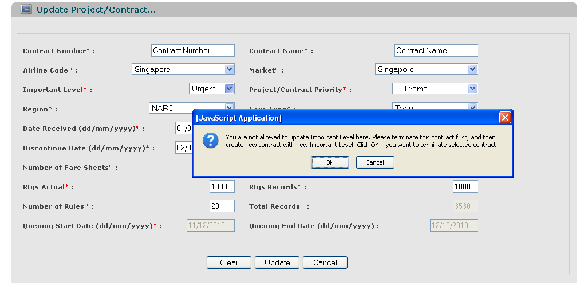

|  |  |  |  |  |  |
| --- | --- | --- | --- | --- | --- |
| **Screen** | Project/Contract Information Maintenance – Inform user to terminate contract. | | | | |
| **Description** | | When user choose to update Important Level of an active contract schedule, the system displays a dialog to inform user has to terminate the contract first, then create new another contract with new Important Level. User can’t update directly Important Level of an active contract schedule. | | | |
| **Screen Access** | | User chooses to update Important Level of an active contract schedule. | | | |
| **Screen Content** | | | | | |
| **Item** | | **Type** | **Data** | | **Description** |
| “You are not allowed to update Important Level here. Please terminate this contract first, and then create new contract with new Important Level. Click OK if you want to terminate selected contract.” | | Label |  | | Information message.  In the case if user is viewing Active Project/Contract Maintenance screen, then we only display message:  “You are not allowed to update Vendor Name/Important Level here. Please terminate this contract first, and then create new contract with new Vendor Name/Important Level.”  And display button OK.  When user clicks on button OK, the system stands on the same screen. |
| OK | | Button |  | | If user really wants to terminate selected contract, he can click on the button and go to “Update” screen of Active Project/Contract schedule and terminate contract. |
| Cancel | | Button |  | | Back to “Update” screen. |
|  | |  |  | |  |
| **Screen Actions** | | | | | |
| **Action Name** | | **Description** | | **Success** | **Failure** |
| OK | |  | | * Go to “Update” screen of active project/contract schedule. | Displays message “Database connection error.” |
| Cancel | |  | | * Back to “Update” screen, user can’t change Important Level of the current record. |  |

#### Project/Contract Information Maintenance – Add

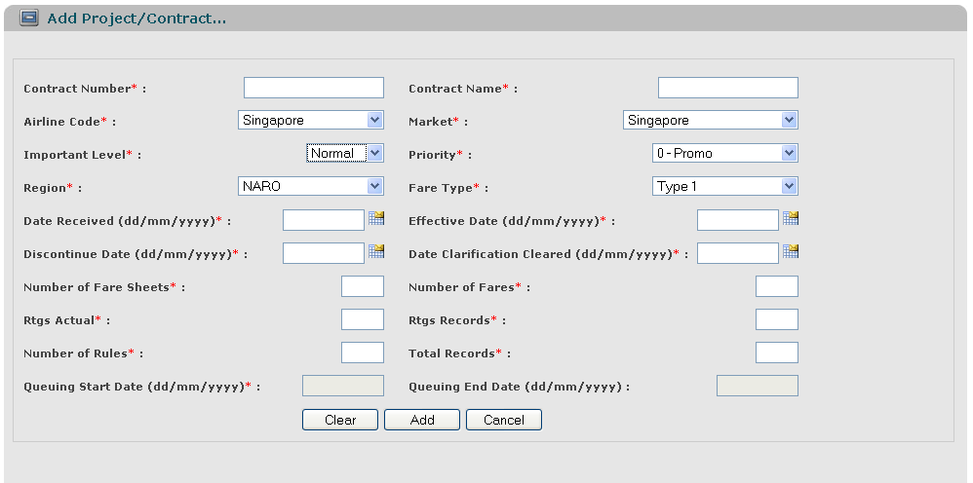

|  |  |  |  |  |  |
| --- | --- | --- | --- | --- | --- |
| **Screen** | Project/Contract Information Maintenance – Add | | | | |
| **Description** | | Allow Administrator and Normal User Account to add new projects/contracts. | | | |
| **Screen Access** | | Users click on the button Add. | | | |
| **Screen Content** | | | | | |
| **Item** | | **Type** | **Data** | | **Description** |
| Contract Number | | Text field - Alpha numeric (20) | Inserted into CONTRACT.CONTRACT_NUMBER | | This field is mandatory. |
| Contract Name | | Text field – String (100) | Inserted into CONTRACT.NAME | | For displaying Job Name in reports section.  This field is mandatory. |
| Airline Code | | Dropdown list - Alpha numeric (5) | Lookup from AIRLINE.NAME - AIRLINE.CODE and displayed in dropdown list, default value is the first value (order by AIRLINE.NAME). After being chosen, SEQUENCE NUMBER of selected airline will be inserted into CONTRACT.AIRLINE_ID | |  |
| Market | | Dropdown list - String (50) | Lookup from COUNTRY.NAME, displayed as dropdown list, default is the first value of the list (ordered by COUNTRY.NAME). After being chosen, will be inserted into CONTRACT.COUNTRY_CODE. | |  |
| Important Level | | Dropdown list | Normal,  Urgent  Default value is “Normal”.  After being chosen, inserted into CONTRACT.IMPORTANT_LEVEL | |  |
| Priority | | Dropdown list - Number (1) | Lookup from PRIORITY_NAME - PRIORITY.CODE and displayed in dropdown list, default value is the first value (ordered by PRIORITY.NAME). After being chosen, inserted into CONTRACT.PRIORITY_CODE | |  |
| Region | | Dropdown list - String (10) | Lookup from REGION.NAME - REGION.CODE and displayed in dropdown list, default value is the first value (order by REGION.NAME). After being chosen, SEQUENCE NUMBER of selected region will be inserted into CONTRACT.REGION_ID | |  |
| Fare Type | | Dropdown list - String (1) | Lookup from FARE_TYPE.NAME - FARE_TYPE.CODE and displayed in dropdown list, default value is the first value (order by FARE_TYPE.NAME). After being chosen, inserted into CONTRACT.FARE_TYPE (store CODE only). | |  |
| Date Received (dd/mm/yyyy) | | Text field – Date (Date Picker) | Inserted into CONTRACT.DATE_RECEIVED | | The date when Customer received the fares from clients.  This field is mandatory. |
| Effective Date (dd/mm/yyyy) | | Text field – Date (Date Picker) | Inserted into CONTRACT.EFFECTIVE_DATE | | The date shows the validity of the Fares.  This field is mandatory. |
| Discontinue Date (dd/mm/yyyy) | | Text field – Date (Date Picker) | Inserted into CONTRACT.DISCONTINUE_DATE | | The date shows the validity of the Fares.  This field is mandatory. |
| Number of Fare Sheets | | Text field - Number (3) | Inserted into CONTRACT.FARE_SHEETS | | This field is mandatory. |
| Number of Fares | | Text field - Number (5) | Inserted into CONTRACT.NUMBER_OF_FARES | | This field is mandatory. |
| Date Clarification Cleared (dd/mm/yyyy) | | Text field – Date (Date Picker) | Inserted into CONTRACT.DATE_CLARIFICATION_CLEARED | | The date when Customer cleared all the doubts on the Fares with clients.  This field is mandatory. |
| Rtgs Actual | | Text field - Number (5) | Inserted into CONTRACT.RTGS_ACTUAL | | This field is mandatory. |
| Rtgs Records | | Text field - Number (5) | Inserted into CONTRACT.RTGS_RECORDS | | This field is mandatory. |
| Number of Rules | | Text field - Number (3) | Inserted into CONTRACT.RULES | | This field is mandatory. |
| Total Records | | Label - Number (8) | Inserted into CONTRACT.TOTAL_RECORDS | | This field is auto-populated, equals to: Number of Fares + Rtgs Records + Number of Rules |
| Queuing Start Date (dd/mm/yyyy) | | Label – Date (Date Picker) | Inserted into CONTRACT.QUEUING_START_DATE | | Queuing Start Date = Date Clarification Cleared. This field is auto-populated after Date Clarification Cleared is inputted. |
| Queuing End Date (dd/mm/yyyy) | | Label – Date (Date Picker) | Inserted into CONTRACT. QUEUING_END_DATE | | Queuing End Date = Expected Start Date.  This field is auto-populated after Expected Start Date is inputted. |
| Clear | | Button |  | | Clear all inputted data. |
| Add | | Button |  | | Add data into the DB. |
| Cancel | | Button |  | | Cancel action and return to the “List” screen. |
| **Screen Actions** | | | | | |
| **Action Name** | | **Description** | | **Success** | **Failure** |
| Submit | | Inputted data will be saved into the DB. | | Back to the “List” screen with new record on the List (default list with all data).  When go back to the list from “Add” screen, the new record will be focused on. | Display message: “Database connection error.”  Display message “The project/contract exists in the system. Please enter a new Contract Number.”  Display message:  “Contract Number must be entered.”  Display message:  “Contract Number must be in the format of alpha numeric.”  Display message:  “Contract Name must be entered.”  Display message:  “Date Received must be entered.”  Display message:  “Date Received must be a Date type.”  Display message:  “Effective Date must be entered.”  Display message:  “Effective Date must be a Date type.”  Display message:  “Discontinue Date must be entered.”  Display message:  “Discontinue Date must be a Date type.”  Display message:  “Number of Fare Sheets must be entered.”  Display message:  “Number of Fare Sheets must be a number and > 0.”  Display message:  “Number of Fares must be entered.”  Display message:  “Number of Fares must be a number and > 0.”  Display message:  “Date Clarification Cleared must be entered.”  Display message:  “Date Clarification Cleared must be a Date type.”  Display message:  “Rtgs Actual must be entered.”  Display message:  “Rtgs Actual must be a number and > 0.”  Display message:  “Rtgs Records must be entered.”  Display message:  “Rtgs Records must be a number and > 0.”  Display message:  “Number of Rules must be entered.”  Display message:  “Number of Rules must be a number and > 0.”  Display message:  “Date Clarification must be later than or equals to Date Received.”  Display message:  “Discontinue Date must be later than or equals to Effective date.”  Display message:  “Discontinue Date must be later than or equals to Date Clarification.” |
| Clear | | Clear inputted data. | | Display “Add” screen with blank data (except dropdown lists, displayed the first values). |  |
| Cancel | | Close “Add” screen and return to the list. | | Return to the “List” screen (default list with all data). |  |

# NON-FUNCTIONAL REQUIREMENTS AND OTHERS

Performance

|  |  |
| --- | --- |
| No. | Requirement |
| 1. | Allow at least 5 users to access into the system at the same time. |

Scalability

|  |  |
| --- | --- |
| No. |  |
| 1. |  |
| 2. |  |

Security

|  |  |
| --- | --- |
| No. | Requirement |
| 1. | Web Server => Redhat 4, running apache 2.2  Appl Server => Solaris 10, running weblogic 10 MP1 |
| 2. |  |

Infrastructure

|  |  |
| --- | --- |
| No. | Requirement |
| 1. |  |

Browser

|  |  |
| --- | --- |
| No. | Requirement |
| 1. | IE6 and above (IE8 is not recommended).  FireFox is not mandatory. |

Reliability

|  |  |
| --- | --- |
| No. | Requirement |
| 1. |  |

Purchased Components

|  |  |
| --- | --- |
| No. | Requirement |
| 1. |  |
| 2. |  |

Interfaces

|  |  |
| --- | --- |
| No. | Requirement |
| 1. | Font style is the same with [http://www.customer.com.sg/default.aspx](http://www.abacus.com.sg/default.aspx) |

Extensibility

|  |  |
| --- | --- |
| No. | Requirement |
| 1. |  |

Assumptions

|  |  |
| --- | --- |
| No. | Requirement |
| 1. |  |

# APPENDIX