GENERALCONFEDERATION OF LABOR OF VIETNAM

**TON DUC THANG UNIVERSITY FACULTY OF**

**INFORMATION TECHNOLOGY**



**SOFTWARE ENGINEERING**

**RESTAURANT MANAGEMENT SOFTWARE**

*Instructing Lecturer*: **Mr. DANG MINH THANG**

*Student’s name*: **Chiêu Khánh Linh-518H0527**

**Nguyễn Thị Tuyết Ngân-51800084**

Class **: 18H50201**

Course  **: 22**

**HO CHI MINH City, 2020**

GENERALCONFEDERATION OF LABOR OF VIETNAM

**TON DUC THANG UNIVERSITY FACULTY OF**

**INFORMATION TECHNOLOGY**



**SOFTWARE ENGINEERING**

**RESTAURANT MANAGEMENT SOFTWARE**

*Instructing Lecturer*: **Mr. DANG MINH THANG**

*Student’s name*: **Chiêu Khánh Linh-518H0527**

**Nguyễn Thị Tuyết Ngân-51800084**

Class **: 18H50201**

Course  **: 22**

**HO CHI MINH City, 2020**

ACKNOWLEDGEMENT

I would like to thank the Faculty of Information Technology, Ton Duc Thang University for creating conditions for me to study and practice Software Engineering so that today I can complete the big exercise of this subject.

I would like to thank Mr. Dang Minh Thang for his enthusiastic help and guidance in the teaching process so that I can complete this great exercise.

I would like to thank the brothers and sisters, who were very enthusiastic in helping me complete the big assignment. Although I have tried my best, I cannot avoid the shortcomings in the homework process.

I look forward to receiving enthusiastic sympathy and suggestions from our teachers.

THE PROJECT WAS COMPLETED AT TON DUC THANG UNVERSITY

I pledge that this is a product of our own project and is under the guidance of Mr Dang Minh Thang. The content of research, results in this subject is honest and not published in anyform before.

The data in the tables used for the analysis, comment, and evaluation were collected by the authors themselves from various sources indicated in the reference section. In addition, the project also uses a number of comments, assessments as well as data of other authors, other organizations and agencies that have cited and annotated the origin.

If any fraud is found, I am fully responsible for the content of my project. Ton Duc Thang University is not involved in any copyright infringement or copyright infringement in the course of implementation (if any).

TP. Ho Chi Minh, day 15 month 04 year 2020

( Sign and write your full name)

*Chiêu Khánh Linh*

*Nguyễn Thị Tuyết Ngân*

EVALUATION OF INSTRUCTING LECTURER

**Confirmation of the instructor**

_______________________________________________________________________________________________________________________________________________________________________________________________________________________________________________________________________________________________________________________________________________________________________________________________________________

Ho Chi Minh city, day month year 2020

(Sign and write your full name)

**The assessment of the teacher marked**

_______________________________________________________________________________________________________________________________________________________________________________________________________________________________________________________________________________________________________________________________________________________________________________________________________________

Ho Chi Minh city, day month year 2020

(Sign and write your full name)

Intellectual Property

***Copyright 2020 Chiêu Khánh Linh and Nguyễn Thị Tuyết Ngân.***

The following documentation, the content therein and/or the presentation of its information is proprietary to and embodies the confidential processes, designs, technologies and otherwise of our team. All copyright, trademarks, trade names, patents, industrial designs, and other intellectual property rights contained herein are, unless otherwise specified, the exclusive property of our team.

The ideas, concepts and/or their application, embodied within this documentation remain and constitute items of intellectual property which nevertheless belong to our team.

The information (including, but by no means limited to, data, drawings, specification, documentation, software listings, source and/or object code) shall not be disclosed, manipulated, disseminated or otherwise in any manner inconsistent with the nature and/or conditions under which this documentation has been issued.

The information contained herein is believed to be accurate and reliable. Our team accepts no responsibility for its use in any way whatsoever. Our team shall not be liable for any expenses, damages and/or related costs which may result from the use of the information contained herein.

The information contained herein is subject to change without notice.

All Rights Reserved. Copyright herein is expressly protected at common law, statute and under various International and Multi-National Treatises (including, but by no means limited to, the Berne Convention for the Protection of Literary and Artistic Works).

CONTENTS

ACKNOWLEDGEMENT 1

THE PROJECT WAS COMPLETED AT TON DUC THANG UNVERSITY 2

EVALUATION OF INSTRUCTING LECTURER 3

Intellectual Property 4

CONTENTS 5

I. SURVEY – EXECUTIVE SUMMARY – INTRODUCTION SOFTWARE 7

1. Introduce Restaurant System 7

2. Organization Chart / Project Chart 7

3. The scope of the system 8

4. Problem of Restaurant 8

5. System range 8

II. SRS DOCUMENT 9

1. Actor 9

2. Flow chart 9

3. Question Of Author and Customer Answer: 10

4. List Requirement 12

5. User and their goals 12

6. List of Events 13

7. List of Use Cases 13

8. Use Case Diagram And Specification 13

III. DESIGN DOCUMENT 16

1. Class Diagram 16

2. Activity And Sequence Diagrams: 17

3. Entity Relationship Diagram 25

IV. REALIZE SOFTWARE 26

1. Database 26

2. Interface design and manipulation 27

V. TESTCASE – UNIT TEST 34

1. Testcase: 34

2. Unit test 37

3.Software and software requirements: 41

VI. REFERENCES 42

I. SURVEY – EXECUTIVE SUMMARY – INTRODUCTION SOFTWARE

1. Introduce Restaurant System

In the restaurant, there are many employees from different departments. A system to help manage employees (employee information, shift, salary level ...), customer list (VIP customers, patrons, incentives ...) as well as a list of dishes, diagrams Dining table, ... is very necessary. The system will help the restaurant operation become easy, convenient and limit errors.

The purpose of this document is to provide an overview of our restaurant system. This system will provide functions for managers to easily capture employee information, sales process, sales report statistics, etc.

2. Organization Chart / Project Chart

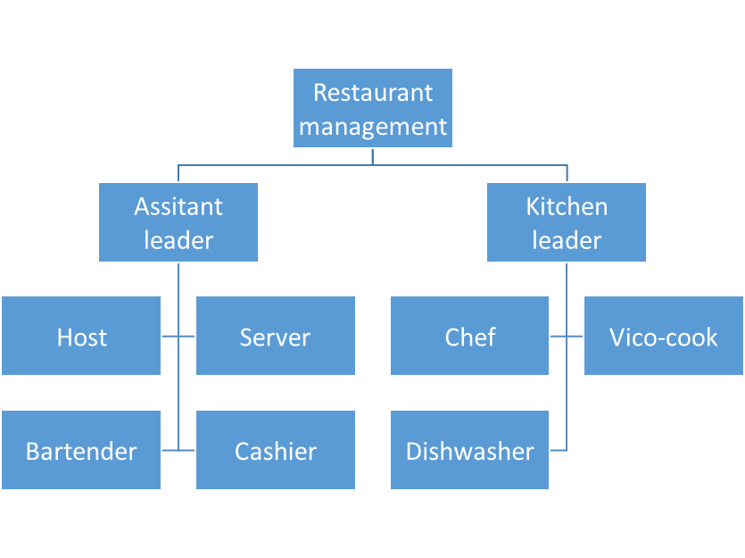

3. The scope of the system

Provide software or restaurant solutions with the following requirements:

* Customer information management.
* Support customers to use restaurant service.
* Support employee or admin managing the service.
* Full reporting system detailing customer’s invoices

4. Problem of Restaurant

Vietnamese restaurant is a Restaurant system chain which specializing in providing special dishes of Vietnamese culinary culture. The traditional services of this restaurant is still being applied: After acknowledging the customer's order, we will transfer it to the cashier and kitchen to process according to customer request menu.

With this manual method, it will take a lot of time, and at peak hours with a large number of customers, the whole service process will be almost numb.

Therefore, the restaurant needs a more professional alternative method to manage the restaurant effectively, accurately, scientifically as well as save time and cost.

5. System range

The solution to the problem of this Vietnamese food restaurant is "Restaurant management software - FIFI", FIFI has the main functions

* + Order management
  + Menu management
  + Customer management
  + Import and export management
  + Material use management
  + Manage revenue and expenditure

II. SRS DOCUMENT

1. Actor

When customers come to the restaurant, the host will lead guests to the appropriate table, giving the menu to the guests.

Guests: receive the menu and order food

Server: introduce the appropriate dish to the customer, record the dish, re-read the order, confirm the order, ask for customer information and enter the system, take the order paper to leave the table of the customer (when entering the order) enter the system, the printer will print order paper) to track the status of the dish

Kitchen: Receiving the voucher, processing the dish, putting it on the attached sheet (name of the dish and table number)

When customers pay: the cashier will print a check, the customer will give it to the customer to check, if there are no errors, the invoice will be printed and paid to the customer.

2. Flow chart

With new customer:

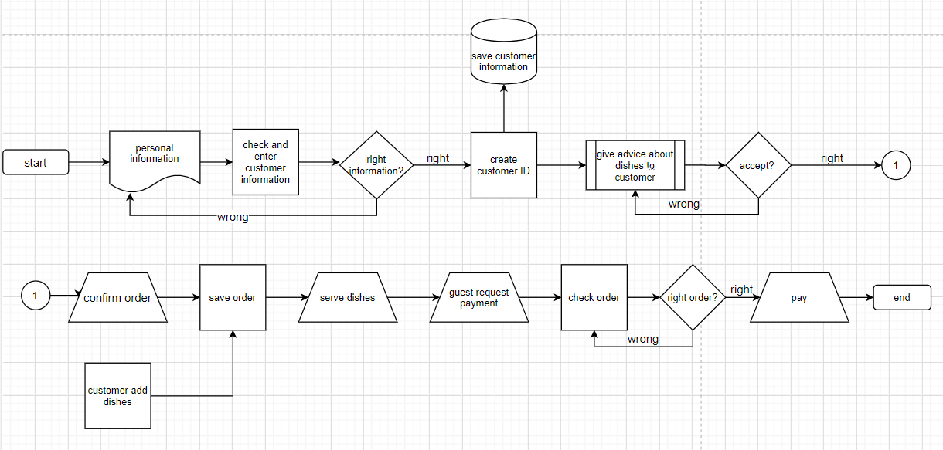

*P2.2.1: The process of booking tables and ordering dishes for New customers*

With old customer:

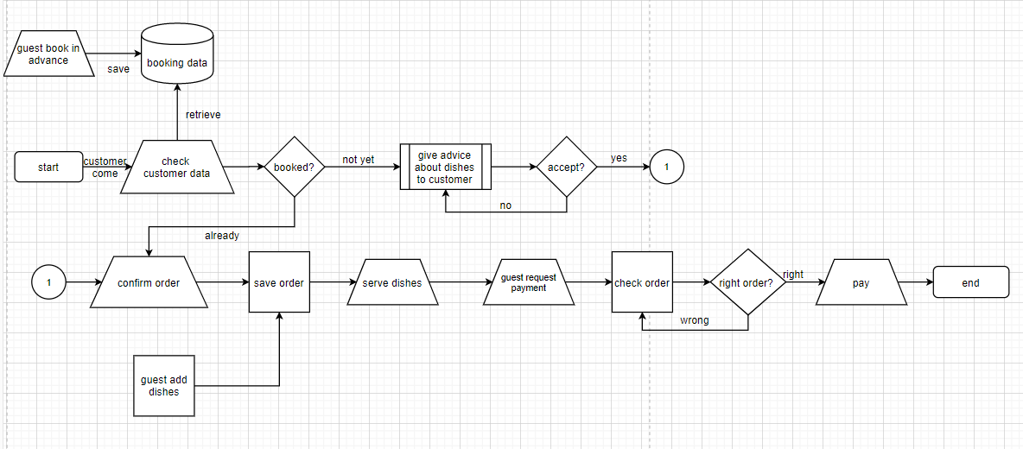

*P2.2.2: Process of reservation and ordering for Old customers*

3. Question Of Author and Customer Answer:

|  |  |  |
| --- | --- | --- |
| **Section / Screen** | **Comment / Question** | **Answer** |
| Form Login | Q: Is there a division between employees and customers about login?  Offer: There is a division, after logging in, customers can order at the restaurant. Staff logs in to check the tables placed on the system. | We totally agree. |
| Form Reset Password | Q: Can we recover it if we forget the password?  Offer: Of course, you just need to press the forget password button and we will allow you to edit your new password | We totally agree |
| Form Register | Q: What's the difference between old and new customers?  Offer: The first difference is that old customers only need to log into the system, new customers will have to fill out an account registration form. Each account will have a different ID, based on the ID and the number of times diners eat at the restaurant, we will have a special offer. | We totally agree |
| Order form | Offer: You can see our Menu on website/ system, choose the food you want, our system will show you the food’s price. After that, you click the button “confirm” to go to the order form. In the form, customer need to fill in all information. | We totally agree |
| Book form | Offer: If you want to reserve a table, fill in the form date, time and the number of people to the restaurant before 1 day to book, we will arrange the table for you.  After ordering, the system will notify the restaurant staff to call you back to confirm your order | We totally agree |
| Bills Pay | Our system will print the prices of the dishes you choose before you confirm the order, if you eat at the restaurant and there is a change, the staff will re-enter the system and charge you |  |

4. List Requirement

|  |  |  |
| --- | --- | --- |
| Requirements | Functional | Nonfunctional |
| The system allows users to create accounts | x |  |
| User interface must be gray |  | x |
| Allow server to create / change orders | x |  |
| Create a table diagram | x |  |
| Allow checking orders | x |  |
| Allow users create booking | x |  |

5. User and their goals

|  |  |
| --- | --- |
| Actor/ user | User Goal |
| Host | Guide customer to the appropriate table |
| Customer | - See menu  - Choose food |
| Staff | - Instruction guests to choose the appropriate dishes  - Record information (customer information, food ...)  - Serving dishes  - Update food status |
| Chef | - Processing dishes on request  - Updated item status |
| Cashier | - Check the dishes  - Print invoices and pay |

6. List of Events at restaurant

|  |  |  |  |  |  |
| --- | --- | --- | --- | --- | --- |
| Event | Trigger | Source | Use case | Response | Destination |
| Customer want to create account | New account | Customer | Create customer id | Account detail | Customer |
| Customer want to create booking | New booking | Customer | Create booking | Booking detail | Customer  Host |
| Host check booking | Booking inquiry |  | Check booking | Booking available detail | Host |
| Server make order | New order | Server | Make order | Real-time link  Order confirmation  Order detail  Transaction | Customer  Chef  Server |
| Server change or cancel order | Order change request | Server | Update order | Change confirmation  Order change details  Transaction | Server  Customer  Chef |
| Cashier make payment | Make payment request | Cashier | Make payment | Order detail  Bill confirmation | Cashier  Customer |

7. List of Use Cases

Create Account: Register new member as when new member applies to be a member. Member would initiate this action and serviced by Attendant. If you are an old member, your reservation can be made before coming to the restaurant.

Create Booking : Once an account is available, customers can make a reservation, which requires information such as accID, time (required) and table, meals (optional).

Check Booking : The host will use this function to check guest booking and prepare their table.

Make Order: The staff will use the system to make the menu, the system will send the total price of the meals for customer.

Update Booking : When guests have additional needs, change the order, the waiter will review and make the changes (possibly) for the guest, the changes will be sent to the kitchen.

Make payment : When the meal is over, the cashier will summarize the order detail, then print the bill for the customer to check, if there are no errors, make payment and finish the order.

8. Use Case Diagram And Specification

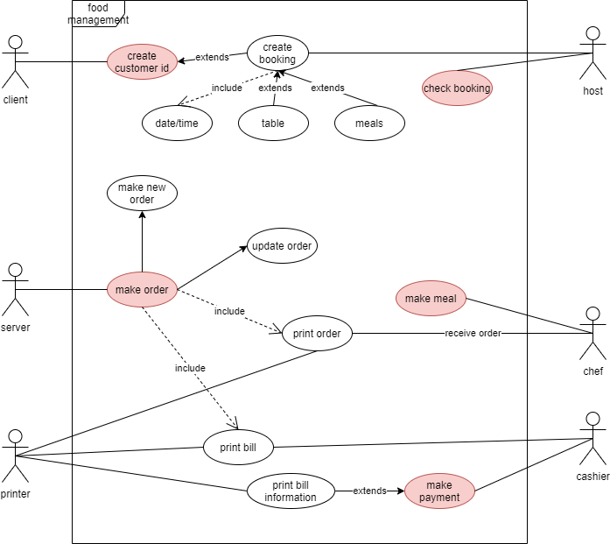

P2.8.1: The use case diagram of FIFI System

**Specification:**

*Make Account:*

**Login**

|  |  |
| --- | --- |
| **Actor** | Employee  Admin  Customer |
| **Description** | The system requires entering a username and password  If you do not have an account, click on register  forget password click "forget password"  After logging in, the system checks whether the user has entered it correctly  If yes, go to the homepage  If it is wrong, the system will notify the user to re-enter |
| **Illegal** | Username and Password uncorrect |
| **Script** | Correct account open system  Wrong username or password, show notification to input again |

*Register/ sign up:*

|  |  |
| --- | --- |
| **Actor** | Employee  Customer |
| **Description** | The actor doesn't have an account, click "create an account" to create an account  Enter name, username, password, confirm password  After completing press the "register" button to create an account  After pressing the create account button  If all information is filled in, return to the log in page to log in to the system  If there is missing information, a message will appear to enter |
| **Illegal** | First Password and Second Password not the same |
| **Script** | Succeed sign up open Login form  Fail sign up show notification to input again |

*Log Out:*

|  |  |
| --- | --- |
| **Actor** | Employee, admin, customer |
| **Description** | Actor sign in the system  Actor click “Logout” to logging out the system/website |
| **Illegal** | System sutdown |
| **Script** | Actor logout |

*Order:*

|  |  |
| --- | --- |
| **Actor** | Customer  Employee |
| **Description** | Actor sign in the system  Customer look for dishes and click button “add” to see the total price in Cart  If customer agree with cost, go to the order form to fill in information at restaurant  Employee sign in database to see what customer order, base on their phone and call them to confirm order.  If customer want to have dishes at restaurant, staff will come and make order for you. |
| **Illegal** | Cart empty |
| **Script** | Customer confirm order and go to the Book form |

*Booking/check booking:*

|  |  |
| --- | --- |
| **Actor** | Customer  Employee |
| **Description** | Actor sign in the system  Customer input the information like “name”, “phone number”, “Number of customer”, “day”, “time”, “note”  Customer want to come to restaurant, choose in selection: “Book table”  If customer need something more, write at “Note”  Finally press the “Confirm” button. |
| **Illegal** | Empty one or more information except “Note” |
| **Script** | Customer confirm to book  Employee check book |

*Payment:*

|  |  |
| --- | --- |
| **Actor** | Customer |
| **Description** | We have payment on delivery or payment at the end of a meal at the restaurant  The amount after the payment is cashier entered into the system  If you at the restaurant, after dishes syste will sent price to cashier for them to check payment. |
| **Illegal** | Unpaid orders |
| **Script** | Customer pay to cashier  Cashier input in system |

III. DESIGN DOCUMENT

1. Class Diagram

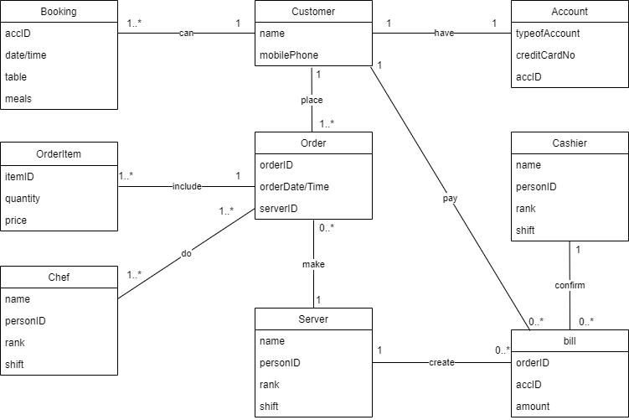

*P3.1.1: Class diagram about restaurant management system-FIFI.*

2. Activity And Sequence Diagrams:

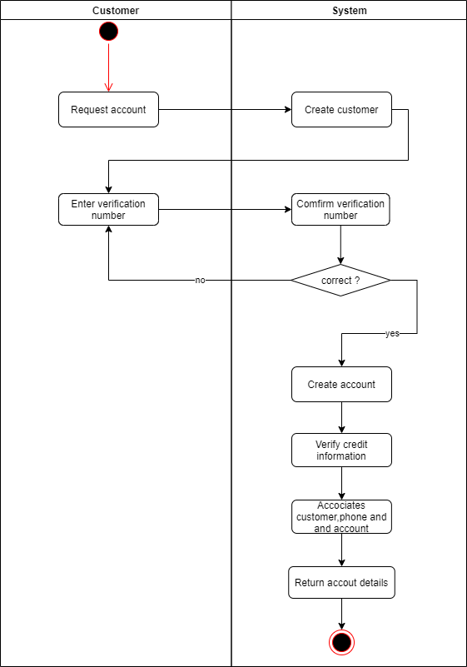

*P3.2.1: Activity diagram for Use Case: Create Account*

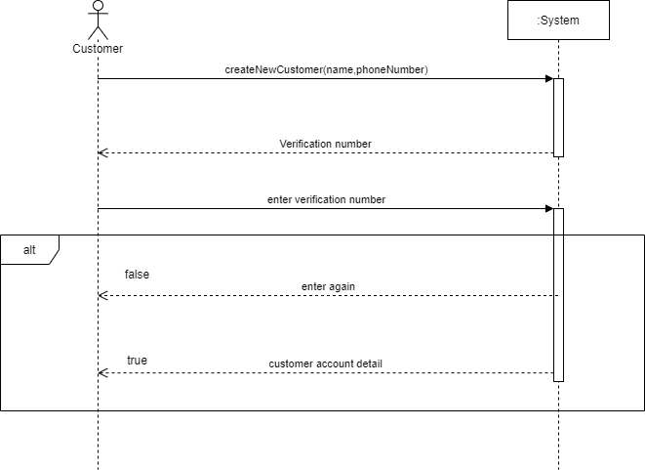

*P3.2.2: System sequence diagram for Use Case: Create Account*

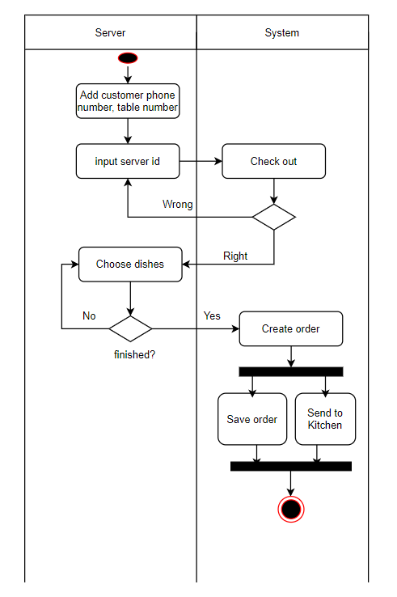

*P3.2.3: Activity diagram for Use Case: Create Order*

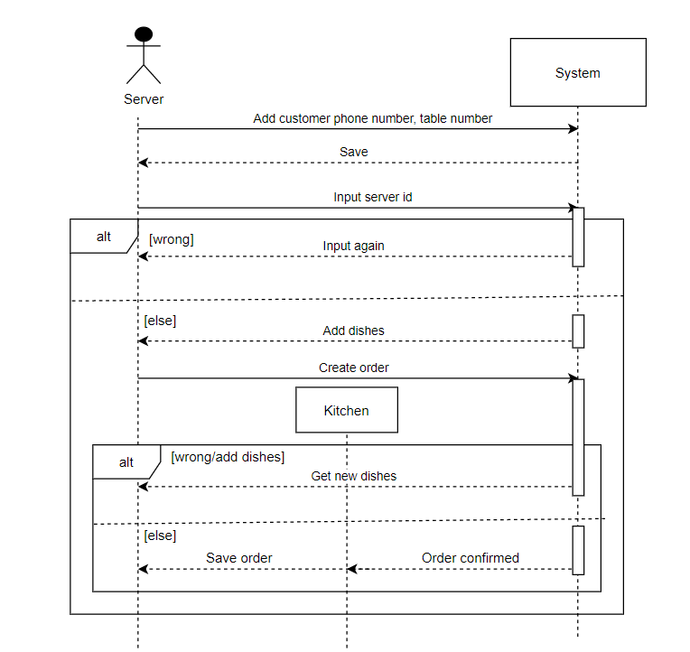

*P3.2.4: System sequence diagram for Use Case: Create Order*

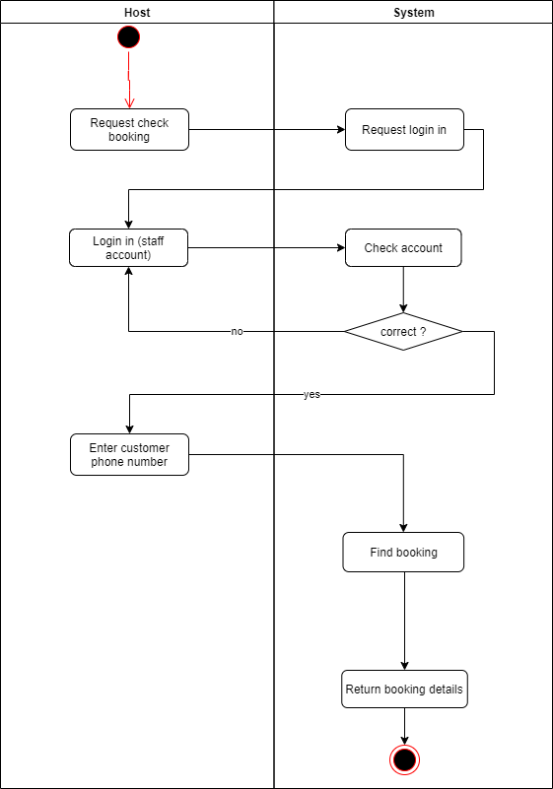

*P3.2.5: Activity diagram for Use Case: Check booking*

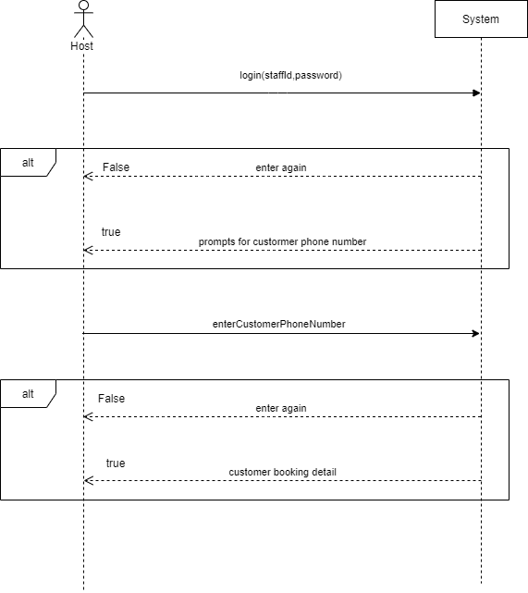

*P3.2.6: System sequence diagram for Use Case: Check booking*

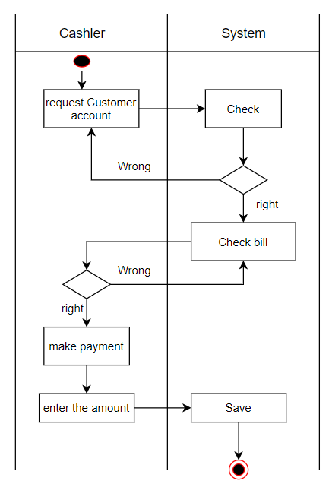

*P3.2.7: Activity diagram for Use Case: Make Payment*

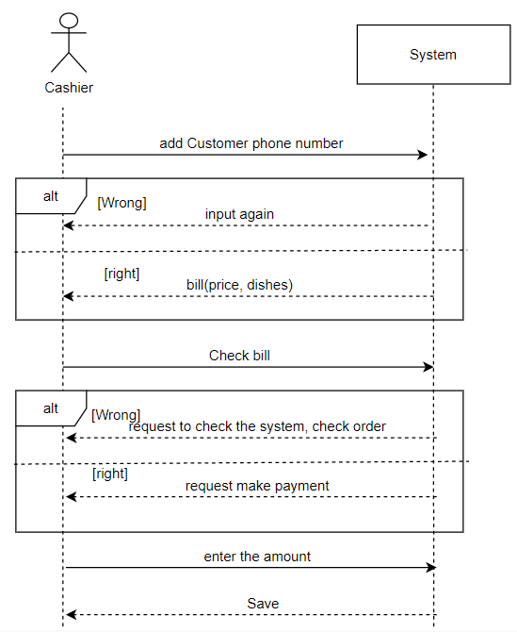

*P.3.2.8: System sequence diagram for Use Case: Make Payment*

3. Entity Relationship Diagram

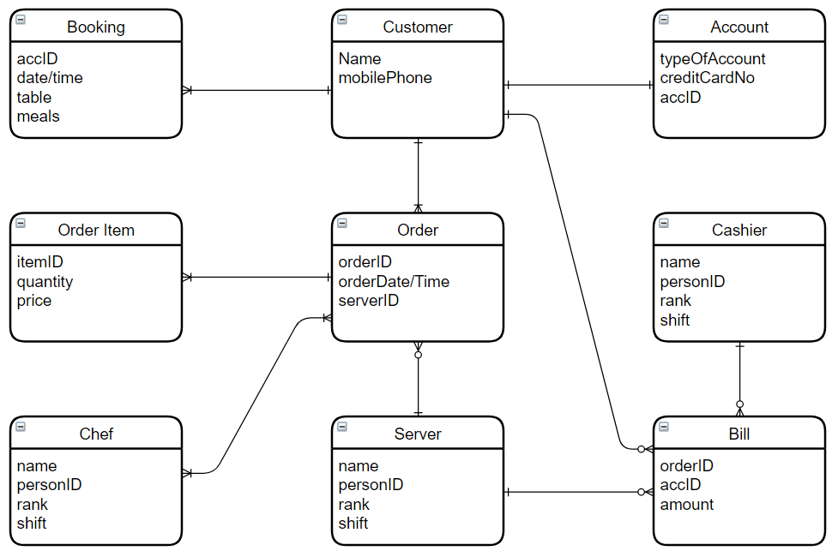

*P3.3.1: Entity relationship diagram about hotel management system.*

IV. REALIZE SOFTWARE

1. Database

***Details of the tables:***

**“Users” table:**

|  |  |  |  |
| --- | --- | --- | --- |
| **Num** | **Name** | **Type** | **Binding** |
| 1 | id | Int(11) | Primary key |
| 2 | User_name | Varchar(255) | No null |
| 3 | Password | Varchar(255) | No null |
| 4 | Name | Varchar(255) | No null |

**“tbl_product” table:**

|  |  |  |  |
| --- | --- | --- | --- |
| **Num** | **Name** | **Type** | **Binding** |
| 1 | id | Int(11) | Primary key |
| 2 | name | Varchar(255) | No null |
| 3 | image | Varchar(255) | No null |
| 4 | price | Int(100) | No null |

**“book” table:**

|  |  |  |  |
| --- | --- | --- | --- |
| **Num** | **Name** | **Type** | **Binding** |
| 1 | id | Int(11) | Primary key |
| 2 | phone | Varchar(255) | No null |
| 3 | Num_of_cus | Int(11) | No null |
| 4 | day | date | No null |
| 5 | time | Time | No null |
| 6 | Note | Varchar(255) | Null |
| 7 | Selection | Varchar | Null |

**“checkorder” table:**

|  |  |  |  |
| --- | --- | --- | --- |
| **Num** | **Name** | **Type** | **Binding** |
| 1 | id | Int(11) | Primary key |
| 2 | Phone_num | Varchar(255) | No null |
| 3 | address | Int(11) | No null |
| 4 | note | date | Null |

2. Interface design and manipulation

*a. Form “Log In”: required to log in to get into the system*

***Case 1:*** Old customer Login:

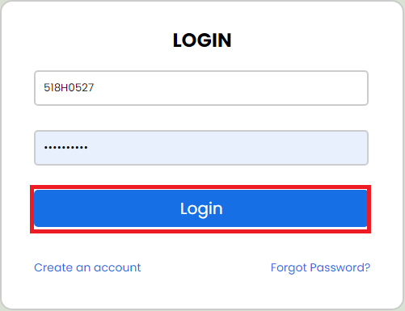

*P 4.2.1: Sign in with old customer.*

***Case 2***: New customer login:

First: customer have to click the “create an account”

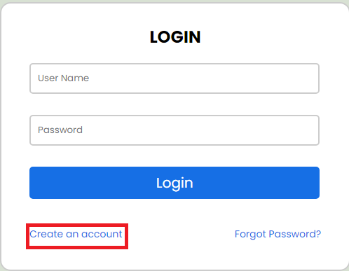

*P 4.2.2: move to form sign up.*

After fill in all information, press “Register” button

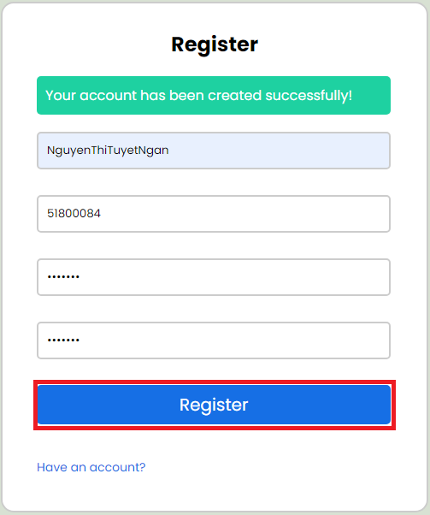

*P 4.2.3: Sign up with new customer.*

After showing successful registration message, you click on the button "Have an account" to return to the login page to sign in to your account.

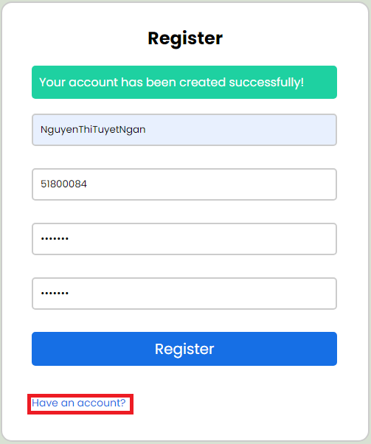

*P 4.2.4: Register success.*

Then you can login into system:

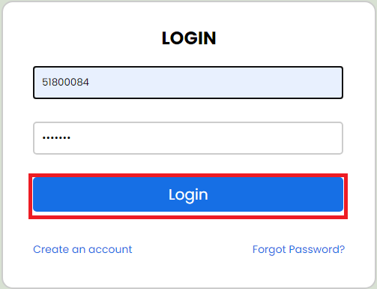

*P 4.2.5: Login for new customer.*

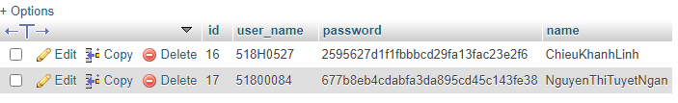

*P4.2.6: after sign up, your inform will be added to database*

**Case 3**: If customer forget pass, click “forgot password”

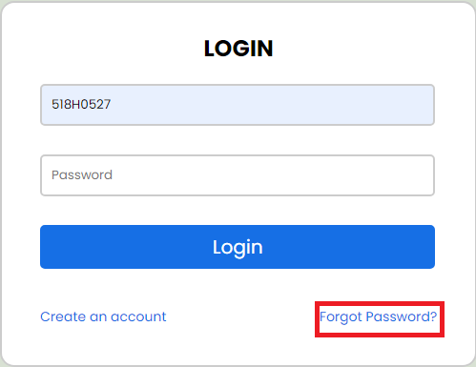

*P 4.2.7: Customer forget pass.*

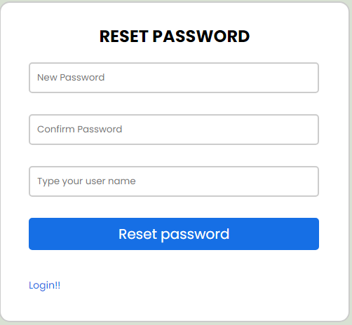

*P 4.2.8: ForgetPass form.*

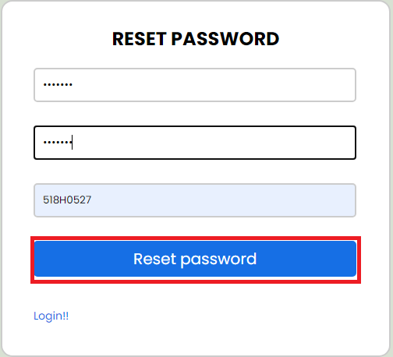

*P 4.2.9: reset pass.*

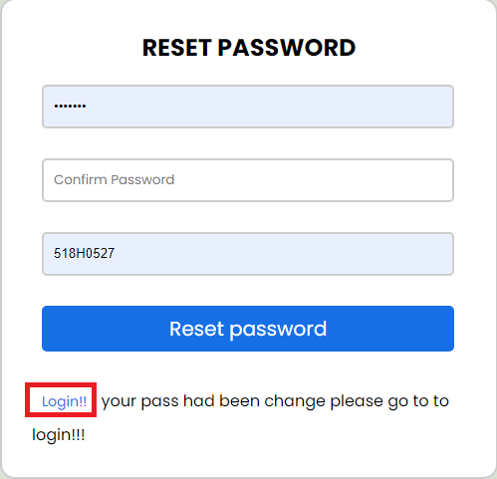

*P 4.2.10: Reset was successful.*

*b. Order food:*



*P 4.2.11: Click here to look at menu and total price.*

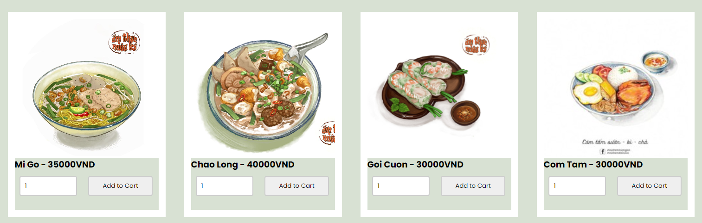

*P 4.2.12: Add food to cart.*

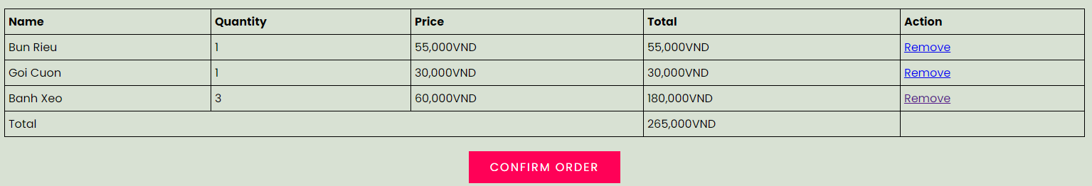

*P 4.2.13: total price.*

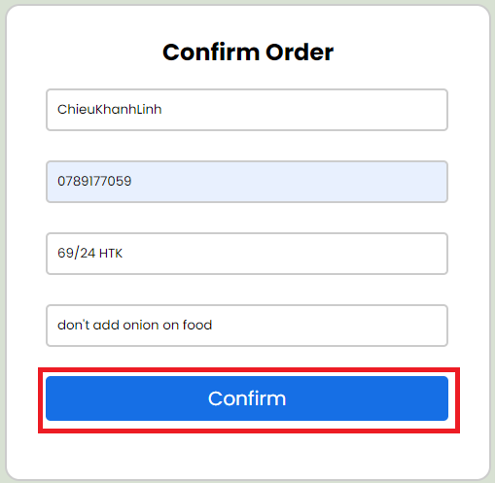

*P 4.2.14: Order form.*

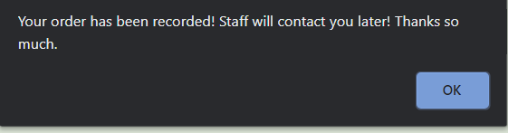

*P 4.2.14: After fill all the form, click confirm, system will print this notification.*

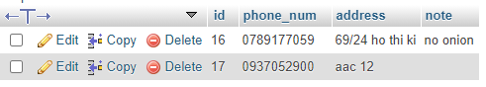

*P 4.2.15:* *Ordering success will be added to database.*

*c. Booking*



*P 4.2.16: click here to open booking form.*

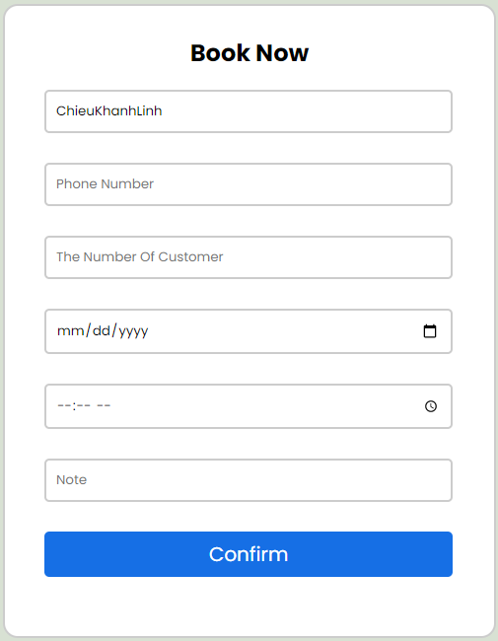

*P 4.2.17: Booking form.*

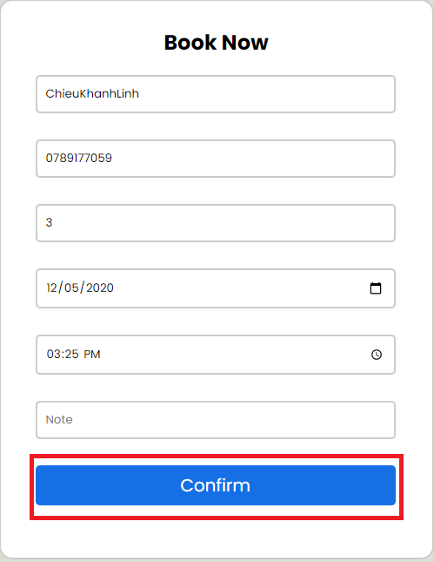

*P 4.2.18: Fill all information, choose the selection you want, then press “Confirm”.*

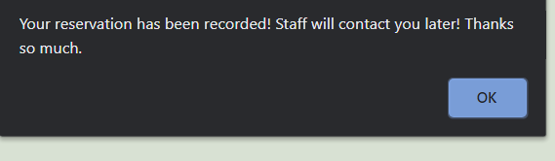

*P 4.2.19:* *Successful order notification.*

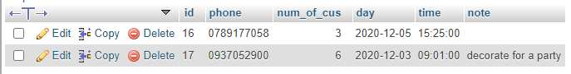

*P 4.2.20:* *Booking success will be added to database.*

After booking, staff will base on your phone and call you again to check order.

*d.Logout*

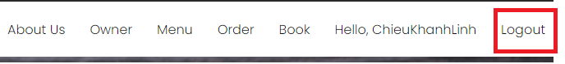

*P4.2.21: click here to logout.*

V. TESTCASE – UNIT TEST

1. Testcase:

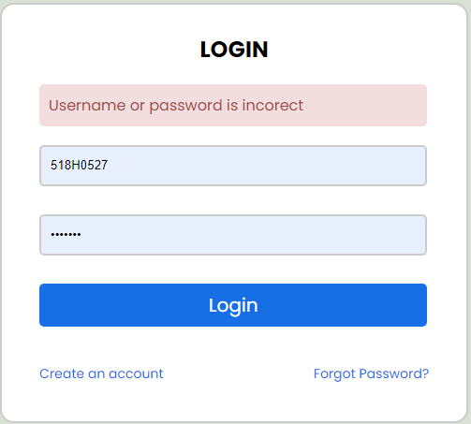

*P5.1.1: An exam don’t have account sign system.*

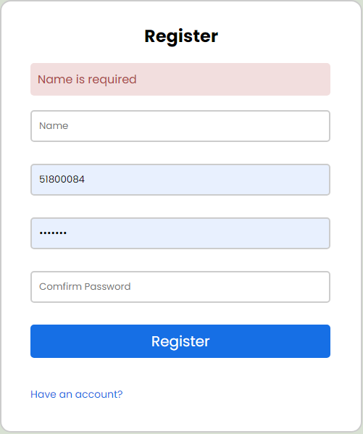

*P5.1.2: Name, username, pass is required.*

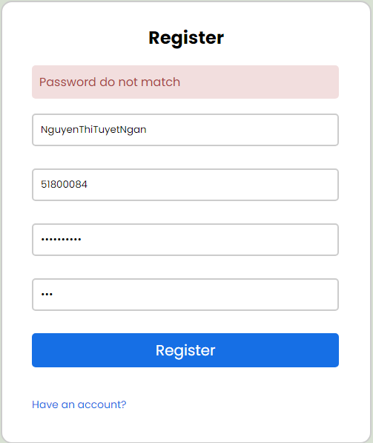

*P5.1.3: Pass have to match each other.*

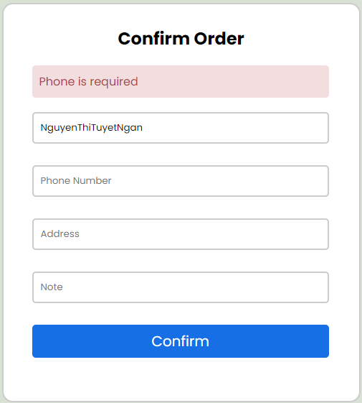

*P5.1.4: All information is required except note*

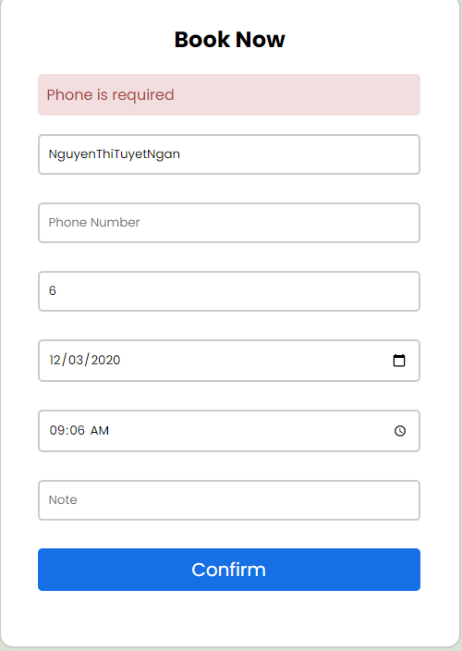

*P5.1.5: All inform is required except Note.*

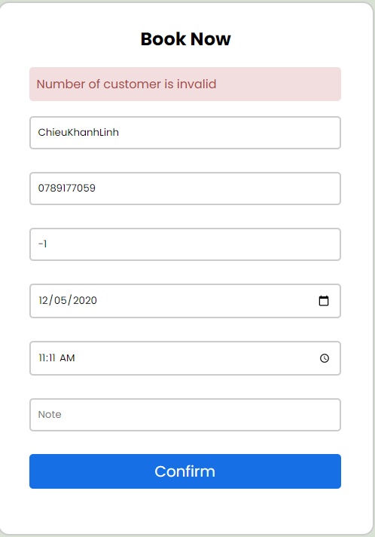

*P5.1.5: Number of customer cannot negative or 0.*

2. Unit test

**Test case:**

***Login_test:***

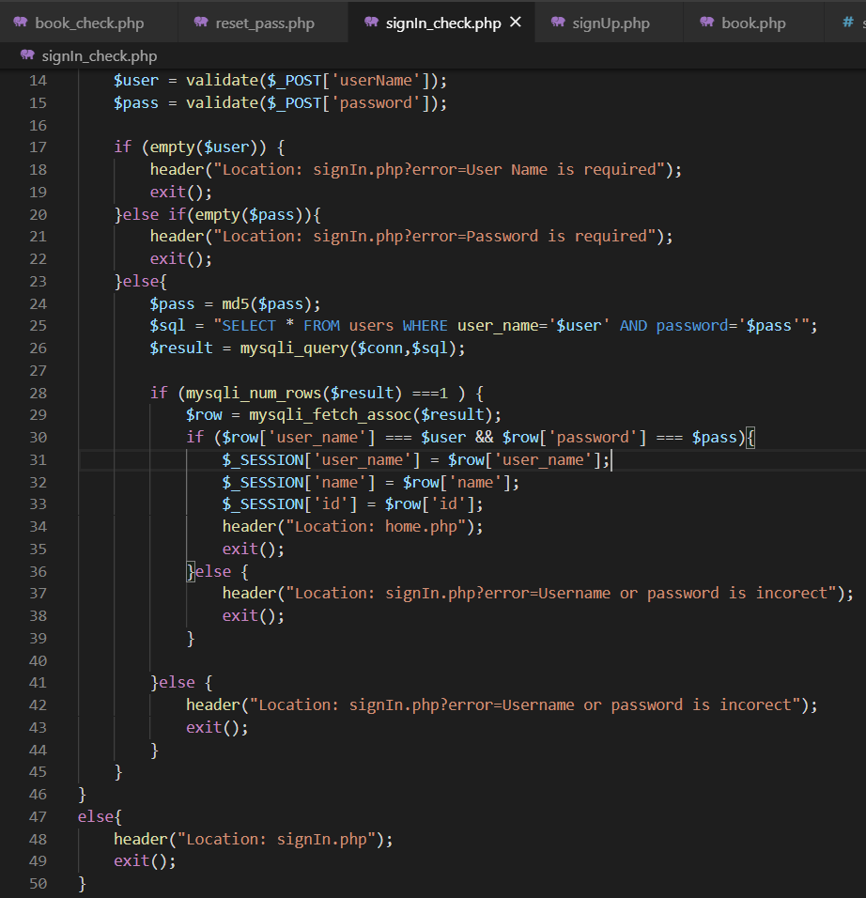

* If username not the same at the user_name in database => false
* If password not the same at password in database => false
* Else => return homepage.

***Sign up_check:***

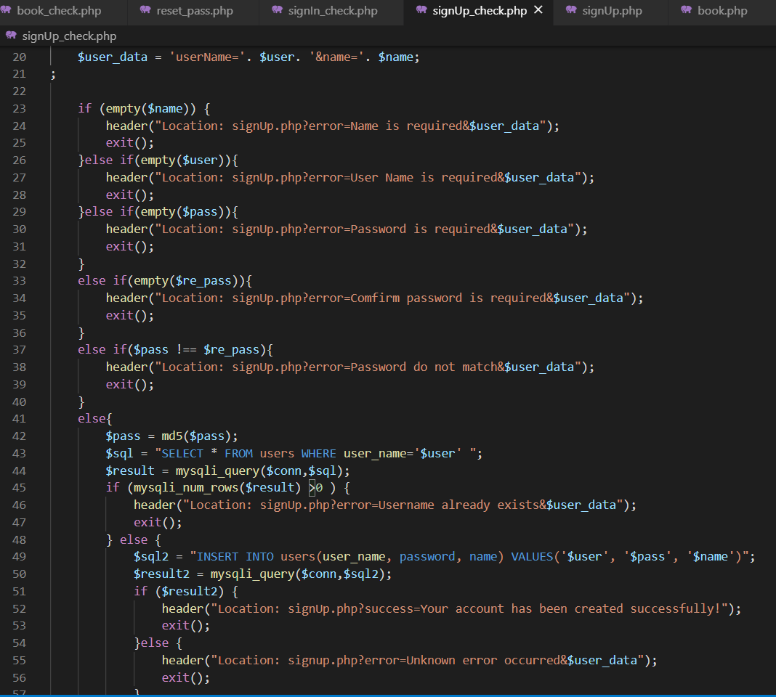

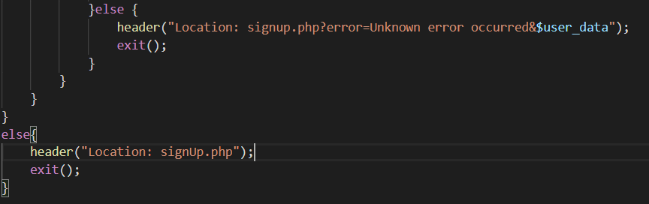

* If all test cases above are true
* Else => return signup form

***Order_check:***

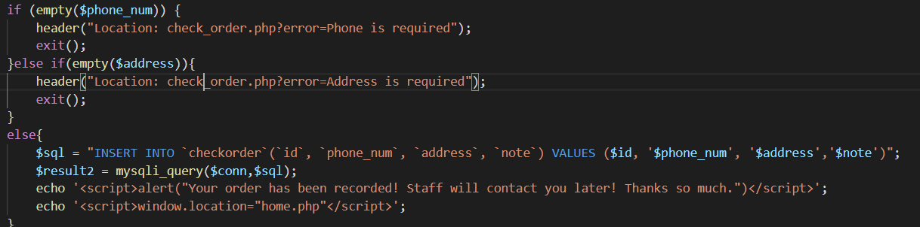

* If all test case is true => add information to database
* Else => return homepage

***Book_check:***

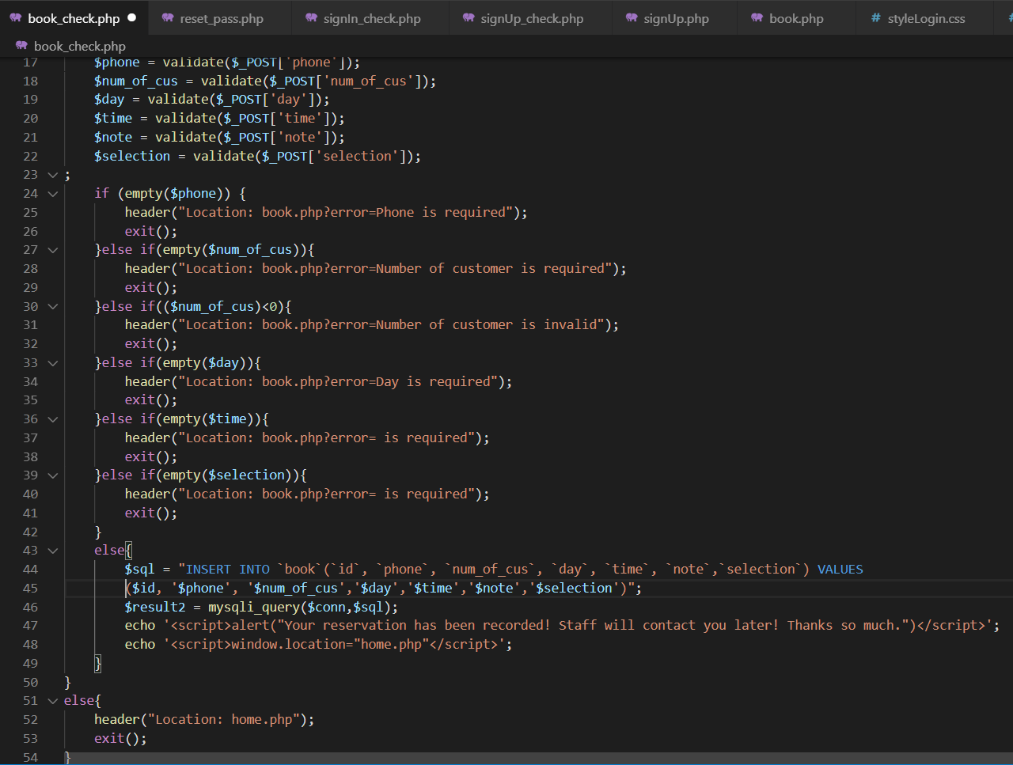

* If all test cases above are true => add inform to database
* Else => return homepage

***Reset_pass:***

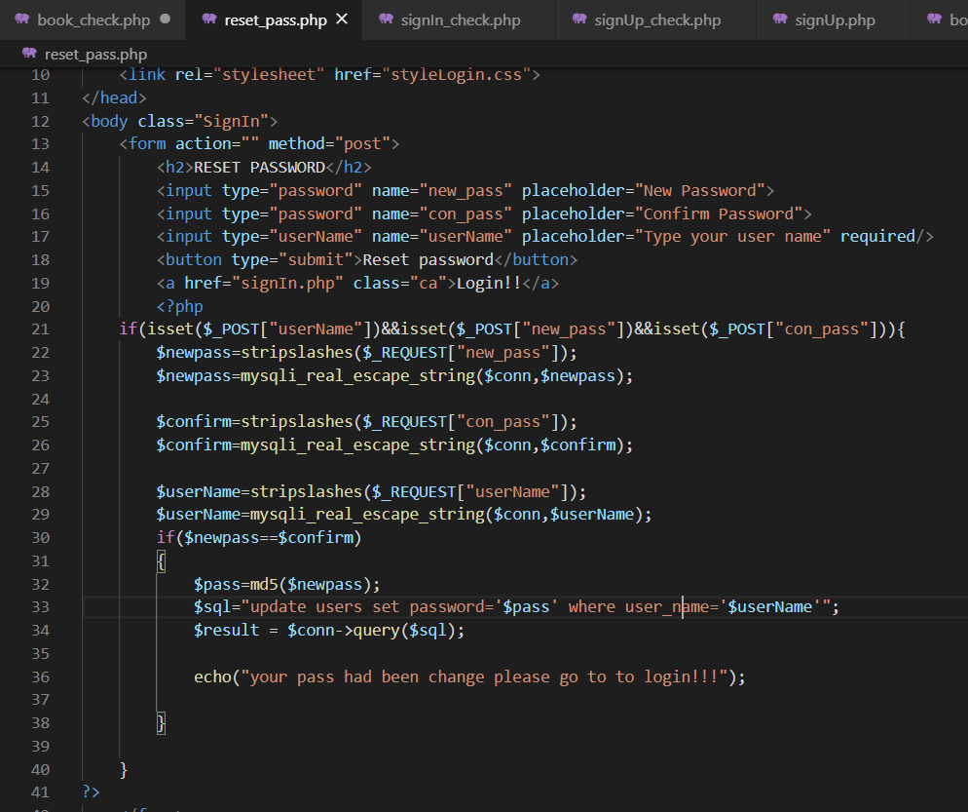

* If all test cases above are true => change pass in database

3.Software and software requirements:

* The restaurant management system must have IT infrastructure support.
* Added a component registry to allow access by hotel managers.
* Create file to save registration information and access information.

VI. REFERENCES

1. Wikipedia

2. Report_sample

3. W3School

4. Draw.io