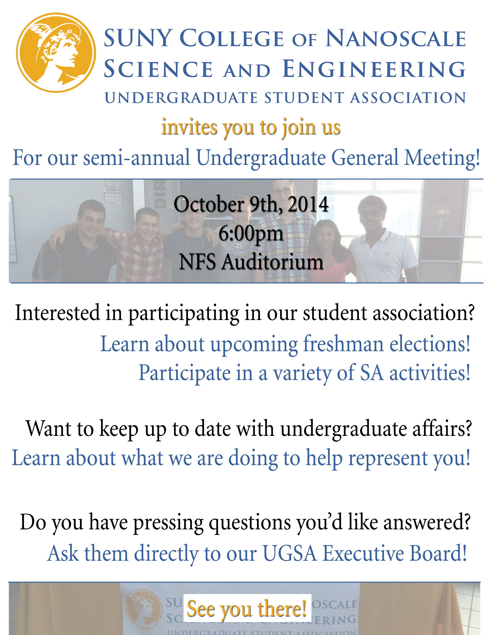

**October 7, 2015**

**NFS Auditorium**

**6pm-7pm**

**CNSE UGSA Fall General Meeting**