**2 Operations on simple sequences**

**2.2 Plot x**

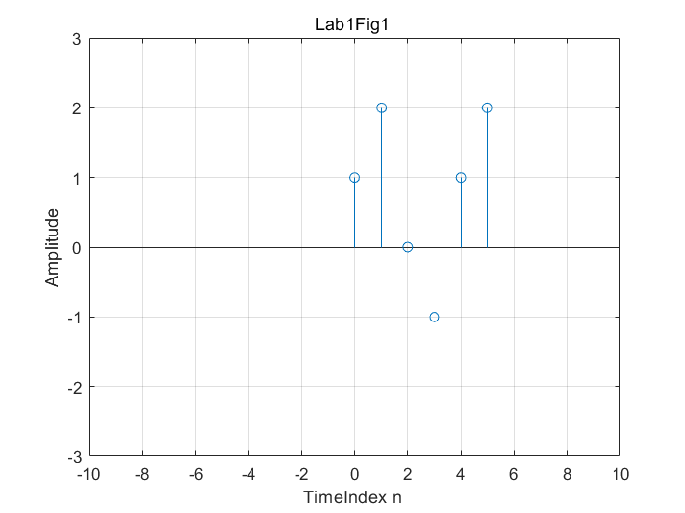

**2.3 Plot delayed and advanced signal**

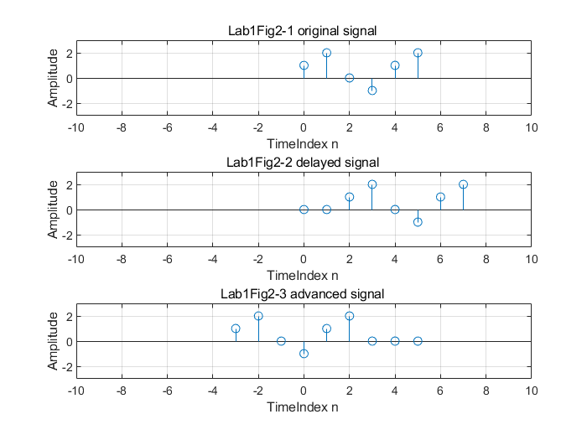

**2.4 Addition of two signals**

Method:

Fill the array with 0, thus making the two signals aligned.

Code:

x1 = [0, -1, 3, 0, 0];

x2 = [0, 3, 3, 1, 2];

t = 0 :1 :4;

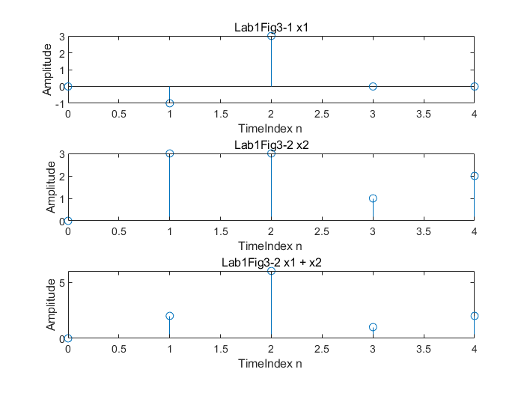

**2.5 Addition of two signals**

Demo:

AddSeq([4,2,6,1],[5,7,6,2],[12,5,6,9],[5,7,6,2]);

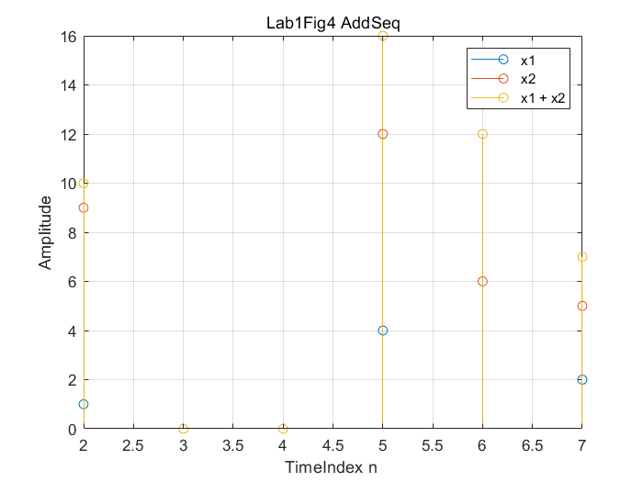

% Confident for

% error test

% 1.null input

% 2.x gets different size with n

% 3.can avoid row add col

% Special Input types

% 1.input can be single element

% 2.input n can be not in order

% 3.step size of two inputs can be different

% 4.step size can be double

% 5.input can be row or col

% 6.input can have different symbol size

**2.6 Convolution of two signals**

Plot x[n] and y[n]:

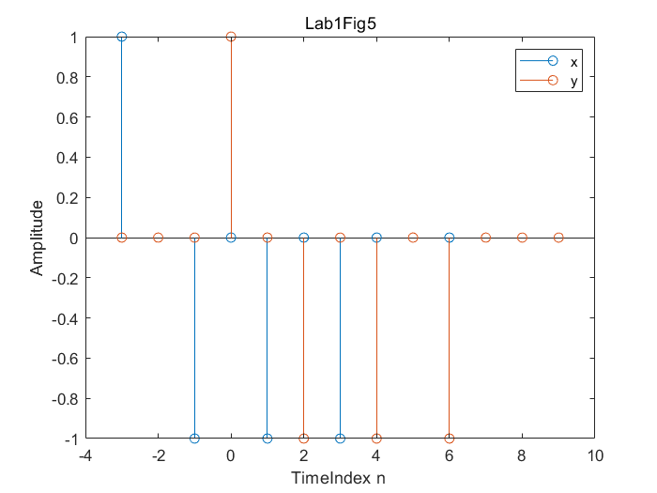

y[n] is the delay shifted x by 3.The $h_{a[n]}$ will delay the input signal by (a + 3) samples.

**2.7 Moving average**

Comparing the original image and the convolution image, it can be found that the new image is the result of the original image after moving average. For h, different values at different positions represent the current value in turn, and the previous period and the previous two period values represent different gravity, and their combination should be 1. The longer the length of h, the more historical data it uses, the number of elements in h corresponds to the number of samples in the moving average, and the values represent the weights used in the moving average. The longer h, the greater the proportion of historical values, the smoother the image will be.

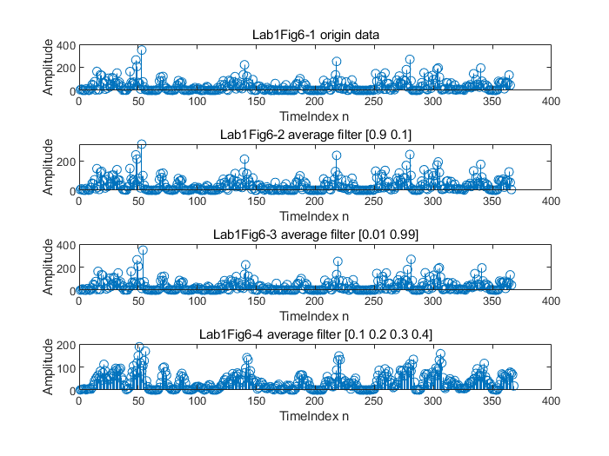

**4 Sine Wave**

**4.2 Choose N**

N = ceil(fs * d); % one more sample maybe better

It will leads to one more sample at the end of the sequence as the hint says “there is no problem to append zeros ate the end of the signal”.

**4.5 Listen to the signal**

When the frequency f0 is low, it sounds deep, if the f0 is high, it sounds high-pitched. Maybe in sound, frequency is how fast or slow an object vibrates, which determines the pitch.

**4.6 Sampled signal**

The fundamental period T0 of x(t) is 1.25 ms and the frequency of the signal is 800 Hz

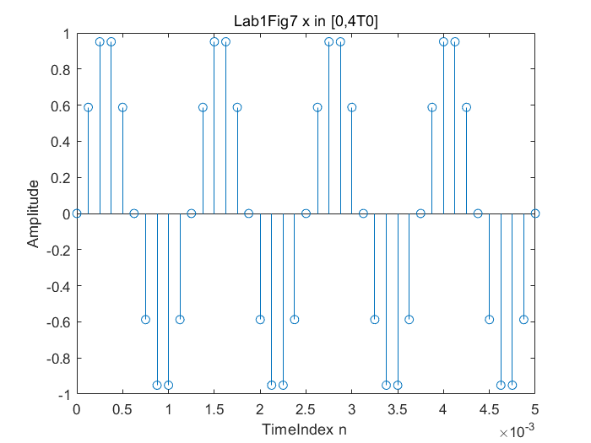

**4.8 Added signal**

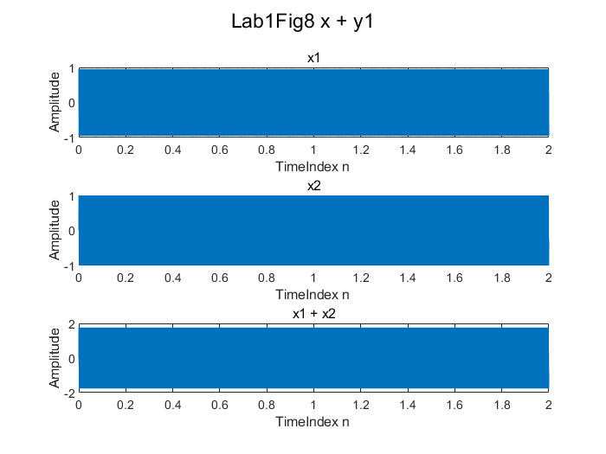

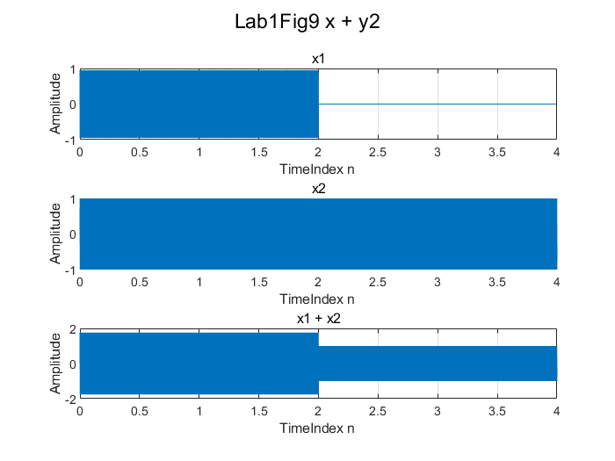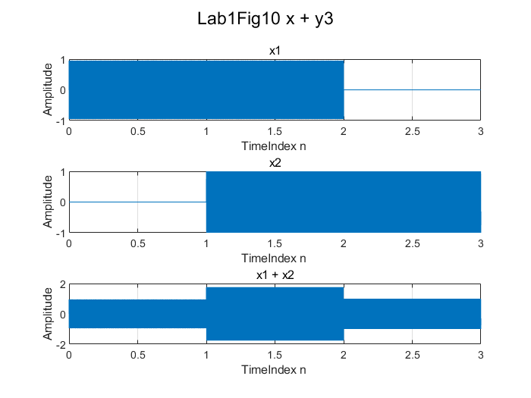

**4.9 multiplied signal**

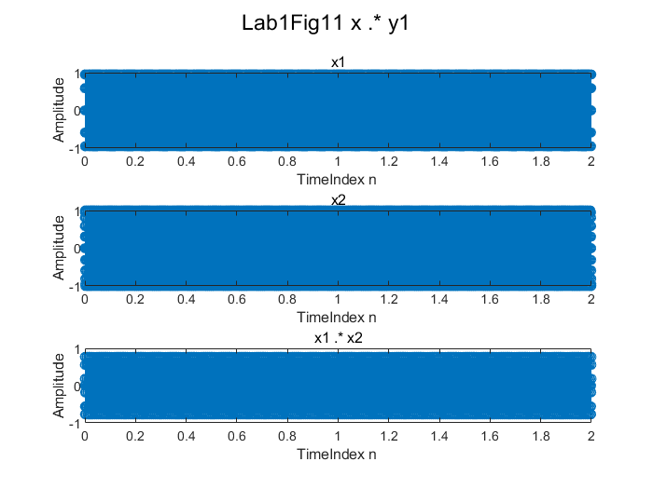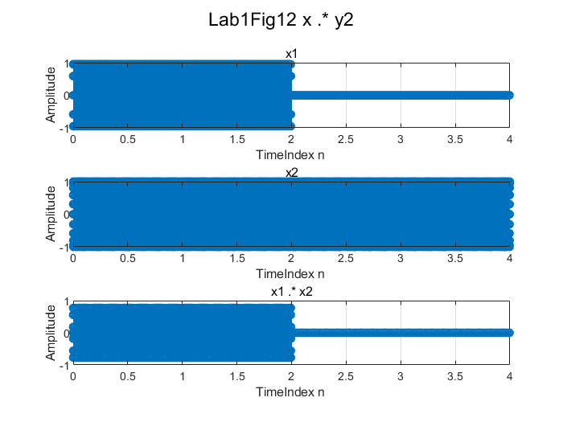

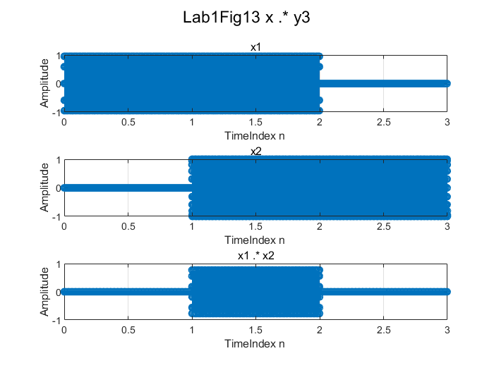

**4.10 Convolved signal**

