**1.2 Nyquist criterion**

**1.2.1**

minimum value of fs = 1600

**1.2.2**

Yes, I can verify the theory.

I will choose the values of fs as 800,1000, 1600, 3200, 6400 Hz.

When the sample rate is less than 1000, the function sound will throw the exception “invalid value”, when the sample rate is between 1000 - 1600, the sound is getting sharper, and there will be less alias. When the sample frequency is getting higher that more than 1600, the sound will be almost unchanged any more .(The waveform when the sample rate is 1600 is quite weird, discussed with guidance staff, they said just record the result).

**1.2.3**

The waveform and the sound of these two signal are the same. During the sampling, the signal in the frequency domain will be periodically extended with the sampling frequency as the period.

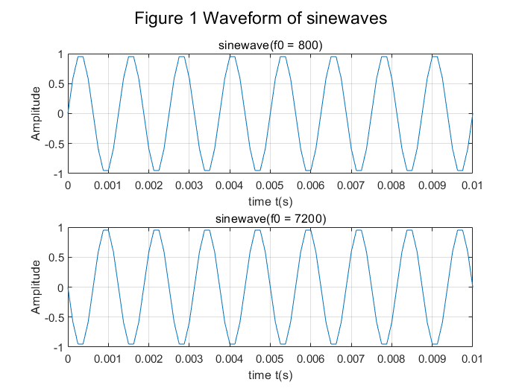

**1.2.4**

The sampling rate of this signal is 8192 Hz. I first perceive aliasing when the sampling rate is 6000 Hz.The voice began to get muffled and blurred.When the sampling frequency is less than 6000, the waveform will be changed and a lot of details will be lost.

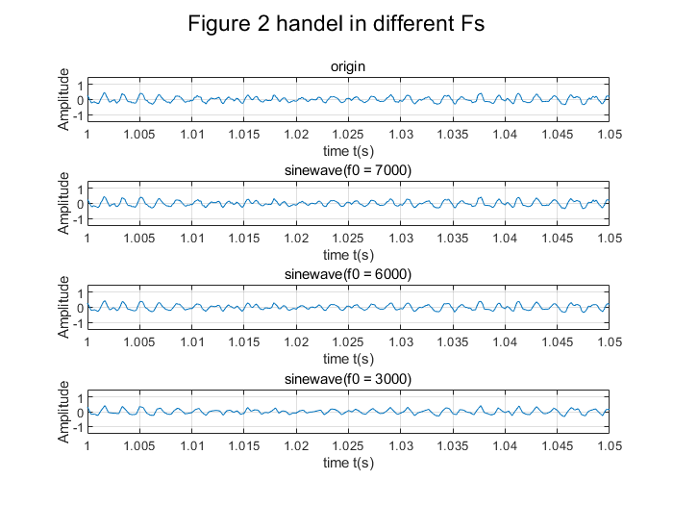

**1.3 Create a note**

**1.3.3**

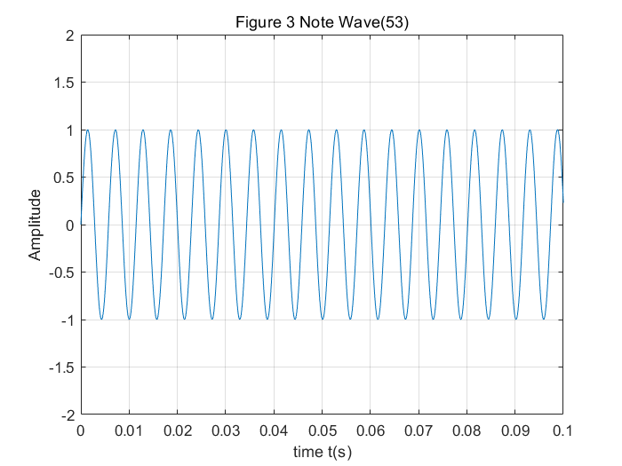

**1.3.4**

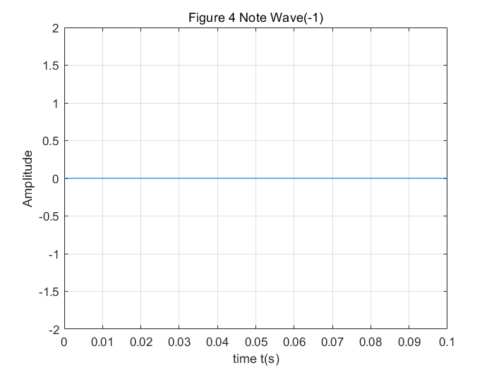

**1.4 Create a melody**

**1.4.3**

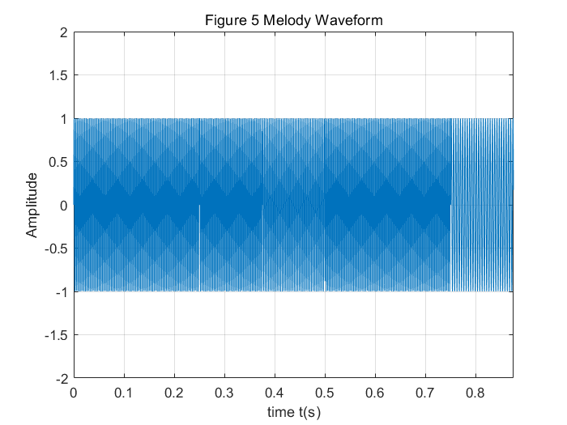

note_durations = [0.25, 0.125, 0.125, 0.25, 0.125];

note_pitch = [64, 64, 62, 64, 57];

**1.4.4**

I changed the array of notes and the duration to fit the requirement.The name of the wav file is “Melody1_Fast_highPatch”.

note_pitch2 = note_pitch + 12;

note_durations2 = note_durations ./ 1.5;

**1.4.5**

Music.wav is the start of the music “little stars” that constructed by the function ”createMusic”.

**1.5 Upsampling / downsampling**

**1.5.1**

Upsampling increases the number of sampling points in the image, but inserts many 0 points meanwhile.

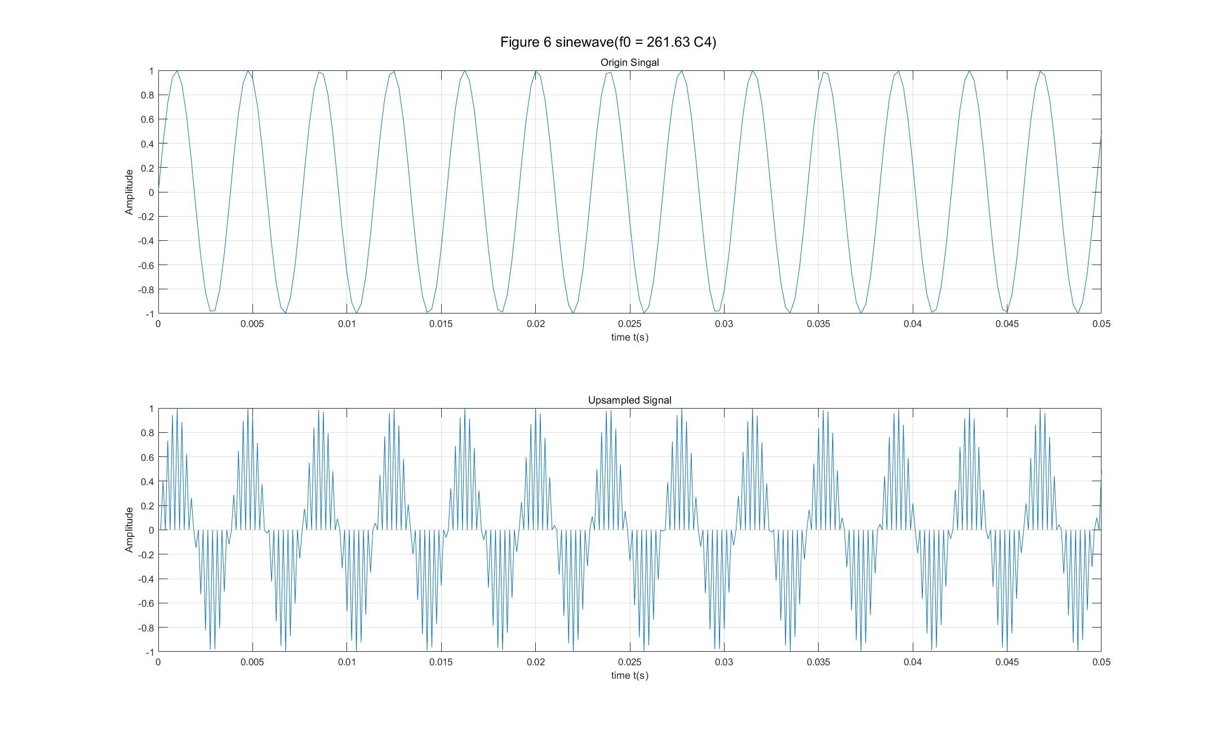

**1.5.2**

Upsampling or downsampling?