**1.1 IIR filters**

**1.**

The order of the filter is 13, the phase is what I expect for.

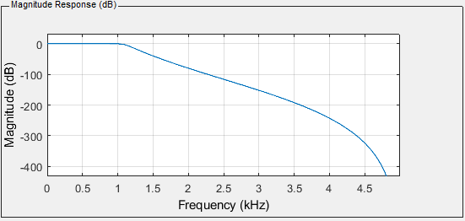

1. Magnitude Response

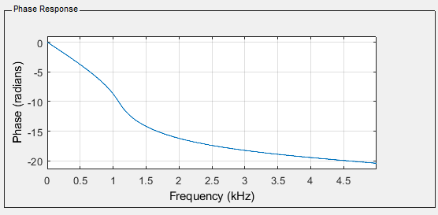

1. Phase Response

**2.**

Change the transition region to a narrow one, Fpass = 1 kHz, Fstop = 1.5kHz, the order increase to 22.

Change the transition region to a widen one, Fpass = 1 kHz, Fstop = 2.5kHz, the order decrease to 9.

When we narrow the transition region, we will get better performance in transition region, but we will increase the order of the filter which means consuming more resources. When we widen it, the order will decrease. We need to balance the performance and resource consumption at the same time.

**3.**

As the result of the calculation, the minimum order of the filter should be 1.64, we use 2. We create the filter as follow and the minimum order is 2.

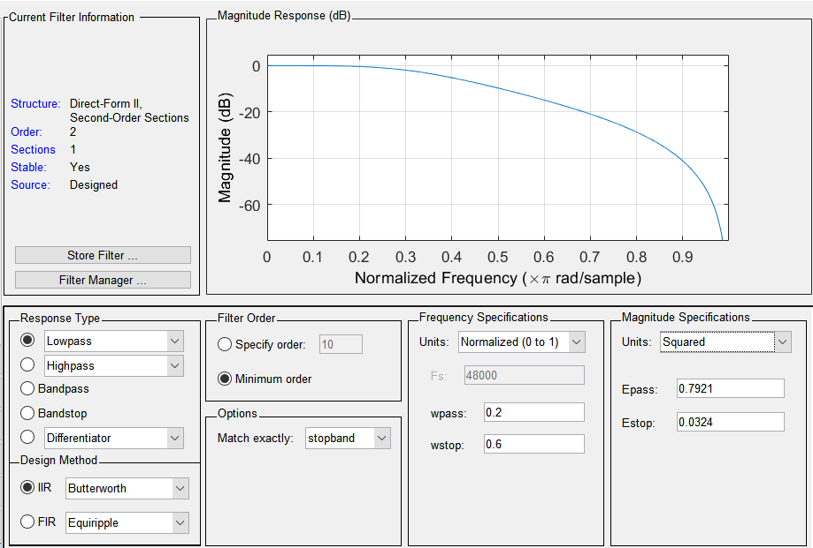

1. Verification of theoretical result

**4.**

NO, Order 7 will be OK if we calculate it with impulse invariance but in MATLAB, the software will calculate the order with bilinear transform, and we will get the order 5.

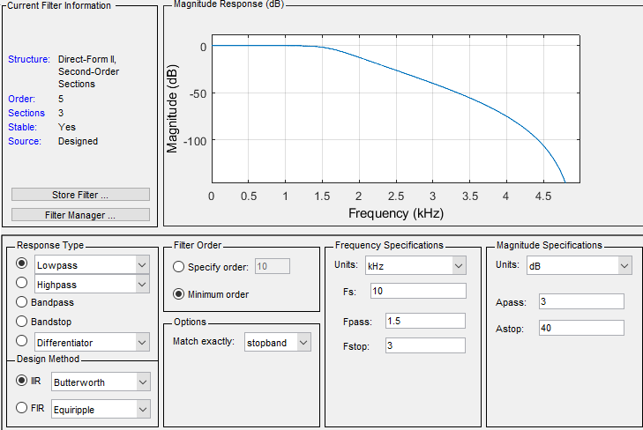

1. Order 5 low pass filter

**5.**

No, it does not match the figure which found in the impulse invariance method and the reason is that if we calculate it with impulse invariance but in MATLAB, the software will calculate the order with bilinear transform, and we will get the order 5.

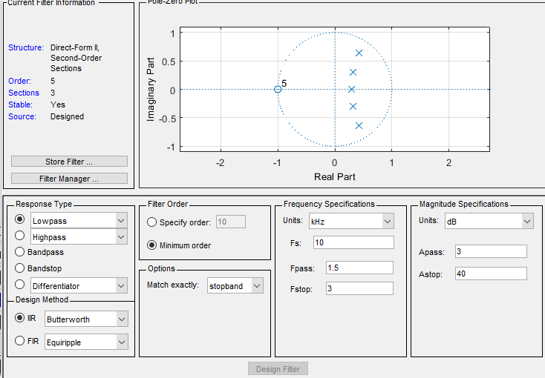

1. Pole-Zero Plot of the filter

**6.**

Compare with Butterworth filter:

1. Butterworth: no ripples in passband and stopband, smooth in transition region.
2. Chebyshev : equiripple ripples in passband and stopband. Sharper roll-off in the transition region.

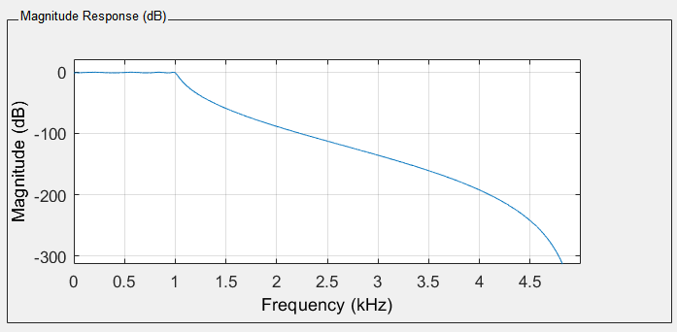

1. Magnitude Response of Chebyshev Type 1

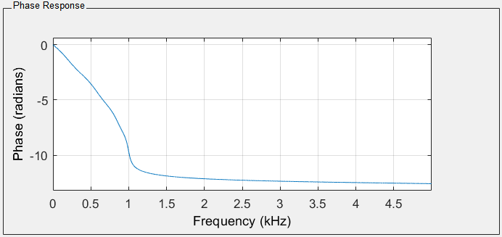

1. Phase Response of Chebyshev Type 1

The order of Chebyshev Type I is 8.

**7.**

Consider the filter designed before, we can conclude the pros and cons of these two filters as below.

1. Compare two filters

|  |  |  |
| --- | --- | --- |
|  | Chebyshev | Butterworth |
| filter order | 8(lower) | 13(higher) |
| Pass-band response | equiripple | no ripple |
| Stop-band response | equiripple | no ripple |
| transition region | narrow | wide |
| phase response | non-linear | linear |
| Stop-band attenuation | high | low |
| Group Delay | non-constant | constant |

**1.2 FIR filters**

**1.**

The order of the filter should be 36, the magnitude response and phase response are as below.The phase response of IIR filter is not linear, but the one of FIR filter is linear and stable. The FIR filter has better phase response, but meanwhile, it needs higher level in orders and the ripples in the stop-band will be much worse.

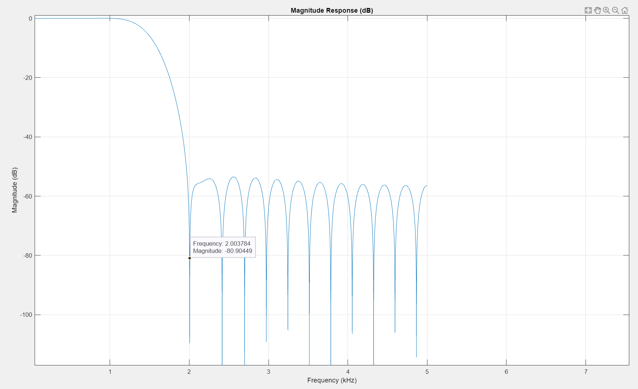

1. Magnitude Response of FIR filter

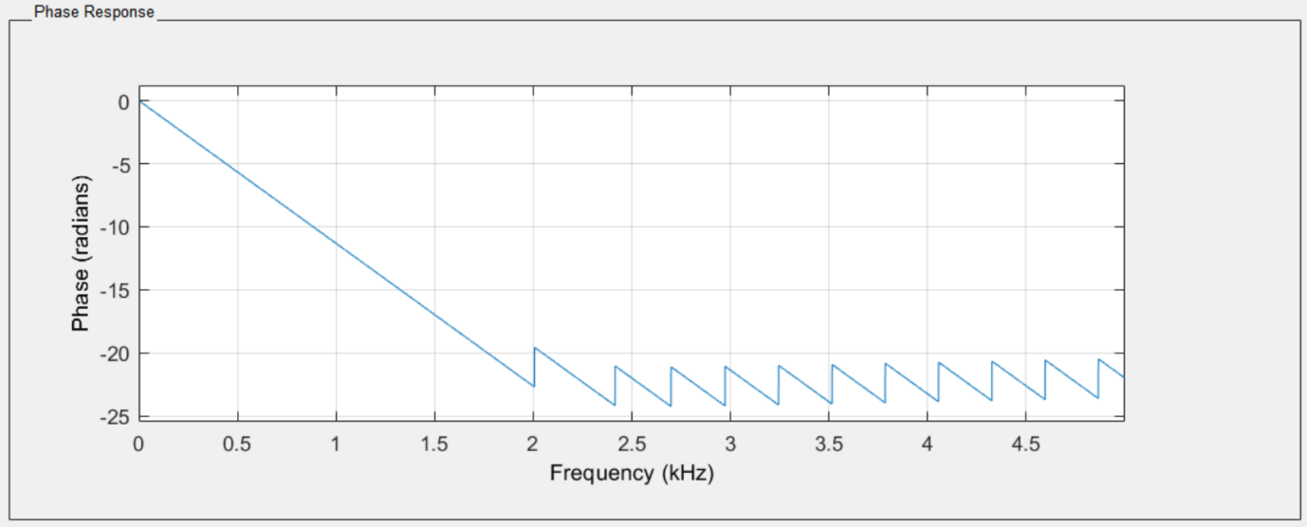

1. Phase Response of FIR filter

The impulse response of the filter is Type I, because it is axis symmetric and has an odd number of points.

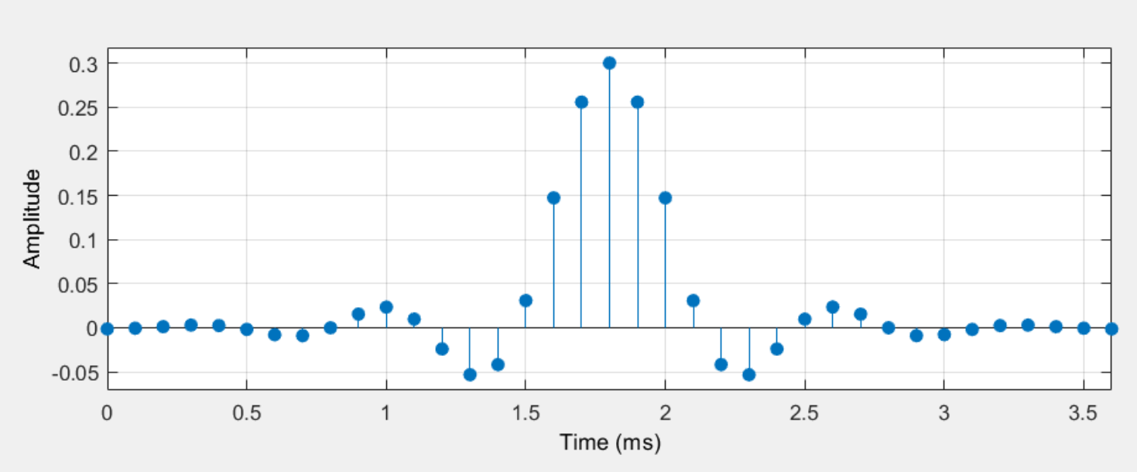

1. Impulse Response of FIR filter

**2.**

Using **Barlett window**, the order 6 will be necessary. The magnitude response is as follow. It has minimum order to achieve the goal that 40dB attenuation before 15kHz. But meanwhile it has a wide range of transition region in order to decrease the order of the goal which is not so ideal.

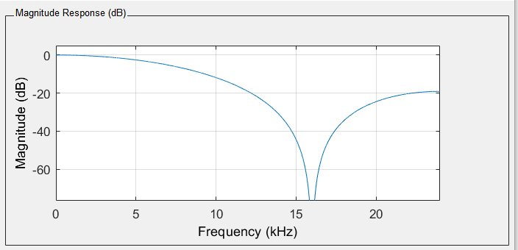

1. Magnitude Response of Barlett window

Using **Kaiser window** with same order(29), the stop-band is more like an equal ripple and get better

attenuation. When I tune the beta to 5, we can get a better response to meet the requirement.

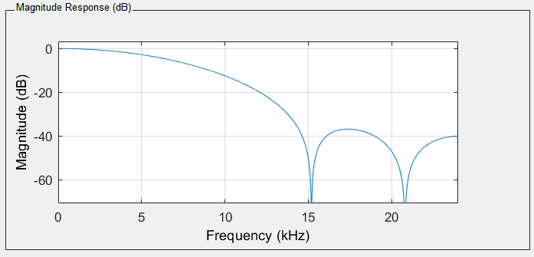

1. Magnitude Response of Kaiser Window(beta = 5)

The phase response and impulse response are as below. The phase response of kaiser FIR filter is linear which can keep the phase relationship between different signals. The impulse response of this filter belongs to Type I impulse response which means shorter length, less oscillating and more smooth waveform, it means the filter will get more stable features and more reliable.

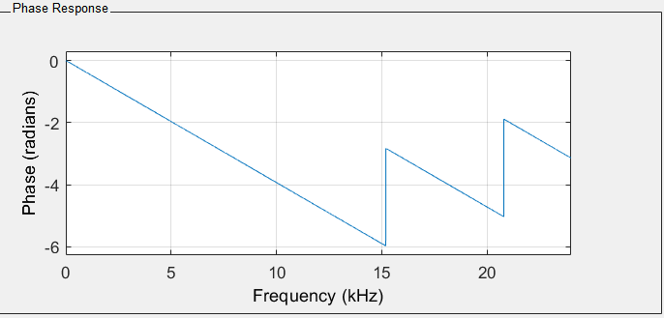

1. Phase Response of Kaiser Window(beta = 5)

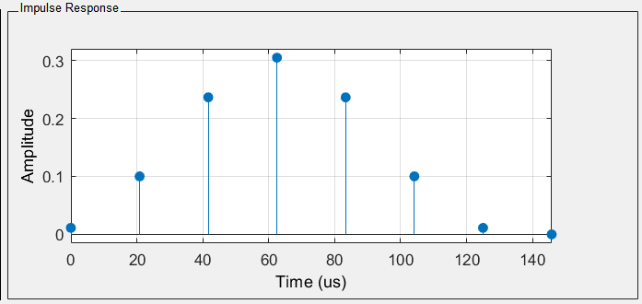

1. Impulse Response of Kaiser Window(beta = 5)

**3.**

Calculate with the given formula we can find that N = 18.2, so N = 19 for better performance. Try to design the Kaiser filter to meet the requirement. We found that the minimum order the filter is 23 when using Kaiser filter, 14 with Equiripple method and 15 with Generalized Equiripple method and all of them are around 19 which means the approximation is valid.

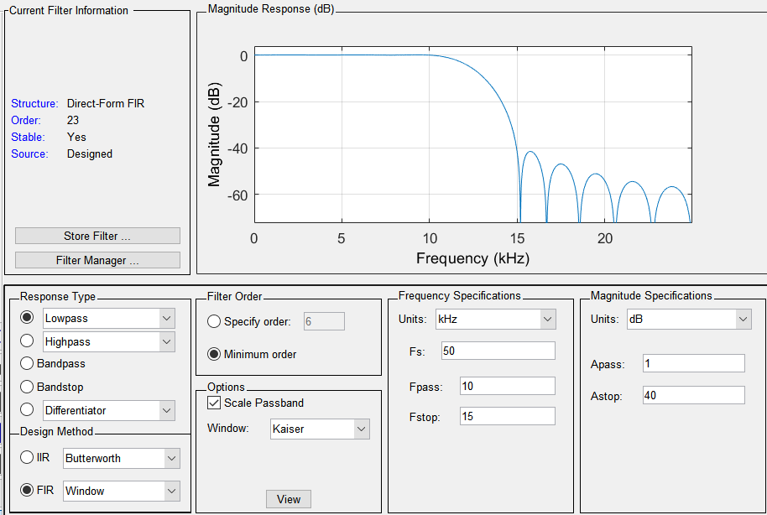

1. Kaiser filter to meet the requirement

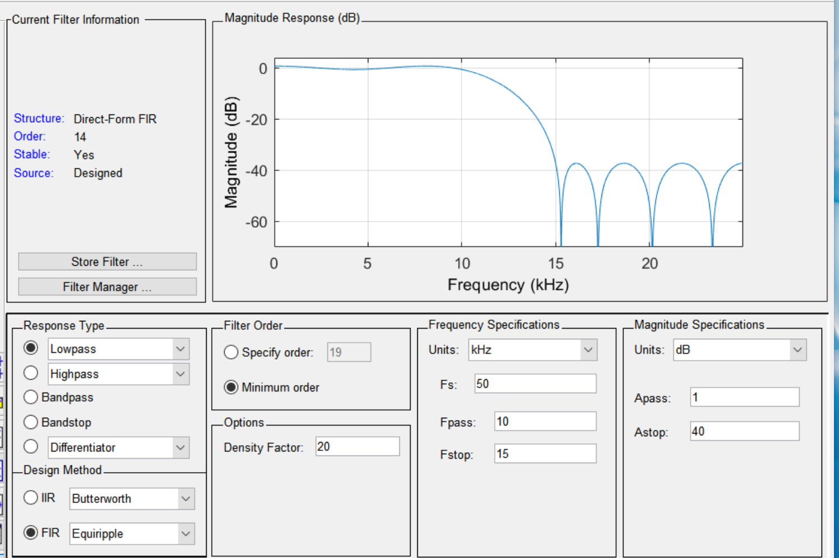

1. Equiripple filter to meet the requirement

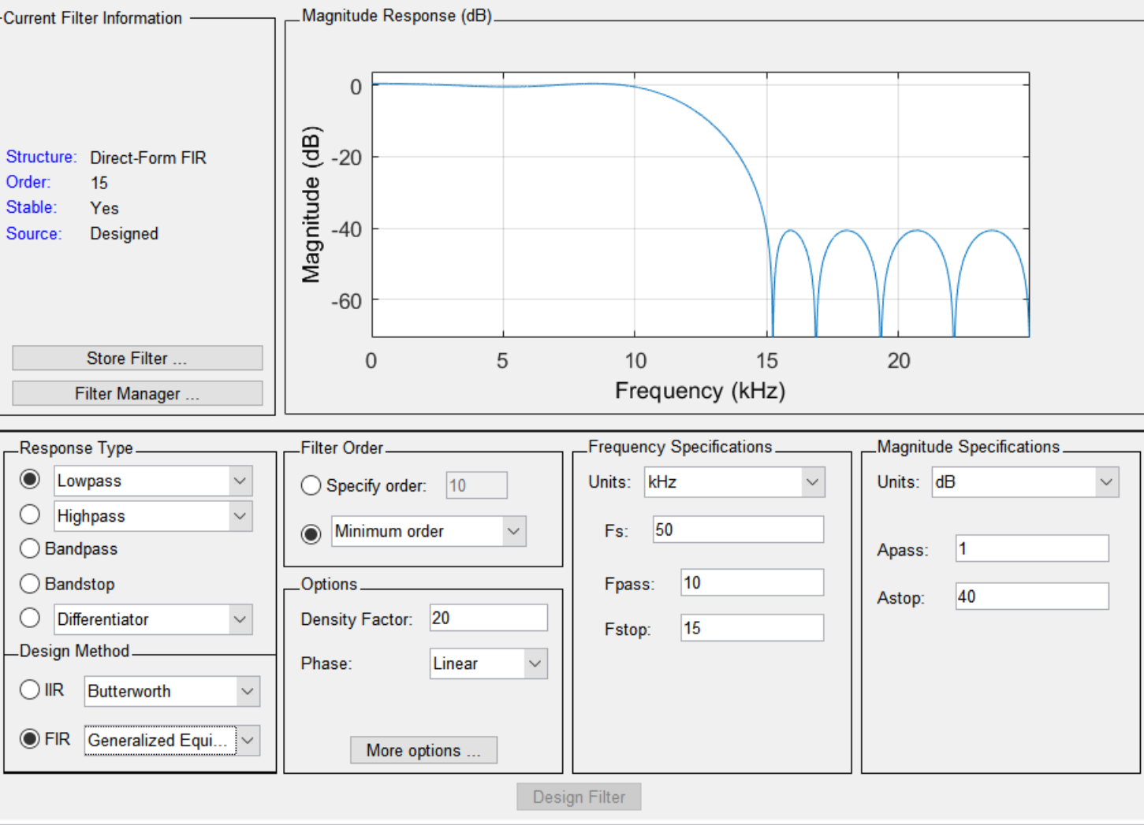

1. Generalized Equiripple filter to meet the requirement

**1.3 Restore a speech file with a suitable filter**

**2.**

Using Butterworth filter with parameters as below, the MSE has been reduced from 0.1115 to 0.0017.

% parameter of the filter

filter_type = 'butter';

Fpass = 1000; % First Passband Frequency

Fstop = 3000; % Second Stopband Frequency

Apass = 1; % Passband Ripple (dB)

Astop = 80; % Second Stopband Attenuation (dB)

match = 'stopband'; % Ban d to match exactly

To achieve the stretch goal, I built up a function to try different parameters of the filter.By listening to the result and observe the MSE of the filter, I finally chose the filter which has the parameter marked in green.

1. Compare performance

|  |  |  |  |  |  |
| --- | --- | --- | --- | --- | --- |
| type | Fpass | Fstop | Astop | MSE | Order |
| butter | 800 | 3500 | 60 | 0.00071 | 3 |
| butter | 1000 | 3000 | 60 | 0.001125 | 5 |
| butter | 1000 | 3500 | 60 | 0.000437 | 4 |
| butter | 1000 | 3500 | 70 | 0.000702 | 4 |
| butter | 1000 | 3500 | 80 | 0.001069 | 4 |
| butter | 1000 | 3800 | 60 | 0.000169 | 3 |
| butter | 1100 | 3500 | 60 | 0.000437 | 4 |
| cheby1 | 1000 | 3500 | 60 | 0.000652 | 3 |

The method and the reason why I choose this parameter can be concluded as below. Considering the MSE performance and the listening experience, I made this choice.

1. Result of different parameters

|  |  |  |  |
| --- | --- | --- | --- |
|  | lower | current | higher |
| Fpass | poor MSE | 1000 | higher filter order |
| Fstop | poor MSE | 3500 | better MSE, but poor listening experience because introduce note noise |
| Astop | better MSE, but poor listening experience because cant remove noise effectively | 60 | poor MSE |
| filter type | cheby1 poor in MSE | Butterworth | cheby1 poor in MSE |

**3.**

Insert distortion with note 30 and process with a high pass filter, the waveform are as below. We got MSE = 0.0030 with the parameters below.

filter_type = 'butter';

Fpass = 300; % First Passband Frequency

Fstop = 50; % Second Stopband Frequency

Apass = 1; % Passband Ripple (dB)

Astop = 80; % Second Stopband Attenuation (dB)

match = 'stopband'; % Ban d to match exactly

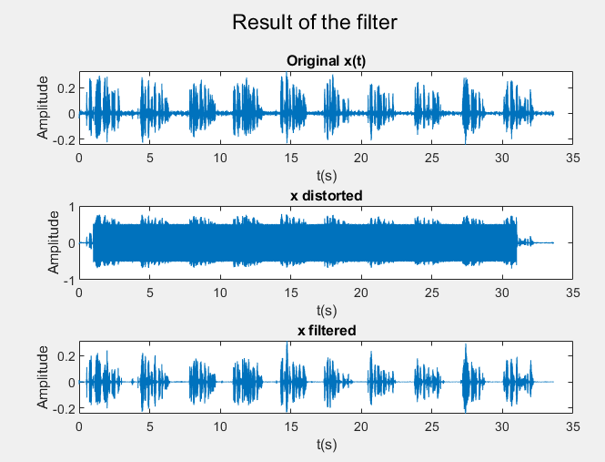

1. Process with high-pass filter(note = 30)

**4.**

Insert distortion with note 30 and 105 and process with a high pass filter and a low pass filter, the waveform are as below. We got MSE = 0.0027 with the filter parameters like below.

% highpass filter

filter_type = 'butter';

Fpass = 300; % First Passband Frequency

Fstop = 50; % Second Stopband Frequency

Apass = 1; % Passband Ripple (dB)

Astop = 80; % Second Stopband Attenuation (dB)

match = 'stopband'; % Ban d to match exactly

% lowpass filter

filter_type = 'butter';

Fpass = 1000; % First Passband Frequency

Fstop = 3500; % Second Stopband Frequency

Apass = 1; % Passband Ripple (dB)

Astop = 60; % Second Stopband Attenuation (dB)

match = 'stopband'; % Ban d to match exactly

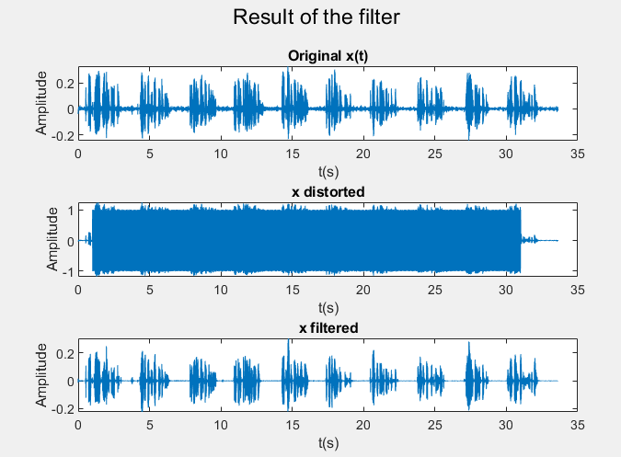

1. Process with low-pass filter and high-pass filter (note = 30, 105)