Lab 4

Report for Module EEP55C05 Digital Signal ProcessingJiacheng Li, Student ID 23330637

Trinity College Dublin

lij31@tcd.ie

October 2023

*This report is submitted in part fulfilment for the assessment required in* *EEP55C05 Digital Signal Processing. I have read and I understand the plagiarism provisions in the General Regulations of the University Calendar for the current year.*

1.1.1

2. By using the function and we can get Figure 1:

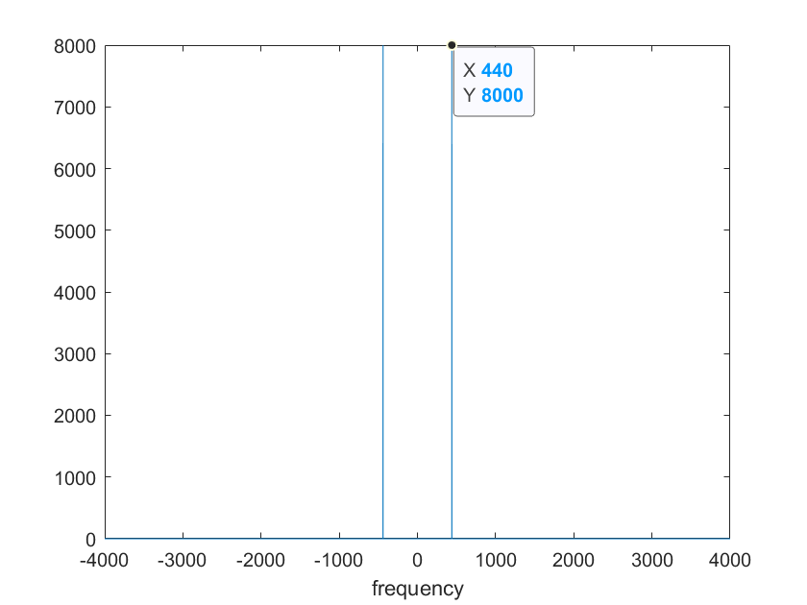

Figure 1: Note = 69 ‘s signal in frequency domain

From the marked point we can see that the value shows in the frequency 440Hz. Which shows the same as Figure 1 in lab4 requirement. And we can also see that after the FFT transform, we will get the symmetrical point in the negative axis.

3. Since the can transfer the time domain to the frequency domain by the code , we can just get integer or the integer number add 0,5. Thus we can know that:

Is the notes that we can get correctly from the DFT.

From lab2 we know that:

After calculation, we know that should be 3.417, which show that the should not be an integer. Thus we cannot get the correctly by .

1.1.2

2. To create music I choose Note: 59 42 53 95, then we get frequency figure like this:

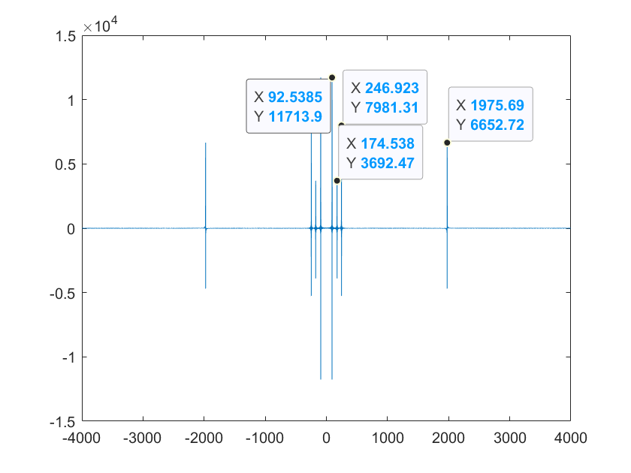

Figure 2: Using for notes to create a melody

1.2.1

1. I choose 59 and 95 as the high-pitched and low-pitched note. So I get the Figure 3:

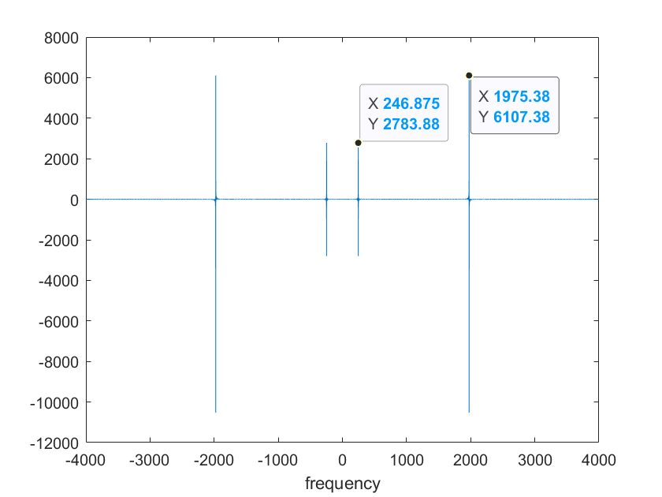

Figure 3: figure of two different notes waiting to separate

As we can see that Note 59 has the frequency 246.875 and Note 95 has the frequency 1975.38, they can be detected when cutoff frequency is 1000.

2. The vector HLP and HHP are created and after filter in the frequency domain, it shows like:

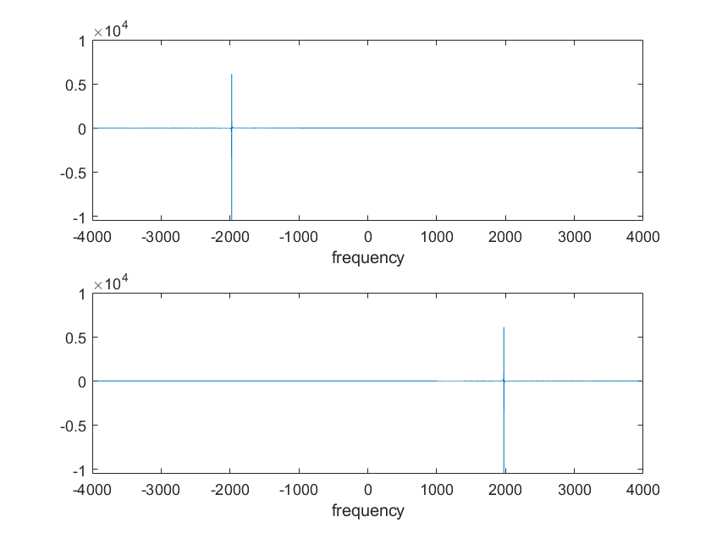

Figure 4: figure after HLP and HHP filter

After the detection we can see that we truly remove the note I expected with this filter.

1.2.2

1.

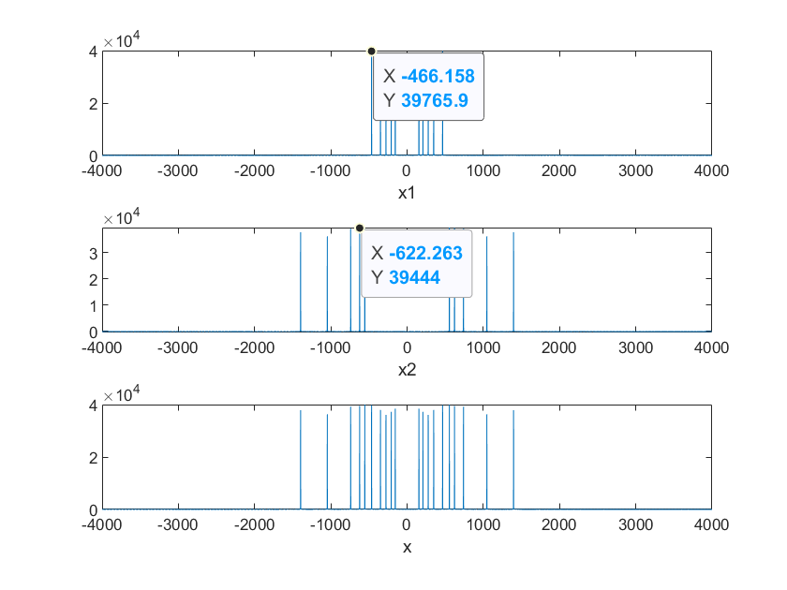

Figure 5: figure of x1, x2 and

So I will choose 550 as my cut-off frequency.

1.3.1

1. After loading wav files and audioread them, I get their spectrogram below:

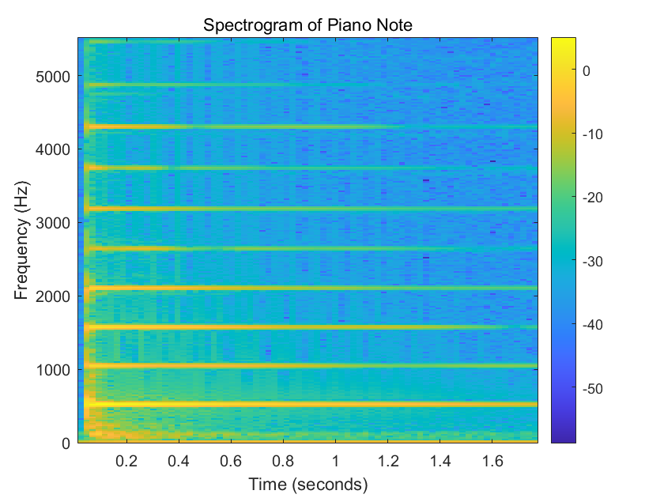

Figure 6: spectrogram of piano

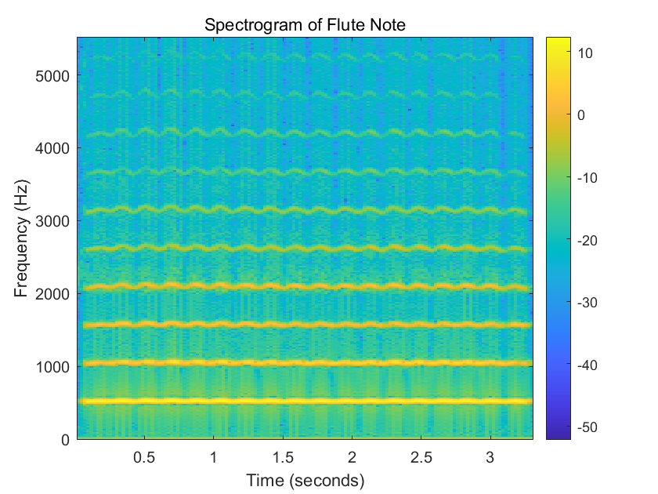

Figure 7: spectrogram of flute

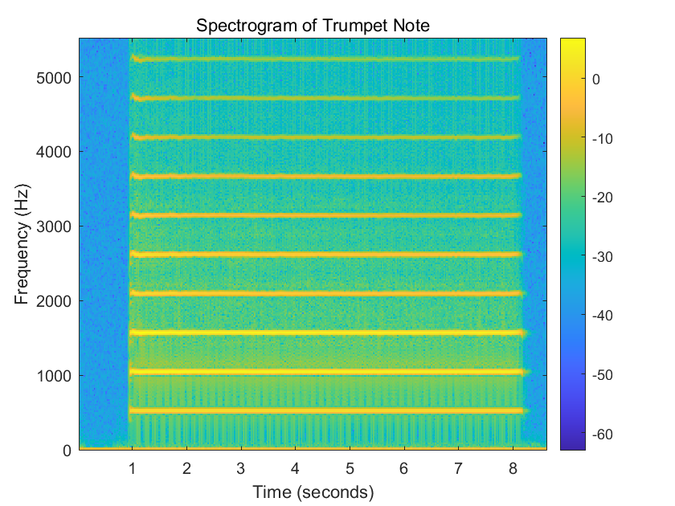

Figure 8: spectrogram of trumpet

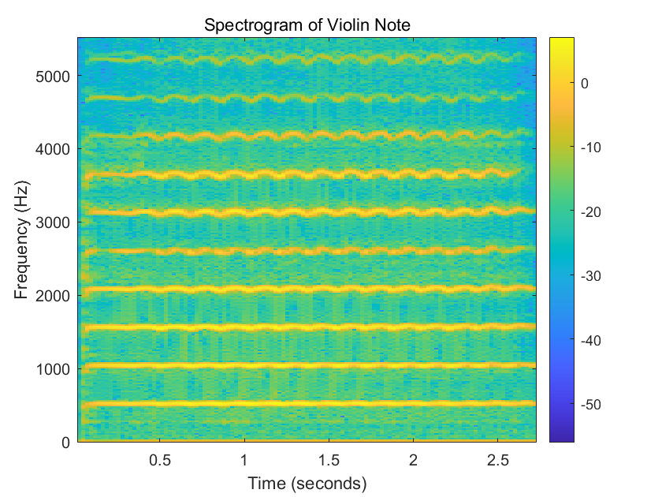

Figure 9: spectrogram of violin

These different instruments show different in the yellow part which can be seen that the different amplitude of waves. The higher amplitude of waves that the spectrogram gets, the more tremolo the voice of this instrument contains. What’s more, the bright color means the higher amplitude. The bright color light near zero shows the main voice and others show the harmony of the sound of instruments.

1.3.2

1. After cutting the time sequence 2’28 – 2’31, I get the spectrogram in Figure 10:

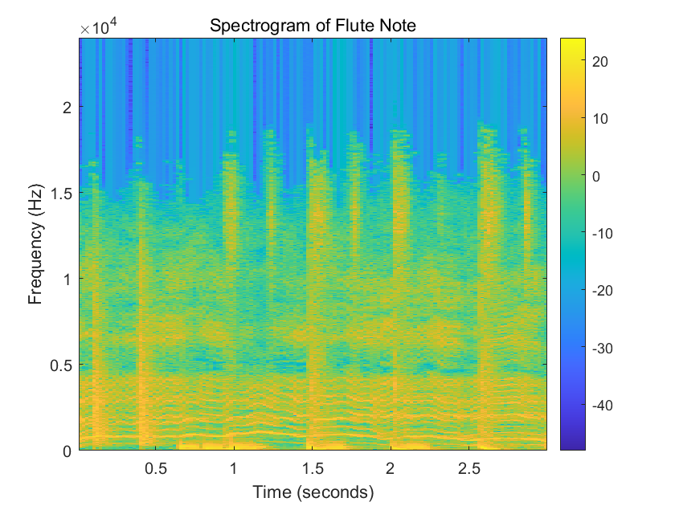

Figure 10: the spectrogram of part of this song

2. The yellow part limited in 0 to 0.5 should be the drums, the part that limited in 0.5 to 1 should be the electro effects and the impulse-like yellow parts should be Freddie Mercury singing.

1.3.3

1.

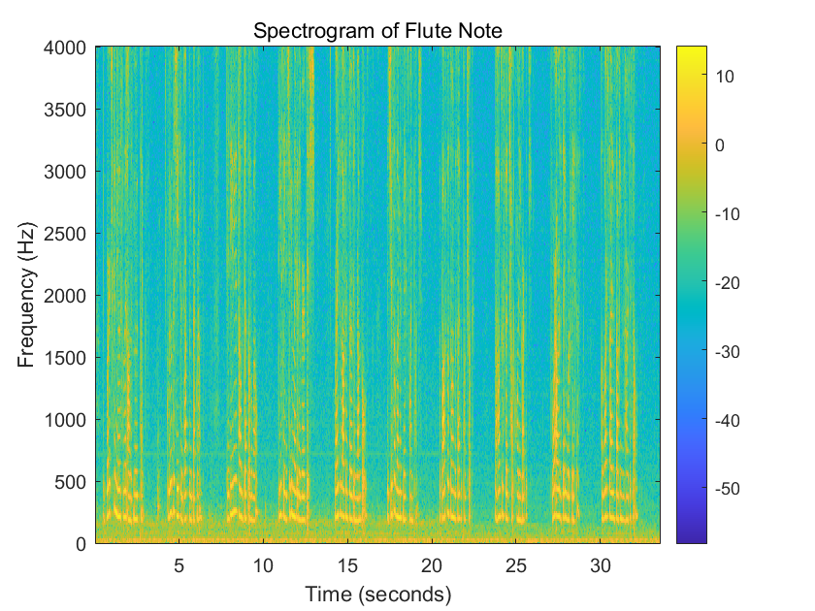

Figure 11: the spectrogram of 40ms

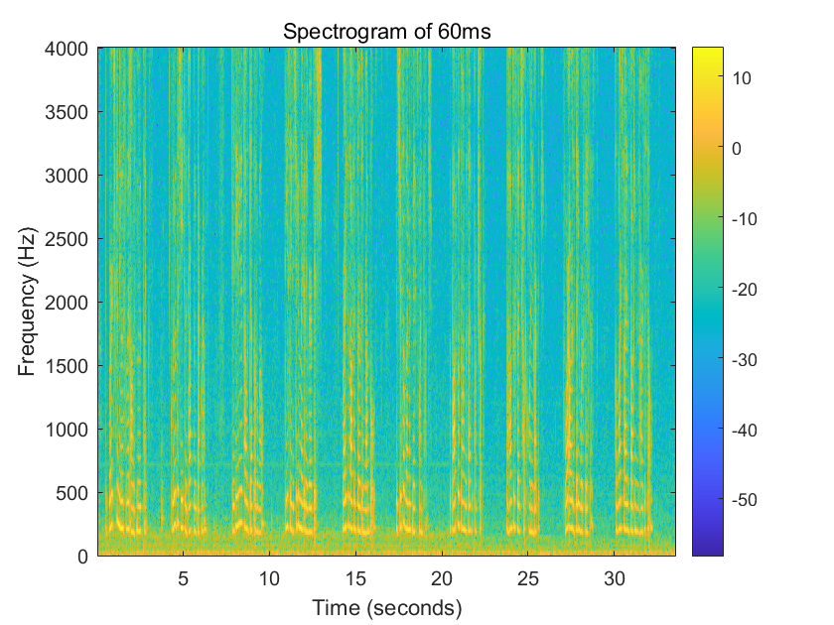

Figure 12: the spectrogram of 60ms

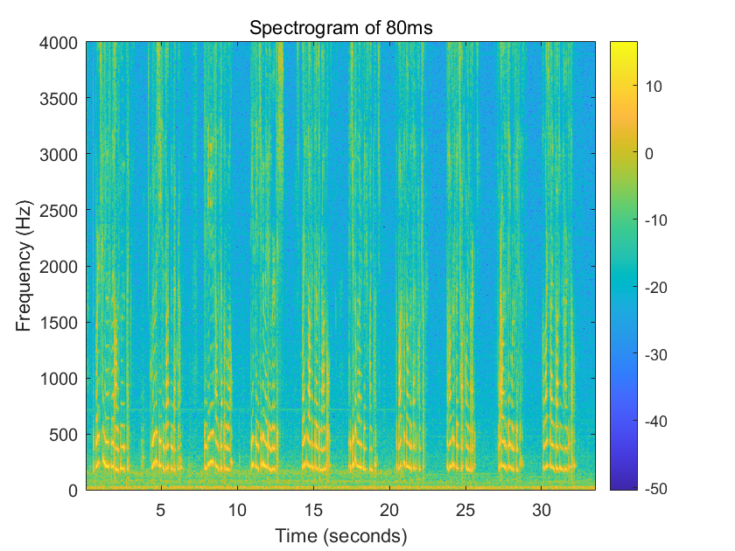

Figure 13: the spectrogram of 80ms

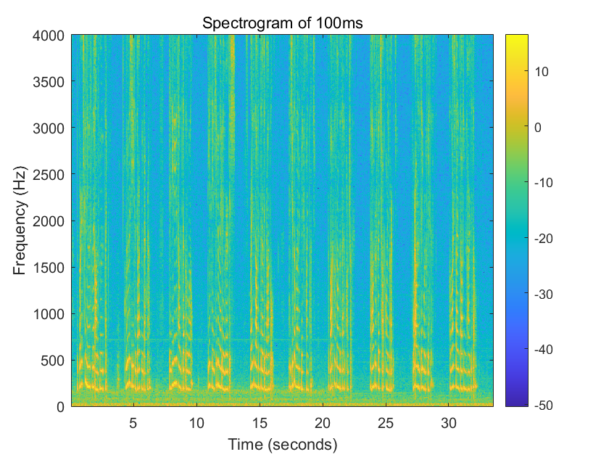

Figure 14: the spectrogram of 100ms

As the window lengths go higher, we will get more detail in one time sampling and as the sampling rate are reduced, we will get more separate time of these high amplitude lines.

1. To corrupt the speech file, I use function. Then we plot the spectrogram for a window with 100ms, which shows in Figure 15:

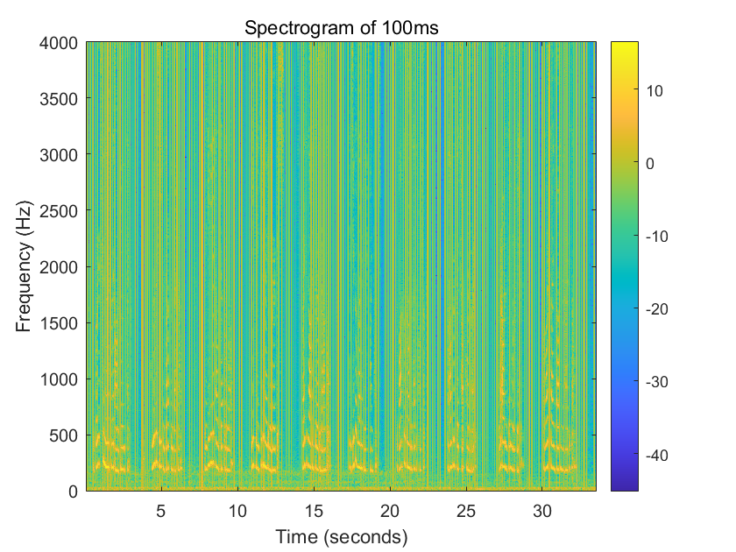

Figure 15: the corrupted spectrogram of 100ms

We can see obviously that there is more space which has higher frequency than before of the whole figure. Which means some noises are obviously added into the speech and cause influence on the spectrogram.

1.3.4

1. plot the normal patient’s figure will be shown in Figure 16:

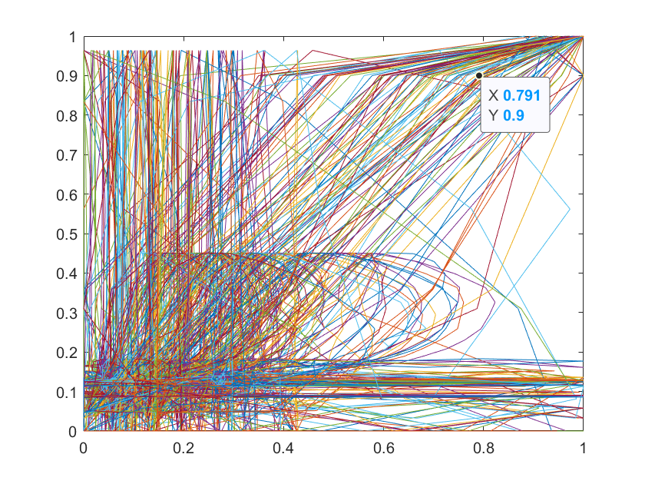

Figure 16

It is hard to detect whether the patient is normal or not.

2. Let’s use the spectrogram to deal with this problem. I first use the normal patients to get Figure 17:

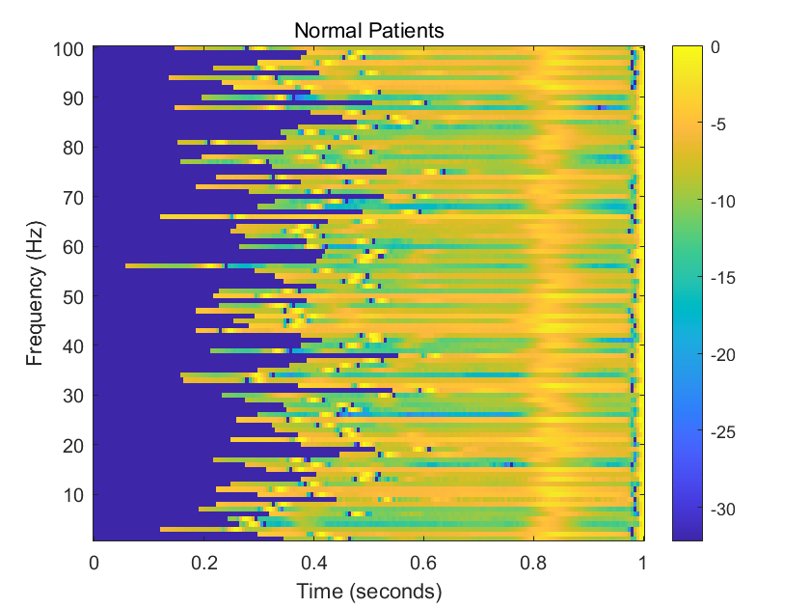

Figure 17: the spectrogram of normal patients

Then we change file to abnormal patients, then we can get Figure 18:

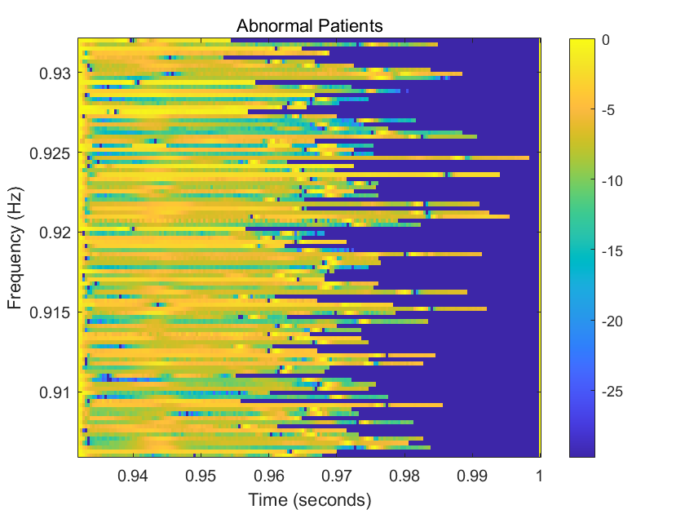

Figure 18: the spectrogram of abnormal patients

From these two figures, we can easily detect abnormal patients and normal patients.