**Lab4**

**1.1.1.2**

By applying a discrete Fourier transform to the signal created using the existing function, the following image is obtained, and we can see that the frequency of the signal is concentrated at plus or minus 440Hz.

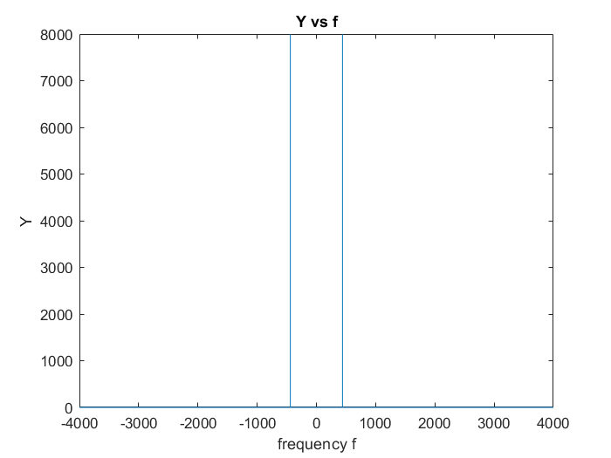

1. **Y vs f**

**1.1.1.3**

We can only correctly observe the notes which frequency is 0.5*N Hz like “Note 31, 33, 42, 43, 45, 54, 55, 57, 67, 69, 81, 93, 96, 105” which are in the table.

With the formula below, we can derive that the frequency of note 110 is 4698.64 which is not 0.5*N Hz, so we can not observe it correctly.

$$f_{0}^{note} = 440 × 2^{\frac{\left(note−69\right)}{12}}$$

The reason why we can’t do that is because of the function myFFT, the minimum step size of the frequency is 8000/16000 as 0.5.

f=(0:NFFT-1)'*Fs/NFFT;

**1.1.2.2**

The figure of the signal is as below.

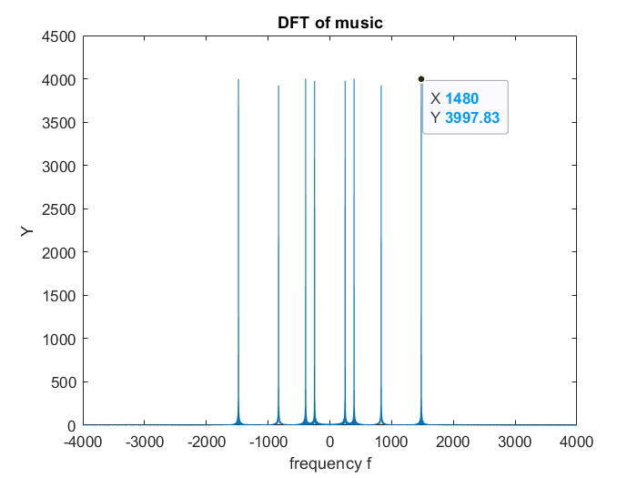

1. **DFT of the music**

**1.2.1.1**

We create a melody with note 25 and 107, the DFT figure of the signal is shown as below and the cutoff frequency I choose is 250 Hz.

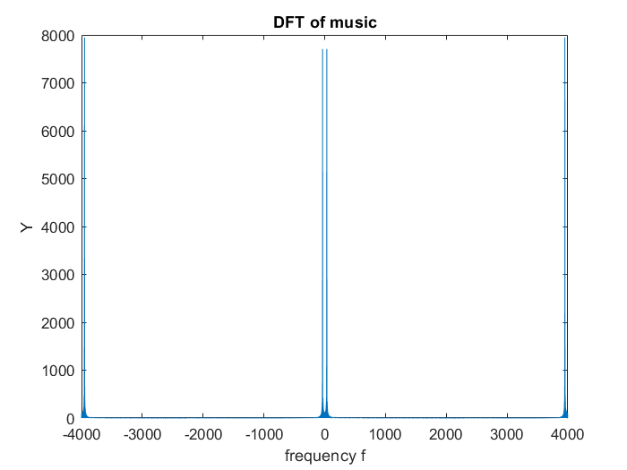

1. **DFT of the music**

**1.2.1.3**

The audio after the filter sounds deep. The DFT of the filtered audio is shown as below, we can see that we have removed the high frequency part.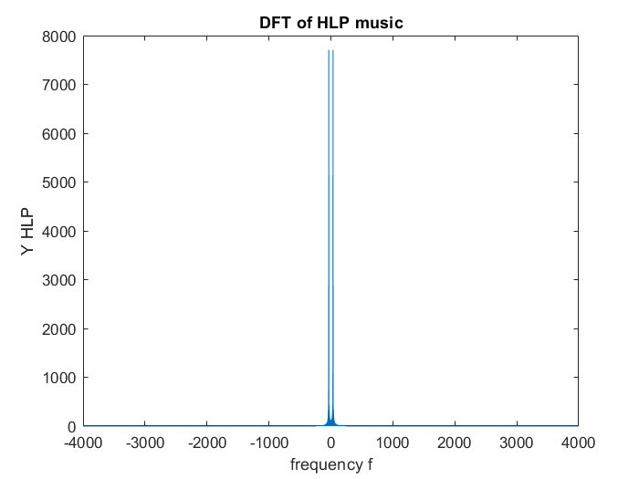

1. **DFT of HLP music**

**1.2.1.4**

The audio after the filter sounds sharp. The DFT of the filtered audio is shown as below, we can see that we have removed the low frequency part.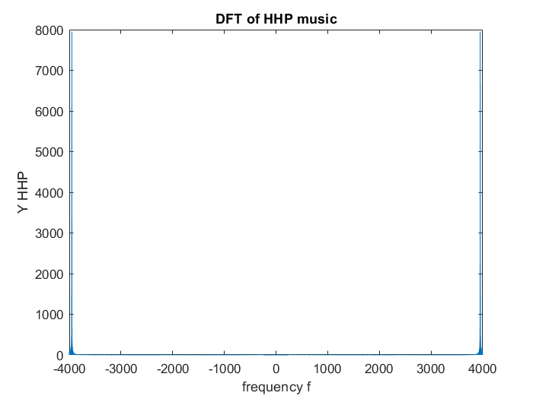

1. **DFT of HHP music**

**1.2.2.1**

I created a signal which contains the note from 51 to 60 and the duration of each note is 1 s. The DFT spectrum is as below.

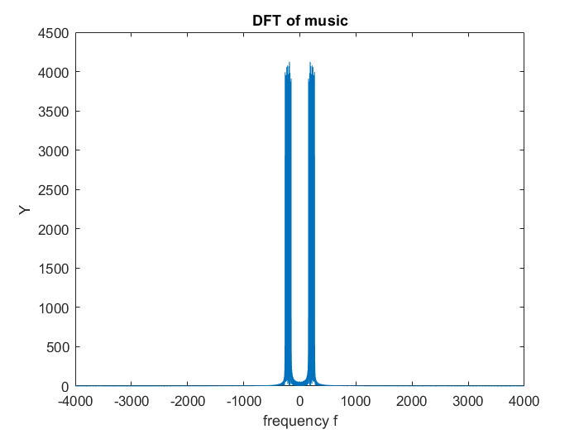

1. **DFT of x1**

**1.2.2.2**

I created a signal which contains the note from 72 to 81 and the duration of each note is 1 s. The DFT spectrum is as below.

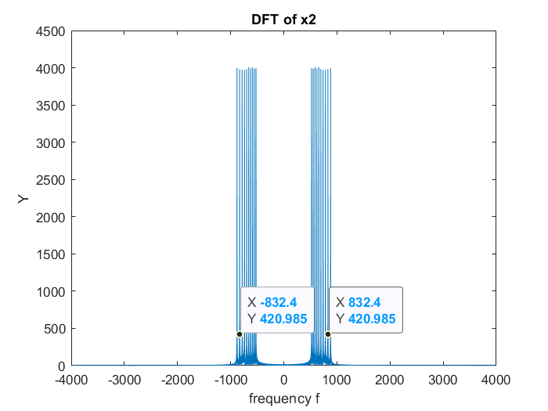

1. **DFT of x2**

**1.2.2.5**

The result signals are similar to the real sources. The Euclidean distance between x1 and y1, x2 and y2 are both 3.43.

**1.2.2.6**

The spectrum of the signals is shown as below.

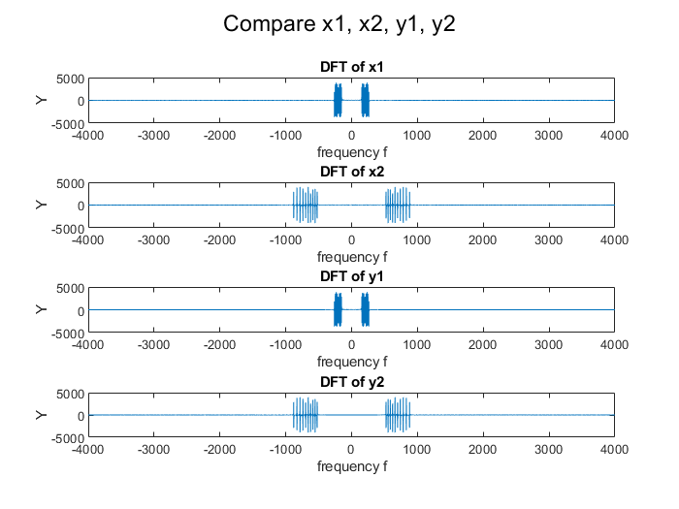

1. **DFT of x1, x2, y1, y2**

**1.2.2.7**

When we decrease the cutoff frequency to the threshold value , high frequency signal will be distorted by low frequency signal and the the low frequency signal will lose its information.

When we increase the cutoff frequency to the threshold value , low frequency signal will be distorted by high frequency signal and the the high frequency signal will lose its information.

**1.2.2.8**

The spectrum of the original signal is shown as below. In order to obtain uniquely the melodic line, we could use a ideal low-pass filter with cutoff frequency is 70 Hz, and the result spectrum is also shown as below.

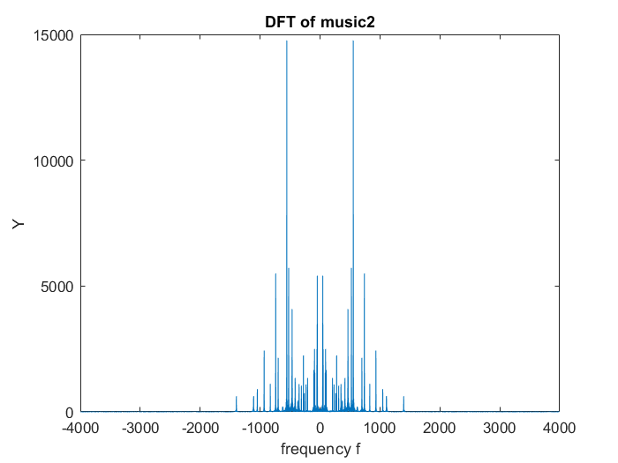

1. **DFT of original music**

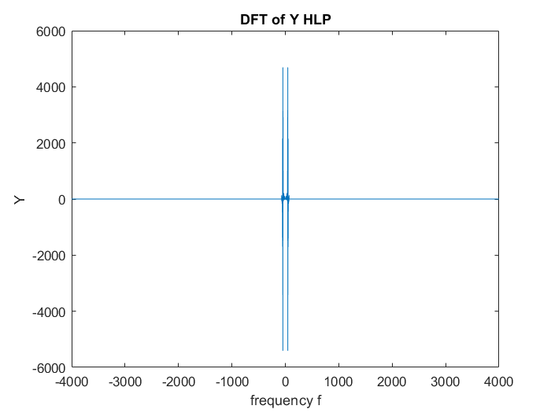

1. **DFT of uniquely the melodic line**

**1.3.1.1**

The spectrum of each instrument are shown as below.

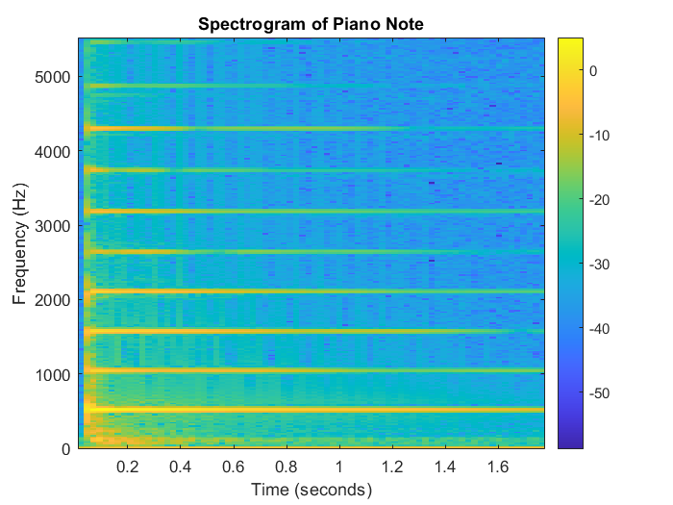

1. Spectrum of Piano Note

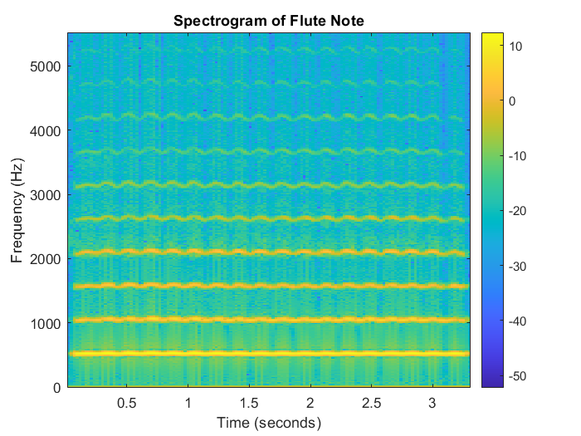

1. Spectrum of Flute Note

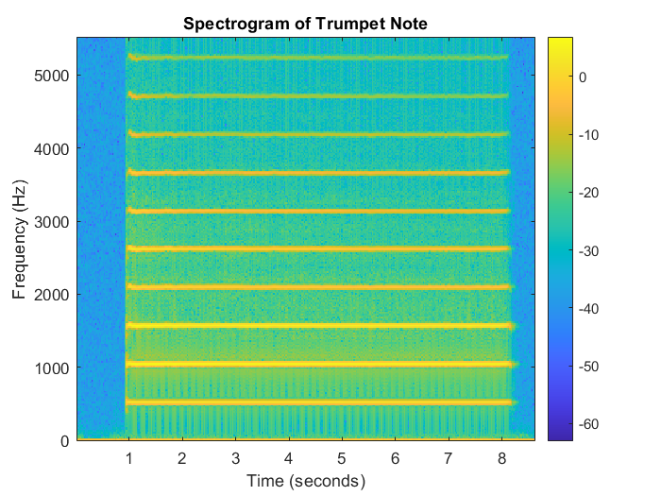

1. Spectrum of Trumpet Note

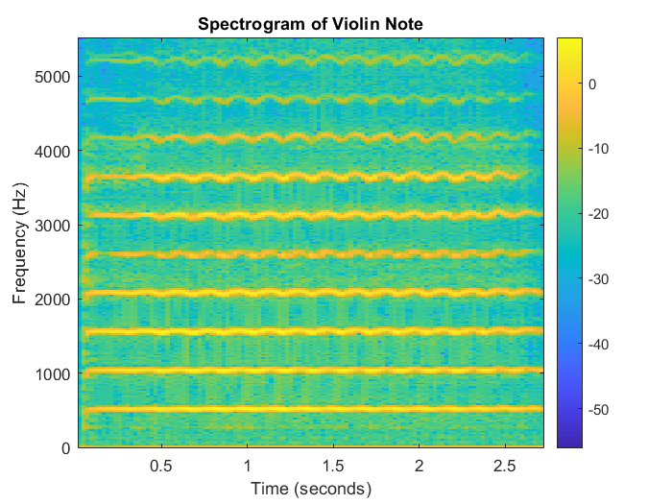

1. Spectrum of Violin Note

Through the spectrum, we can see that the spectrum diagram of different Musical Instruments has different performances at different frequencies, and the amplitude of the piano is more concentrated on its main frequency, and the attenuation is faster,as a result, it will perform more accurately. Violins, on the other hand, have a more uniform frequency distribution, decay more slowly, and behave more harmoniously.

**1.3.2.1**

The spectrogram of the song(2’28 - 2’31) is shown as below.

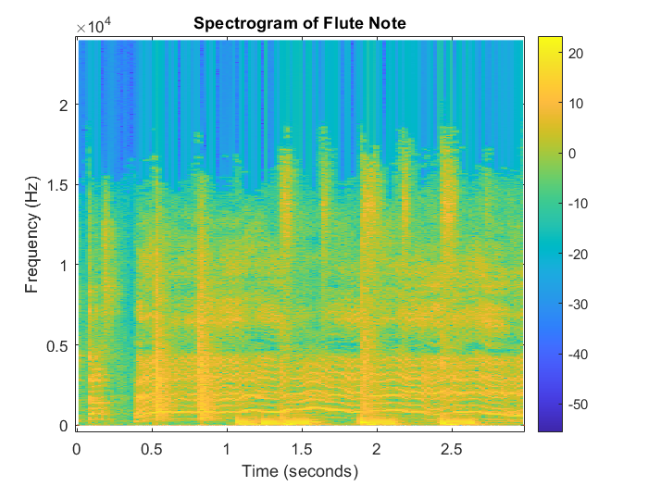

1. Spectrum of the music

**1.3.2.2**

The electro effect is the very low frequency part, the sing frequency is the continuous part vary from 0 - 0.5.And the drum is the sticks vary from 0 to 1.5.

**1.3.2.3**

The figure below clearly shows the spectrogram from 1s - 8s. With no human voice, it allows us to better distinguish between the three features

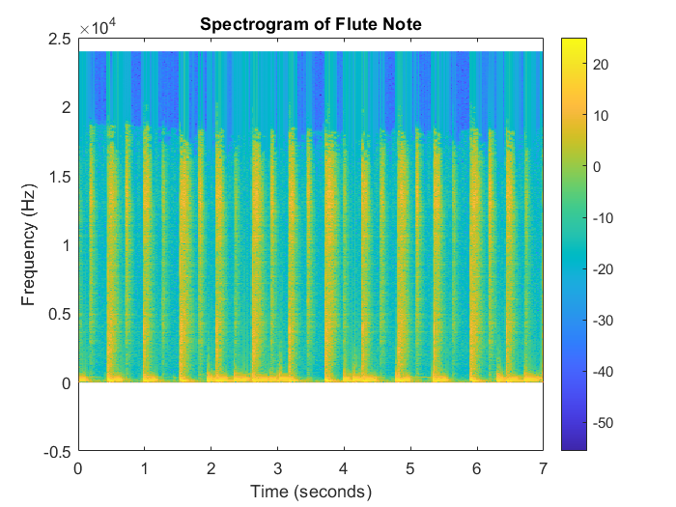

1. Spectrum of the music

**1.3.3.1**

The Spectrogram with different window size is shown as below.

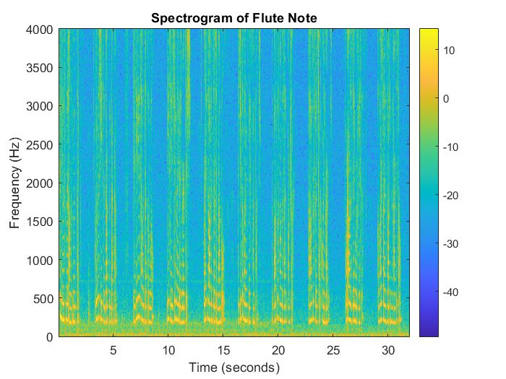

1. Spectrum with window size 40ms

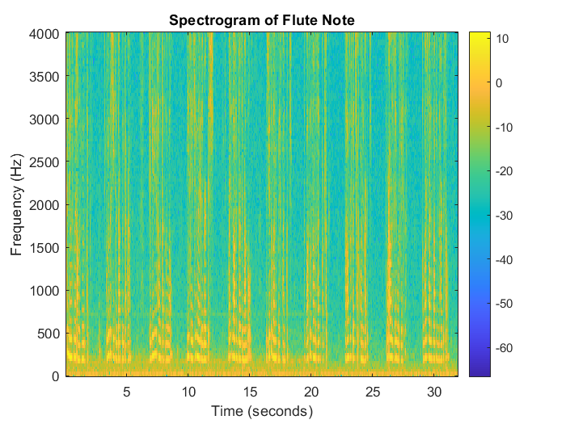

1. Spectrum with window size 20ms



1. Spectrum with window size 60ms

**1.3.3.2**

The Spectrogram with a super-imposed tone is shwon as below. We can clearly distinguish the noise from the speech.

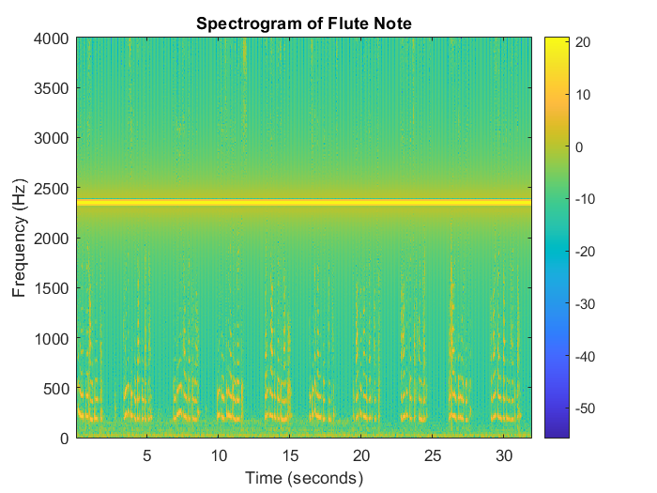

1. Speech with a noise note

**1.3.4.1**

The ECG of two types of patients is shown as below.

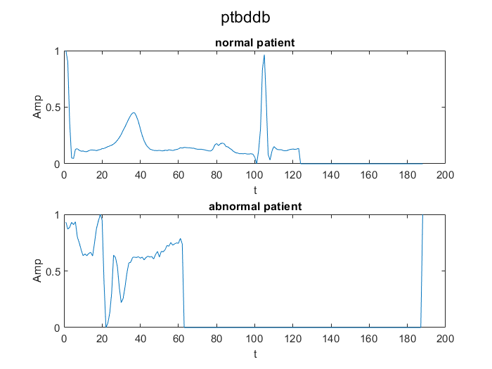

1. ECG of two types of patients

**1.3.4.2**