**EEP55C28: Digital Wireless Communications Lab**

Arman Farhang, Libin K Mathew and Sanoopkumar P S



**Contents**

**1 Wireless Channel: Modelling and Simulations****2**

1.1 Introduction 2

1.2 AWGN Channel 3

1.3 Wireless Channel 6

1.4 Simulation of wireless channel 9

1.5 Channel estimation and equalization 11

**2 OFDM: Performance Evaluation****13**

2.1 OFDM Transmitter 13

2.2 Wireless Channel 15

2.3 Receiver 16

**Lab 1**

**Wireless Channel: Modelling and**

**Simulations**

**1.1 Introduction**

The main objectives of this lab are to generate random data, modulate/demodulate them using quadrature amplitude modulation (QAM), while we analyse the impact of additive white Gaussian noise (AWGN) and fading channels in MATLAB. At the end

of this lab, you should be able to:

1. Implement a QAM modulator and demodulator for different modulation orders.

2. Generate the received signal considering the AWGN channel.

3. Generate wireless channel using the 5G standard channel models.

4. Perform Montecarlo simulations to obtain and plot the bit error rate as a function

of signal to noise ratio (SNR) and Eb /N0 .

Communication takes place with real-valued signals (also called passband signals) transmitted from the antenna. As it was discussed in the class, most of the signal processing algorithms at both transmitter and receiver are implemented on the discrete baseband signals. At the transmitter side, these discrete complex baseband signals

are up-converted to passband using radio frequency (RF) front ends to enable their

transmission off the antenna. At the receiver, all passband signals are down-converted to baseband by the receive RF frontend and then they are sampled. Hence, to simulate the communication systems, we implement the equivalent discrete baseband models of the transmitter, the channel and the receiver. Using the equivalent discrete baseband model of the overall system, we can evaluate and analyse the performance of different

modulation and signal processing techniques with simulations.

**1.2 AWGN Channel**

The AWNG channel is the simplest channel model. Since the wireless channel is consid- ered as a random process, the noise introduced by the wireless channel is also considered to be a random process with zero mean (Gaussian process). Therefore, the white noise introduced by the wireless channel is generally known as AWGN. In this exercise, we

study the effect of AWGN on the performance of QAM modulation.

The nth sample of the received signal in an AWGN channel can be represented as

y[n] = s[n] + v[n], (1.1)

where s[n] is the transmitted QAM symbol n and v[n] is the noise sample, which is obtained from the complex Gaussian random variable with zero mean and the variance N0 , i.e., v[n] ∼ CⅥ(0, N0 ). It should be noted that v[n] = vR [n]+jvI [n] with vR [n] and vI [n] as the inp-phase and quadrature components of the noise, respectively, each with

 .

**Signal-to-Noise Ratio (SNR):** If the average transmit symbol energy is Es , and

the noise power spectral density is N0 , the SNR of the received signal, y[n] is

SNR =

Es

.

N0

(1.2)

**Energy per bit to noise power spectral density (**Eb /N0 **):** Let the order of the modulation be M, i.e., s[n] is obtained by mapping log2 (M) bits to one of the M

symbols in the constellation. Then, Es = log2 (M)Eb , where, Eb is the average energy

per bit. Hence,

|  |
| --- |
| Check  Constellation  scatterplot |

|  |
| --- |
| Modulation  Mapping  qammod |

|  |
| --- |
| Demodulation Demapping  qamdmod |

|  |
| --- |
| Bits to Symbol Mapping  b2dec |

|  |
| --- |
| Bits to Symbol Mapping  dec2b |

|  |
| --- |
| BER Calculation  xor, mean |

Eb /N0 =  .

SNR and Eb /N0 are usually expressed in dB. Hence,

SNRdB = 10log10 (SNR),

（ )dB = 10log10（ ) ,

（ )dB = SNRdB − 10log10 (log2 (M)).

(1.3)

(1.4)

(1.5)

(1.6)

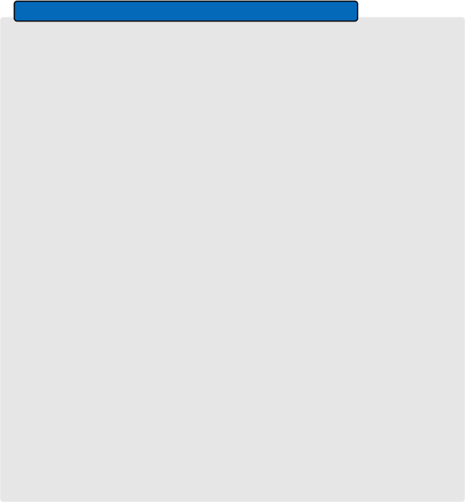**Exercise 1: Effect of AWGN on Signal Constellation**

Generate a random information bit sequence and modulate it using 4 −QAM (nor- malize the signal constellation to unit energy) and then observe the constellation of the transmitted signal. Obtain the received signal for an SNR of 15 dB (calcu- late the noise variance corresponding to the given SNR). Then, demodulate the received signal and calculate the average number of bits in error or bit error rate (BER) by comparing the detected bits with the transmitted bits. Please refer to the block schematic of the simulation procedure below with the same Matlab

functions (and the Matlab documentation) which can aid your simulations.

|  |
| --- |
| Check  Constellation  scatterplot |

|  |
| --- |
| AWGN  randn, awgn |

|  |
| --- |
| Information Bit Generation  randn |

1. What happens to the received signal constellation when SNR is increased?

2. What happens to the BER when the order of modulation is increased?

3. Compare the received signal constellation plots, the BER performance of

4-QAM, 16-QAM and 64-QAM and comment on your observations.

4. Compare the amount of average energy per bit that is required for 4-QAM

and 64-QAM to have no more than 1 erroneous bit every 1000 bits.



**Flow Chart of Monte Carlo Simulation**

|  |
| --- |
| Intialize: Error Count =0, Iteration Count =N |



Information bits



Modulator



Channel



Demodulator



Detected bits



|  |
| --- |
| BER Calculation BERi |



|  |
| --- |
| Error Count=Error Count + BERi |



Yes

is i < N

No



|  |
| --- |
| BER= Error Count |



N



τ1 = 450 ns, α1

τ4 = 1 μ s, α4

τ3 = 740 ns, α3

τ2 = 600 ns, α2

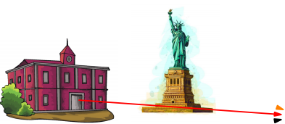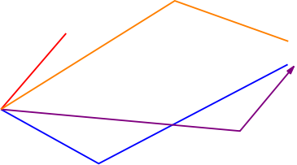 τ0 = 0 ns, α0 

Receiver

Transmitter  ®

Figure 1.1: Multipath wireless channel.

**1.3 Wireless Channel**

Unlike the wired channel, in a wireless communication system, the transmitted signal reaches the receiver after travelling through multiple paths, see Fig. 1.1. Depending on the length of the path, each received signal copy experiences different delay and attenuation. From Fig. 1.1, it can be seen that there exist 5 different paths from the transmitter to the receiver. For the sake of simplicity, we assumed that the line of sight

path (black arrow) has zero delay. Then the received signal can be expressed as

y[n] = α0 s[n] + α1 s[n − τ1] + α2 s[n − τ2] + α3 s[n − τ3] + α4 s[n − τ4] + v[n]. (1.7)

This received signal can also be represented as

y[n] =  αis[n − τi] + v[n] = s[n] *  αi δ[n − τi]) + v[n], (1.8)

where P is the number of paths in the wireless channel andΣ1 αi δ[n − τi] represents the channel impulse response. For the wireless scenario depicted in Fig. 1.1, if we



Amplitude

Amplitude

Amplitude

 α

|  |  |  |  |  |  |
| --- | --- | --- | --- | --- | --- |
|  | | |  | |  |
| α0 | α1 | | α4 | |  |
|  | | α2 | 3 |  |  |

h

0 0:37 0:74 1:1

Time (μs)

(a) Full impulse Response

|  |  |  |  |  |
| --- | --- | --- | --- | --- |
|  | |  |  |  |
| h0 | |  |  |  |
|  |  | 1 | h2 |  |

Ts 2Ts 3Ts

Time

(b) Bw = 2.7 MHz

|  |  |  |  |  |
| --- | --- | --- | --- | --- |
|  | |  |  |  |
| h0 | |  |  |  |
|  |  |  |  |  |

Ts 2Ts 3Ts

Time

(c) Bw = 900 KHz

Figure 1.2: Impulse response for wireless scenario depicted in Fig. 1.1 resolved by

receivers with different bandwidths.

assume that an impulse is transmitted at time instant 0, the signal through the black path reaches the destination at the same instant (assumed for the sake of simplicity) and the signal through the blue path reaches the destination after 450 ns. The black path has the lowest delay and the orange path has the highest delay, hence, the delay

spread of the multipath channel is

Tm = 1 − 0 = 1 µs (1.9) Eventhough there exist multiple paths from the transmitter to the receiver, the receiver

can separately identify the paths with minimum delay separation of sampling period.

The sampling period of a system is determined by its bandwidth i.e., Ts = 1/W, where

Ts is the sampling period and W is the bandwidth. This is illustrated in Fig. 1.2.

Let the bandwidth of the system be W = 2.7 MHz, then Ts  the receiver will not be able to identify the signal coming through the first two paths (black and blue) in Fig. 1.2a. In other words, the receiver will effectively see them as a single path with delay 0 µs. Similarly, red and purple paths will be seen together with a delay of 2Ts = 0.370 µs, and the orange path will be separately observed at a delay

of 3Ts = 0.740 µs. Hence the received signal will become

y[n] = (α0 + α1 )s[n] + (α2 + α3 )s[n − 1] + α4 s[n − 2] + v[n]. (1.10) Based on (1.10), eventhough the channel has 5 paths the receiver will be able to identify only three different delayed signals. Hence, depending on the sampling period of the

system the wireless channel can be modelled as a filter with 3 taps where each tap

gain depends on the multipath coefficients. Consequently, the received signal can be

expressed as

y[n] = h0 s[n] + h1 s[n − 1] + h2 s[n − 2] + v[n], (1.11)

where h0 = α0 + α1 , h1 = α2 + α3 and h2 = α4 . Considering the transmit signal bandwidth to be W = 900 kHz, then Ts 

will be within the 1/W interval of the first tap and the received signal will be

y[n] = (α0 + α1 + α2 + α3 + α4 )s[n] + v[n],

y[n] = h0 s[n] + v[n].

(1.12)

(1.13)

It can be observed that in the first scenario, the Ts < Tm which resulted in a channel with multiple taps. Such a channel is called a frequency-selective channel. The input-

output relationship for the frequency-selective channel is

y[n] =  h(l)s[n − l] + v[n] = s[n] *  h(l)δ[n − l]) + v[n]. (1.14)

In the second scenario Ts > Tm which resulted in a channel with a single tap, the channel has a frequency-flat response. The input-output relationship for the frequency

flat channel is

y[n] = h0 s[n] + v[n].

(1.15)

**1.4 Simulation of wireless channel**

In order to statistically model the wireless channel, we need to specify the following.

1. The number of channel taps and delay of each tap which depends on the sampling

period and in turn the signal bandwidth.

2. Power of each delay tap: It is specified by the power delay profile (PDP) of the channel. We take the PDP from the standard channel models,e.g., the 5G channel

models TDL-C and TDL-D.

3. Statistical distribution of the delay tap coefficients.

Here, we consider the 5G channel models TDL-C and TDL-D whose PDPs are shown

in Fig. 1.3.

Once we specify the system bandwidth, we need toresample this power delay profile to see how many of these taps can be identified by our system. Once we have the new power delay profile based on the signal bandwidth, the channel coefficients can be

generated for each channel realization as below.

**Generation of Wideband Wireless Channel**

Step 1: Fix the sampling period (Ts 

Step 2: Obtain the number of channel taps and the PDP from the standard, i.e,

σ for all l = 0,..., L − 1, using MATLAB function interp1 (See Fig.

1.4, which shows how to obtain the PDP for the sampling period from an

arbitrary exponential PDP)

Step 3: For all l = 0,..., L − 1, generate h[l] = hR [l] + jhI [l], where, hR [l] ∼

N (0, σ/2) and hI [l] ∼ N(0,σ/2). This can be also implemented by h[l] =

 (hR [l] + jhI [l]), where, hR [l] ∼ N(0, 1) and hI [l] ∼ N(0, 1).

The channel coefficients generated will have Rayleigh distribution.

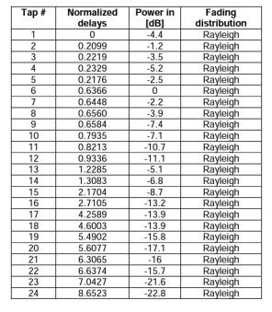

(a) TDL-C

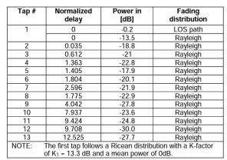

(b) TDL-D

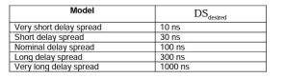

(c) Normalized delay to actual delay conversion

Figure 1.3: 5G channel models [1].

[1] [Study on channel model for frequency spectrum above 6 GHz](https://www.etsi.org/deliver/etsi_tr/138900_138999/138900/14.02.00_60/tr_138900v140200p.pdf)



Power (dB)

Power (dB)

Power (dB)

Power (dB)

|  |  |  |  |  |  |  |  |  |  |
| --- | --- | --- | --- | --- | --- | --- | --- | --- | --- |
|  |  | |  | |  | |  |  | PDP |
|  |
|  | |  |
|  |  | |  | |  | |  | |  |
|  |  |  |  | |  | |  | |  |
|  |  |  |  |  |  | |  | |  |
|  |  |  |  |  |  |  |  | |  |

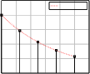

Interpolation

|  |  |  |  |  |  |  |  |  |  |
| --- | --- | --- | --- | --- | --- | --- | --- | --- | --- |
|  |  |  | | Final | | PDP f | | or simul | ation |
|  |  |
|  | |  | |  | |  |  |
|  |  | | |  | |  | |  |  |
|  |  | | |  | |  | |  |  |
|  |  | |  |  |  |  | |  |  |
|  |  | |  |  |  |  |  |  |  |

PDP at sampling interval

Delay

(a) Exponnetial PDP

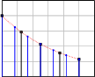

Delay

(c) PDP for the sampling rate

Delay

(b) PDP after interpolating

Delay

(d) Final PDP

Figure 1.4: Obtaining PDP for simulation from an arbitrary exponentially decaying

PDP according to required sampling period.

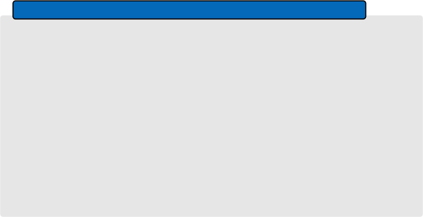

**Exercise 2: Frequency-Selective Fading Channel Simulation**

Generate a frequency-selective fading channel using the TDL-C channel model

considering the nominal delay spread.

1. With an example show the effect of increasing bandwidth on the delay spread

of the channel and the number of taps.

2. With an example show the effect of decreasing bandwidth on the delay spread

of the channel and the number of taps.

3. Compare the constellation plots of the received signal in an AWGN channel, frequency-flat and frequency selective channel for an SNR of 15 dB for 4-QAM,

16-QAM and 64-QAM and briefly comment on your observations.

**1.5 Channel estimation and equalization**

From the received signal described in (1.14) and (1.15) it is clear that in order to detect the transmitted information bits, the receiver needs to know the wireless channel response (h0 for flat fading channel and h0 , h1 ,... hL− 1 for frequency selective channel). The signal processing performed at the receiver to estimate the channel is called channel

estimation. The signal processing technique performed to undo the channel effect is called equalization. Since the channel estimation is beyond the scope of this module,

|  |
| --- |
| Modulation  Mapping  qammod |



|  |
| --- |
| Bits to Symbol Mapping  b2dec |

Wireless Channel

|  |
| --- |
|  |

AWGN

randn, awgn

|  |
| --- |
| Bits to Symbol Mapping  dec2b |

Constellation

scatterplot

|  |
| --- |
| Demodulation Demapping  qamdmod |

|  |
| --- |
| Single Tap Equalization  ./ |

we will only look into the channel equalization.

Considering the flat fading channel the simple multiplication of the channel coeffi- cient with the transmitted signal makes equalization quite simple. The equalization in the flat fading channel can be simply performed by dividing the received signal by the

channel coefficient.

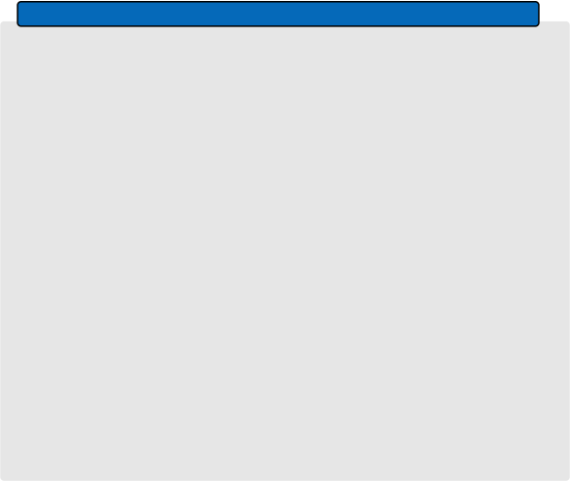**Exercise 3: Effect of Flat-Fading Channel on Signal Constellation**

Generate a flat-fading Rayleigh channel, (adjust the system bandwidth so that the channel is a single-tap channel). Then, calculate the BER for the system

parameters described in Excercise. 1.

|  |
| --- |
| Check  Constellation  scatterplot |

|  |
| --- |
| Information Bit Generation  randn |

Check

|  |
| --- |
|  |

|  |
| --- |
| BER Calculation  xor, mean |



|  |
| --- |
| Check  Constellation  scatterplot |

1. What happens to the constellation when you increase the SNR?

2. What happens to the BER when the order of modulation is increased?

3. Compare the BER vs SNR curves for an AWGN and flat fading channel and

briefly comment on the challenges in a fading channel.

For the frequency-selective channel, due to the convolution operation, channel equal- ization becomes complex. However, we will learn in the next lab that by using OFDM, as a multi-carrier modulation technique, frequency selective channels can be split into a set of frequency flat sub-channels and simple single-tap equalization per subcarrier

can be utilized to equalize the channel.

**Lab 2**

**OFDM: Performance Evaluation**

In Lab 1, we learned that channel equalization is quite challenging when the channel is frequency-selective. With the help of multi-carrier modulation techniques, a frequency- selective channel can be converted to a set of frequency-flat sub-channels where single- tap equalization can be deployed. The main objective of this lab is to implement the OFDM transmitter, OFDM receiver with single-tap frequency domain equalization and

to evaluate the BER performance. After completing this lab, you should be able to

1. Implement the OFDM modulator and demodulator.

2. Understand the role of cyclic prefix (CP).

3. Implement single-tap frequency domain equalization at the receiver side.

4. Understand the advantage provided by OFDM in a wideband multipath channel.

**2.1 OFDM Transmitter**

Consider an OFDM system with N subcarriers, and the subcarrier spacing of ∆F. Then, the total signal bandwidth will be W = N∆F. For such a system,considering the transmit QAM symbols, x[n], each OFDM symbol will consist of N time domain

samples which can be expressed as

s[k] =   x[n]ej2π , 1,..., N − 1. (2.1)

The above equation can be expressed in vector-matrix notation as

where

l ' '

**s** = **'** ' ' [

**s** = **Fx**,

|  |  |
| --- | --- |
| s[0]  s[1]  .  .  .  s[N − | 」 l ' ' ' ' **'** , **x** = **'** ' ' ' '  1] l [ |

x[0]

x[1]

.

.

.

x[N −

」

'

'

'

'

'

'

1] l

(2.2)

(2.3)

and the (k, n)th element of the normalized DFT matrix is **F**N [k, n] = e . In MATLAB, mathbfFN can also be generated using (1/sqrt(N))*dftmtx(N).

**Cyclic Prefix**

After generating the time domain signal, a cyclic prefix (CP) of length NCP is appended

to the beginning of **s** to form the transmit signal of length N + Ncp , i.e.,

l ' ' ' ' ' ' '

'

**s**tx = **'** ' ' ' ' ' ' ' ' [

s[NCP − 1] s[NCP − 2]

.

.

s[N − 1] s[0]

s[1]

.

.

.

s[N − 1]

」

'

'

'

'

'

'

'

'

'

' .

'

'

'

'

'

'

'

'

l

(2.4)

The transmit signal **s**tx can be also obtained by matrix multiplication as

**s**tx = **A**CP **s**,

(2.5)

l **I** 」

where **A**CP = [ **I**N l, **I**N is an identity matrix of size N and **I** is formed by the last

NCP rows of **I**N .

**2.2 Wireless Channel**

The wireless channel can be generated with the same procedure as in Lab 1 with a band- l h[0] 」 ' '

width W = N∆F. Let the generated wireless channel has L taps, **h** = **'** . **'** .

' h[1] '

' . '

' '

.

[ h[L − 1] l

Then, the received signal can be expressed as

L− 1

yrx [n] =  h[l]stx [n − l] + v[n], n = 0, 1,..., N + Ncp − 1 (2.6)

This can be represented in vector-matrix notation as

**y**rx = **H**t**s**tx + **v**,

(2.7)

l v[0] 」

' '

where **v** = **'** . **'** is the AWGN noise vector and **H**t is the time domain channel

' v[1] '

' . '

' '

.

[ v[N − 1] l

convolution matrix. As it was explained in the class, matrix is described as

l ' ' ' ' ' ' '

'

**H**t = **'** ' ' ' ' ' ' ' ' [

h[0] 0 0 0 0 ... 0

h[1] h[0] 0 0 0 ... 0

h[2] h[1] h[0] 0 0 ... 0

. . .

. . . . ... 0

. .

h[L − 1] h[L − 2] ... . . . h[0] ... 0

0 h[L .− 1] h[L .− 2] ... . . . h[0] 0

. . .

.

. . . . . . .

.

. . . . . .

0 0 0 0 h[L − 1] . . . h[1]

0 」

'

0 '

'

'

0 '

'

. '

'

**'** . (2.8)

0 '

'

'

0 '

'

. '

. '

'

.

h[0] l

It can be observed that **H**t is a convolution matrix of size (N +Ncp ) × (N +Ncp ). This

matrix is obtained by appending N +NCP − L zeros to **h**and then shifting it downwards at each column to form the N + NCP columns .

**2.3 Receiver**

At the receiver, the first operation is removing the cyclic prefix from the received signal

vector **y**. Then OFDM demodulation is performed.

**Removing cyclic prefix**

The received signal after cyclic prefix removal can be expressed as

y[n] = yrx [NCP + n], n = 1, 2,...,N.

This operation can be expressed in matrix form as

**y** = **R**CP**y**rx ,

where **R**CP = [**0**N×NCP , **I**N ], and **0**N×NCP is zero matrix of size N × NCP .

**OFDM Demodulation**

(2.9)

(2.10)

After removing the CP, OFDM demodulation is performed to convert the time domain signal to the frequency domain, i.e., the received samples in frequency domain can be

expressed as

r[n] = √N  y[m]e−j2π N , n = 0, 1,..., N − 1. (2.11)

1 N − 1 mn

Using the DFT matrix, **F**N , (2.11) can be also expressed as

**r** = **F**N**y** (2.12)

Combining (2.2), (2.5), (2.7), (2.10) and (2.12), the received signal in the frequency

domain can be expressed as

**r** = **F**N**R**CP**H**t**A**CP**Fx** + **F**N**R**CP**v** (2.13)

= **H**f**x** + (2.14)

It can be observed that the matrix **R**CP **H**t**A**CP is a circulant matrix. Due to the

property of DFT matrix and circulant matrix, **H**f = **F**N (**R**CP **H**t **A**CP )**F** is a diagonal





|  |
| --- |
| Adding CP |

|  |
| --- |
| Modulation |

|  |
| --- |
| IFFT |

|  |
| --- |
| Demodulation |

|  |
| --- |
| Equalization |

|  |
| --- |
| FFT |

Removing CP

|  |
| --- |
| Information Bit Generation |

Wireless Channel

|  |
| --- |
|  |

AWGN

|  |
| --- |
| Information bit Detection |

Figure 2.1: OFDM system diagram.

matrix with the diagonal elements as the N point DFT of **h** that is zero-padded to have the length equal to N. Since **H**f is diagonal, equalization can be easily performed by dividing each element of **r** by the corresponding diagonal elements of **H**f , i.e., single-tap equalization. The equalized symbol in the nth subcarrier can be expressed as

[n] =

r[n]

Hf [n,n]

.

(2.15)

Once we obtained the equalized received signal vector, QAM demodulation can be performed to estimate the transmitted information bits. The block schematic for the

simulation of the OFDM system diagram is shown in Fig. 2.1.

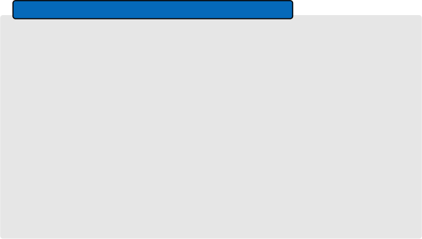

**Exercise 1: OFDM System in AWGN Channel**

 MHz, where i is the last two digits of your student number. Use 4 −QAM as the modulation scheme. Perform the OFDM demodulation in an AWGN channel for SNRs ranging from 0 dB to 20 dB using Monte Carlo simulation runs and plot

the resulting BER.

1. What is the subcarrier spacing, duration of transmitted OFDM symbol and

duration of CP in seconds?

2. Compare the results with a 4-QAM BER in AWGN channel and comment on

your observations.

2. Change the CP length and comment on its effect in AWGN channel.

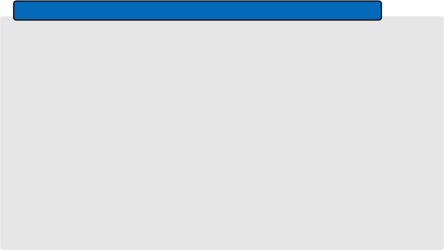

**Exercise 2: OFDM System in Frequency-Selective Channel**

Implement the OFDM system with parameters specified in Exercise 1 in a frequency-selective channel. Perform the simulations for a wireless channel, using the TDL-C channel model from Lab 1, with nominal delay spread and short delay spread (refer to Fig. 1.3). Plot the BER for SNR ranging from 0 to 30 dB in both

scenarios.

1. Compare the BER results for 4-QAM in AWGN Channel and comment on

your observations.

2. What is the minimum CP length required in the channel with nominal delay

spread and the channel with short delay spread?

3. What happens to the BER when having insufficient CP length?