**Exercise 1: Effect of AWGN on Signal Constellation**

1. **What happens to the received signal constellation when SNR is increased?**

When SNR is increased, the received signal constellation will be better and the received signal will be more similar to the original signal.

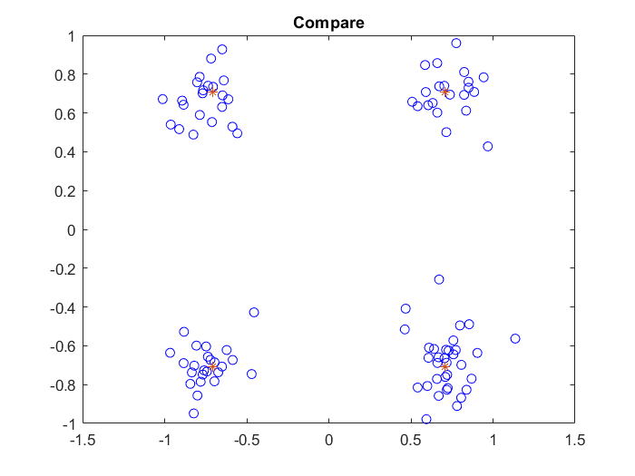

1. Constellation when SNR of 15dB

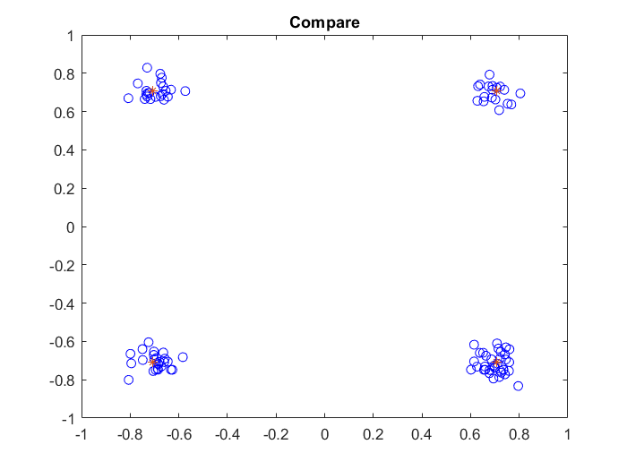

1. Constellation when SNR of 23dB
2. **What happens to the BER when the order of modulation is increased?**

When we increase the order of the modulation, the BER will increase. When we use SNR = 8dB, M = 4, BER will be 0.005, and if we use M = 16 instead, BER will increase to 0.045. It is caused by the reason that if we increase the order, the judgement region will be smaller and the error will be more easier to happen.

The relationship figure of BER versus the order is as below.

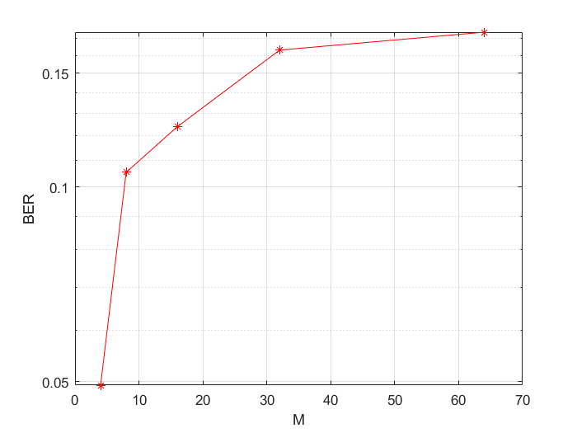

1. BER vs M when EbN0 = 1
2. **Compare the received signal constellation plots, the BER performance of 4-QAM, 16-QAM and 64-QAM and comment on your observations.**

With the SNR = 15dB.

When we use 4-QAM,the BER is around 0, and the constellation figure is as below.

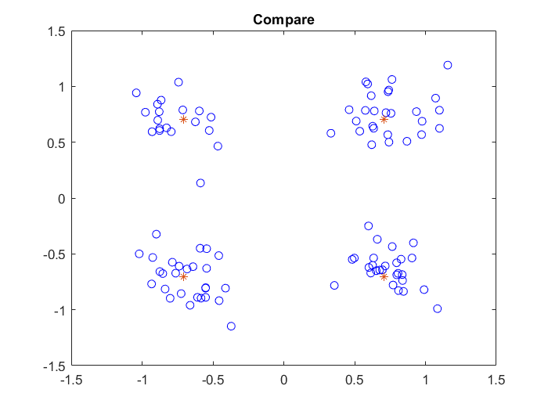

1. Constellation with 4-QAM

When we use 16-QAM,the BER is around 0.005, and the constellation figure is as below.

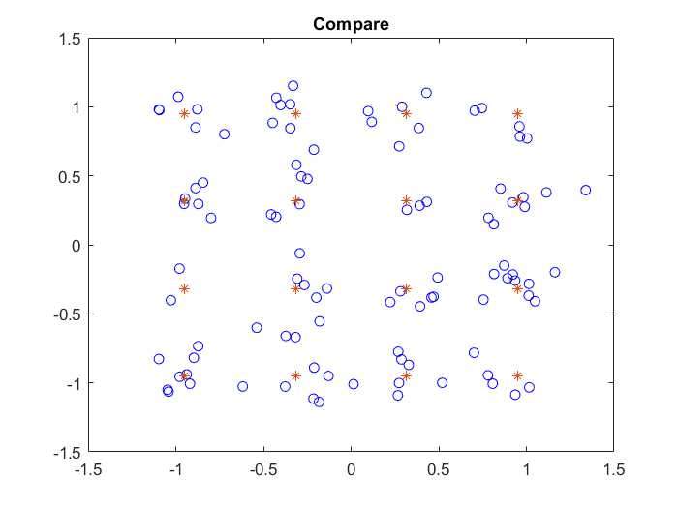

1. Constellation with 16-QAM

When we use 64-QAM,the BER is around 0.038333, and the constellation figure is as below.

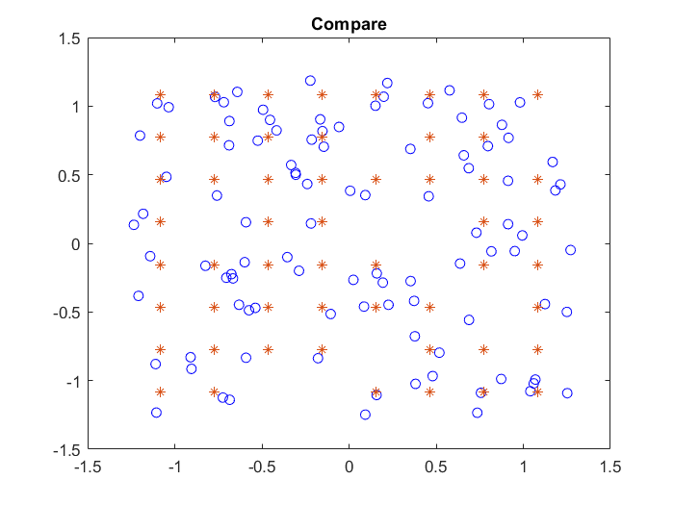

1. Constellation with 64-QAM

We can find that with the increasing of the modulation order, the judgement region is decreasing and BER will increase meanwhile as the price of increased transmission rate.

1. **Compare the amount of average energy per bit that is required for 4-QAM and 64-QAM to have no more than 1 erroneous bit every 1000 bits.**

When we are using 4-QAM, When change Eb / N0 to more than 8, the errorneuous bit per 1000 bits will be no more than 1.

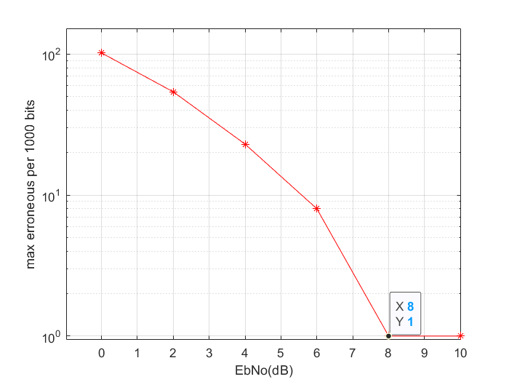

1. errorneuous bit per 1000 bits with 4-QAM

When we are using 64-QAM, When change Eb / N0 to less than 18, the errorneuous bit per 1000 bits will be more than 1.

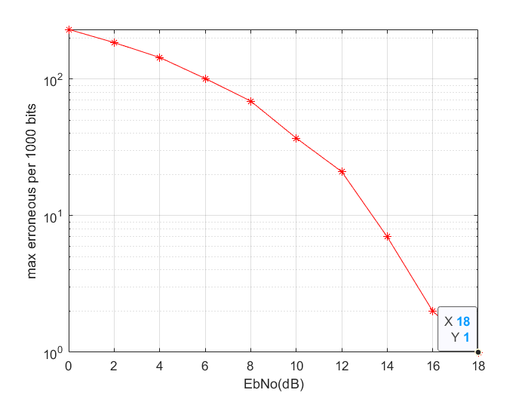

1. errorneuous bit per 1000 bits with 64-QAM

**Exercise 2: Effect of AWGN on Signal Constellation**

With Using the band width of 5Ghz, the Exponnetial PDP figure and final PDP after interpolation are shown as below.

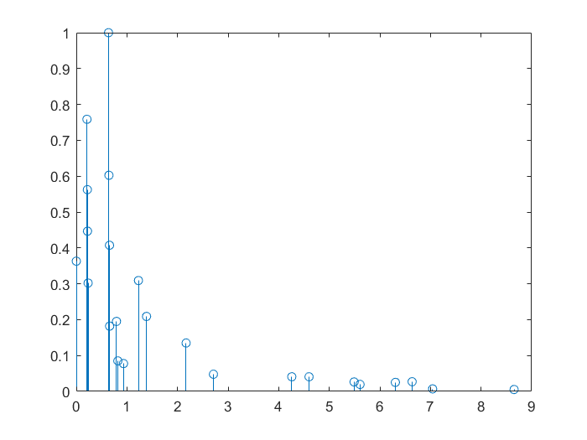

1. Exponnetial PDP

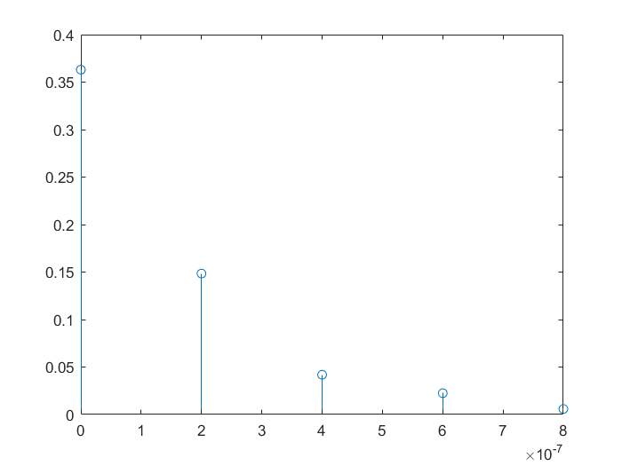

1. PDP after interpolation
2. **With an example show the effect of increasing bandwidth on the delay spread of the channel and the number of taps.**

When we increase the bandwidth to 6Ghz, the delay spread of the channel will decrease to 1.67e-07 and the number of taps will increase to 6.

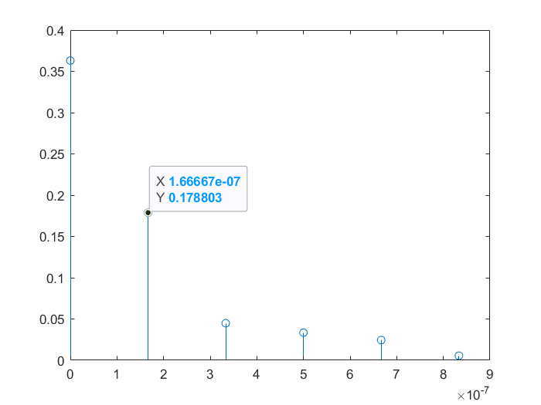

1. PDP after interpolation with 6Ghz
2. **With an example show the effect of decreasing bandwidth on the delay spread of the channel and the number of taps.**

When we decrease the bandwidth to 4Ghz, the delay spread of the channel will increase to 2.5e-07 and the number of taps will decrease to 4.

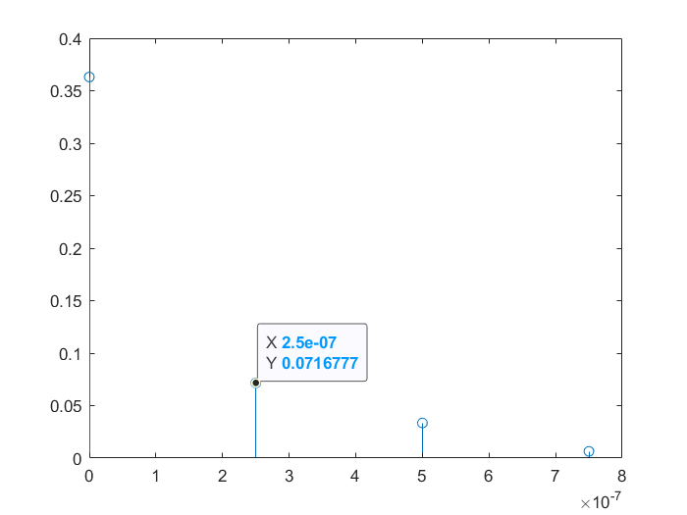

1. PDP after interpolation with 4Ghz
2. **Compare the constellation plots of the received signal in an AWGN channel, frequency-flat and frequency selective channel for an SNR of 15dB for 4-QAM, 16-QAM and 64-QAM and briefly comment on your observations.**

When we are using 4-QAM, we can obtain the constellations as below.

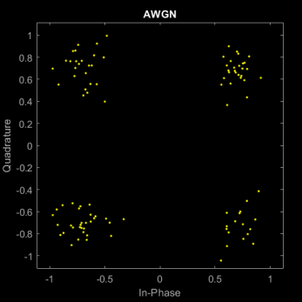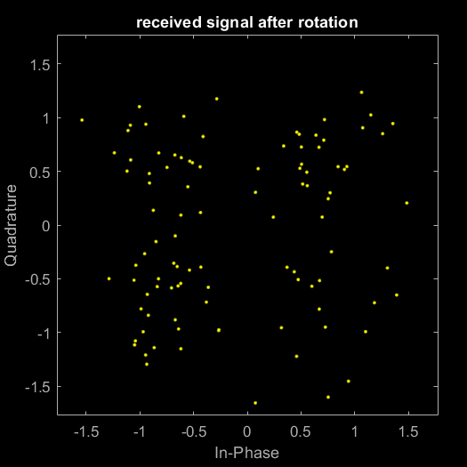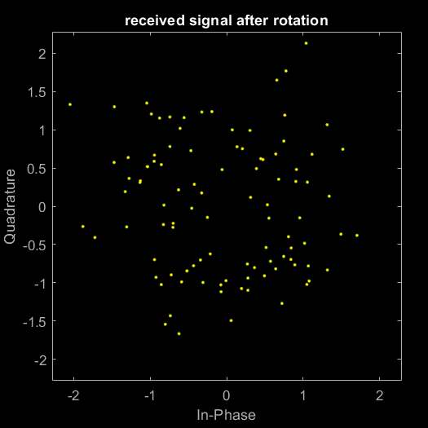

1. **4-QAM** **AWGN, flat, selective frequency(2G)**

When we are using 16-QAM, we can obtain the constellations as below.

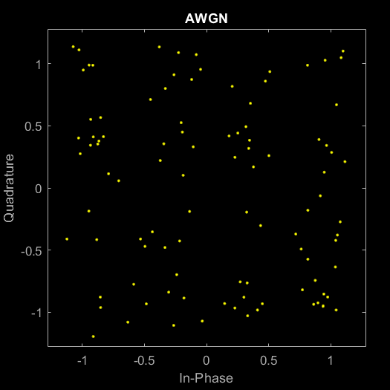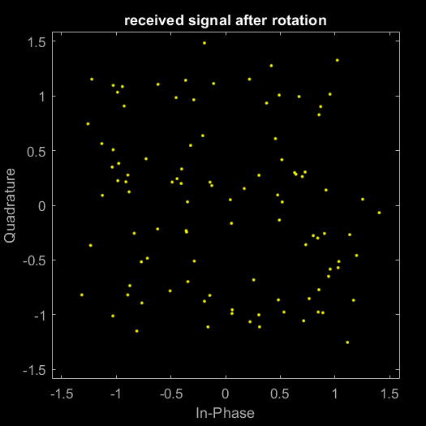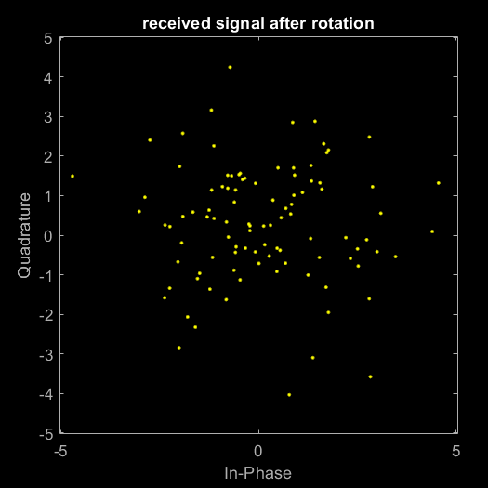

1. **16-QAM AWGN, flat, selective frequency(2G)**

When we are using 64-QAM, we can obtain the constellations as below.

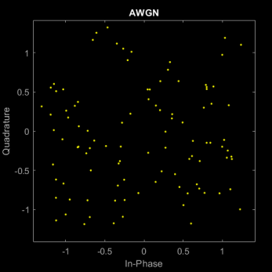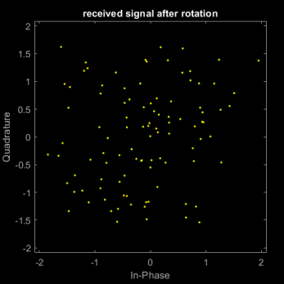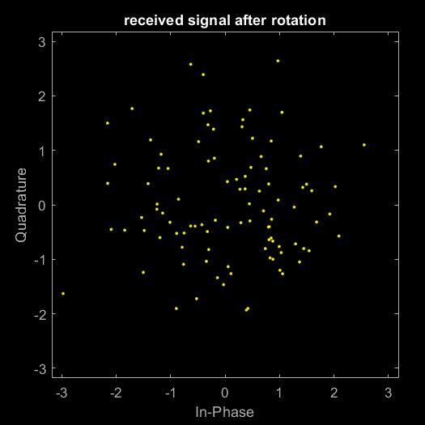

1. **64-QAM AWGN, flat, selective frequency(2G)**

From these constellations, we can see that flat or selective frequency with channel will make more effect to the signal than only AWGN. Although using high order of modulation and wider bandwidth could speed up the transmission, the cost is more distortion.

**Exercise 3: Effect of Flat-Fading Channel on Signal Constellation**

1. **What happens to the constellation when you increase the SNR?**

When we increase the SNR from 15 to 20 and 25, the constellation is shown as below. We can find that the error vector is decreasing.

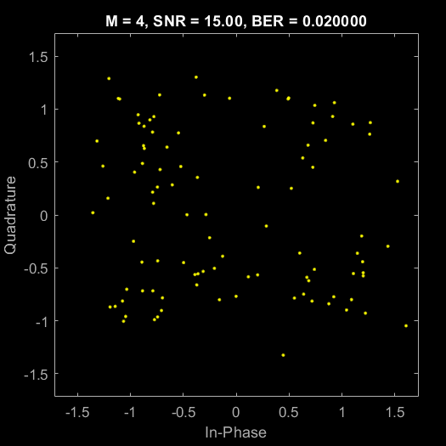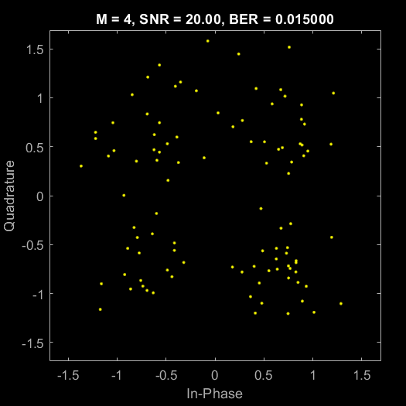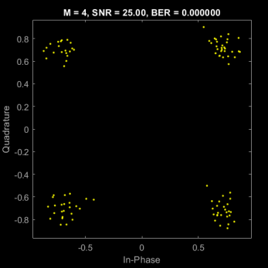

1. 4-QAM with SNR of 15, 20, 25
2. **What happens to the BER when the order of modulation is increased?**

When we increase the order of the modulation, the relationship of the mean value of BER(100 iterations) vs modulation order is shown as below. We can see that the BER is increasing with the modulation order M.

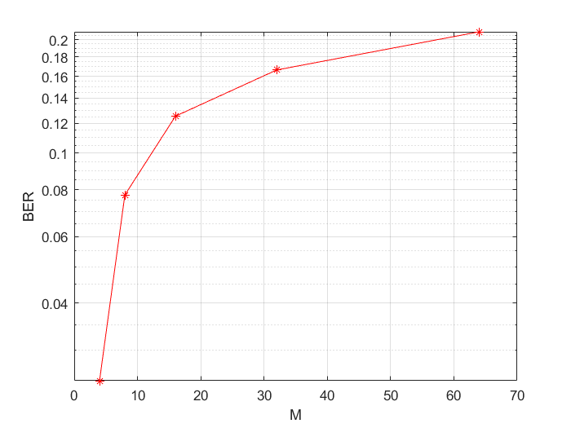

1. BER vs M
2. **Compare the BER vs SNR curves for an AWGN and flat fading channel and briefly comment on the challenges in a fading channel.**

When we increase the BER of the channel, the relationship of the mean value of BER(100 iterations) vs SNR of the channel is shown as below. We can see that the BER is decreasing with the SNR(dB).

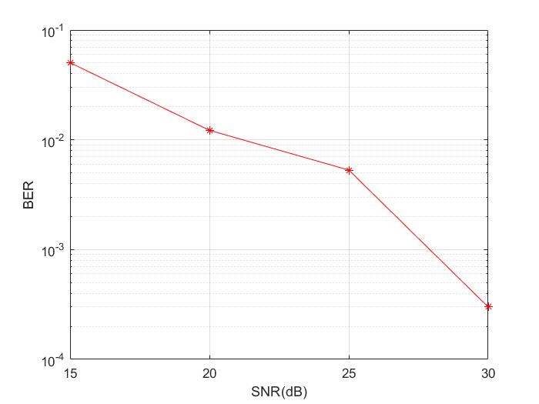

1. BER vs SNR

In the fading channel model, BER increases with the modulation order and decreases with the SNR. The challenge is to balance the relationship between these variables and obtain a more reasonable BER while achieving a higher transmission rate