**Lab2 OFDM: Performance Evaluation**

**Exercise 1: OFDM System in AWGN Channel**

1. **What is the sub-carrier spacing, duration of transmitted OFDM symbol and duration of CP in seconds?**

for Bandwidth = 37/50 * 1e6:

Sub-carrier Spacing can be calculated as below:

$∆F = \frac{W}{N} =$ 12.19 kHz

Duration of transmitted OFDM Symbol:

$∆T = \frac{N}{W} =$ 82.05us

Duration of Cp:

$D_{cp} = max(D_{N})∙{DS}_{Nomial} =$ 0.86523us

**2. Compare the results with a 4-QAM BER in AWGN channel and comment on your observations.**

With the iteration time as 1000 and the number of the symbol 640. The BER result of AWGN channel 4-QAM and OFDM is shown as below. The performance of OFDM is similar to 4-QAM.

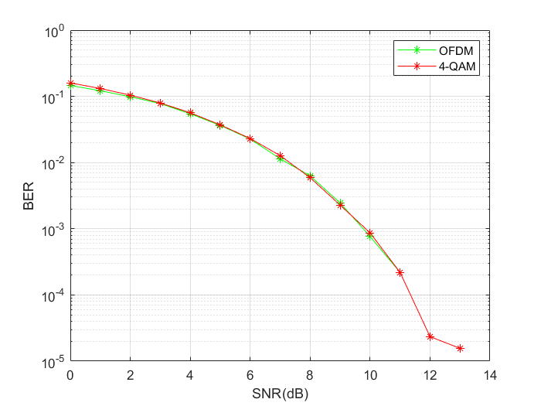

1. **BER vs SNR (OFDM and 4-QAM) symbol num = 640**

With the iteration time as 1000 and the number of the symbol 6400. The BER result of AWGN channel 4-QAM and OFDM is shown as below. The performance of OFDM is slightly better than 4-QAM.

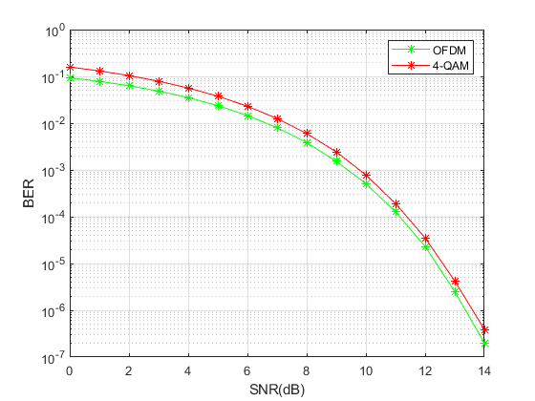

1. **BER vs SNR (OFDM and 4-QAM) symbol num = 6400**

**3. Change the CP length and comment on its effect in AWGN channel.**

Changing the CP length, we could obtain the figure as below, as we can see in the figure, when use 20% length of the data symbol length, we could get better performance of BER in different noise environments in 1000 iterations. But the difference between them is not significant and with different iteration loops, we may get different performance order with different CP length.Hence, in this situation(AWGN channel), change the CP length will not significantly effect the BER.

That is because CP is used for overcoming the ISI in the frequency flat channel, but in this situation, we are facing a frequency flat channel. Hence the length of CP will not make big difference toward the result.

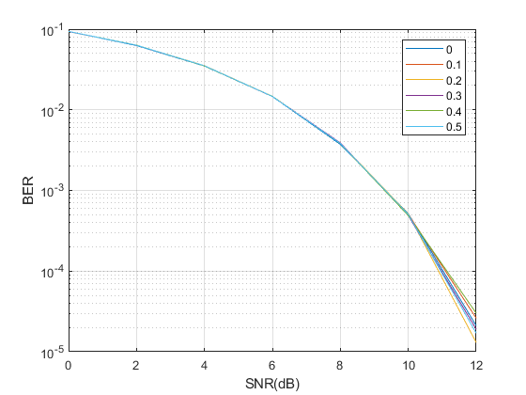

1. **BER vs SNR (CP length factor)**

**Exercise 2: OFDM System in Frequency-Selective Channel**

**1. Compare the BER results for 4-QAM in AWGN Channel and comment on your observations.**

The BER results for **4-QAM in Frequency-Selective channel** and the **OFDM system in Frequency-Selective Channel** is shown as below(1000 iterations). We can see that in high noise environment, OFDM will perform better in this situation.

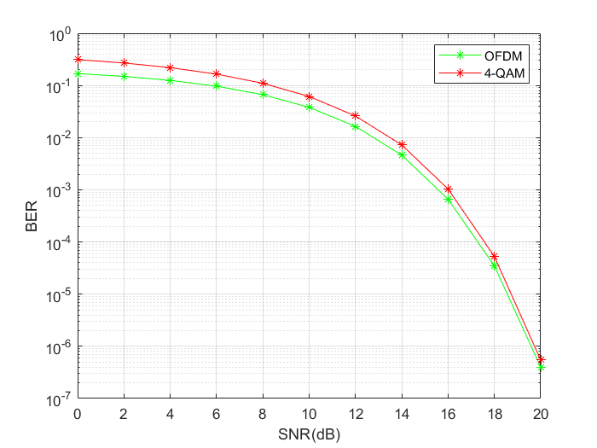

1. **BER vs SNR (OFDM and 4-QAM in frequency selective channel)**

The BER results for **4-QAM in AWGN channel** and the OFDM system in **Frequency-Selective Channel** is shown as below(1000 iterations). We can see that in high noise environment, OFDM will perform better, in low noise environment, 4-QAM will perform better.

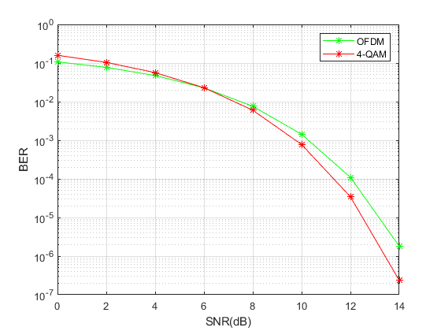

1. **BER vs SNR (OFDM(frequency-selective) and 4-QAM(AWGN))**

**2. What is the minimum CP length required in the channel with nominal delay spread and the channel with short delay spread?**

The minimum CP length required in Nominal delay spread is calculated as below.

$D_{cp} = max(D_{N})∙{DS}_{Nomial} =$ 0.86523us

The minimum CP length required in short delay spread is calculated as below.

$D_{cp} = max(D_{N})∙{DS}_{Short} =$ 0.25957us

**3. What happens to the BER when having insufficient CP length?**

According to the lab result and the slides, The length of the cyclic prefix must be greater than the overall time-dispersion of the channel. Otherwise, the received signal will suffer from inter-symbol interference and the BER will increase meanwhile.

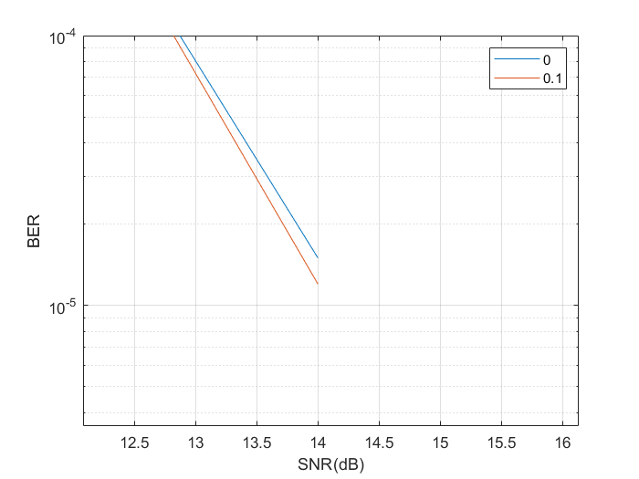

1. **BER vs SNR (OFDM)(CP = 0us and CP = 13.51 us)**