In lab0,we learn through the PYNQ board and get the method to light the led on the board by click the button on the board.

1. Creation of the Project

Create the vivado project by importing the relevant constraint files and v files

1. Modify the verilog files

Modify the verilog files and assign the input button signal to the led.

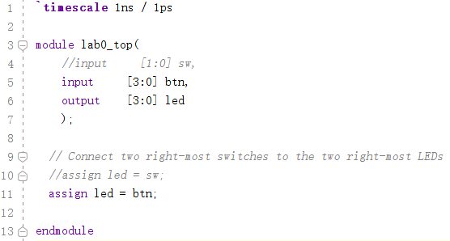

1. Modify the constraint files

Modify the constraint files and connect the signal to the board.

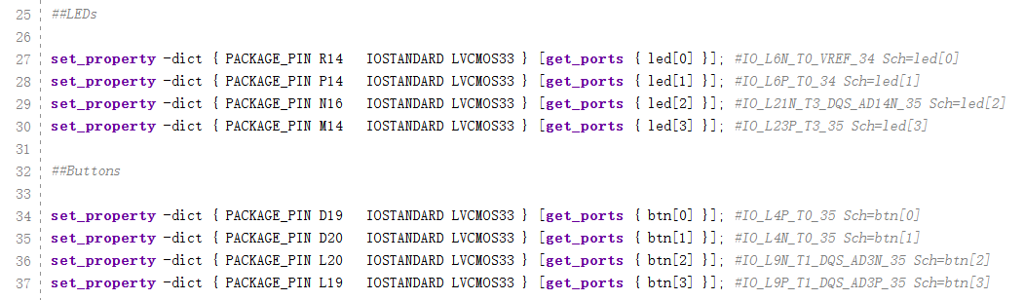

1. Generate bis stream

With using the tools in the vivado, process the synthesis and the implementation, and then generate the bit stream.Use the data wire to download the program to the board and then finish the verification of the function.

