1.Block diagram of my FSM design

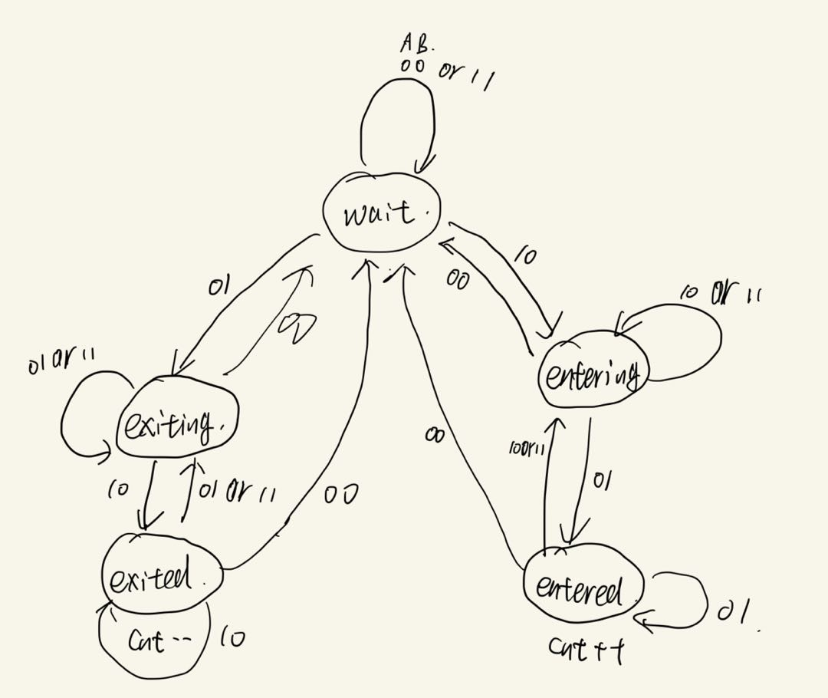

2.The difference between a Mealy and Moore FSM

Mealy: The output is not only related to the current status but also the inputs.

Moore: The output is only related to the current status.

3.Did you use a Mealy or Moore FSM in your Design? Why?

I used a Mealy FSM in my design, because the status transformation is based on the status changing of the sensors A & B.