**• The lab report questions and screen captures from the first filter design exercise (refer to**

**Part 3).**

**I. What is the order of the filter you designed? What does this mean?**

36, it means that in order to achieve the parameter we specified, at least 36 orders filter will be used for the filtering, the order number of 36 means there will be 36 coefficients in the formula, this also determines how much historical data will be used.

**II. What are the effects of altering the passband and stopband attenuation?**

|  |  |  |
| --- | --- | --- |
|  | lower | higher |
| Apass | Passband will be more smooth, less ripple on the passband, order will be higher | Passband will be less smooth, more ripple on the passband, order will be lower |
| Astop | Stopband attenuation is less and slower, less ripple number, order will be lower | Stopband attenuation is less and slower, less ripple number, order will be higher |

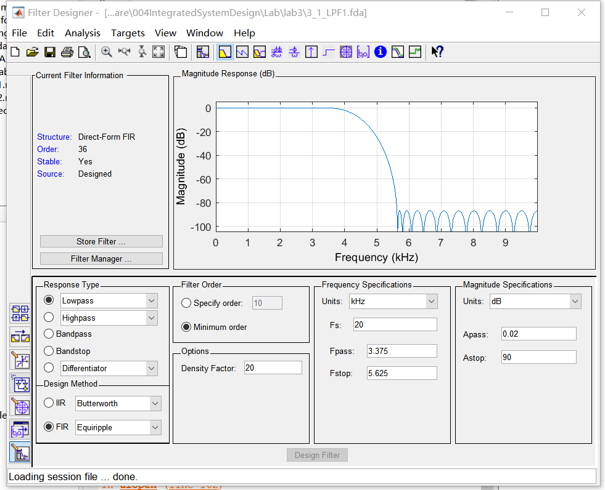

**• Details of your decision process to design the noise-removing FIR filter.**

1. **Observe the original audio spectrum and look for the noise location**

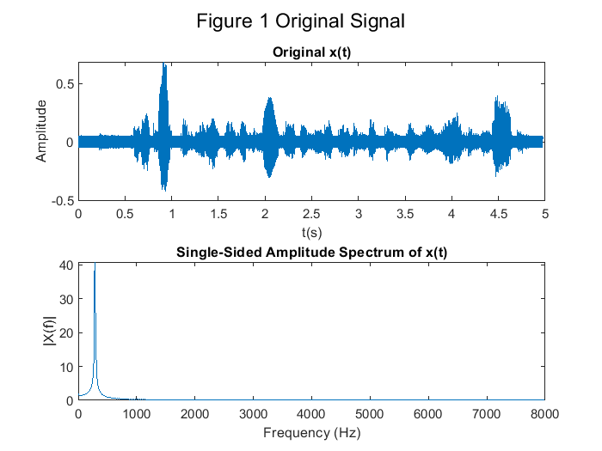

Xf_max = 40.7837

Xf_max_f = 281.2500

1. **Select the filter type according to the noise position**

Noise is concentrated at 281Hz, consider using a band-stop filter.

1. **Observe the filter processing result and adjusting filter parameters**

The filter parameters can be adjusted so that the filter can obtain better performance while using less resources.

1. **Consider the filter order and make trade-offs to reduce its order and performance**

In order to reduce the order and facilitate the implementation, a high-pass filter is used instead.

1. **Quantification and performance evaluation**

The filter is quantified by considering the resource and performance requirements.

**• Graphs of the frequency response before and after the audio is filtered.**

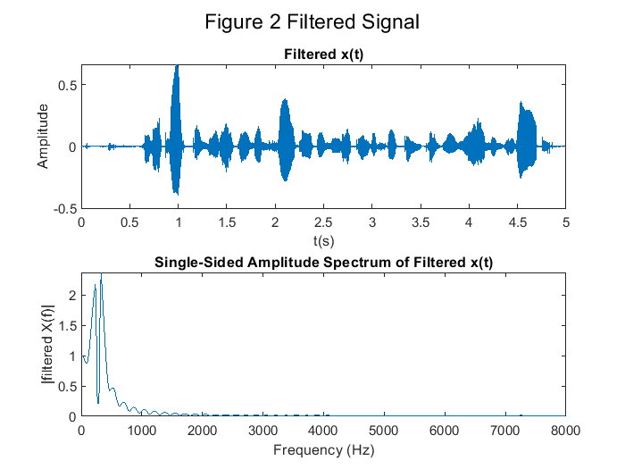

**• Your method for quantising the filter coefficients and graphs of the frequency response**

**after applying the** **‘under-quantised’, ‘appropriately quantised’ and ‘over-quantised’ filters.**

The filter is quantified by considering the resource and performance requirements.

‘under-quantised’:

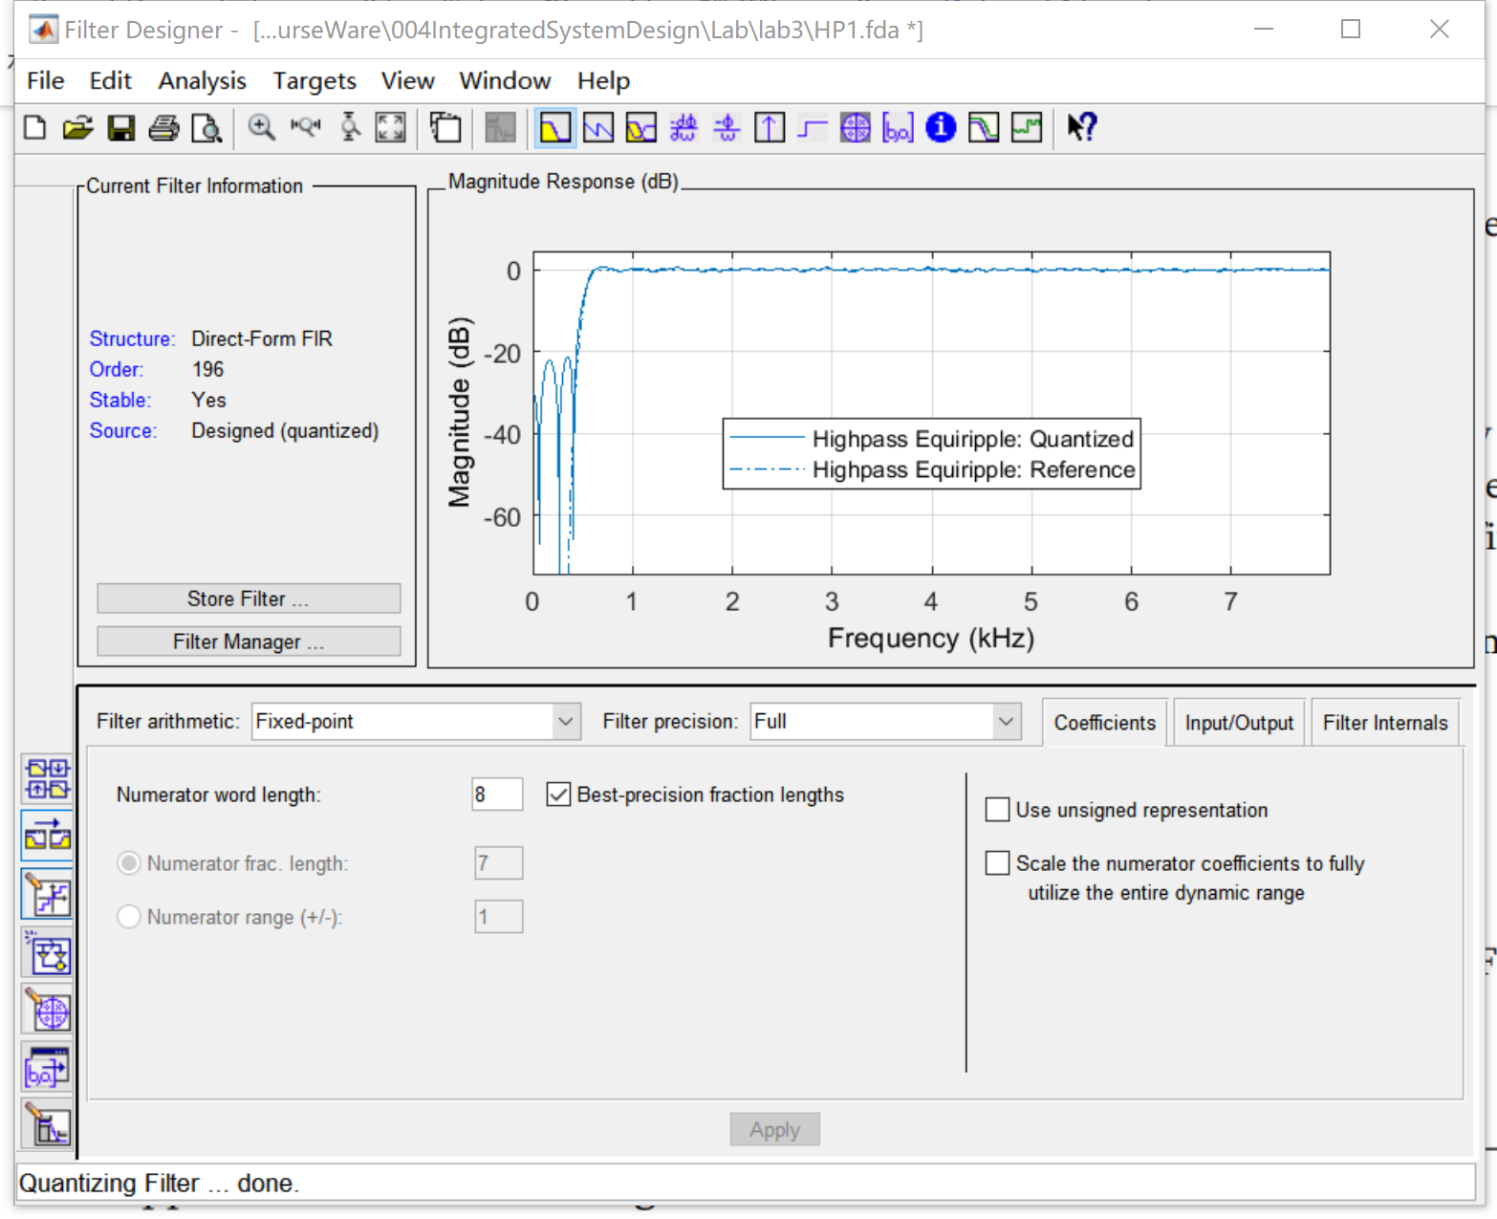

‘appropriately quantised’:

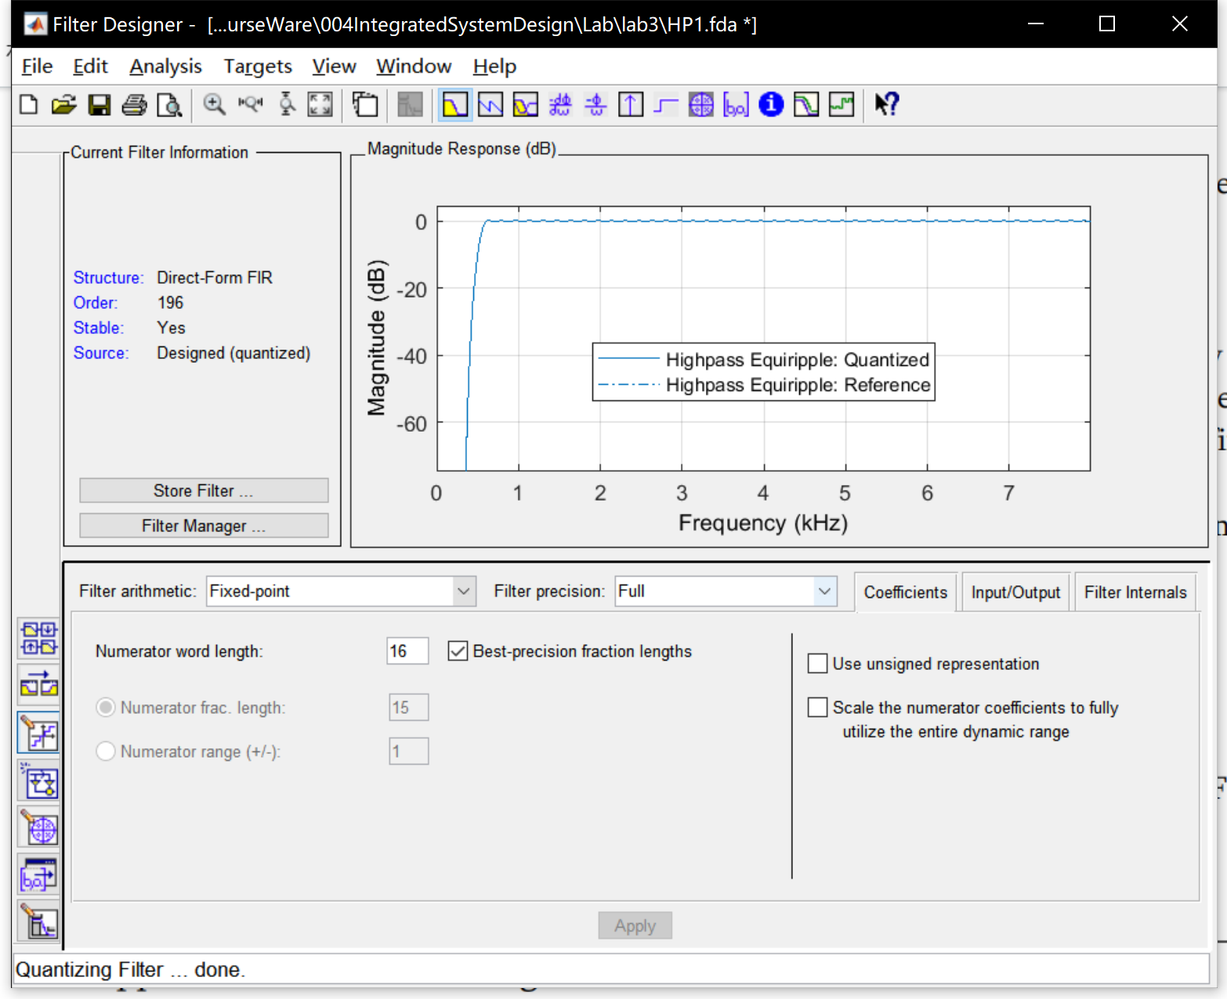

‘appropriately quantised’:

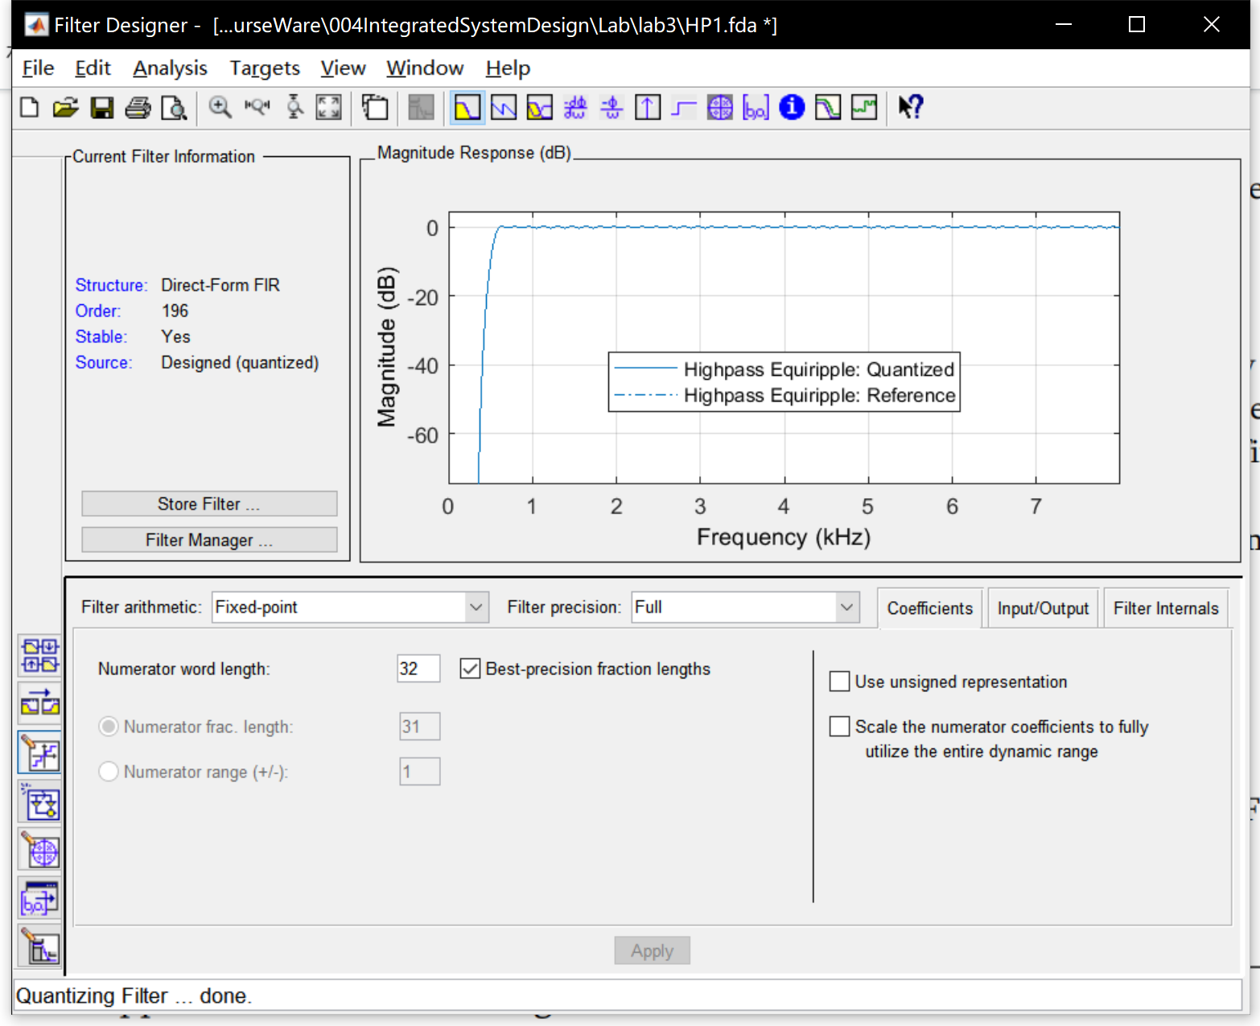

**• Discuss the trade-offs you considered for selecting the number of bits for your final filter**

Although higher performance can be obtained by using higher bits and higher order filters, considering the limited resources, we must reduce the order of the filter and the number of bits when quantizing, so as to obtain higher performance with fewer resources. I have changed from an ideal band-stop filter to a quantized high-pass filter, which greatly reduces the order and bits and improves the realizability while the performance is guaranteed.