**Lab 3: Digital Modulation & Transmission - II**

**1. Carrier Synchronisation and Symbol Timing Recovery in BPSK**

**Question 1.1: Observe the Eye Diagram plots at the input and output of the Carrier Synchronizer block. Using a screenshot of the plots, explain any observations and/or interpretations.**

As we can see in the following two screenshots, after the carrier synchronizer block, the eye diagram is more open which indicates the quality of the signal has been improved. That is because Carrier Synchronizer block will adjust for the carrier frequency and phase offsets of the input signal. With this operation, the frequency offset could be decrease.

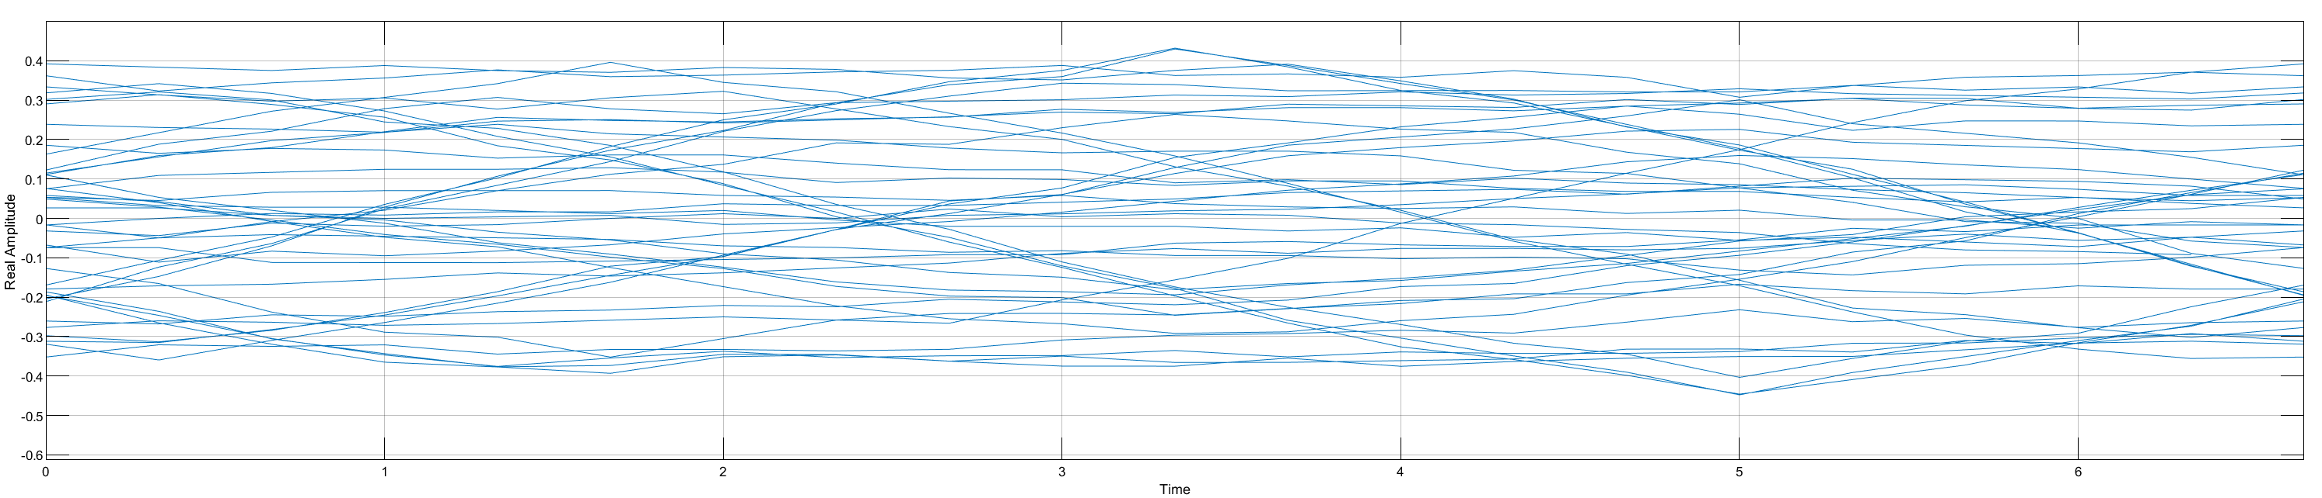

1. Eye Diagram before Carrier Synchronizer

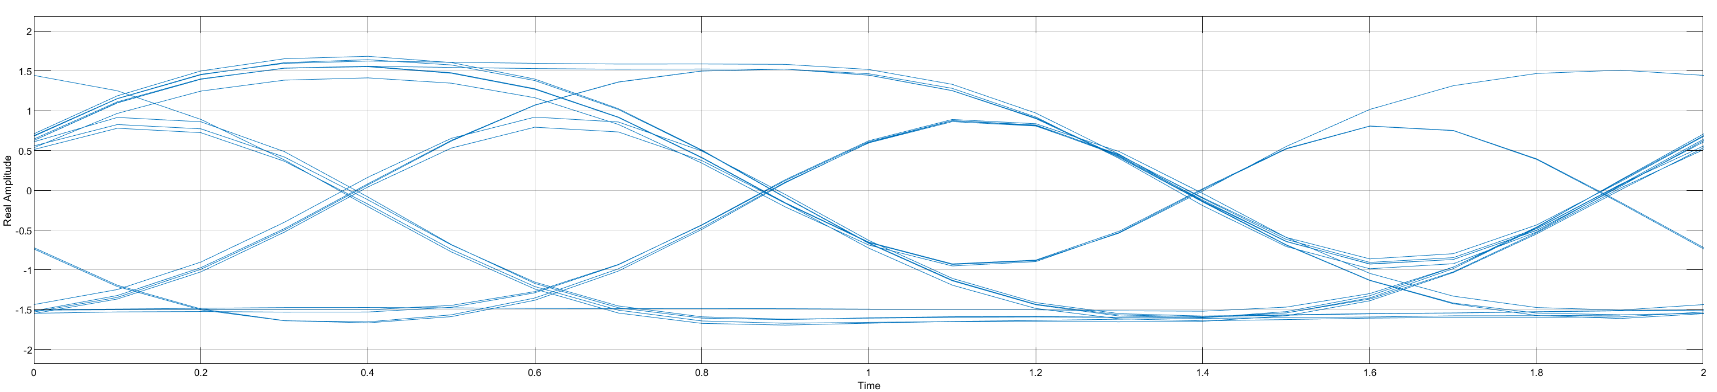

1. Eye Diagram after Carrier Synchronizer

**Question 1.2: Observe the Constellation Diagram plots at the input and output of the Carrier Synchronizer block. Using a screenshot of the plots, explain any observations and/or interpretations.**

Observing the constellation before and after the carrier Synchronizer, we can find that the phase of the constellation point has been adjusted to the correct place.

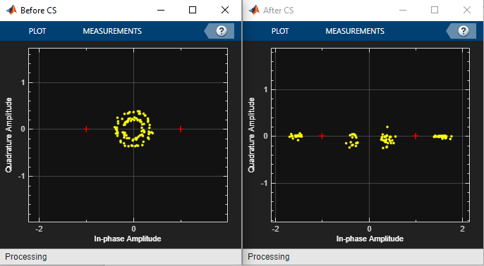

1. Constellation before and after Carrier Synchronizer

**Question 1.3: Observe the Constellation Diagram plots at the input and output of the Symbol Synchronizer block. Using a screenshot of the plots, explain any observations and/or interpretations.**

Observing the constellation before and after the symbol synchronizer, we can see that the timing offset is effectively decreased. That is because using symbol synchronizer could deal with the problems like clock out of sync and timing offset, to make it possible to decode the message.

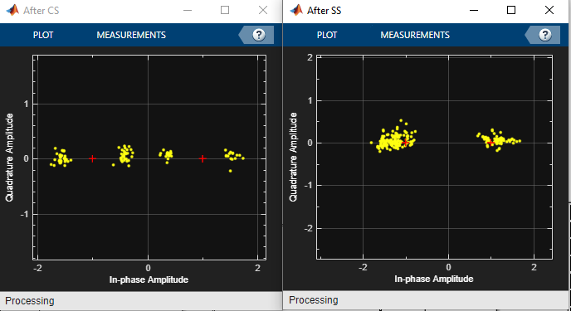

1. Constellation before and after Symbol Synchronizer

**Question 1.4: Observe the effects of reduced signal-to-noise ratio (SNR) at the input to the receiver by**

**decreasing the Gain of the PLUTO-SDR Receiver**

The signal and constellation we observed before are using the gain as 60.

SNR is the signal-to-noise ratio, when we decrease this value, this means more noise will be introduced. Let’s change the SNR from 30 to 70, from the constellation, we can clearly see that with the decreasing of the SNR, more noise will be introduced, and the constellation will be more separate, the eye diagrams will be more “closer”, the signal will be more distorted, vice versa. And the constellations and eye diagrams with SNR from 30-70 are listed as below.

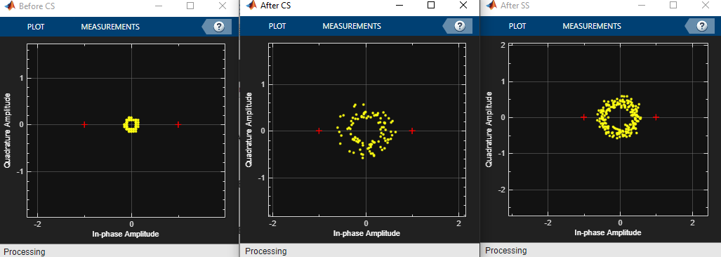

1. Constellations (SNR = 30)

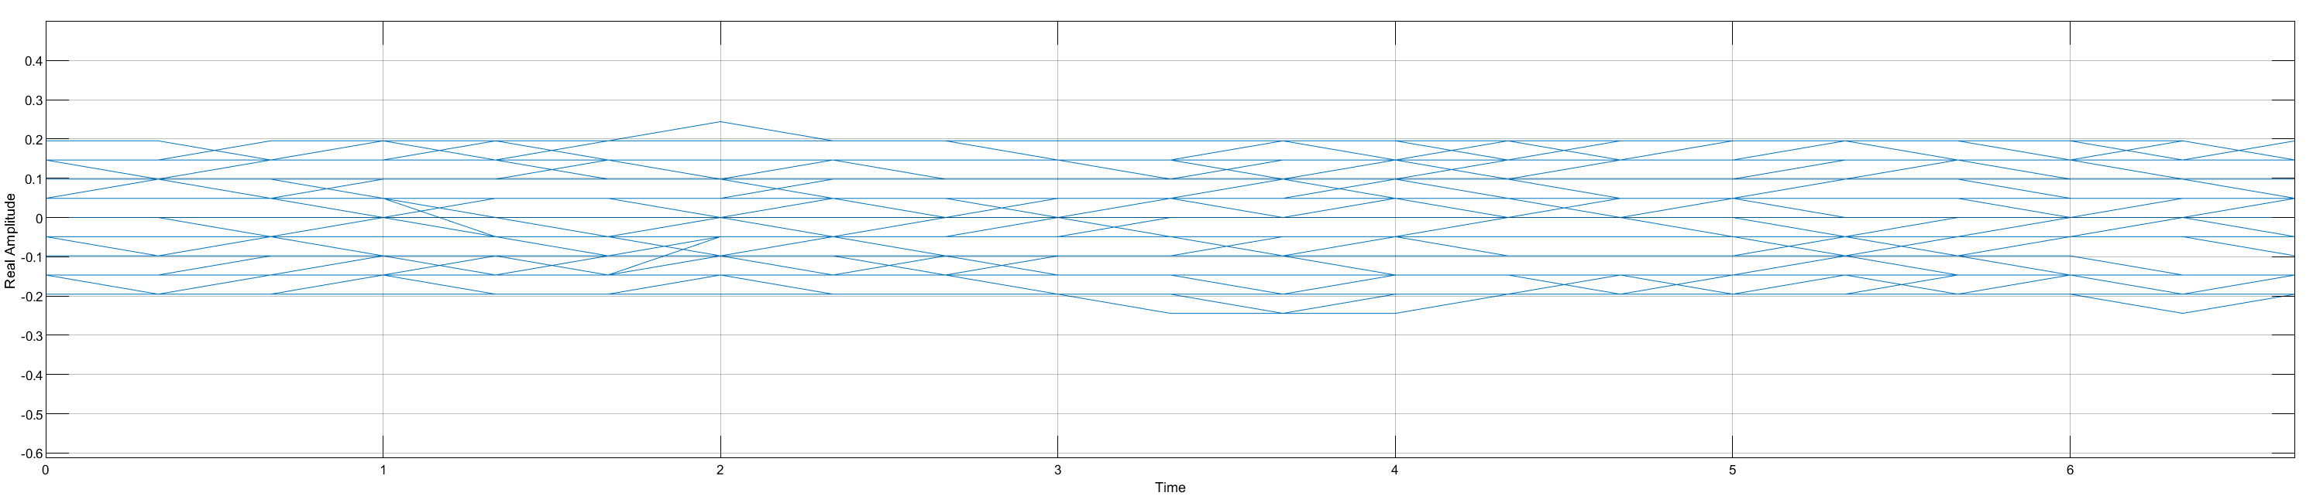

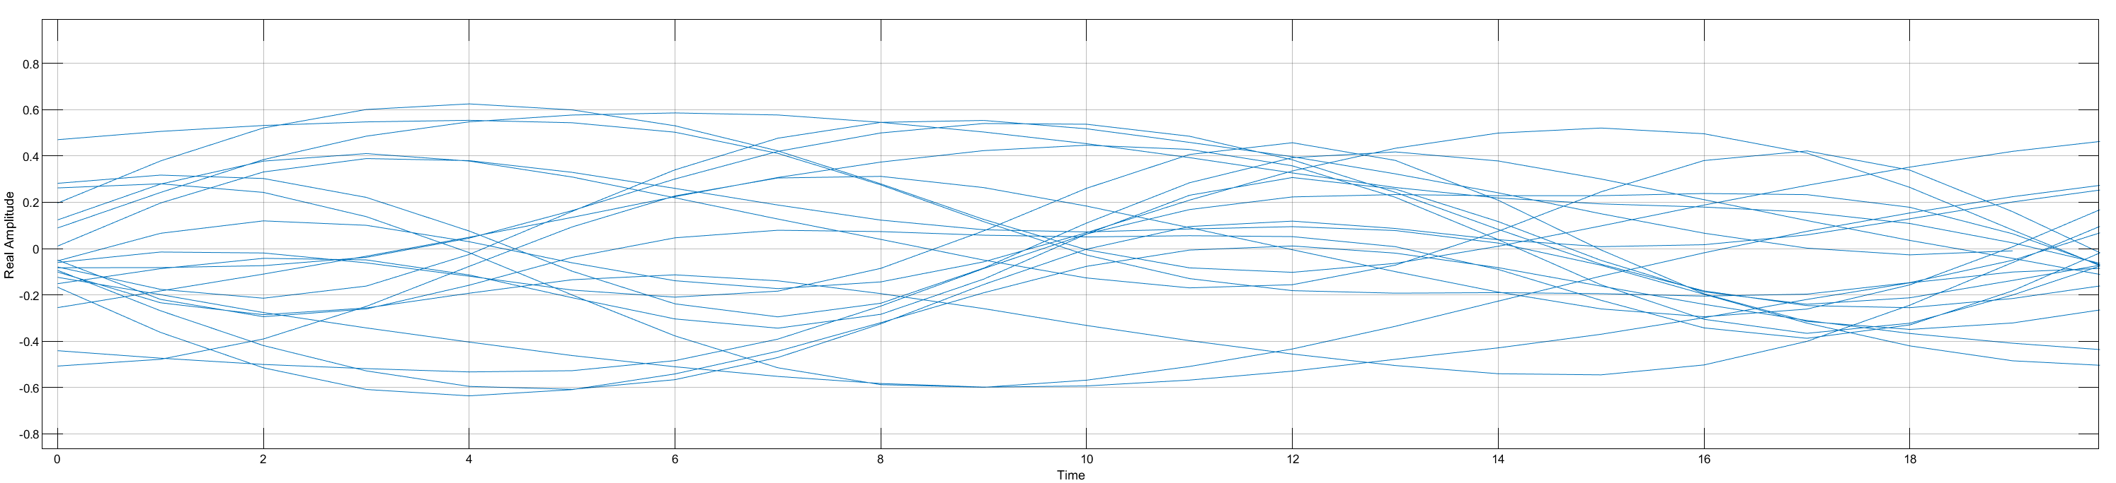

1. Eye Diagram (SNR = 30)

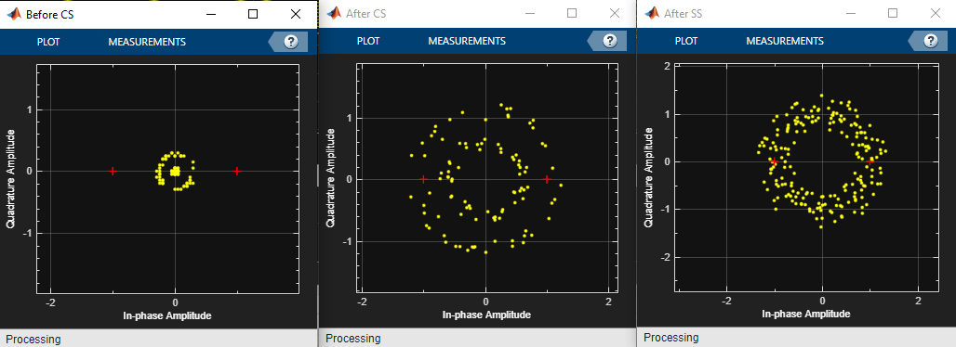

1. Constellations (SNR = 40)

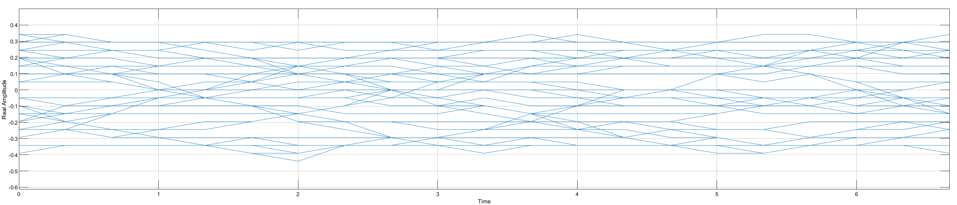

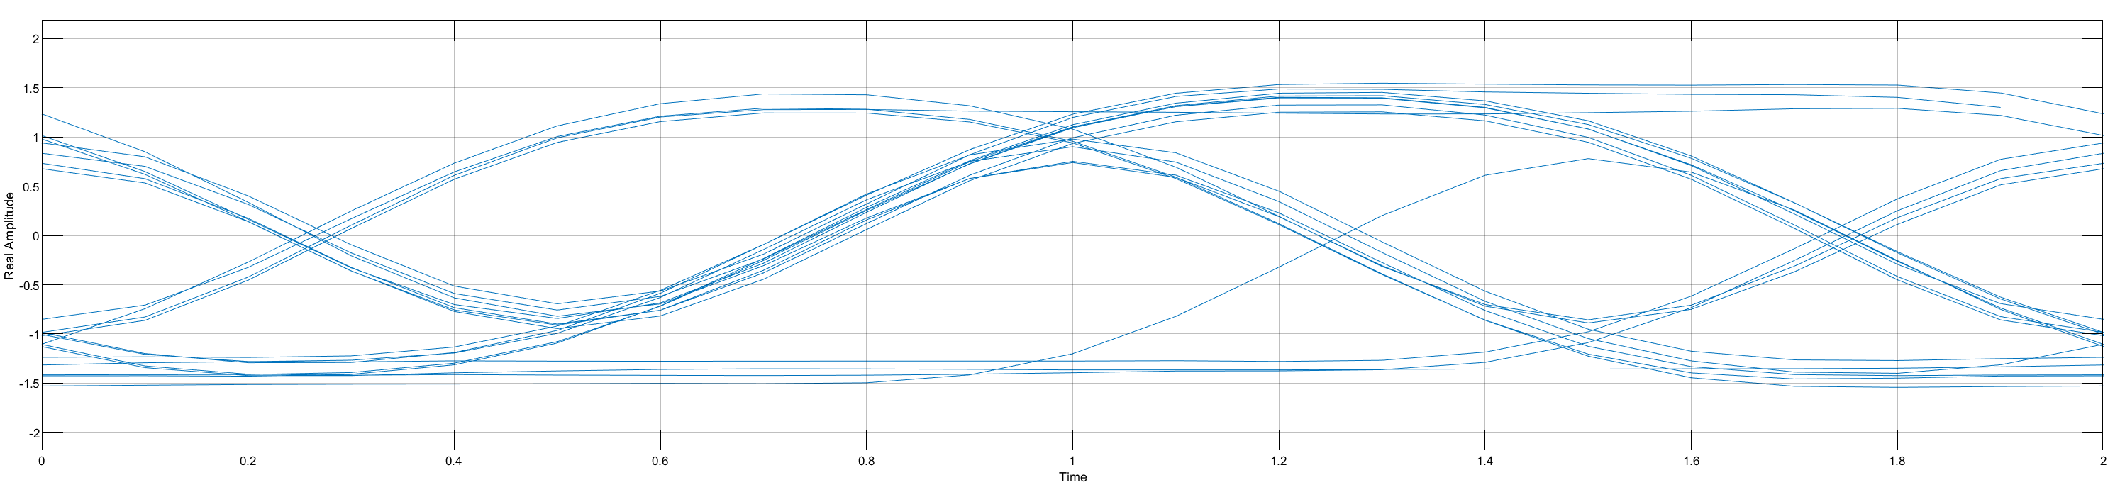

1. Eye Diagram (SNR = 40)

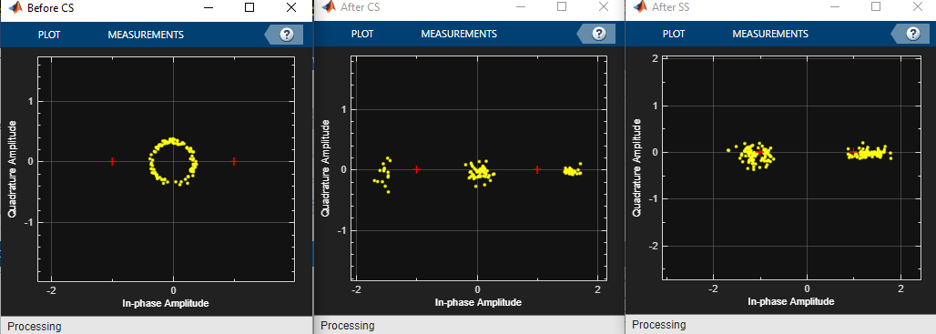

1. Constellations (SNR = 50)

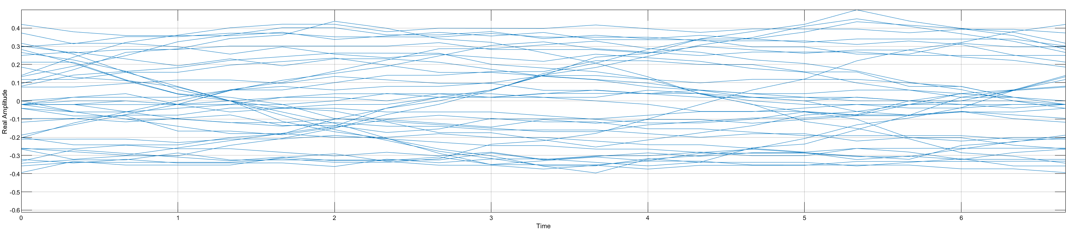

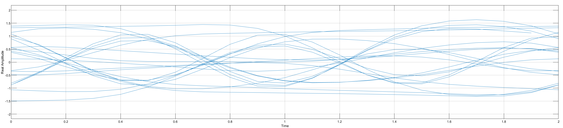

1. Eye Diagram (SNR = 50)

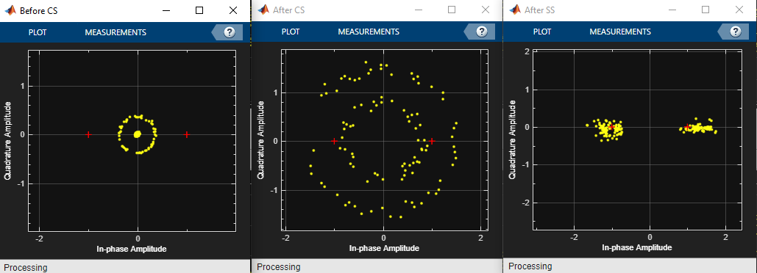

1. Constellations (SNR = 70)

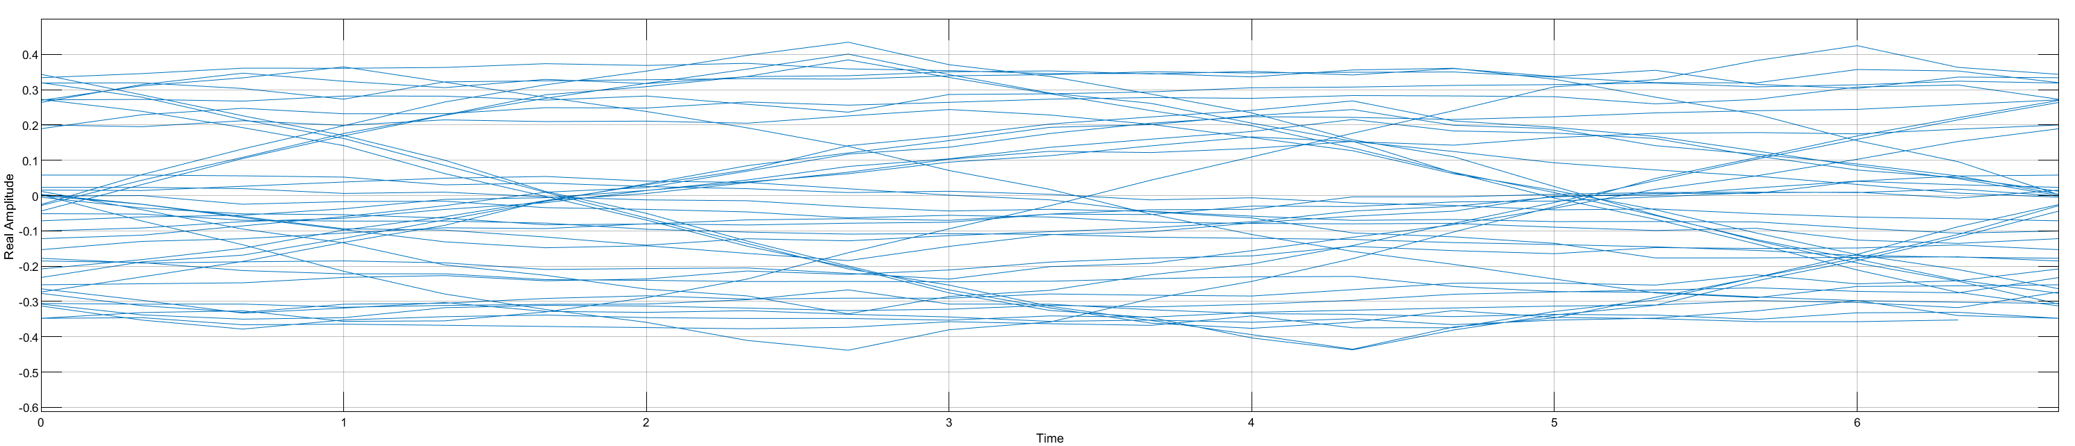

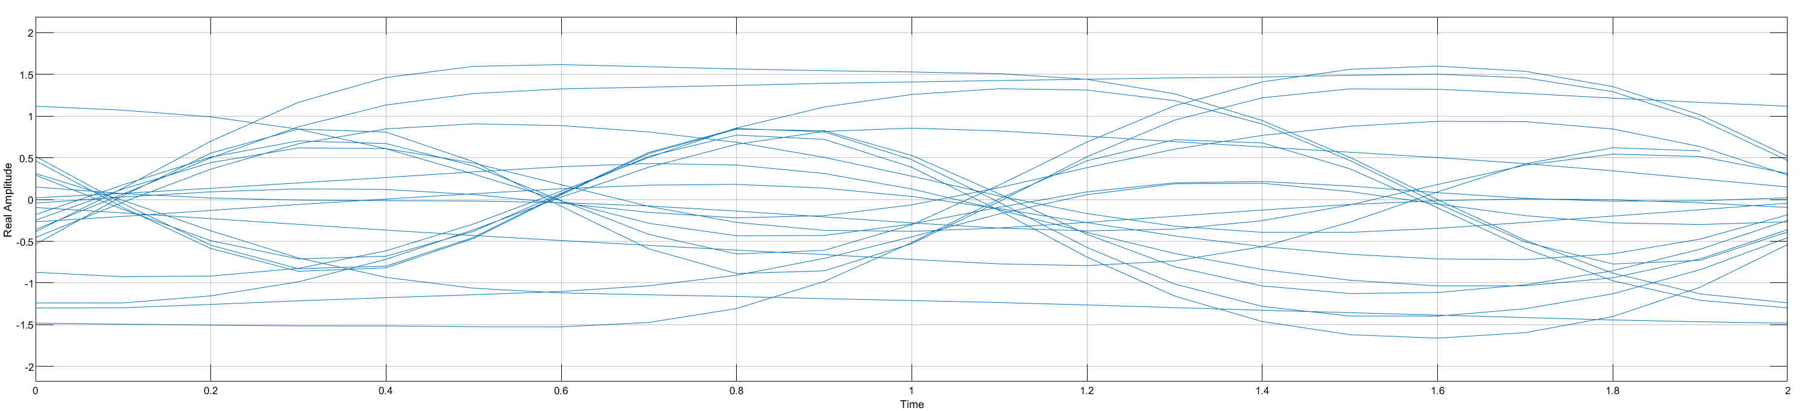

1. Eye Diagram (SNR = 70)

**placing an object near/over the receive antenna.**

When we are trying to place a barrier or object near or over the receive antenna, observing the constellation and eye diagram, we can see that the signal is completely distorted.

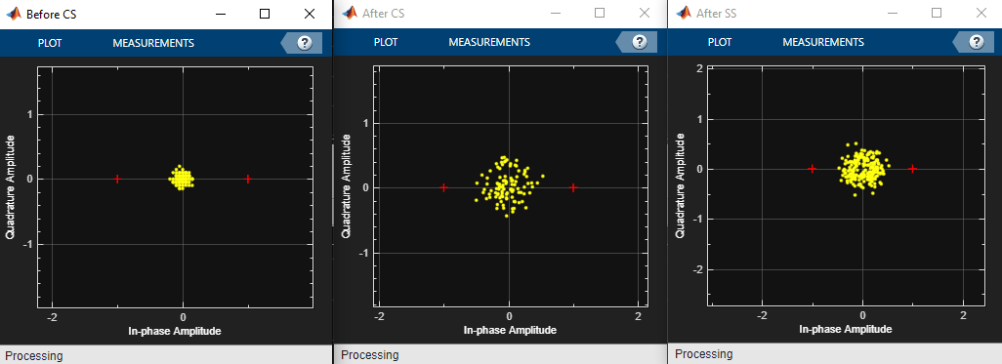

1. Constellations (SNR = 60, placing object over antenna)

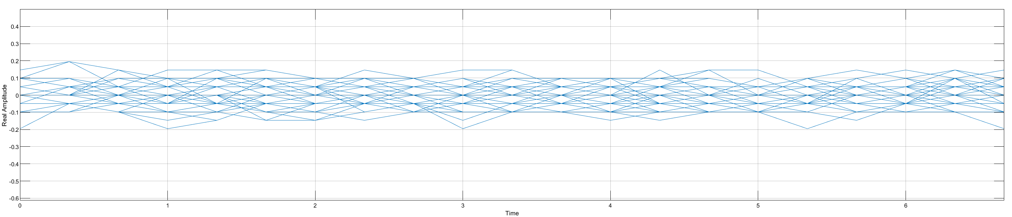

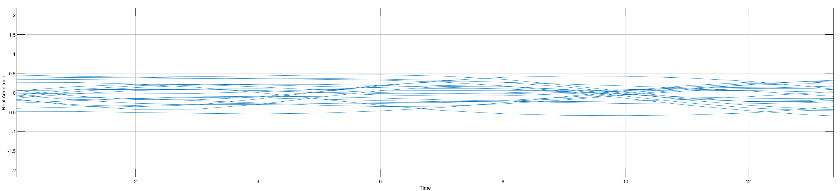

1. Eye Diagram (SNR = 60, placing object over antenna)

**2. Differential BPSK**

**Question In Part 2.1 D—BPSK Simulation**

**The D-BPSK Modulator Baseband block applies differential encoding followed by BPSK modulation to the binary message generated by the Bernoulli Binary Generator block. It uses the differential encoding scheme shown in Table 1 (Appendix B). Carefully examine the Time Scope plot to see the message bits and the differentially encoded symbols.**

The original message and encoded message waveform in time domain are shown as below. We can see with the differential encoding scheme. The system will change the output value when bk = 1, and remain value when bk = 0, then transform the origin waveform to an edge form.

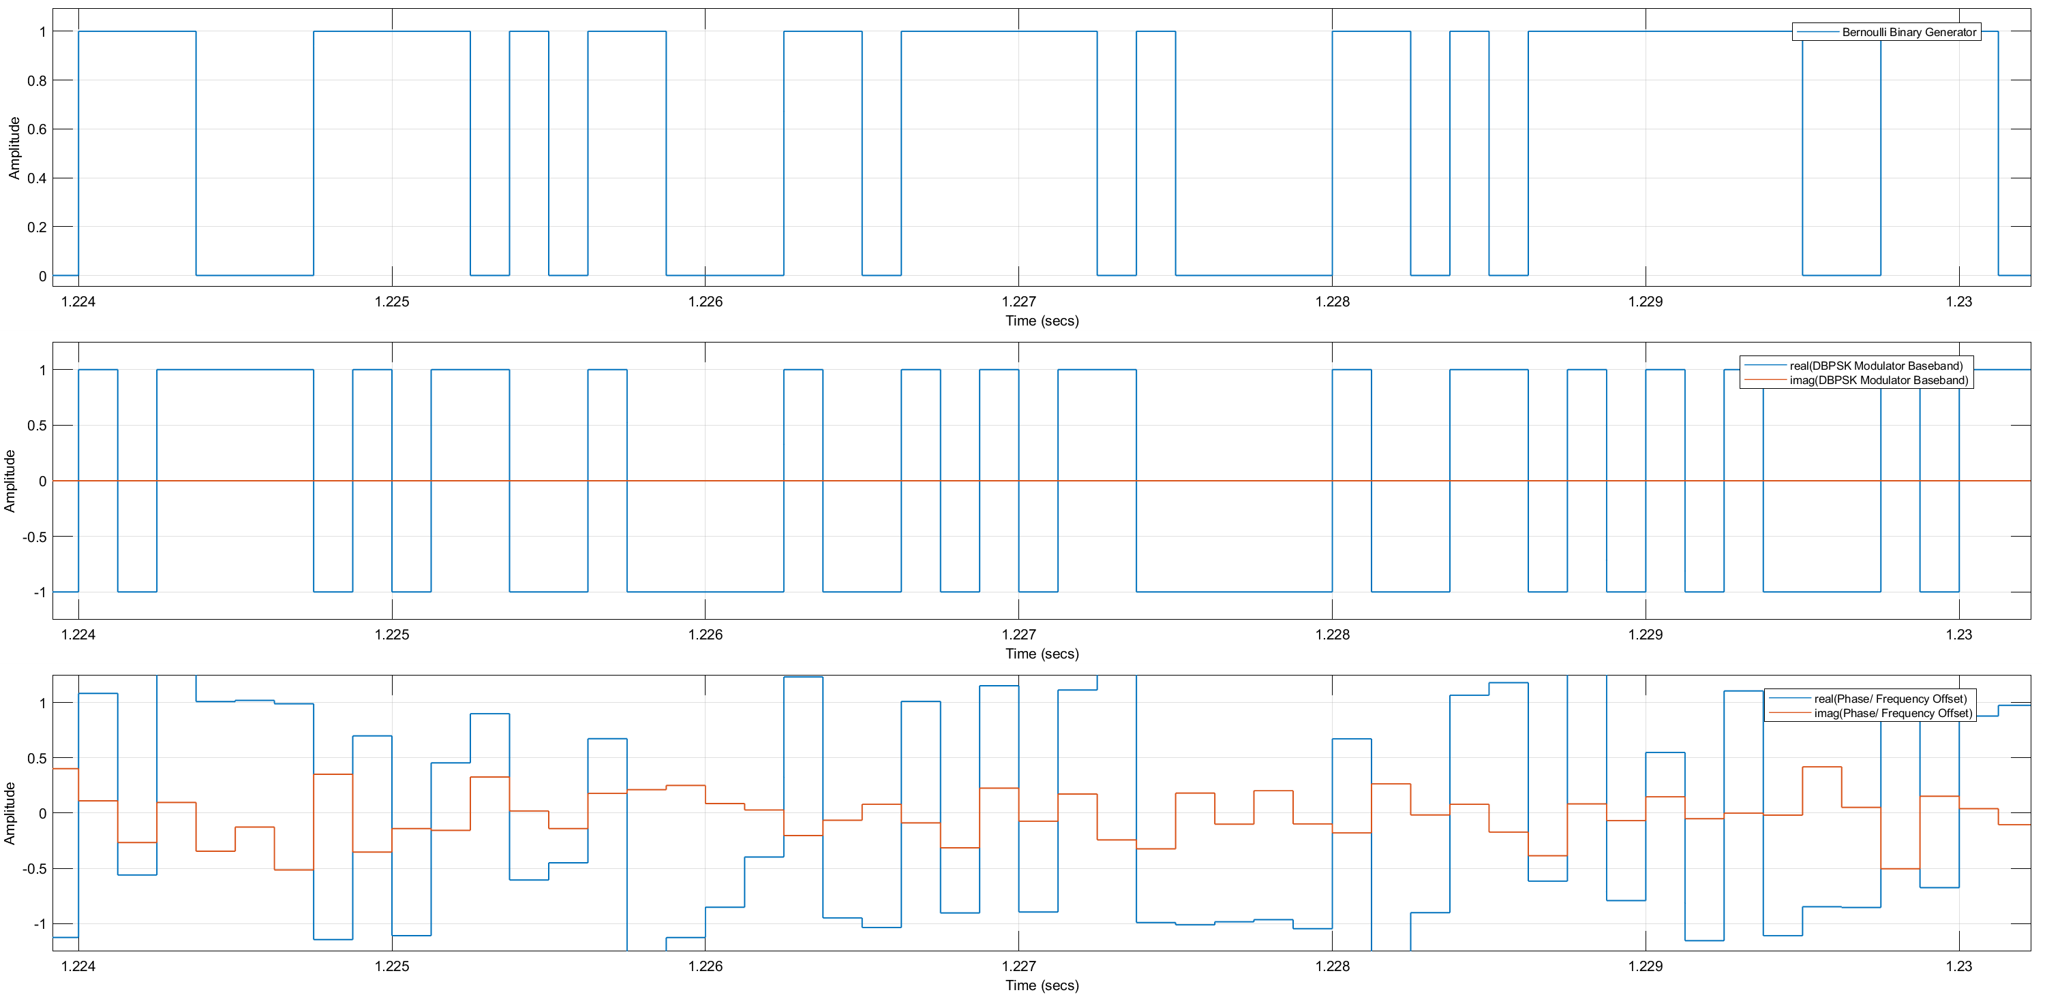

1. Origin message, encoded message, message after channel

**The Phase/Frequency Offset block is used to apply frequency offsets and phase offsets to the received symbols. Based on the constellation diagram, can you explain what these offsets are**

Observing the constellation after applying frequency offsets, we could obtain the figure as below left, we can see that the constellation points are moving around the original point periodically and finally act like a circle. That is because the phase offset of the frequency offset is a function of t, it will vary with the time.

Observing the constellation after phase offsets, we could obtain the figure as below right one. And the phase shifted is as a constant value that we set in offset block.

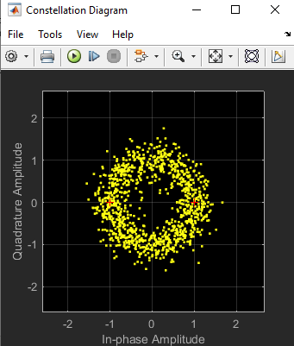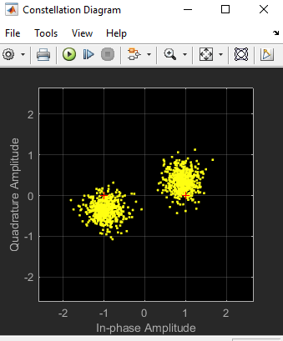

1. Constellation with frequency offset (left) and phase offset (right)

**At what frequency offset do you begin to see large numbers of errors? Why is this the case?**

I tried different frequency offset as the tables below, we can see that when the frequency offset is higher than 1000, the error rate becomes significant. And when the frequency offset is 4000 which is half of the signal frequency, the BER reach the max value. This phenomenon is periodic by the frequency of the signal.

We can explain this phenomenon that, when the frequency offset is 4000, half of the signal frequency, all the signals are coincidently turned to the wrong status by changing the phase by . When it reaches 8000, the signals are rotated back to the original situation. So this phenomenon could be periodic.

Table 1 Error Rate with different frequency offset

|  |  |  |  |  |  |  |
| --- | --- | --- | --- | --- | --- | --- |
|  | 0 | 500 | 1000 | 2000 | 4000 | 6000 |
| Error Rate | 0 | 0.0004 | 0.00839 | 0.4998 | 0.9999 | 0.4992 |
|  | 8000 | 8500 | 9000 | 10000 | 12000 | 14000 |
| Error Rate | 0 | 0.0004 | 0.00843 | 0.5003 | 1 | 0.4977 |

**The Constant block controls the channel noise power. Experiment with the toggle to see the impact of channel noise.**

By increasing the noise power from 0.1 to 0.3 and 0.5, we can observe the constellation and the BER as blow, it is clear that the with the increasing of the channel noise, the signal is more distorted, the constellation will be more separated and the bit error rate will increase.

**Noise power = 0.1**

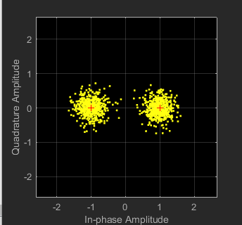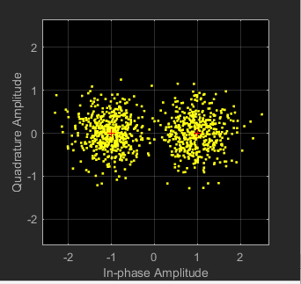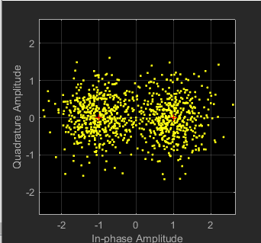

1. Constellation with noise power (0.1 0.3 0.5)

Table 2 Error Rate with different noise power

|  |  |  |  |  |
| --- | --- | --- | --- | --- |
|  | 0 | 0.1 | 0.3 | 0.5 |
| Error Rate | 0 | 0 | 0.01715 | 0.0688 |

**2.2 D-BPSK Demodulator**

**Question 2.1: Differential encoding is quite useful to overcome the phase noise issues that you encountered with standard BPSK. However, what could be a potential issue with building them using the Pluto devices for our lab?**

When we are using differential encoding with Pluto devices in our lab, the main problem maybe the timing synchronization. Differential encoding requires high-level clock synchronization to work well. But with different Pluto devices, it is hard to ensure this requirement which means errors could be introduced when we are using differential encoding and decoding.

**Question 2.2: Describe in a few lines your method for decoding the differentially encoded symbols. Include the salient parts of your MATLAB code you wrote to perform the decoding.**

The main code (in fig 18) to decode the differentially encoded symbols is shown as below. In the code, we iterate all the data and calculate the phase difference from two adjacent symbols, when the difference is 1, we recover the symbols to original ones.

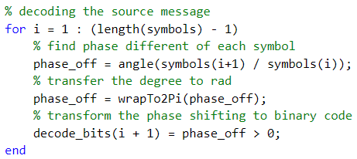

1. Main code for decoding

We can analyse the data after decoding, I marked the guard part as blue, preamble as red, data as green. Then directed by this analysing, we can separate the data frame from this can translate it from ascii code to chars.

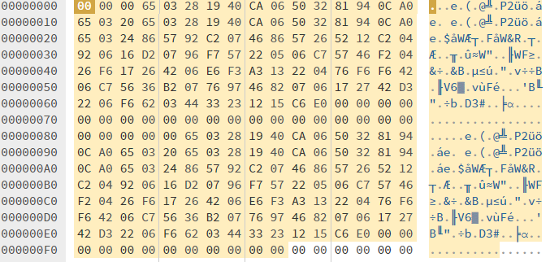

1. Constellation with noise power (0.1 0.3 0.5)

**Question 2.3: What is the text message?**

There are two data frames in the message, which contain same text. Combine them will be:

Hey, there!, I am your Pluto Board no:12 Good luck with part-2 of 4C21!\nHey, there!, I am your Pluto Board no:12 Good luck with part-2 of 4C21!\n