IDE Setup notes - Eclipse CDT on Ubuntu

Get Eclipse
You can get get eclipse CDT from here:
https://www.eclipse.org/downloads/packages/

select ‘Eclipse IDE for C/C++ Developers’ and the linux install
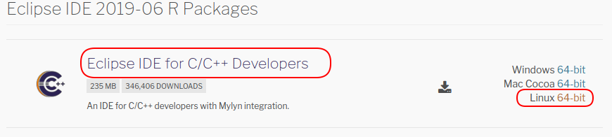

choose, then download the install of your choice

unpack it where you want it (mines just in /home/keith/eclipse)
run it by double clicking on the eclipse executable

Prereqs
Get a C/C++ compiler if not there
If you can find your compiler using the following command then GNU is installed and working (it should be default installed on ubuntu)
whereis g++

If not, from command line (ctrl-alt-T) type the following to get it.
sudo apt-get install build-essential

Install Java if not there
if you try to run eclipse and get a ‘No Java Runtime was found’ then install Java SE JDK.
http://www.oracle.com/technetwork/java/javase/downloads/jdk8-downloads-2133151.html
get tar.gz follow insructions here https://docs.oracle.com/javase/8/docs/technotes/guides/install/linux_jdk.html#BJFJJEFG

put tar.gz file where you want it
tar -zxvf fn.tar.gz

update the PATH variable in .bashrc to point to correct java. Then source .bashrc after edits to commit the changes.

Verify you are using correct Java from the command line:
whereis java
which java
java -version

