Multithreaded code – mutexes, atomics, when things go wrong

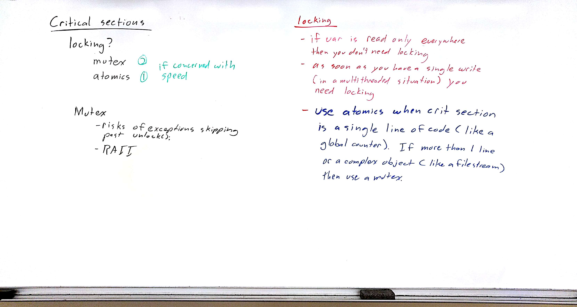
demo RAII for mutex (create a class that takes a pointer to a mutex and locks in constructor and unlocks in destructor) point out flaws, (exceptions, dont lock in constructor, unlock in destructor, what if shallow copied pointer from constructor is not there when destructor calls it)

Tell them to use lock_guard<mutex> m(amutex);
does all RAII class does in an exception safe way

talk a little about templates in atomics (take any type) show page where standard types are
http://www.cplusplus.com/reference/atomic/atomic/?kw=atomic
atomics are lighter weight than mutexes, faster to lock and less code to write

When things go wrong
lock a mutex twice
join a thread twice
deadlock (2 mutexes)

how to tell where a locked program is? In IDE, set breakpoint, debug until you hit it, then resume. When it locks hit pause button to see where threads are.

Lots more- see in Operating Systems

