Does your program compile with no errors but still appears to have errors as shown in the UI?
You may be the victim of the eclipse indexer. A module that tracks what is where in your codebase but has the unfortunate habit of flagging its inadequacies as errors in your code :(

The fix. If the above yellow bit is true then;
right click on your project in Project Explorer
Choose Index
Choose Rebuild

If all the errors go away in it was the indexer falling behind.
Project seems to build fine but you get a ‘binary not found’ on running your app. You are probably missing a debug or Release configurations

Right click your project
choose ‘Properties’
in left pane choose ‘Run/Debug Settings’
in right pane if there is nothing in the ‘Launch configurations for ...’ your project
choose New
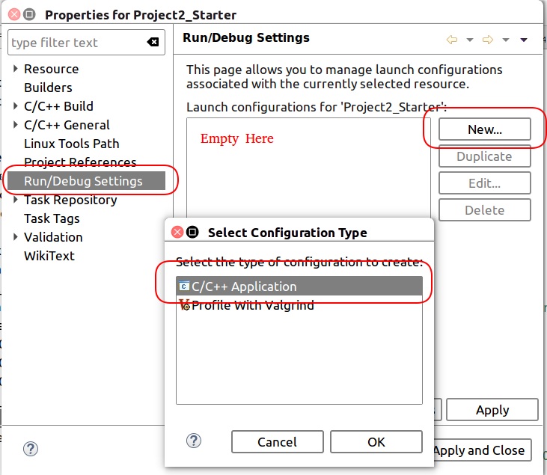

then OK, in the following screen do

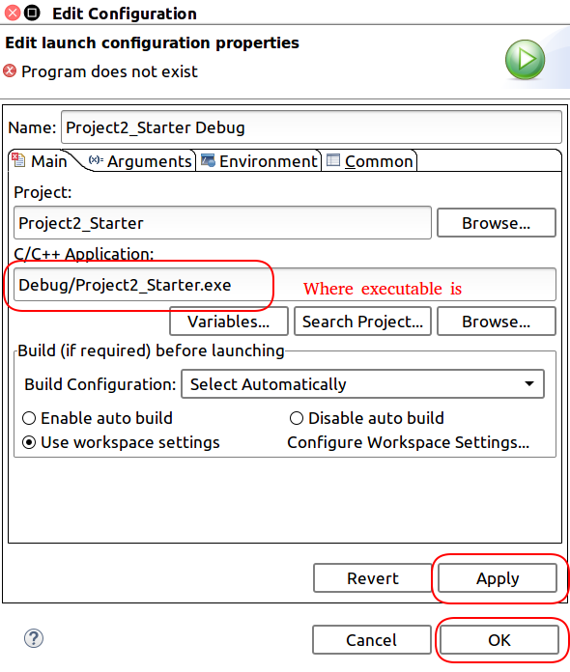

Things should work now.
Using a toolchain other than GNU?
All course projects are built with this toolchain, in order to select another toolchain;
- right click on the project
- follow below
Before you submit, Be sure to test your solution on the Hunter Creech computers to ensure it is compatible with the GNU toolchain

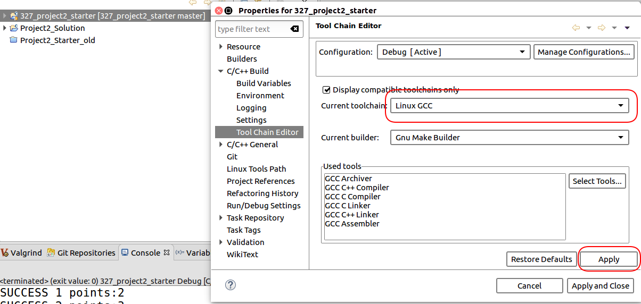
What version of C++ do you use? The default is 98, but you can change what standard you code too
You can also do the following
- go to project properties (alt enter)
- In the left pane, scroll to "C/C++ Build", expand it, select settings.
- In the right pane, select and expand your compiler under the Tool Settings menu, select"Dialect", choose your languange standard from the drop down, or enter -std=c++0x in the "other dialect flags" text input.
Alternatively,
- Properties --> "C/C++ Build" --> collapse and and select "Settings"
- Under the Tool settings tab, select your compiler, and highlight the "Miscellaneous" field.
- Add -std=c++0x to the "Other flags" input field.

Additional Include Paths
select project in project explorer
alt-enter (properties for project)
under c/C++ general
paths and symbols
includes tab
enter the directory that you want c++ preprocessor to look in for include files
How about when you build a project and the console shows an error like the following:
... undefined reference to 'pthread_create' ...
Just add the pthread library in the project properties page
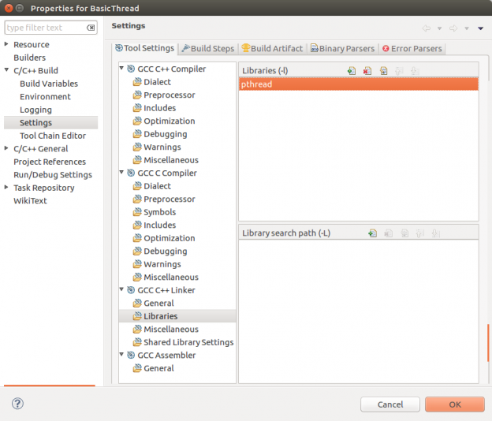

Want to autoselect the correct compiler?
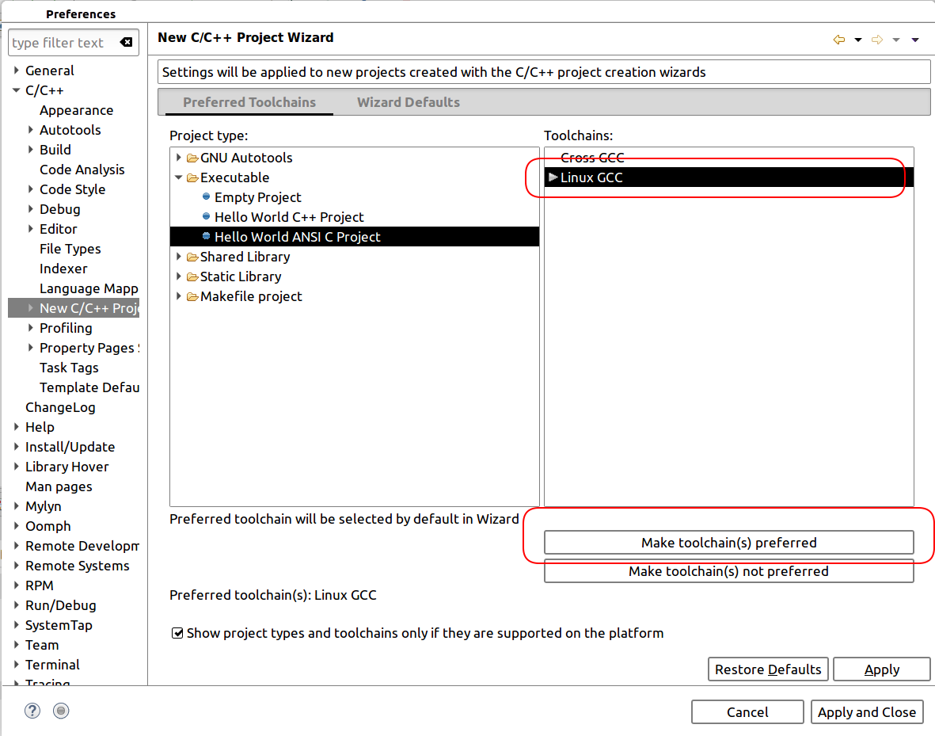
Window→preferences

Sick of switching between c/C++ perspective and Debug Perspective? Then stay in only 1 perspective for both!
Window→preferences
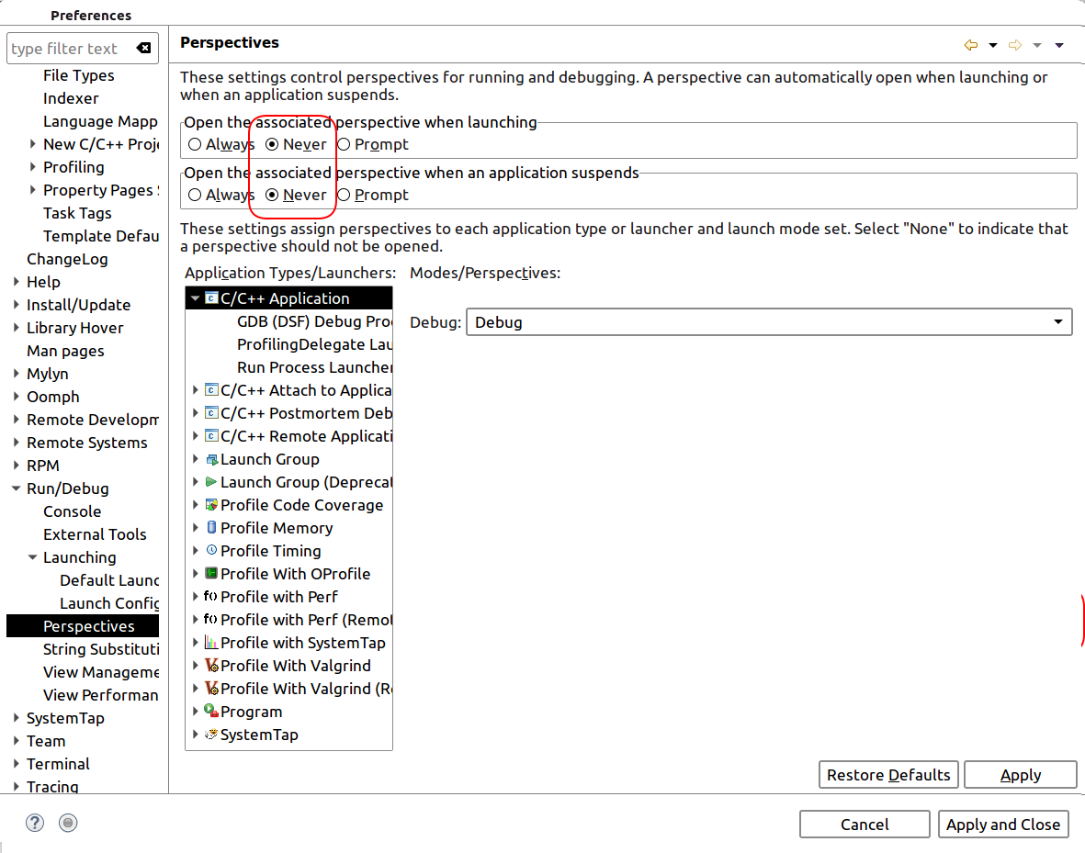
Want to turn off stopping at main when you debug?
Windows->Preferences
