Demo – outline a project
main
File R/W
Data manip
User I/O
utils

Use Case?
- Get src filename to from user
- load filename
- manipulate filename data
- get dest filename to put manipulated data
- save to dest filename
- go to 1

Have module functions , Set up dir structure
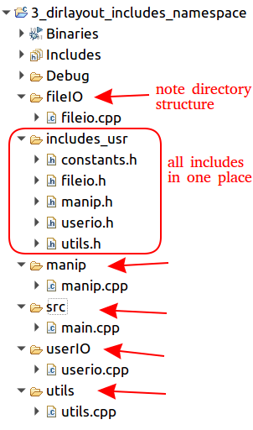

Now flesh out code in each module
1. create userio (cpp and h) files
2. move header to includes_usr (adjust header include in userio.cpp)
3. add two functions in userio.h
std::string read(const std::string &phrase);
void write(const std::string &phrase);

but these are common so put them in a namespace to avoid collisions

4. then main
whole thing is a loop,
always ask for "Please enter a filename or X to exit" so make a constant in constants.h
so make a constant in the constants file

const std::string ASK_FOR_FILE_OR_EXIT_CHAR "Please enter a filename or X to exit";

5. build the constants.h file as we go

6. As we build the modules move the header files up into includes_usr and adjust the paths in the cpp files

7. declare minimal functionality in the headers, define minimal functions in cpp

8. get it to compile and run

9. fill infunction definitions one at a time

