The purpose of this project is to create a more efficient and effective system for signing in/out visitors to dorm rooms.

**Current System:**

The current system is a Microsoft Excel Spreadsheet containing all of the data.

Pros:

* This system is already in place.
* System is easy to learn.

Cons:

* Microsoft Excel will continue to need expensive upgrades.
* All data can easily be lost as it is kept locally.
* Anyone with access to the computer can access and edit the data.
* Inputting sign in information is meticulous.
* Signing people out is slow due to finding each entry.
* Times are often rounded at inconsistent intervals.
* The sticker system for getting into buildings can be circumnavigated using small colored stickers bought at a store.

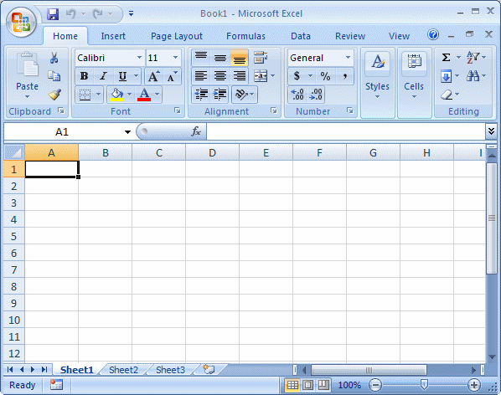

**Other Options:**

It is possible to use Google Docs Excel to integrate the different buildings around campus. Each building would operate under a different page so that all of the information would be accessible. However, this would put the entire system at risk of going down if there is power failure or any internet loss. This system would also have security issues as it can be accessed from anywhere with internet access to anybody whose account has permissions. All other pros and cons of Microsoft Excel use remain the same.

**New System Goals:**

* Create a system for checking students and guests in and out of dorm rooms
* Give the system an easy interface for data entry
* Give the system a smart and easy interface for data retrieval.
* Secure all data collected using password system.
* Ensure the system

**Tactics :**

Browser

* + Advantages
    - Accessible from anywhere
    - Data cannot be lost if the local machine crashes
    - Updates can be distributed from one source instead of needing to be put on each machine.
    - Easiest means of gathering the data from all computers at a central source.
  + Disadvantages
    - Internet access is required at all times
    - Web browser compatibility with multiple browsers
    - Web browser updates could break the system
    - The system could potentially be accessed from any computer on campus.

Local Software App

* + Advantages
    - No internet required
    - Data is safe from unwanted external manipulation
  + Disadvantages
    - Data can be lost with the machine
    - Data must be exported to join any central database

**Types of User:**

* Student
  + Name*
  + Room Number*
  + ID#*
  + Time in
  + Time Out
* Guest
  + Name
  + Host’s Name
  + Host’s Room Number
  + Type of ID taken
  + Time in
  + Time out

**Timestamps:**

In order to ensure that timestamps do not get corrupted by changing of the internal computer clock a central server will be queried for the time. In the event that the central server cannot be reached, the timestamp will be taken from the local machine. However, the system will notify the user there is potential for error in the time and ask them to check the timestamps for any discrepancies.

It would be good if an atomic clock app on the server is used to ensure that time is tracked exactly.

1. Host
   1. Name
   2. ID
   3. Room #
2. Guest
   1. Hands over card
   2. Retrieve card (alone) upon exit.

**Server Check**