**SCTE 130 Transactions ETL and Data integration Overview**

As Of 06/27/2012

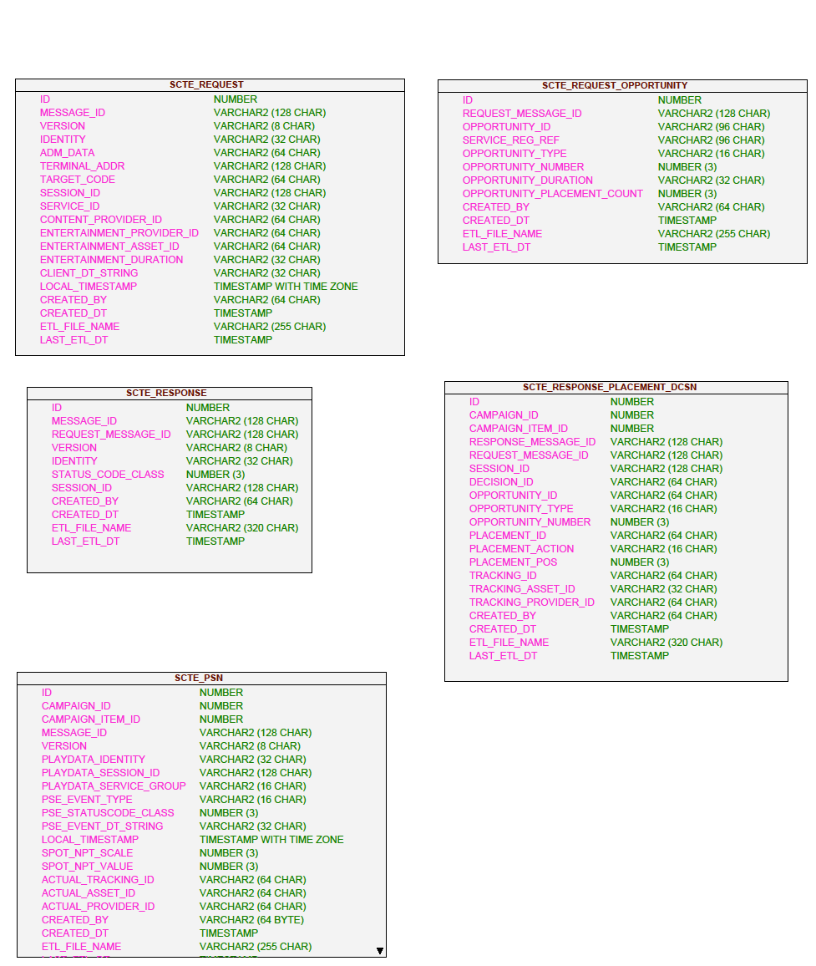

1. ETL Application loads SCTE Transaction Files to these 5 Stage Tables

2. Using internal database Triggers, we copy specified fields from a subset of the SCTE Tables to a secondary data layer, referred to as the “Canoe Layer”. Each of these Tables is paired with an Error table to record any processing errors.

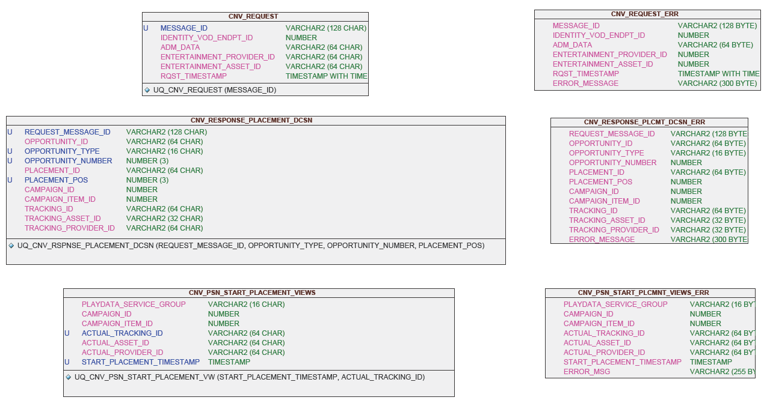

3. This illustrates the 3 SCTE Transaction and 2 Campaign Manager Tables which are the foundation for the aggregated / summarized Materialized View used for Campaign-based reporting.

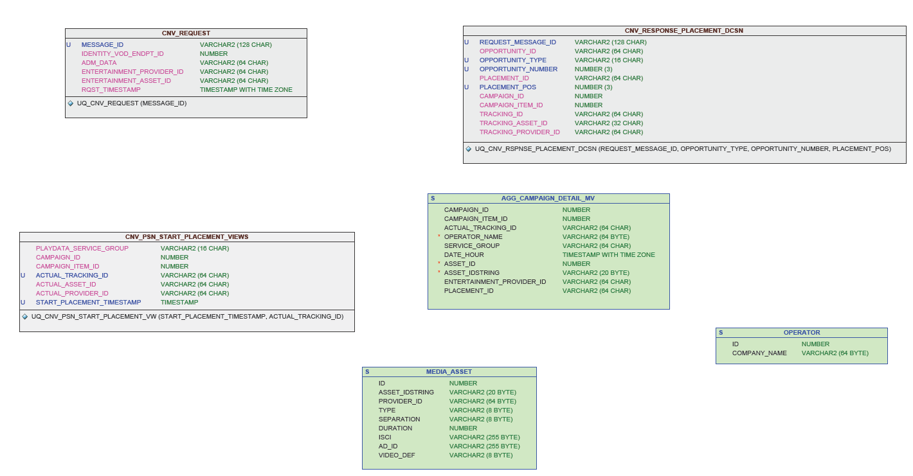

**Original Proof-of-Performance reporting SQL statement:**

**select**

agg.entertainment_provider_id **as** network,

agg.date_hour **as** dt,

agg.view_count **as** total_views,

agg.insert_count **as** total_insertions,

agg.campaign_item_id **as** line_item,

to_char(**trunc**(**trunc**(agg.date_hour,'MM'),'MM'), 'fmMM/DD/YYYY')

|| ' - ' ||

to_char(LAST_DAY(agg.date_hour), 'fmMM/DD/YYYY') **as** date_range

**from** DAI_REPORTING_ODS.RPT_AUDIT_AGG_CAMPAIGN_DETAIL agg,

DAI_REPORTING.CAMPAIGN_ITEM campaignitem

**Where** agg.campaign_id **=** ?

**And** campaignitem.campaign_id **=** agg.campaign_id

**And** agg.date_hour >=to_date(?, 'MON YYYY')

**And** agg.date_hour <=LAST_DAY(to_date(?, 'MON YYYY'))

**order** **by** agg.date_hour

**Revised Proof-of-Performance reporting SQL statement:**

SELECT

campaign.name,

agg_campaign_detail_mv.campaign_item_id,

agg_campaign_detail_mv.entertainment_provider_id NETWORK,

round(agg_campaign_detail_mv.date_hour,'hh') TXN_DATE,

count(agg_campaign_detail_mv.placement_id) NUM_INSERTIONS,

count(agg_campaign_detail_mv.actual_tracking_id) NUM_VIEWS

FROM agg_campaign_detail_mv, campaign

where agg_campaign_detail_mv.campaign_id = campaign.id

GROUP BY

campaign.name,

agg_campaign_detail_mv.campaign_item_id,

agg_campaign_detail_mv.entertainment_provider_id,

round(agg_campaign_detail_mv.date_hour,'hh')

ORDER BY 1, 2, 3

# Proof of Performance Reports

## List of Campaigns Dataset

**select** **distinct**

campaign.id **as** id,

campaign.name **as** name,

programmer.name **as** programmer_name

**from** DAI_REPORTING.campaign campaign,

DAI_REPORTING_ODS.RPT_AUDIT_AGG_CAMPAIGN_DETAIL agg,

DAI_REPORTING.programmer programmer

**Where** agg.campaign_id **=** campaign.id

**and** campaign.programmer_id **=** programmer.id

## List of Months and Years Dataset

**select** **distinct**

to_char(DATE_HOUR,'Mon') **as** MO,

to_char(DATE_HOUR, 'YYYY') **as** Yr,

**extract**(**month** **from** DATE_HOUR) **as** MoNum,

to_char(**trunc**(**trunc**(DATE_HOUR,'MM'),'MM'), 'fmMM/DD/YYYY') **as** FDOM,

to_char(LAST_DAY(DATE_HOUR), 'fmMM/DD/YYYY') **as** LDOM

**from** DAI_REPORTING_ODS.RPT_AUDIT_AGG_CAMPAIGN_DETAIL

**where** DATE_HOUR < **trunc**(sysdate) **-** (to_number(to_char(sysdate,'DD')) **-** 1)

**order** **by** Yr desc, MoNum **desc**

## Proof of Performance Dataset

**select**

agg.entertainment_provider_id **as** network,

agg.date_hour **as** dt,

agg.view_count **as** total_views,

agg.insert_count **as** total_insertions,

agg.campaign_item_id **as** line_item,

to_char(**trunc**(**trunc**(agg.date_hour,'MM'),'MM'), 'fmMM/DD/YYYY') || ' - ' || to_char(LAST_DAY(agg.date_hour), 'fmMM/DD/YYYY') **as** date_range

**from** DAI_REPORTING_ODS.RPT_AUDIT_AGG_CAMPAIGN_DETAIL agg,

DAI_REPORTING.CAMPAIGN_ITEM campaignitem

**Where** agg.campaign_id **=** ?

**And** campaignitem.campaign_id **=** agg.campaign_id

**And** agg.date_hour >=to_date(?, 'MON YYYY')

**And** agg.date_hour <=LAST_DAY(to_date(?, 'MON YYYY'))

**order** **by** agg.date_hour