|  |
| --- |
|  |
| SaFI-SMS Schema Changes Supporting Event Data |
| Version: 0.7  20 June 2012 |

This document contains proprietary and confidential information of **CANOE VENTURES, LLC** that is protected from disclosure. If you are not an authorized recipient you are hereby notified that any dissemination, distribution, or copying of this communication is strictly prohibited. By accessing this information, you agree to keep this information confidential, and to only disclose it within your company to employees with a "need to know" who are instructed and agree not to disclose the information and not to use the information for any unauthorized purpose.

(c) 2012 Canoe Ventures, LLC.  All rights reserved.

**Document Status Sheet**

| **Document Control Number:** | TBD | | |
| --- | --- | --- | --- |
| **Document Title:** | SaFI-SMSI Schema Changes Supporting Event Data | | |
| **Document File Name:** | SaFI-SMSI Schema Changes Supporting Event Data v0.6.docx | | |
| **Release Date:** | 20 June 2012 | | |
| **Document will Enter Change Management System:** | Yes | | |
| **Status:** | Draft |  |  |
| **Distribution Restrictions:** | Canoe, MSO Dev |  |  |

**Key to Document Status Codes**

|  |  |
| --- | --- |
| **Work in Progress** | An incomplete document, designed to guide discussion and generate feedback within the drafting group. May include several alternative positions for consideration. |
| **Draft** | A document in specification format considered largely complete, but lacking review by project stakeholders. Drafts are susceptible to substantial change during the review process. |
| **Issued** | A stable document, which has undergone rigorous stakeholder review and approval. The document is ready for broad distribution and can serve as the basis for product design and development. |

**Revision History**

| **Revision** | **Date** | **Author(s)** | **Notes** |
| --- | --- | --- | --- |
| **WIP 0.1** | **2012-04-16** | **Tim Whitton** | Initial Draft |
| **WIP 0.2** | **2012-04-30** | **Tim Whitton** | Updated to include variant attribute and Error Message structure |
| **WIP 0.3** | **2012-05-16** | **Tim Whitton** | Update to consistently reference proposed xml structure, to include epsid with peid, to describe the source for the attributes of VisitResult, to use AssetRef@peid/epsid as source for adAssetRef, to add adAssetPAID, standardize order of attributes, reduce VisitResult to visit related data, to add more guidance on processing. |
| **Draft** | **2012-06-01** | **Tim Whitton** | Change type of HHID from nonnegativeint, considerable change to the structure of elements and the attribute names within elements (section 4) |
| **Draft** | **2012-06-12** | **Tim Whitton** | Rename doc as generic SaFI spec recommendation, make content generic (non Canoe Specific), Majoe updates to schema – to numerous so consider this a new docment, Update Processing Rules to sync with schema changes. |
| **Draft** | **2012-06-20** | **Tim Whitton** | Change name of “programPAID” to “titlePAID” and segregate into it’s own element with a startTime attribute |
| **Draft** | **2012-06-22** | **Tim Whitton** |  |

Table of Contents

1 introduction 1

1.1 Document Purpose 1

1.1 Scope 1

1.2 Audience 1

1.3 Assumptions 1

2 Overview 2

3 EVENT Data Set delivered by Service Operator to Canoe 4

Sample Reports 5

Figure 1 – Safi Message Flow Canoe to SO to Canoe 10

4 Required SMSI Spec Changes 11

Add a “VisitResultType” to the CL-SaFI-SMSI-1.1.0 schema 11

Add a “VodEventPackageType” to the CL-SaFI-SMSI-1.1.0 schema 13

Add a “VodResponseType” to the CL-SaFI-SMSI-1.1.0 schema 13

5 Processing Rule General Guidelines 14

6 VOD DAI Processing Rule Definition 15

6.1 VodEventType1 (for Event Data) 15

# introduction

## Document Purpose

The purpose of this document is to define the changes necessary for the CL-SaFI-SMSI-1.1.0 specification to enable support of Summary Reporting (Data Products) for the Dynamic Ad Insertion in Video on Demand product. Specifically, this document should:

1. Define the Safi specification changes necessary.
2. Define the xml structures required within the SMSI schema to support Summary Reporting for DAI in VOD.
3. Define and provide examples of Summary Reporting data needed to support DAI VOD.
4. Define the Processing Rules that must be executed by Service Operators to support the messaging for Summary Reporting for DAI in VOD.

This document uses the CL-SaFI-SMSI-1.1.0 specification as a baseline. Evaluation of this specification has led to the conclusion that, in its current form, the specification does not support Summary Reporting for DAI in VOD in a practical or acceptable fashion. The document defines the necessary schema changes and the implementation instructions concerning those structural changes in support of the DAI in VOD business requirements.

## Scope

This document covers the DAI VOD 1.0 advertising products. Ad products beyond the 1.0 capabilities have been defined and will be addressed in a subsequent revision of this document as requirements become available.

## Audience

This document is intended for use by Canoe Ventures, its application development team throughout the application development life cycle, and partner Service Operators who may be implementing the rules defined in this document. While targeted at team members involved in the day to day development and deployment efforts, this document may provide value to stakeholders who are less directly involved in the project but are interested in understanding the application details.

## Assumptions

* This document will be managed under Canoe Venture’s Change Control process.
* This document is not intended to completely describe how the Processing Rules are applied by the Service Operator in their environments.
* This document defines implementation guidelines specific to the Canoe Ventures business applications. The Cable Labs specifications may enable additional capabilities that are not required by Canoe to support VOD DAI Summary Reporting and non-use of those extraneous components is expected to be acceptable.
* This document does not define the campaign execution feedback provided by the CIP feedback mechanism added in CIP 3.0.

# Overview

The Summary Reporting of DAI in VOD requires a set of changes to the existing Cablelabs SMSI specification to support business goals. The following is an overview of the process flow and changes necessary to support these business goals.

A Campaign Information Package (CIP) is sent by the CIP Publisher to the CIP Consumer(s) for each order. The order will represent one or more dynamic ad placements within a given programming group. During a VOD session on a given set top box, the CIP Consumer’s VOD delivery platform will make decisions and insert the specified ads into the playlist to be streamed to the viewer. As the session plays out, the VOD delivery platform will send event records to the CIP Consumer’s aggregation point(s). These event records will be encoded with a variety of information including an identifier for the set top box, session identifier, a timestamp for the event, and the duration of the event. The event records themselves do not carry enough information to support the Canoe Data Products summary reporting needs. The CIP Consumer must “decorate” the event records with additional information defined by the delivery platform to insure that a full information set is delivered for each event. That information set must include:

1. Session Identifier
2. Session Start DateTime
3. Household Identifier
4. Program PAID
5. provider (network)
6. Variant
7. Ad Asset PEID
8. Ad Asset EPSID
9. Ad Asset PAID (Actually Placed)
10. VOD System reference
11. Placement Opportunity Reference
12. Break Type
13. Opportunity Type
14. Session Break Sequence (poGroupIndex)
15. Session Opportunity Sequence
16. Break Opportunity Sequence
17. Break Placement Sequence
18. Opportunity Placement Sequence
19. isFirst Flag
20. isLast Flag
21. Max Duration
22. Max Placement Count
23. View Flag
24. Play Time
25. Run Time
26. VisitStart DateTime
27. Processing Rule ID (currently always = “VODEventType1”)
28. Error Conditions

The use of Event Data is an alternative to aggregated data. The use of Event Data supports a Web Portal providing Ad Hoc reporting capabilities allowing Programmers to request reports with unrestricted time frames and other configurable filters and receive reports which contain data, including unique household views, that accurately reflects the timeframe the event occurred in.

The CIP Consumer’s aggregation servers are expected to communicate these Event records using the SMSi interface as defined by the CableLabs SaFI-SMSi specification and dictated by the processing rules established.

Unlike the processing of summary reporting for Interactive products, the VOD DAI CIP does not communicate the Processing Rule to apply to the execution information. All DAI VOD executions for a given CIP consumer are expected to be processed using the same currently active Event Data processing rule. Processing rules may vary between CIP consumers.

# EVENT Data Set Definition

The CIP Consumer(s) must deliver the Event data set(s) to the designated location for every VOD execution. A VOD execution is defined as the insertion of an Ad Asset into a VOD session playlist. A full Event data set is delivered for executions which are visited. A partial execution is delivered for executions which are not visited. In addition, a partial Event data set must be delivered for unfilled opportunities.



The Event Data Set includes the following information for each event when the execution is visited. The source for each is also provided.

## Event Data Set delivered for visited VOD executions

1. sessionID - which is provided with the placement request
2. sessionStart - which is defined though placement notification messaging
3. hhID - which is provided with the placement request or derived based on information in the request
4. titlePAID – which is the PAID of the entertainment asset defined in the placement request
5. titleStart – which is the start datetime of the entertainment asset defined by the associated titlePAID and is defined at session run time
6. provider – which is provided with the placement request
7. variant - which is defined at Request generation
8. adAssetPEID – which is defined within the CIP and is the AssetReference@PEID executed at decision time.
9. adAssetEPSID – which is defined within the CIP and is the AssetReference@EPSID executed at decision time
10. adAssetPAID – which is the PAID of the ad asset executed by the delivery platform.
11. VOD System reference - which is provided with the placement request
12. placementOpportunityRef – which is the unique identifier of a placement opportunity within a session and is provided with the placement request.
13. breakType – which is provided with the placement request
14. opportunityType - which is provided with the placement request
15. sessionBreakSequence (poGroupIndex) - which is provided with the placement request
16. sessionOpportunitySequence – which is provided with the placement request
17. breakOpportunitySequence - which is provided with the placement request
18. breakPlacementSequence - which is defined by the delivery platform at execution
19. opportunityPlacementSequence - which is defined by the delivery platform at execution
20. isFirst - which is defined by the delivery platform at execution
21. isLast - which is defined by the delivery platform at execution
22. maxDuration - which is provided with the placement request
23. maxPlacements - which is provided with the placement request
24. viewFlag - which is defined at session run time
25. playTime - which is defined at session run time
26. runTime - which is defined at session run time
27. visitStart - which is defined at session run time
28. ProcessingRuleID – which is determined when the Event record is created through a configuration setting.
29. ErrorStatus – which is defined at session run time

## Event Data Set delivered for VOD executions not visited

The Event data set delivered for VOD executions that are not visited during session run time will include all data defined in section 3.1 except;

1. playTime
2. runTime
3. visitStart
4. viewFlag

## Event Data Set delivered for unfilled opportunities

An unfilled opportunity is an opportunity that has no placements. An opportunity that has a placement, but has not reached its maxDuration or maxPlacements is not considered unfilled. The Event data set delivered for unfilled opportunities will include all data defined in section 3.1 except;

1. adAssetPEID
2. adAssetEPSID
3. adAssetPAID
4. breakPlacementSequence
5. opportunityPlacementSequence
6. playTime
7. runTime
8. visitStart
9. viewFlag

There is no aggregation of data. There are no requirements for sorting or control totals for the data.

## Business Report Samples

The Event Data Set supports common business reporting needs for DAI in VOD.

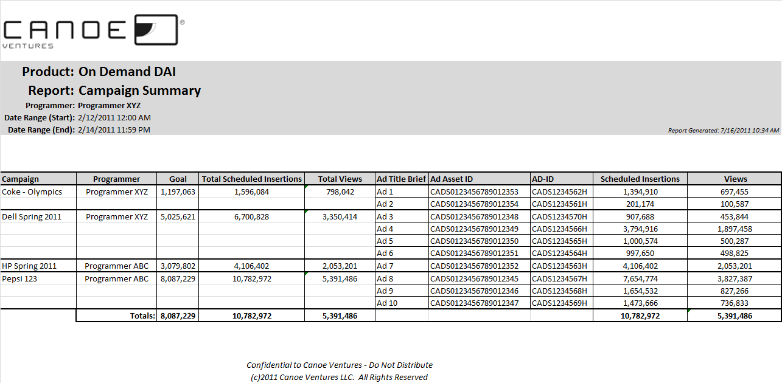

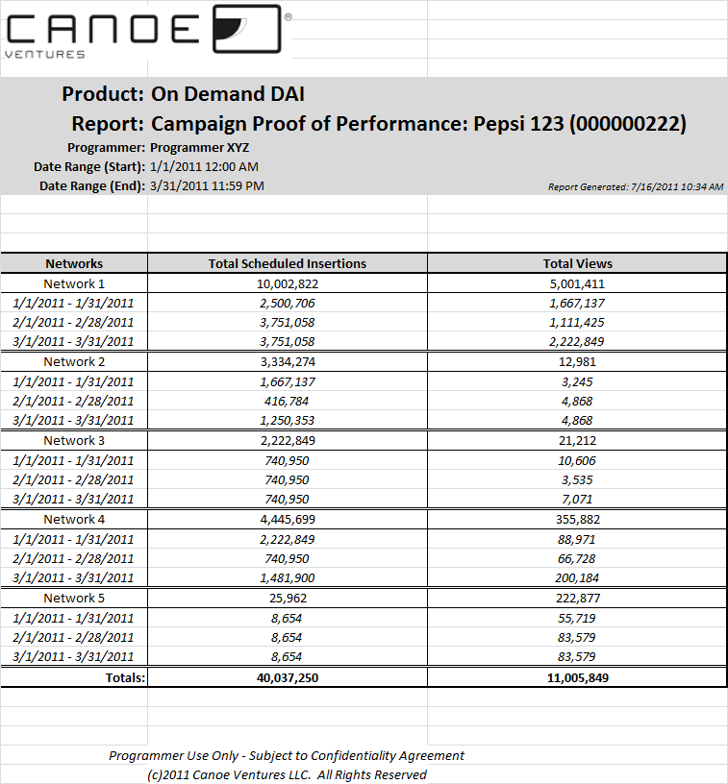

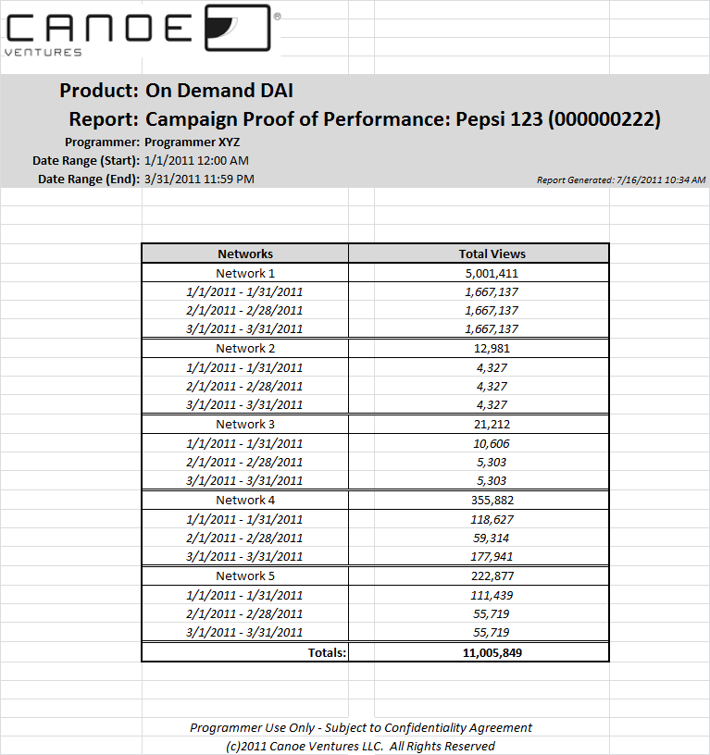

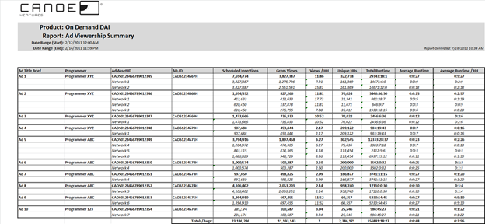

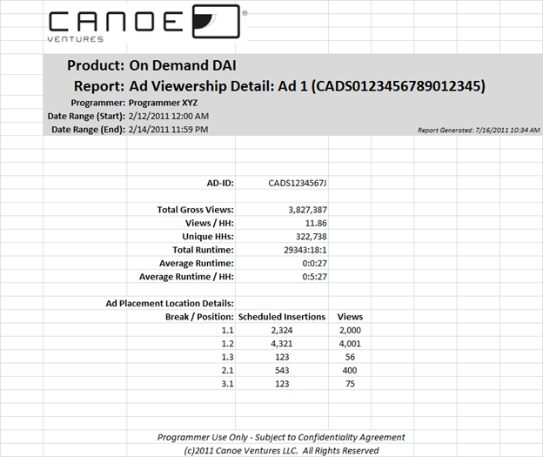

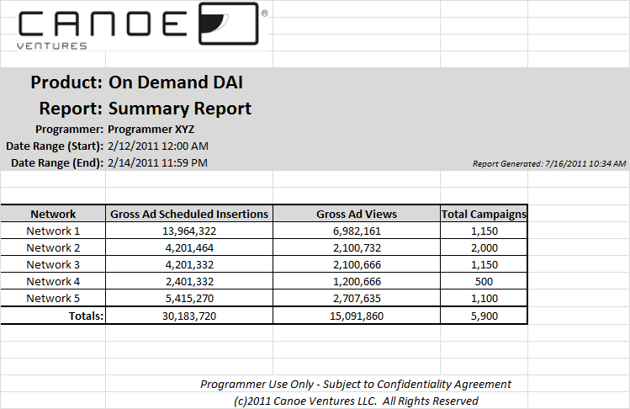

# Required SMSI Spec Changes

Certain additional elements are required in the CL-SaFI-SMSI specification to support reporting business deliverables. The following requirements outline the modifications to the SMSI specification necessary to support the DAI in VOD reporting business requirements.

1. Definition of ServiceMeasurementType must be changed to allow minOccurs=”0” of GeoCode element.
2. Change the definition of FaultType to contain an errorID attribute.
3. Definition of ErrorStatusType, which contains ErrorAlert (of type FaultType).
4. Definition of VodEventPackageType (Event Data), which would contain VodSessionInfo (which is of type VodSessionInfoType) and ErrorStatus (which is of type ErrorStatusType).
5. Definition of VodResponseType element that allows VodEventPackage (which is of type VodEventPackageType and contains Event Data).
6. Definition of VodSessionInfoType which contains 1 or many TitleInfo elements (of type TitleInfoType) elements and ErrorStatus (which is of type ErrorStatusType).
7. Definition of a TitleInfoType which contains 1 or many VodOpportunityInfo (of type VodOpportunityInfoType) elements
8. Definition of VodOpportunityInfoType which contains 0 or many VodPlacementInfo elements (of type VodPlacementInfoType) and ErrorStatus (which is of type ErrorStatusType).
9. Definition of VodPlacementInfoType which contains 0 or many VisitResult elements (of type VisitResultType) and ErrorStatus (which is of type ErrorStatusType).
10. Definition of VisitResultType, which specifies the Event data we need to support VOD DAI Summary Reporting. This set of data is very different than the ResultType defined for Interactive.

Proposed structures of all elements is as follows:

### Add “errorID” attribute to the FaultType in CL-SaFI-COM-2.0 schema

<xs:complexType name="FaultType">

<xs:sequence>

<xs:element name="reason" type="xs:string" />

</xs:sequence>  
        <xs:attribute name="code" type="xs:int" use="optional"/>

**<xs:attribute name="errorID" type="common:nonNegativeIntType" use="optional"/>**  
</xs:complexType>

### Add a “ErrorStatusType” to the CL-SaFI-SMSI-1.1.0 schema

<xs:complexType name="ErrorStatusType">

<xs:element name="ErrorAlert" type="FaultType" minOccurs="1" maxOccurs=”unbounded”/>  
</xs:complexType>

### Add “VariantType” to the CL-SaFI-SMSI-1.1.0 schema

<xs:simpleType name="VariantType">  
 <xs:annotation>  
 <xs:documentation>  
 <p> designates the platform source of the event </p>  
 </xs:documentation>  
 </xs:annotation>  
 <xs:restriction base="xs:string">  
 <xs:pattern value="stb|internet|mobile|private:.+"/>  
 </xs:restriction>  
</xs:simpleType>

### Add “VodResponseType” to the CL-SaFI-SMSI-1.1.0 schema

<xs:complexType name="VodResponseType">  
    <xs:complexContent>  
        <xs:extension base="MeasurementType">  
            <xs:sequence”>  
                <xs:element name="VodEventPackage" type="VodPackageType"  
                    minOccurs="1" maxOccurs="unbounded"/>

            </xs:sequence>  
        </xs:extension>  
    </xs:complexContent>  
</xs:complexType>

### Add “VodEventPackageType1” to the CL-SaFI-SMSI-1.1.0 schema

<xs:complexType name="VodEventPackageType">  
    <xs:element name="VodSessionInfo" type="VodSessionInfoType” minOccurs="1" maxOccurs="unbounded"/>

<xs:element name="ErrorStatus" type="ErrorStatusType” minOccurs="0" maxOccurs="1"/>

</xs:complexType>

### Add “VodSessionInfoType” to the CL-SaFI-SMSI-1.1.0 schema

<xs:complexType name="VodSessionInfoType">  
   <xs:element name="TitleInfo" type="TitleInfoType” minOccurs="1" maxOccurs="unbounded"/>

<xs:element name="ErrorStatus" type="ErrorStatusType” minOccurs="0" maxOccurs="1"/>

<xs:attribute name="sessionID" type="xs:id" use="required"/>

<xs:attribute name="sessionStart" type="xs:dateTime" use="required"/>

<xs:attribute name="hhId" type="xs:id " use="required"/>

    <xs:attribute name="provider" type="n2:ProviderIdType" use="required"/>

    <xs:attribute name="variant" type="VariantType" use="required"/>

<xs:attribute name="vodSystemRef" type="xs:string" use="required"/>

</xs:complexType>

### Add “TitleInfoType” to the CL-SaFI-SMSI-1.1.0 schema

<xs:complexType name="TitleInfoType">

<xs:element name="VodOpportunityInfo" type="VodOpportunityInfoType” minOccurs="1" maxOccurs="unbounded"/>

<xs:attribute name="titlePAID" type="n2:AssetIdType” use=”required”/>

<xs:attribute name="titleStart" type="xs:dateTime" use="optional"/>

</xs:complexType

### Add “VodOpportunityInfoType” to the CL-SaFI-SMSI-1.1.0 schema

<xs:complexType name="VodOpportunityInfoType">

<xs:element name="VodPlacementInfo" type="VodPlacementInfoType” minOccurs="0" maxOccurs="unbounded"/>

<xs:element name="ErrorStatus" type="ErrorStatusType” minOccurs="0" maxOccurs="1"/>

<xs:attribute name="placementOpportunityRef" type="common:PeidType " use="required"/>

<xs:attribute name="opportunityType" type="xs:string" use="required"/>

    <xs:attribute name="sessionBreakSequence" type="common:nonNegativeIntType" use="required"/>

    <xs:attribute name="sessionOpportunitySequence" type=" common:nonNegativeIntType" use="required"/>

<xs:attribute name="breakOpportunitySequence" type=" common:nonNegativeIntType" use="required"/>

<xs:attribute name="maxDuration" type="xs:duration" use="optional"/>

<xs:attribute name="maxPlacements" type=" xs:string " use="optional"/>

</xs:complexType>

### Add “VodPlacementInfoType” to the CL-SaFI-SMSI-1.1.0 schema

<xs:complexType name="VodPlacementInfoType">

<xs:element name="VisitResult" type="VisitResultInfoType” minOccurs="0" maxOccurs="unbounded"/>

<xs:element name="ErrorStatus" type="ErrorStatusType” minOccurs="0" maxOccurs="1"/>  
    <xs:attribute name="adAssetPEID" type="common:PeidType" use="required"/>

<xs:attribute name="adAssetEPSID" type="common:epsidType" use="required"/>

    <xs:attribute name="adAssetPaid" type="n2:AssetIdType" use="required"/>

<xs:attribute name="breakPlacementSequence" type=" common:nonNegativeIntType" use="required"/>

    <xs:attribute name="opportunityPlacementSequence" type="common:nonNegativeIntType" use="required"/>

  <xs:attribute name="isFirst" type="xs:boolean" default="false" use="required"/>

  <xs:attribute name="isLast" type="xs:boolean" default="false" use="required"/>

</xs:complexType>

### Add “VisitResultType” to the CL-SaFI-SMSI-1.1.0 schema

<xs:complexType name="VisitResultType">

<xs:element name="ErrorStatus" type="ErrorStatusType” minOccurs="0" maxOccurs="1"/>

        <xs:attribute name="viewFlag" type="xs:boolean" default="false" use="required"/>  
        <xs:attribute name="playTime" type="xs:duration" use="required"/>

        <xs:attribute name="runTime" type="xs:duration" use="required"/>

        <xs:attribute name="visitStart" type="xs:dateTime" use="required"/>

    <xs:attribute name="processingRuleID" type=”xs:string" use="required"/>

</xs:complexType>

Also included as part of the bundle of information with this document is a spreadsheet with a sample Event Data set as well as sample xml message implementing the changes described for this data set.

# Processing Rules

Phase Processing Rules are a set of instructions that tell a CIP Consumer’s aggregation servers how to perform the necessary calculations on the data returned from the execution of dynamic ad insertion. The CIP Consumer’s aggregation servers provide a general purpose application response server within their network. This allows applications to use standard messaging based on agreed upon processing rules and campaign instructions so that multiple applications can run across the National footprint without requiring installation of specialized response servers. The Publisher’s objective is to distribute a set of well-defined processing rules that can be used by multiple applications.

A typical processing rule will express whether summarization is needed or if detailed records are expected, specifically what data is expected, and how certain data attributes are derived. An example of a typical processing rule might include information details around a specific dynamic ad insertion event. These rules are defined in this document.

Figure 1 below illustrates the flow of information between Canoe and a representative set of logical components at a Service Operator.



## Processing Rule General Guidelines

The following is the overview of the VODEventType1 processing rule. VODEventType1 defines the processing that must be implemented by participating CIP Consumers who will be responsible for collecting and communicating viewer responses during the execution of VOD DAI.

| **Processing Rule**  **Identifier** | **Description** | **Default Delivery Time** | **CableLabs Advanced Advertising Spec** |
| --- | --- | --- | --- |
| VODEventType1 | For a given execution (placement of an ad asset) this rule provides sessionID, sessionStart, hhID, titlePAID, titleStart, provider, variant, adAssetPEID, adAssetEPSID, adAssetPAID, vodSystemRef, placementOpportunityRef, breakType, opportunityType, sessionBreakSequence, sessionOpportunitySequence, breakOpportunitySequence, breakPlacementSequence, opportunityPlacementSequence, isFirst, isLast, maxDuration, maxPlacements, viewFlag, playTime, runTime, visitStart, ProcessingRuleID and ErrorStatus. | As soon as possible after termination of session – target 15 minutes after session termination. | SMSI |
|  |  |  |  |
|  |  |  |  |

## VOD DAI Processing Rule Definition

The following section describes the processing requirements for CIP Consumers participating in the execution of Canoe Interactive 1.0 campaigns. For each Processing Rule, CIP Consumers are expected to develop the necessary software and processing to ensure delivery of the requested data within the specified processing times. Since many different systems within several CIP Consumers may be participating in a given campaign, it is critical that the processing be handled consistently and uniformly across all aggregation servers.

For each processing rule the following components will make up the description of the processing expected:

1. **Data Specification** – the CableLabs Advanced Advertising specification that must be used to carry the information back to Canoe’s aggregation point.
2. **Type** – Type of the Measurement blocks within SMS
3. **Processing Times –** in order to execute a single application across a footprint of multiple Service Operator scattered around the country, it is critical that the collected data be returned within the specified window. The StartDateTime / EndDateTime of the data request is used to restrict data in the set to only events with a TimeStamp falling within that window.
4. **Late Data Processing** -- for any number of reasons, some data may be collected outside of the Processing Times window. These rules should be followed when data collected by the Service Operator falls outside of the required Processing Times but is available for distribution to Canoe.
5. **Geocode Type –** describes what geographic summarization is expected. Options are either Syscode or Zip Code.
6. **Level of Summary –** Not all data will be summarized before sending to Canoe Ventures, but when summarization is required, the Level of Summary describes the lowest level of summarization when all values are included. For example, if the Level of Summary lists Zip Code, PEID, EPSID, EventID and UserInput, than Canoe would expect a single numeric value for each of the Processing Data Elements within that full summary list.
7. **Processing Data Elements** – includes the list of data elements that must be delivered to Canoe Venture’s aggregation point and the processing rules expected by the Service Operator.
8. **Data Mapping** – it may not always be obvious what the expected data source of the data elements are from the event record. This section describes those mappings from the event record to the output data to be sent to Canoe.
9. **Example –** where appropriate, an example will be included to show how the data might be formatted to return the appropriate Processing Data Elements.

## VodEventType1 (for Event Data)

VodEventType1 supports communication of request, decision and session run-time information related to a particular VOD opportunity or execution.

**Data Specification**: Service Measurement Summary Interface (SMSi)

**Measurement Type:** VodResponseType/VodEventPackage

**Processing Times**: SMSi messages for each event should be generated within 15 minutes of session termination

**Late Data Processing**: There are no processing time frames. Event data is communicated to the CIP Publisher as it becomes available, regardless of the delay from session termination. The CIP Publisher will be responsible for filtering late data.

**GeoCode Type**: N/A

**Level of Summary: N/A**

**Processing Data Elements**:

Each instance of VodEventPackage represents the viewership information for 1 or more VOD sessions. Each instance of VodSessionInfo represents the session information for a specific VOD session. Each instance of VodOpportunityInfo represents the opportunity information for a specific opportunity within a session. Each instance of VodPlacementInfo represents the placement information for a particular placement into a specific opportunity within a specific VOD session. Each instance of VisitResult represents the viewership information for a particular “visit” to a placed ad asset. “Visit” simply means that that the ad asset is entered into by the stream. This can be through the start or end binding of the ad asset. Every session must have at least 1 opportunity (instance of VodOpportunityInfo). Not every opportunity will have a placement (instance of VodPlacementInfo). Not every placement results in a visit (instance of VisitResult). All instances of VodEventPackage and VodOpportunityInfo must be reported even when they do not result in a visit or placement.

Each instance of VodEventPackage.VodSessionInfo.VodPlacementInfo.VisitResult will contain:

1. @viewFlag - will be "true" if the visit represents a "view" based on the currently in use definition of a view. A visit which includes a startplacement with NPT value of 0 and scale=”1” will be represented with @viewFlag=”true”. This means the first frame of the ad asset was played in normal play time in the forward direction. If not, the @viewFlag=”false”.
2. @playTime - represents the duration of time the ad asset associated with the event played in NPT scale=1 during this "visit". Every visit accumulates it's own VisitResult@playTime. Play time = the sum of the NPT values of all named events for the visit that have a scale=”1”. If a viewer fast forwards through the entirety of an ad, the playTime=P00M00S. If the viewer rewinds through the entirety of an ad, the playTime=P00M00S. If a viewer pauses the session, playtime DOES NOT accumulate. If the viewer terminates the session while in the ad, this is considered exiting the ad (the visit ends). A viewer can rewind and play during a visit such that the playtime value may exceed the duration of the ad.
3. @runTime - represents the duration of time the ad asset associated with the event played regardless of scale. Run time is the duration from the actual date/time of the first named event of the visit to the actual date/time of the last named event of the visit. If a viewer fast forwards through the entirety of an ad, the runtime will be (time when the ad was exited – time when the ad was entered) and will vary based on the speed of the fast forward mode. If the viewer rewinds through the entirety of an ad, the runtime will be (time when the ad was exited – time when the ad was entered) and will vary based on the speed of the rewind mode. If a viewer pauses the session, runtime continues to accumulate. If the viewer terminates the session while in the ad, this is considered exiting the ad (the visit ends) and runtime accumulation ends for the visit. A viewer can rewind and play during a visit such that the runtime value may exceed the duration of the ad.
4. @visitStart - represents the date/time stamp of the named event at which the "visit" of the asset began (the front or back binding was crossed). If a viewer enters the ad in play or fastforward mode, the visitStart is the datetime the front binding of the ad was crossed. If the viewer enters the ad in rewind mode, the visitStart is the datetime the back binding of the ad was crossed. If the viewer enters the ad using a “jump forward” mode, the visitStart is the datetime the front binding of the ad was crossed. If that information is not captured, it is acceptable to use the datetime the “jump forward” was initiated as the visitStart value. If the viewer enters the ad using a “jump back” mode, the visitStart is the datetime the back binding of the ad was crossed. If that information is not captured, it is acceptable to use the datetime the “jump back” was initiated as the visitStart value.
5. @processingRuleID – represents the method for calculating certain metrics such as @runTime, @ playTime, @viewFlag

**Data Mapping:**

Each event is represented by a VodEventPackage, which may including 1 or many VodInfoSession elements. Each VodSessionInfo element may include 1 or many VodOpportunityInfo elements. Each VodOpportunityInfo element may include 1 or many VodPlacementInfo elements. Each VodPlacementInfo element contains 1 or many VisitResult element(s) (described above). In addition to the VodOpportunityInfo element(s), the VodSessionInfo element contains the following attributes:

1. VodEventPackage.VodSessionInfo.ErrorStatus – communicates error messages and codes.
2. VodEventPackage.VodSessionInfo@sessionID – represents the identifier of the session that the event relates to (from Request).
3. VodEventPackage.VodSessionInfo @hhID - determined at the time the placement request is generated
4. VodEventPackage.VodSessionInfo @sessionStart - represents the time stamp at which the Session related to the event began.
5. VodEventPackage.VodSessionInfo.TitleInfo @titlePAID –Entertainment content PAID from Request
6. VodEventPackage.VodSessionInfo @provider – providerID of Entertainment asset from Request
7. VodEventPackage.VodSessionInfo @variant
8. VodEventPackage.VodSessionInfo @vodSystemRef

In addition to the VodPlacementInfo element(s), the VodOpportunityInfo element contains the following attributes:

1. VodEventPackage.VodSessionInfo.TitleInfo. VodOpportunityInfo@opportunityType – opportunityType of the opportunity relating to the event from Response (Slate, Pre-roll, Mid-roll, Post-roll, Interstitial)
2. VodEventPackage.VodSessionInfo. TitleInfo. VodOpportunityInfo@placementOpportunityRef – GUID for the opportunity specific to this session.
3. VodEventPackage.VodSessionInfo. TitleInfo. VodOpportunityInfo@sessionBreakSequence – pogroupindex of the opportunity of the related event.
4. VodEventPackage.VodSessionInfo. TitleInfo. VodOpportunityInfo@sessionOpportunitySequence – the sequential enumeration of the opportunity of the related event across breaks.
5. VodEventPackage.VodSessionInfo. TitleInfo. VodOpportunityInfo@maxDuration – the maximum aggregate duration of all placements for an opportunity (from Request).
6. VodEventPackage.VodSessionInfo. TitleInfo. VodOpportunityInfo@maxPlacements – the maximum number of placements for the opportunity related to the event (from Request).
7. VodEventPackage.VodSessionInfo. TitleInfo. VodOpportunityInfo@breakOpportunitySequence - the sequence of the opportunity scoped by the break (POGROUPINDEX) (from Response)

In addition to the VisitResult element(s), the VodPlacementInfo element contains the following attributes:

1. VodEventPackage.VodSessionInfo.TitleInfo. VodOpportunityInfo.VodPlacementInfo@adAssetPEID – Bundle.Bundle.Placement.AssetReference@peid executed
2. VodEventPackage.VodSessionInfo.TitleInfo. VodOpportunityInfo.VodPlacementInfo @adAssetEPSID – Bundle.Bundle.Placement.AssetReference@epsid executed
3. VodEventPackage.VodSessionInfo.TitleInfo. VodOpportunityInfo.VodPlacementInfo @adAssetPAID – PAID of the ad executed by the delivery system.
4. VodEventPackage.VodSessionInfo.TitleInfo. VodOpportunityInfo.VodPlacementInfo@breakPlacementSequence – the sequence of the placement scoped by the break (POGROUPINDEX) (from Response)
5. VodEventPackage.VodSessionInfo.TitleInfo.VodOpportunityInfo.VodPlacementInfo @opportunityPlacementSequence - the sequence of the placement scoped by the opportunity (POGROUPINDEX) (from Response)
6. VodEventPackage.VodSessionInfo. TitleInfo. VodOpportunityInfo.VodPlacementInfo @isFirst – will be "true" if the event represents a placement in the 1st position of a break (at times determined from Response, at times dependent on execution)
7. VodEventPackage.VodSessionInfo. TitleInfo.VodOpportunityInfo.VodPlacementInfo @isLast – will be "true" if the event represents a placement in the last position of a break at times determined from Response, at times dependent on execution)

Each VodSessionInfo, VodOpportunityInfo, and VodPlacementInfo elements may contain the ErrorStatus.ErrorAlert element. Each of these contains;

1. ErrorAlert@code – required
2. ErrorAlert@errorID - optional
3. ErrorAlert.Reason – optional

The MessageTime element is required for every ServiceMeasurementMessage element. The MessageTime element defines the time the ServiceMeasurementMesssage was created.

The SMTimeRange element contains 2 attributes.

1. SMTimeRange@startTime – the earliest of all VodEventPackage@sessionStart in the ServiceMeasurement element
2. SMTimeRange@endTime – the latest of all VodEventPackage@sessionStart in the ServiceMeasurement element

**Sample Data Set:**



**Sample XML for sample data set**:

<!-- Use Case #1 Sample XML -->  
<?xml version="1.0" encoding="UTF-8"?>  
<ns2:ServiceMeasurementMessage xmlns:xsi="http://www.w3.org/2001/XMLSchema-instance"  
 xsi:schemaLocation="http://www.cablelabs.com/namespaces/safi/xsd/sms/1.1 CL-SaFI-SMS-1.1.0.xsd"  
 xmlns:ns1="http://www.cablelabs.com/namespaces/safi/xsd/com/1.1"  
 xmlns:ns2="http://www.cablelabs.com/namespaces/safi/xsd/sms/1.1">  
 <ns2:Version MajorVersion="1" MinorVersion="1" MinSchemaVersion="1"/>  
 <ns2:MessageTime>2009-05-21T18:13:51.0Z</ns2:MessageTime>  
 <ns2:ServiceMeasurement>  
 <!-- startTime is the earliest of any VodEventPackage@sessionStart and endTime is the latest  
 of any VodEventPackage@sessionStart -->  
 <ns2:SMTimeRange starttime="2012-02-01T09:15:32.563-05:00" endtime="2012-02-01T09:15:32.563-05:00"/>  
 <!-- The ServiceMeasurement element will NOT have a GeoCode element -->  
 <!-- This Measurement element is providing VOD data. Measurement elements can contain any  
 number of VodEventPackage elements and these elements can be from different sessions,  
 for different campaign items, different assets, etc. -->  
 <!-- The process attribute defines how this message should be processed in relation to others.  
 Messages flagged with the "additive" attribute should be added to other recieved  
 reports for same time period and identifiers. While messages with the "overwrite"  
 attribute should replace records for the identifiers -->  
 <!-- "reporting" Defines if this message contains final/complete data or if it is a partial/incremental update.-->  
 <ns2:Measurement process="overwrite" reporting="final"  
 xsi:type="ns2:VodResponseType">  
 <ns2:VodEventPackage  
 <ns2:VodSessionInfo sessionID="smgqa34209vfe178954"  
 sessionStart="2012-02-01T09:15:32.563-05:00" hhID="MES89234782457629hhID"  
 provider="ABC_HD" variant="STB" vodSystemRef="EST274">  
 <TitleInfo titlePAID="datg.com/Title/BOEV1423409500000000"  
 titleStart="2012-02-01T09:15:32.563-05:00">  
 <ns2:VodOpportunityInfo placementOpportunityRef="wer12asd23kjlsi456k001"  
 opportunityType="Slate" sessionBreakSequence="1"  
 sessionOpportunitySequence="1" breakOpportunitySequence="1"  
 maxDuration="PT00H00M03S" maxPlacements="1">  
 <ns2:VodPlacementInfo adAssetPEID="ntDbws5AEd6ukwAfASSET1"  
 adAssetEPSID="0" adAssetPAID="ads.datg.com/Asset/COKE1900002100000000"  
 breakPlacementSequence="1" opportunityPlacementSequence="1" isFirst="true"  
 isLast="true">  
 <!-- Line 3 -->  
 <ns2:VisitResult viewFlag="true" playTime="PT00H00M03S" runTime="PT00H00M03S"  
 visitStart="2012-02-01T09:15:32.565-05:00" processingRuleID="VODEventType1"/>  
 </ns2:VodPlacementInfo>  
 </ns2:VodOpportunityInfo>  
 <ns2:VodOpportunityinfo placementOpportunityRef="wer12asd23kjlsi456k002"  
 opportunityType="Pre-roll" sessionBreakSequence="1"  
 sessionOpportunitySequence="2" breakOpportunitySequence="2"  
 maxDuration="PT00H00M60S" maxPlacements="">  
 <ns2:VodPlacementInfo adAssetPEID="ntDbws5AEd6ukwAfASSET2"  
 adAssetEPSID="0" adAssetPAID="ads.datg.com/Asset/COOK1900002200000000"  
 breakPlacementSequence="2" opportunityPlacementSequence="1" isFirst="true"  
 isLast="true">  
 <!-- Line 4 -->  
 <ns2:VisitResult viewFlag="true" playTime="PT00H00M60S" runTime="PT00H00M60S"  
 visitStart="2012-02-01T09:15:35.565-05:00" processingRuleID="VODEventType1"/>  
 </ns2:VodPlacementInfo>  
 </ns2:VodOpportunityinfo>  
 <ns2:VodOpportunityInfo placementOpportunityRef="wer12asd23kjlsi456k004"  
 opportunityType="Mid-roll" sessionBreakSequence="3"  
 sessionOpportunitySequence="4" breakOpportunitySequence="1"  
 maxDuration="PT00H00M60S" maxPlacements="4">  
 <ns2:VodPlacementInfo adAssetPEID="ntDbws5AEd6ukwAfASSET6"  
 adAssetEPSID="0" adAssetPAID="ads.datg.com/Asset/GRAS1900002600000000"  
 breakPlacementSequence="1" opportunityPlacementSequence="1" isFirst="true"  
 isLast="true">  
 <!-- Line 8 -->  
 <ns2:VisitResult viewFlag="true" playTime="PT00H00M60S" runTime="PT00H00M60S"  
 visitStart="2012-02-01T09:34:05.565-05:00" processingRuleID="VODEventType1"/>  
 </ns2:VodPlacementInfo>  
 </ns2:VodOpportunityInfo>  
 <ns2:VodOpportunityinfo placementOpportunityRef="wer12asd23kjlsi456k005"  
 opportunityType="Post-roll" sessionBreakSequence="4"  
 sessionOpportunitySequence="5" breakOpportunitySequence="1"  
 maxDuration="PT00H00M60S" maxPlacements="4">   
 <ns2:VodPlacementInfo adAssetPEID="ntDbws5AEd6ukwAfASSET7"  
 adAssetEPSID="0" adAssetPAID="ads.datg.com/Asset/CHAI1900002700000000"  
 breakPlacementSequence="1" opportunityPlacementSequence="1" isFirst="true"  
 isLast="false">  
 <!-- Line 9 -->  
 <ns2:VisitResult viewFlag="true" playTime="PT00H00M30S" runTime="PT00H00M30S"  
 visitStart="2012-02-01T09:42:35.565-05:00" processingRuleID="VODEventType1"/>  
 </ns2:VodPlacementInfo>  
 <ns2:VodPlacementInfo adAssetPEID="ntDbws5AEd6ukwAfASSET8"  
 adAssetEPSID="0" adAssetPAID="ads.datg.com/Asset/BROM1900002800000000"  
 breakPlacementSequence="2" opportunityPlacementSequence="2" isFirst="false"  
 isLast="true">  
 <!-- Line 10 -->  
 <ns2:VisitResult viewFlag="true" playTime="PT00H00M30S" runTime="PT00H00M30S"  
 visitStart="2012-02-01T09:43:05.565-05:00" processingRuleID="VODEventType1"/>  
 </ns2:VodPlacementInfo>  
 </ns2:VodOpportunityinfo>  
 </TitleInfo>  
 </ns2:VodSessionInfo>  
 </ns2:VodEventPackage>   
 </ns2:Measurement>  
 </ns2:ServiceMeasurement>  
</ns2:ServiceMeasurementMessage>